

Constructing a Functional Web Application

Educational Tool

By Jake Ward

Student Number: 20808653

***Supervisor:***

Jennie Harding

***Second Reader:***

Sanaz Fallahkhair

University of Brighton

BSc (Hons) Computer Science

CI601 The Computing Project

05/05/2023

# Abstract

This is a reflective report containing details of the project’s; original aims & objectives, requirements, potential methodologies, planning, research findings, design, documentation of implementation and critical review/evaluation. The purpose of this project was to create a software artefact that could be used as an educational tool, specifically for companies to use for training employees with an emphasis on usability with visual indicators such as notifications, statistics, a progress bar and more. This is a useful artefact to make as many training sites are overcomplicated and confuse users, so it could potentially improve training outcomes for companies or reduce the time and cost of training. The agile methodology was used over the course of several months and all work is documented in the implementation section of this report as well as on a GitHub repository. The requirements were prioritised by importance to functionality as well as desire gauged from user testing and primary research. The process involved; the use of black-and-white box regression testing, research using both online and physical resources as well as five programming languages. Overall, the project was a success with a comprehensive, compatible, accessible and easy-to-use training system in place. This project displays a product that sets itself apart from competitors due to its accessibility and easy-to-use features and shows competency in several areas of computer science including client-server computing, file handling, database management, project management, management of ethical & legal issues, security as well as documentation of the entire agile development life cycle. The project’s development is permanently ongoing and is in its current format due to time constraints. If more development were to continue after the deadline, then features such as saving page states or dark mode would be added. The codebase was written efficiently, identifying and avoiding rewriting of code.

The website is currently live at this URL: <https://jw1448.brighton.domains/jwTraining>

While the API is contactable via <https://jw1448.brighton.domains/jwTrainingAPI>

The API Documentation is available at: [JW API Documentation.docx](https://unibrightonac-my.sharepoint.com/:w:/g/personal/j_ward26_uni_brighton_ac_uk/EcL3WwND4NVHoOG9qED2HbEBe1Bl3NzSY59Z58-ua_JIJw?e=hA1qxI)

<https://unibrightonac-my.sharepoint.com/:w:/g/personal/j_ward26_uni_brighton_ac_uk/EcL3WwND4NVHoOG9qED2HbEBe1Bl3NzSY59Z58-ua_JIJw?e=hA1qxI>

User Example Account:

* Username: testUsername1
* Password: testP@ssword1

Admin Example Account:

* Username: j.ward26
* Password: password

# Table of Contents

Abstract 1

Table of Contents 2

Introduction 2

Aims, Objectives & Product Description 3

Project Management 4

Initial Requirements 5

Business Requirements 6

User Requirements 6

System Requirements 7

Revised Requirements 8

Deliverables 10

Approach 10

Methodologies 11

Waterfall 11

Agile 13

Agile v Waterfall 14

Tools and Techniques 15

Planning 17

Schedule 17

Risk Analysis 17

Research 19

Management of Legal & Ethical Issues 19

Intellectual Properties 19

Copyrighted Content 20

Patents 20

Research & GDPR 20

Design & GDPR 22

Subject-matter 23

Participants 23

Informed Consent 23

Structure & Resources 24

Architecture 24

Peer-to-Peer 24

Client-Server 25

Peer-to-Peer vs Client-Server 27

Server-Side Rendering vs Client-Side Rendering 28

Environments 29

Node.js 29

Brighton Domains 30

Frameworks 31

React 32

Angular 33

React vs Angular 33

Express.js 34

Django 35

Express vs Django 35

Toolkits 35

Gulp 35

Webpack 36

Gulp vs Webpack 36

Database Management 37

MySQL/phpMyAdmin 37

Middleware & Packages 38

cors 38

mysql2 38

body-parser 38

express-fileupload 38

ejs 38

nodemailer 39

Testing 39

Postman 39

Browser Dev Tools 40

W3C Markup Validation Service 41

APIs 41

Fetch API 41

YouTube Player API 42

Primary Research 42

Secondary Research 49

Design 64

Architecture Design 64

Database Design 66

UI Design 67

Use Case Table 70

Implementation 72

Sprint 1: Set-up 73

15/11/22 73

Sprint 2: Basic Layout & Login/Signup System 77

07/02/23 77

08/02/23 82

09/02/23 90

10/02/23 91

13/02/23 98

Sprint 3: Dynamic Pages/Articles 106

14/02/23 106

15/02/23 111

17/02/23 112

21/02/23 118

22/02/23 120

27/02/23 127

Sprint 4: Displaying & Completing Training 129

28/02/23 129

01/03/23 134

02/03/23 139

04/03/23 141

06/03/23 154

07/03/23 159

08/03/23 170

09/03/23 189

10/03/23 191

12/03/23 200

Sprint 5: Documentation, Debugging & Minor Additions 202

14/03/23 202

16/03/23 202

18/03/23 203

21/03/23 205

23/03/23 208

01/04/23 211

04/04/23 214

12/04/23 215

Testing 215

Test Requirement Matrix 216

Observational Testing 217

Regression Testing 218

Evaluation & Critical Review 218

Module Relevance 220

Research Evaluation 222

Methodology and Planning Evaluation 224

Progress, Problems and Solutions 226

Further Development 227

Research Material & References 230

Appendix A: Record of meetings 234

Appendix B: Source/Assets & External files 234

# Introduction

This is the reflective report for the Computing Project (CI601) by Jake Ward. It is an independent project whose goal was to create an educational tool in the form of a web app to be used by employers. Small-scale employers face challenges in maintaining a skilled workforce as the job market becomes more competitive. By offering a user-friendly, interactive tool that enables employers to evaluate and enhance the skills of their workforce, my project seeks to fill this need with a target audience of smaller companies as scaling was limited due to resource restrictions, and smaller companies need to maintain quality in the workforce to keep up with larger corporations. The educational tool was built to assign and display video and text-based training to users created via a login/signup system and mark the training as complete after a quiz is taken to prove the user has learned. The app was built to fulfil this need with an emphasis on usability, with visual indicators such as notifications, statistics, a progress bar, and more. The code artefact created is useful as many training sites are overcomplicated and confuse users, so it could potentially improve training outcomes for companies or reduce the time and cost of training.

The project's documentation has been split into three parts (Report, API Documentation, and Testing Documentation), with the codebase being hosted on Brighton Domains and backed up on a GitHub repository. In this reflective report, the project's Aims, Objectives, Requirements, Approach, Planning, Research, Design, Implementation, Testing, and Evaluation have all been documented to display an overarching view of the whole Software Development Lifecycle. I followed the Agile methodology over the course of several months, which allowed for flexibility and iterative development. The process involved the use of black-and-white box regression testing and research using both online and physical resources, as well as five programming languages. The codebase was created with HTML, JavaScript, CSS, MySQL, and EJS with compatibility over a range of devices and browsers. This project makes use of knowledge from a range of modules taken throughout my three-year attendance at the university and serves as my final-year project.

This project has taught me valuable skills in both software development and project management as I have been able to apply my knowledge to independently create a functional web application to solve a real-world problem. This report, as well as additional material, provides evidence of my learning and the quality of my work.

# Aims, Objectives & Product Description

My project was the development of a functional web application that functioned as an educational tool. Specifically, this software artefact was intended to serve as a web application that could potentially be used by a company for training employees through hosted content such as training videos and articles. The system was designed to allow the given management to assign courses to employees as well as track the progress of employees on said courses. This project served as a template, not for commercial use but to emulate a web application of this kind.

I knew that my objectives were achievable because I had designed the objectives based on previous successful experiences at the University of Brighton. I also knew that these objectives would be achievable as I had studied the potential various resources at length over the course of the year, not only to prove that the objectives could be met but also to find the most efficient method to meet these objectives. I knew that these objectives would be achievable as the key objectives wouldn’t require great lengths of development time. I knew this due to my experience in the area of web development. This meant I knew I could spend the remaining development time increasing the complexity of the product without the danger of not meeting the deadline. So, to summarize, I designed the objectives to be achievable. I knew they were achievable because of experience in the area, experience with chosen resources, research into resources capabilities and simply key requirements ensuring a wealth of development time.

# Project Management

As I was the sole developer, I was also the project manager. In this way, I was responsible for deciding the requirements, deliverables, approach, and resources to be used. I took immense time researching each aspect of the project to decide what would be the most effective and efficient methods to meet my set objectives. The justifications for each of my design and management choices can be seen at length in the research section of the report. It must be noted that a portion of this section wasn’t freshly written for the final report as it was also included in the unassessed interim report for feedback purposes.

The project started via refinement through notation format. By mind mapping ideas/potential requirements, the various theoretical goals of the project became solidified requirements, allowing me to organize and carry out each task efficiently.

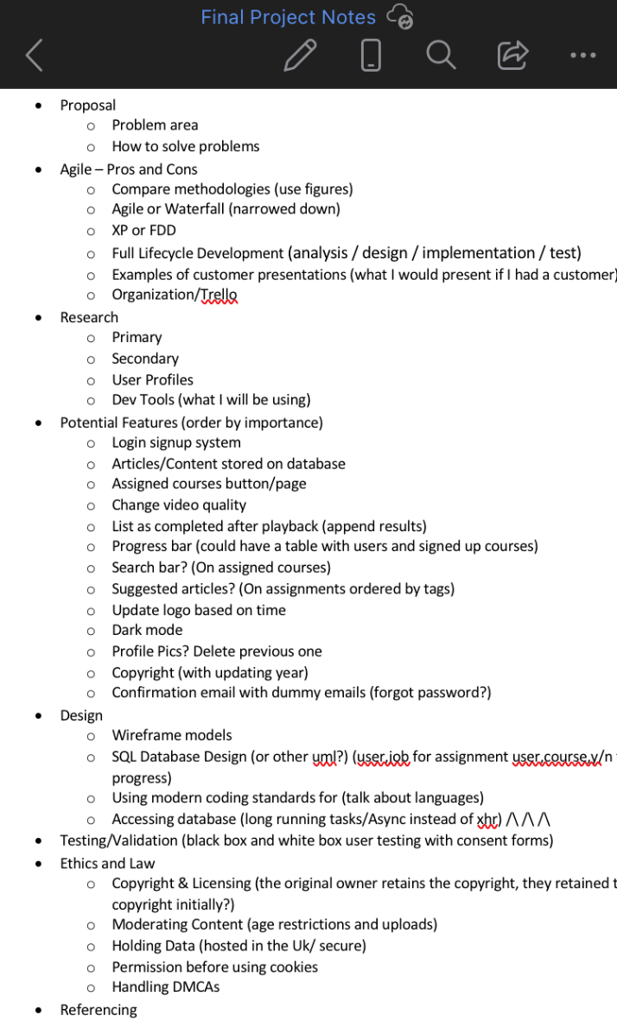

*Figure 1: Project Outline Notes*

This project outline (once refined enough to meet the correct standard) would then be transferred to a more professional web space. In a professional environment, it is common in this scenario to take advantage of a project management tool. I chose to use a Trello workspace to host the project requirements and potential features to take advantage of their user-friendly project management tools, as well as to help clearly document the process of the project's development.

Trello is a free-to-use project management tool developed by Trello Enterprise. It can be used to manage personal and organisational projects via and online Kanban board. This is used to visually depict work at various stages of development. Over the course of development, the requirements will have moved from the first to the final stage while the potential features could progress or be dropped from the table. It also supports integration with other useful services like Dropbox and Google Drive as well as being available on mobile and pc. These facts make Trello a perfect tool to use for documentation.

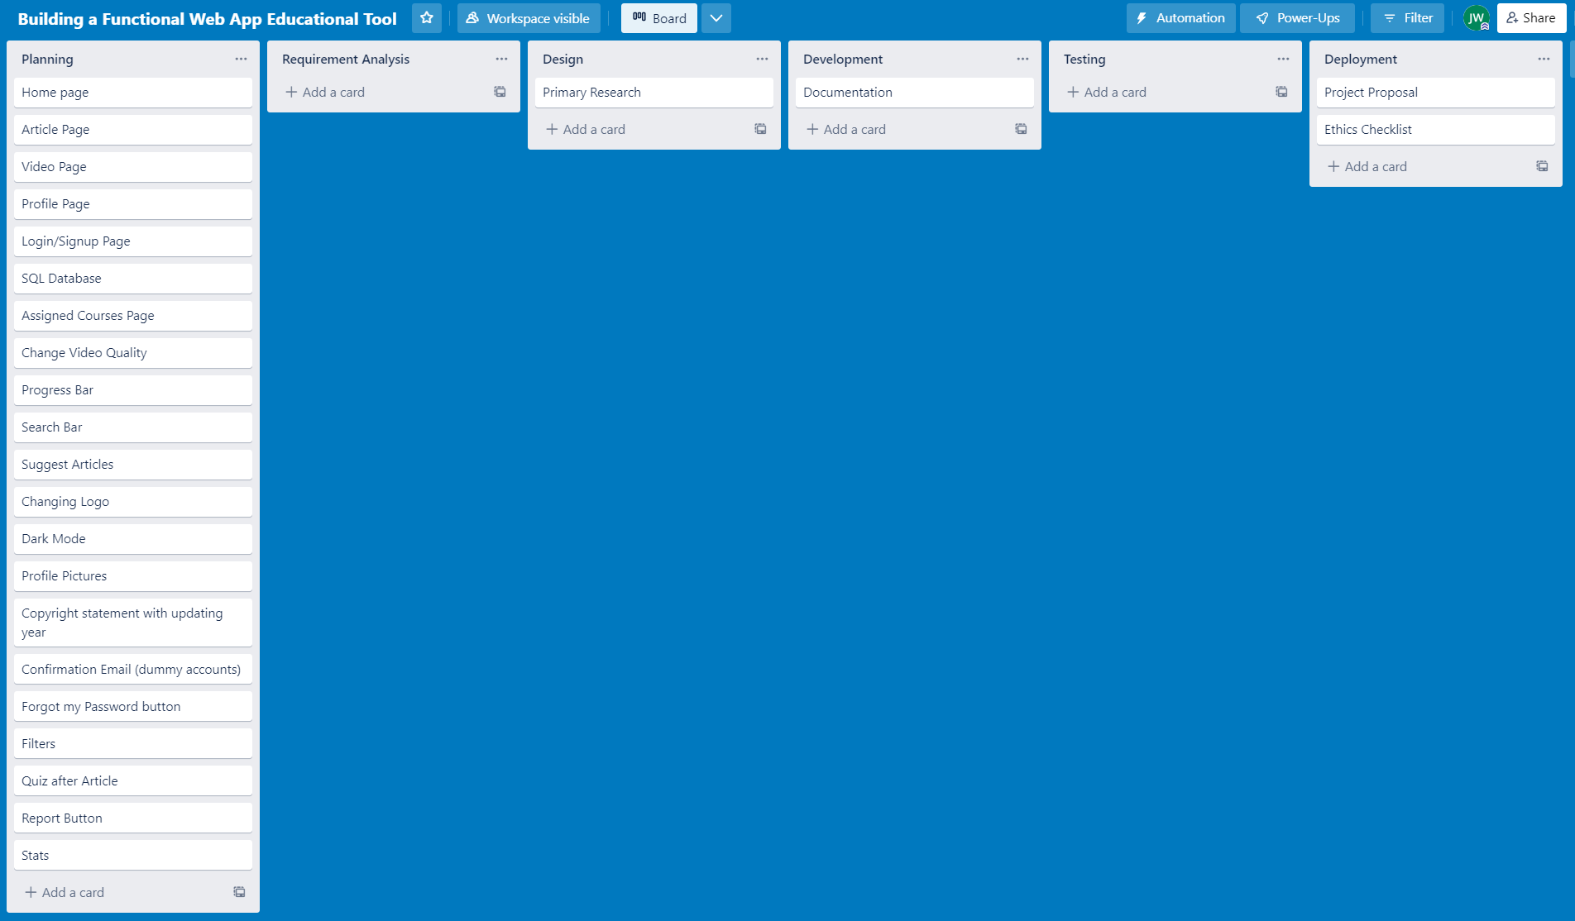*Figure 2: Trello Board based on Agile SDLC, 12/10/22*

I designed my Trello board according to the Agile model of the SDLC (software development lifecycle). Due to this, the stages of development are as follows; Planning, Requirement Analysis, Design, Development, Testing and Deployment. Latest ideas and adjustments could be added to the table instantly via Trello’s mobile support and peers could be invited to view the table to get an understanding of development or give critiques if peer review were allowed.

I decided to document the development of the project in a word document saved on Microsoft’s OneDrive as well as regularly saving copies on my mobile device and personal computer. These various copies would serve as backups for each other to not lose the contents, it was the most effective way as it made use of both cloud and physical storage as well as automatic saving.

The structure of the documentation is to be separated into the stages of my chosen SDLC alongside other requirements such as Methodologies and References, while this may not display feature additions in chronological order it displays the information in an easier-to-understand format.

## Initial Requirements

In this section, I have listed the different types of key functional and non-functional requirements. In basic English, the System Requirements were what was used by myself as the developer to measure success and progress. However, the other requirements are still valid as they represent the needs and expectations of both the business the application would be sold-to/used-on and its potential users. The requirements listed below are the requirements that were decided upon at the start of the project before any practical work had been carried out.

#### Business Requirements

Business requirements are high-level requirements describing what the application was going to do from a business standpoint without considering the objectives on a technical level. These requirements are ordered by priority and separated into key features and non-key features. These requirements are relevant to any businesses who would be using the system, they would be tested by the business to confirm the product is functioning as intended.

Must:

1. Avoid legal and ethical issues (e.g. keep data secure)
2. Validate employees before allowing them access
3. Allow employees to access training resources
4. Allow an administrator to manage training resources
5. Consider accessibility

Should:

1. Be usable from mobile devices
2. Test employees after training
3. Track employees' progress over courses

Could:

1. Add quality-of-life updates

#### User Requirements

User characteristics were defined in the section of the report labelled “primary research”. User requirements refer to the users' needs and represent the actions the user was expected to take once the application was complete. These are ordered by priority and separated into key features and non-key features. These requirements are relevant to users who would be using the system, they were to be tested by potential users to confirm the product is functioning as intended.

Must:

1. Allow the user to signup/login
2. Allow the user to visit training resources
3. Allow the use of a screen reader

Should:

1. Allow users to use the site on a mobile device
2. Allow users to see all their assigned courses
3. Allow users to see their progress in training
4. Allow users to take a test to complete training

Could:

1. Be able to switch between a dark and light theme
2. Send confirmation emails to users
3. Allow users to upload a profile picture
4. Allow users to search and filter through their training
5. Allow users to report a user or video
6. Allow users to view stats
7. Allow users to change the quality of training videos
8. Be notified when a due date approaches

#### System Requirements

System requirements are representative of the literal tasks that I as the developer was to have to carry out to build the web application. Below I have listed the system requirements at the start of my project by order of importance. This was designed so that the bare minimum requirements being met would result in a successful software artefact. Any requirements listed as “must-have” are key functional requirements and are required to meet the project's objectives. Any requirements listed as “should have” or “could have” are non-key requirements and serve only to improve quality and increase complexity. These requirements are relevant to developers who would be building the system, they would be tested by the developers to confirm the system is functioning as intended. As they application was developed, some of the non-functional requirements were dropped or replaced due to incompatibility with how the project evolved or alternate issues such a security.

Must-Have:

1. Home Page exists and is functional
2. Login Page exists and is functional
3. Database exists and is functional
4. Login/Signup functionality
5. Article page outline
6. Content stored on the database
7. API for communication with the database
8. Dynamic article pages with content from the database
9. HTML validation

Should Have:

1. Responsive pages (WIA standard)
2. Ability to assign courses to users
3. Assigned courses page
4. Progress bar
5. Quiz after articles to complete course (results stored on the database)

Could Have:

1. Update logo, light/dark mode and copyright based on time (additional small visual elements)
2. Confirmation emails (using dummy accounts)
3. Profile pictures
4. Search bar (on suggested articles page)
5. Suggested articles
6. Report button
7. Stats (courses complete etc)
8. Change video quality
9. List a video-based course as complete after playback
10. Notify users when a due date is approaching
11. Saving states of a test/page when applicable

I decided that I must use HTML validation to ensure screen readers are compatible with the site to maintain accessibility. The web application needed to feature responsive pages as well to ensure accessibility in case a user can only access the site via a mobile device. The pages were to be separated into a home page, login/signup page, dynamic article page and assigned courses page to maintain user-friendliness. It would do this by assigning different functionality to each page to be conventional and understood by most users.

There was to be a login/signup system in place to ensure no unauthorised access to the application or any of the hosted content. All content was to be stored securely on the domain or in a database to ensure the safety of sensitive information.

An API needed to be created to send data between the database and the client while using restrictions to allow functionality but without potential unauthorised access.

There would be a progress bar/counter to help users see how much training they have left. As well as an assigned courses page with a search/filtering function to aid should there be an overwhelming amount of training to sift through. This ensures a user-friendly design which can be improved via other quality-of-life updates like the use of profile pictures, dark mode and statistics.

A report button could have been added should a piece of uploaded content violate any terms of service and copyright statements could automatically update to prevent copyright issues.

Allowing changing the quality of a video could have been a worthwhile addition to accommodate users with low-speed internet connections, making the application more accessible.

Tests and Logging when there's a video playback ensured that the user had successfully completed their training. This is important for the user experience as it enables a user to keep track of which training they have yet to complete. It would also be important for the company as it enables them to check if users are completing their assigned training.

New content should have been able to be added to simulate how a real company would update their content. Content should have been able to be assigned to a user by the administrator so the user can easily navigate to their relevant training via the appropriate page, this also makes the site user-friendly by conforming to convention.

Overall, these requirements should have ensured an inclusive, user-friendly, fast and efficient experience for the user, devoid of legal or ethical issues. They should have been able to log in; be assigned training and prove they had completed it.

## Revised Requirements

Over the course of the project, certain requirements were dropped, and other requirements were added for various reasons. In this section, I have detailed the requirements that were used to test the success of the project as well as justifications for the alterations. The agile development method supports this practice as it holds an understanding of how projects may evolve due to unforeseen issues or change in direction. These requirements can be viewed as the overall requirements and were based on the system requirements due to them being the most detailed

Must-Have:

1. Home Page exists and is functional
2. Login Page exists and is functional
3. Database exists and is functional
4. Login/Signup functionality
5. Article page template
6. Content securely stored on the database
7. API for communication with the database
8. Dynamic article pages with content from the database
9. HTML validation

Should Have:

1. Responsive pages (WIA standard)
2. Ability to assign courses to users
3. Assigned courses page
4. Progress bar
5. Quiz after articles to complete course (results stored on the database)

Could Have:

1. Copyright based on time (and additional small visual elements)
2. Confirmation emails (using dummy accounts)
3. All articles page
4. Search bar
5. Stats (courses complete etc)
6. Notify user after video playback
7. Notify users when a due date is approaching

Future Additions:

1. Profile pictures
2. Saving states/caching pages when applicable

In terms of additions, an “all-articles” page was added to replace the suggested articles feature. The feature was planned to emulate behaviour seen of YouTube and other video streaming sites where suggested content would crop up in the sidebar after the user was finished. However, due to the nature of the site, it became redundant as users would be assigned work by their superiors and suggested articles would only serve to confuse the user on what work they have been assigned. The same functionality seen in a suggested articles feature would be present on the training page anyway as it would display all assigned articles. So, all the web application would need to do to retain this functionality while being efficient would be to redirect users back to the training page upon completion. The “all-articles” page would display all articles for users to search through using the search bar and would limit the results to not overflow the page while allowing the other results to be viewable through pagination.

On that note the search bar requirement was revised to be for the “all-articles” page and not the assigned training page as users would be unlikely to be given an amount of work that would overload the page with options, but displaying all articles would. Meaning that the training page n wouldn’t have a use for a search feature without being inefficient, while the “all-articles page did”.

The changing of video quality was dropped as a listed requirement as it was already a part of the YouTube API that I would be making use of and so wouldn’t require an amount of effort worthy of listing it as a requirement. While it would still be a feature it was automatically implemented alongside other features like reporting videos and casting videos under the article’s content, so didn’t need to be listed as a requirement anymore. On the topic of reporting, due to the lack of user-to-user interaction and admin status required to submit information, a report button was also invalidated, as users would never see another user's inappropriate content and any videos could already be reported via the player API.

Dark-mode was dropped as it would require a huge investment of time for a not especially complex feature, where the time could have been and was spent better in other areas. It could still be added in the future but many other minor CSS/visual adjustments were made in its place such as the animation of the progress bar, mobile-friendly views and the dynamic username card and copyright.

All requirements were met up until 22 and 23 when I needed to shift my focus to other commitments such as the project’s report, documentation, user-testing and other projects which had yet to have been started due to time constraints. These features were to be implemented after all other work was completed and if there was enough time left to add the features as well as document their additions. I left these additions as I knew how to implement them both as I have mentioned in the research section with express file upload and progressive web app design. However, I also left them as I knew they would be an investment of time which may have prevented me from finishing, thus believing it be the most responsible decision as project manager to stop development after completion of all requirements except 22 and 23. If I were to continue development on the project after its due date then I would implement these features in the same way I had before in the module CI609.

## Deliverables

The chosen deliverables were impacted by research detailed later in the Research section of the report. The deliverables are the items that are evidence of the work detailed in the report as well as the final product.

The deliverables for the CI601 project include:

* The source code for the Client-side of the Web Application
* The source code for the Server-side REST API of the Web Application
* Code displaying the structure of the Database/Tables
* A link to the live Web Application
* The API support documentation
* A Report on the entire project (including project designs, implementation documentation and testing plans and results)

Approach

I decided to make a web application because I am confident in my capabilities in the area of web development. It is because of my experience in the area at the University of Brighton that I was confident that I could create a high-quality web application. The area of web development is also greatly ranging, which would allow me to learn many new techniques and resources over the course of the project. Because the area of Web Development is vast it allows me to showcase competence in various different programming languages and areas.

The project is a web application from a logical standpoint because web applications are amongst the most accessible types of software. As any device with the potential to access the internet can reach a web application, they are one of the most relevant areas to explore in the modern day.

As well as this, the setting in which employees would be required to complete online training is using a desktop. This is often an automated process hosted on a web application and so it stands to reason that if I were to create a software artefact designed to train employees, then the most effective and conventional solution would be to design a web application to host the training content.

A mobile application could have been designed for training employees but this would not be as accessible or relevant in a professional environment as desktops are the conventional professional computer.

Alternatively, a different type of web application could have been selected. However, I chose to create a web application designed to train employees because it allowed me to explore and showcase my knowledge in many varying areas. This choice would allow me to create a functional client, create a REST API, store and access information in a database and explore new development tools like modern frameworks and middleware. Overall, I chose this approach because it would allow me to showcase my skill as a developer in multiple areas and would be useful to potential clients in a real-world scenario.

I have detailed the methodologies, tools and techniques I decided to use in my approach to reach my set objectives below.

### Methodologies

I researched the various methodologies for approaches to project development. There are ranging types of methodologies for project development and some methods may not fit into one simple category. I researched the following SDLC models

* Spiral
* Prototype
* Iterative
* RAD
* JAD
* V
* Big Bang
* Agile
* Waterfall
* DevOps

After researching these different methods on a surface level, I decided to explore a few of the potentially applicable models on a deeper level to find the model most appropriate for my project's development. I concluded that I would be progressing with either the Waterfall or Agile method of development.

#### Waterfall

The waterfall model, also known as the linear-sequential model, is an SDLC model developed in 1970 by Winston Royce. Its name is derived from its chronological and linear structure. Almost all old software was based upon this model, yet it has fallen from its longstanding popularity due to the rise of the Agile development method. Development is segregated into multiple phases, each focusing on distinct goals. Each phase must be completed entirely and successfully to move on to the next phase and there is often no opportunity to modify the project’s previous phase.

Requirements

Design

Developmemt

Testing

Deployment

Maintenance

*Figure 3: Diagram of a Waterfall model*

Projects with stable objectives best use the waterfall method as it makes the development easy to understand and track progress. However, this would mostly benefit teams whose composition changes frequently. This applies a lot less to my individual project’s criteria as my team would consist of myself and myself alone. The method can be slow and obstructive due to its aversion to modifying previous work making the process significantly less flexible. It is because of the methods' lack of flexibility in comparison to other methods that lost its status quo as the conventional SDLC model.

Advantages of using waterfall include:

* Easy to manage with its clear requirements in each phase of development
* Documentation is easy to manage
* Projects are delivered fast so long as they have stable criteria, and no unforeseen errors occur
* Simple dependency management
* Beneficial for teams with fluctuating composition

Disadvantages of using waterfall include:

* Not ideal for large-scale projects
* Lacks flexibility for problem-solving or changing the project's direction
* Unclear requirements become a detriment later
* Testing is only carried out toward the end of a project lifecycle, making bugs likely, potentially endangering the development of the project

It was because of these disadvantages I felt compelled to explore the Agile development method.

#### Agile

The agile development life-cycle model is often used by teams to significantly reduce risk when adding new functionality. It does this via its iterative nature and flexibility, the opposite nature of its counterpart the waterfall model.

The agile model spawned from the iterative waterfall model when developers found difficulty in handling changes or updates requested by clients. The new model was first incorporated in 1990 to combat the potential change in direction of a project and the agile methodology was officially created in 2001 by a 17-person team convening specifically to define the new model.

To combat changing requirements or updates the development method was designed for easy and rapid project achievement. In a team, developers would work simultaneously on the various stages of project development and potentially different iterations. However, in a one-man team, I can only utilize the flexibility of switching between the stages or iterations when appropriate. In both scenarios, the requirements are ordered by priority and then incrementally added via iterations similar to the waterfall model and its stages. However, the agile method is flexible and so older implementations and stages can be changed without the red tape. Once all iterations are complete then the project is successful. At the end of certain iterations, the project would be presented to clients for approval.

Requirements

\/

Design

\/

Development

\/

Testing

Iteration/Sprint 1

Planning

Requirements

\/

Design

\/

Development

\/

Testing

Iteration/Sprint 2

*Figure 4: Diagram of an Agile model*

The model relies on software deployment as opposed to comprehensive documentation and often provides clients with incremental versions at the end of each sprint/iterative cycle in intervals of 2 weeks. System requirements can be changed at any stage of development and in a team, a representative would be elected to showcase the latest version. While I have no client nor intended to get one involved in my project, I note that I could simulate it through vivid documentation. The agile method requires great efficiency between team members, something that is of no concern in an individual project.

The strategy of adding new functionality incrementally has been utilised in various other methodologies considered to be different forms of agile.

* Crystal
* Scrum
* Atern
* XP
* Lean
* Unified Process
* Feature-driven

These models are all attributed to being agile development methods with XP, Scrum and Lean being the most widely used. Utilising elements of these sub-genres of agile allows for the use of greater control and documentation. An example of this is the use of sprints and burndown charts in Scrum typically motivate and document the time and work left in a project or iteration.

Advantages of using agile include:

* Significantly reduces development time
* Clients would have real-time updates and the ability to change the project's direction at any point in the SDLC
* Iterative releases allow for bug fixes earlier in development
* Incremental additions allow for faulty plans to be changed if an unforeseen logic error arises
* Teams using agile are often more motivated and self-organised
* Development quality is maintained throughout
* Overall risk reduction

Disadvantages of using agile include:

* Agile is not particularly useful for small projects as many iterations/sprints wouldn’t be required
* If you have a client an expert must be present to control meetings
* In a team, the cost of using the agile method is more than average
* If the project manager is unclear about what they want, then the project can get off track
* Heavy reliance on real-time communication
* Large commitments of time and labour are required to complete each feature within its designated iteration

I was more inclined to follow the Agile SDLC do to the lack of disadvantages applicable to an individual project without a client such as the one I would be undertaking.

#### Agile v Waterfall

I listed comparisons between the Agile and Waterfall SDLCs alongside my aforementioned advantages and disadvantages to make my final decision and to document the conclusions of my research.

|  |  |
| --- | --- |
| Waterfall | Agile |
| Sequential approach | Incremental approach |
| Rigid structure | Flexible structure |
| Development is divided into phases | Development is divided into iterations/sprints with phases within them |
| Development is completed as one project | Development is completed as incremental versions of the final product |
| Testing takes place at the end of development | Testing occurs frequently and simultaneously with development |
| Changes to requirements cannot be changed during implementation | Changes to requirements can be made at anytime |
| Phases like design, development and testing appear once | Phases like design, development and testing appear multiple times |
| Fixed rates in real-world scenarios | Non-fixed rates in real-world scenarios |
| Coordination is limited | Coordination is required if in a team |
| Developers are dedicated to their assigned roles | Developer's roles are interchangeable |
| Developers are interchangeable | Developers are difficult to change after a project has started |

Due to the disadvantages of the agile approach having a lack of application on my project outline I decided to move forward with the agile approach.

Any inconvenience caused by bad communication when using the agile model does not apply as I am to work on my project as an individual, and any potential teamwork is forbidden from this project. This means unforeseen errors from bad communication on the project manager's or the employees’ part is null and void. As there is no client there is no one to hold meetings with at the end of a sprint and so no experts would need to be present. Instead of holding meetings, I would document my progress in this report to simulate any updates I was required to give the client. Any pricing issues are equally of no consequence as there is no budget and I am the only developer. Finally, as the project outline was designed as a potentially large project depending on how many features could be added bore the deadline, the incremental additions hold great validity.

I found the most attractive feature of the Agile model was the use of incremental development. This is because it almost guarantees that a functional product would be completed before the deadline. The high-priority requirements would outline a basic web application and then further additions would only serve to add greater complexity. This allows for safety in development, as at a bare minimum the success criteria would be met in terms of software artefact creation.

As the Agile methodology often involves the use of sprints, I’ve documented my progress at the end of each sprint via burn-down charts while my predicted schedule is represented by a Gantt chart.

### Tools and Techniques

The web application would follow the client-server model. The client UI and REST API handling all the server-side background services would both be stored on Brighton domains. While a training site could be hosted on an intranet closed from the public I decided to host mine on the internet because it will be more accessible for grading and demonstration of this project as well as being more convenient for employees in a real-world scenario.

I considered two approaches for dedicating the tasks between the server and the client. One approach focused on server-side rendering while the other focused on client-side rendering.

In the first solution, The API would be built in Node.js using Express. It would handle server-side rendering for dynamic pages to lessen the number of pages needing to be stored on the server and reduce strain on the client. The API would handle get requests via different routes for returning dynamic pages as well as JSON responses from communication with the database. The API could also handle post requests to insert new information into the database. Various plugins listed in the research section would be used to render-pages, handle files and contact the database.

The UI elements would be written using HTML, CSS and JavaScript and potentially concatenated using Gulp or Webpack as a secondary option. There would exist a template for the dynamic pages that would be populated/rendered by the API. The UI would contact the API if a dynamic page was requested or if another request needed to be handled by the back end (e.g. posting login information or getting stats).

The second solution involved building the client-side of the application in the React framework and rendering the dynamic pages via dynamic routing. This would mean rending the pages on the client side but would be utilising the conventional and more documented approach. In this approach, the API could still be created with express but would not hold responsibility for rending the dynamic pages and would instead focus solely on handling get and post requests.

I decided to use my first approach as it would greatly add to my development time should I have to learn to use another new framework. As well as this, the concept of rendering pages on the server would benefit the client in terms of speed and computing power. The API would be created as a Node.js application hosted on Brighton domains. It would feature different routes for requesting different types of dynamic pages or uploading files.

All code for the Client and Server would have copies stored on a personal computer, Brighton domains and a GitHub repository. All code would be written in Visual Studio Code while attached to the repository to ensure frequent backups would be a simple task.

The database would be designed and managed using MySQL in phpMyAdmin and contacted via mysql2. It would use constraints to ensure unique entries and would have relations between tables. It would be used for storing login information, page content, quiz results and user statistics.

Middleware and packages installed on the server would include:

* cors to mitigate the risks of cross-origin HTTP requests causing errors
* mysql2 to query the database
* express-fileupload to handle files uploaded by users
* body-parser to read various types of request bodies
* ejs to render dynamic pages with templates

All plugins for node.js would be installed via the npm registry.

The testing of the database would be carried out through the use and monitoring of tables on phpMyAdmin. The testing of the REST API would be carried out via Postman. The testing of the client would be carried out via manual testing through Edge, Chrome and Firefox’s developer tools. The client would be validated by the w3c markup validation service.

The entire report would be written in Microsoft word and stored in multiple separate OneDrives.

Additional reasoning for the selection of these resources can be found in the research section of the report. Overall, I chose these resources because I either had experience with them or had researched them enough to know they were the most effective approach and would be capable of meeting the success criteria.

# Planning

## Schedule

The report was started immediately alongside the planning of the project. This was done so that the project would be documented from start to finish. This was the exception as all other tasks would have to be planned in the schedule. I decided to demonstrate my predicted schedule in the form of a Gantt chart to present it clearly and concisely.

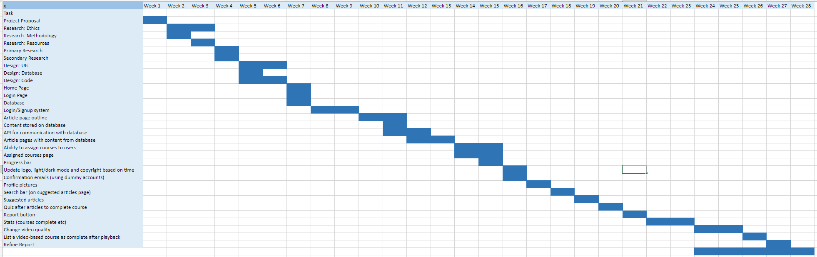*Figure 5: Gantt chart at the start of production*

The schedule was subject to change if another more efficient plan was discovered over the course of additional research, or if any setbacks presented themselves. I also acknowledged that the schedule would potentially have occasional slowed development. This is due to other coursework designated to me by the University of Brighton, with more pressing deadlines, requiring my full attention. To make up for this potential setback, I always planned to work throughout the break between semesters one and two. I also planned to provide the project with as much overtime as necessary, to catch up with the schedule should I fall behind.

While the deadline for the project was the 6th of May 2023, I structured the schedule around a finished product having been developed by the end of April 2023. This was to reduce the risk of not meeting the deadline should the schedule be extended for any unforeseen reasons.

As the agile model was chosen as my methodology for the project, a burndown chart was to be created at the end of each sprint. The first sprint would begin upon the start of implementation. These sprints would last 2 weeks each.

The Gantt chart can be viewed in full by following this URL:

https://unibrightonac-my.sharepoint.com/:x:/g/personal/j_ward26_uni_brighton_ac_uk/Ec4dW_-S27VJuiwTY8-ai5wBnLAFhD54khuMr4eSxwpenw?e=mbnDUN

## Risk Analysis

|  |  |  |
| --- | --- | --- |
| Cause | Effect | Mitigation |
| Hard-disk failure | Loss of progress (code & report) | Backups (GitHub) |
| Account hacked | Loss of progress (report) | Backups (OneDrive) |
| Erroneous code uploaded to the repo | Code breaks or loss of progress | GitHub Version Control |
| CORS policy violated | UI cannot contact API/database | Use ‘cors’ middleware to enable CORS |
| SQL Injection | Loss or alteration of database | Input restrictions |
| The same named file is uploaded to API | File is overwritten | Check if the file exists/ name each image uniquely |
| A user tries to sign up with the same username or email as another user | Only the first user will be fetched | Use unique constraints on email and usernames |
| HTML markup is incorrect | Screen readers and extensions dependant on conventional markup don’t function | Use the W3C validator to fix markup |
| A user attempts to access a page for employees without logging in | Unauthorised access | Redirect the user if not logged in |
| Potential loss of private/sensitive information | Unethical | Use a secure database |
| A user who is not an employee makes an account | Unauthorised access | Require an admin to signup users manually or require a code to create an account |
| Potentially real emails are used in the automated system | Emails are spammed | Use dummy email addresses or personally owned email addresses |

To mitigate the risk of permanently losing source code should a hard drive failure or similar event result in the loss of code, the entire project must have backups in multiple places. This was done by holding the source code on GitHub, a personal computer and Brighton Domain. On top of these being backup locations GitHub would also hold previous versions of the project should erroneous code be backed up accidentally. The code would be written in a VS Code window linked directly to the GitHub repository allowing for quick backup and rollback if necessary. Similarly, the report has multiple versions stored online on OneDrives across multiple accounts. Due to Microsoft word automatically saving regularly there is little risk of losing work due to a crash or network error. In this way, the loss of any work is highly improbable.

Depending on the location of the server and client the requests sent between the client and API may violate CORS policies. This risk is easily remedied as the solution simply involves utilising the cors plugin in the express application/API.

There is always a risk of SQL injection when a SQL-based database is concerned. To avoid this risk, there must be length restrictions in the database to disallow complex code from altering tables. The same restrictions can be added to the API contacting the database as an extra precaution.

To prevent users from potentially overwriting other users' files like profile pictures, I can have the images uploaded be named after the current date and time in milliseconds. This ensures uniqueness in the naming schemes, preventing overwriting via uploads through the client. To prevent overwriting via direct requests to the API I can make the API only allow the upload of an image if its path/name is present in the users' table and Its name is not already present in the destination directory.

To prevent errors regarding users attempting to name themselves the same as others I can program the API to only add a new user to the database if the username and/or email address are not present in the database. I can also give certain elements in the database a unique constraint to prevent the same user from being added twice.

If a user attempts to access a page they are not supposed to have access to, then they will be redirected to the login/signup page so they can get clearance.

There is normally a risk of losing someone's personal data with a signup/login system. However, this web application is to be used inside of a company and so requires very little sensitive information about its users. Even so, any information about the users will not be disclosed by the API because it will only create and check the validity of accounts. While the training resources hosted on the domain and database could be sensitive to a company, there will be no way to access them unless you are logged in as a valid employee.

To prevent an outsider from creating an account, the company the application is given to could either: remove the signup feature and manually create the accounts for employees or have a verification code required to set up an account that goes on rotation to prevent attackers from gaining entry.

To prevent emails from getting spammed or ethical issues, the only emails held in the user table are either my own account or a dummy account.

The security of all resources is also enforced by their location on Brighton domains and in the MySQL database. Both of these resources come with their own security measures in place to prevent potential attacks.

# Research

Research into every area of the project's planning is listed in this section. This includes technical research regarding which resources to use, user research in the form of primary research, research into accessibility, legal and ethical issues. This research was gathered via the study of resource documentation, articles, published books, query’s from other develops and questionnaires. Any external research where a significant amount of knowledge was gained was cited in the references section. It must be noted that a portion of this section wasn’t freshly written for the final report as it was also included in the unassessed interim report for feedback purposes.

## Management of Legal & Ethical Issues

It is important as the project manager that I considered the potential legal, ethical, social, and professional issues relevant to the project. Some issues such as social issues would be minimised by the nature of an individual project in general, however Legal and Ethical requirements range widely with all issues needing to be considered in detail.

The Legal requirements my project needed to meet include: the Data Protection Act, copyright law and intellectual property law, among others. While the ethical concerns I needed to acquaint myself with included: research with human subjects, ethics concerning holding personal data and ethics concerning public sites.

### Intellectual Properties

As a project made under the tutorage of and to be marked by the University of Brighton, the intellectual property rights are as follows. *“The university requires access to intellectual property generated by students. As a condition of joining the university, students grant the university the right to use their work for academic purposes, including assessment and research, and for purposes relating to the administration of the university, including quality assurance and publicity.”* In simpler terms, this means that the university holds the right to view the work in its entirety, but the intellectual property will remain with the students who created it, which in this case would be myself alone. This information would be an important detail to bring to the attention of any third party involved in supporting the project, however as this is a purely academic product rather than a commercial one and I held no plans to involve a third party over the course of this project, no action was required on my part. If I were to have involved a third party, I would have needed to write them a letter explicitly detailing that the IP involves the University of Brighton's critique.

### Copyrighted Content

As this web application is not for actual commercial use and is only an emulation of a commercial product, it is instead classified as academic use. This means I am allowed to use copyrighted material, so long as permission is gained, and reference is given. If it were for commercial use explicit permission would be needed with evidence to host copywritten content. Copyright law also dictates that materials included in the project or project report taken from the internet are subject to the same proprietary rights as those originating from more conventional sources such as written/published materials. For insurance, any permission needed would be better off kept in written form to function as undeniable evidence.

Patents

A patent is a type of intellectual property licence that excludes others from making, using, or selling an invention. As the project presents pre-existing ideas and is not currently to be used for any industrial application it lacks patentability.

### Research & GDPR

Any research involving human subjects must meet the standards of good ethical practice and relevant legislation such as the GDPR (General Data Protection Regulation). The GDPR is an EU regulation on data protection and privacy that went into full effect in 2018 (Data Protection, 2021).

The GDPR was designed to allow consumers more control over how their data is handled by companies. The GDPR dictates that all websites must follow their rules regardless of where they are based and that if breached, must inform the consumers of the relevant information. As an important privacy law, my project must take care not to intrude upon the GDPR, as such the following precautions must be taken. Any user testing or primary research involving participants must:

* gather informed consent for all data to be processed
* only store needed information
* all stored data must be secure/confidential
* users/participants must have control over their data

(Boyd, 2021).

The GDPR dedicates its 2nd chapter to informed consent and states in its 4th article that “*'personal data’ means any information relating to an identified or identifiable natural person (‘data subject’); an identifiable natural person is one who can be identified, directly or indirectly, in particular by reference to an identifier such as a name, an identification number, location data, an online identifier or to one or more factors specific to the physical, physiological, genetic, mental, economic, cultural or social identity of that natural person;”* and “*‘processing’ means any operation or set of operations which is performed on personal data or on sets of personal data, whether or not by automated means, such as collection, recording, organisation, structuring, storage, adaptation or alteration, retrieval, consultation, use, disclosure by transmission, dissemination or otherwise making available, alignment or combination, restriction, erasure or destruction.*” (GDPR Archives - GDPR.EU, 2016) This means that any data that could potentially be used to find a person involved in the user testing or research is classified as personal data and any viewing of this data is classified as processing.

The GDPR states in Article 4 that you are held responsible for the collection of your data but also the passing of collected data to third parties. These are separated as “Controllers” and “Processors.” However, because I didn’t plan to involve third parties in my project, I function without a processor and simply needed to focus on data security.

In terms of participants having control over their data, the GDPR dictates that;

* “You must tell your users why you are collecting their data, what you are doing with it and how long you are keeping it.
* If a user requests it, you must give them a copy of all data you have collected about them.
* If a user says that their data is inaccurate, you must correct it.
* If a user requests it, you must remove all their data.
* If a user requests it, you must stop processing their data.
* If the user wants to move from your service to another service, you must allow them to transfer their data out of your service in a machine-readable format.
* A user has a special right to object to their data being used for certain purposes, like direct marketing.
* If you are using personal data for automated decision-making or profiling (like feeding customer data into a machine learning model to approve a home loan), then you are exposed to a bunch of extra requirements around explaining how your model works, having an appeal system and so on.”

(Geitgey, 2018). If the user/participant in any of my research or testing makes any of these demands I must honour them.

Taking the above facts into consideration, to ensure user testing/participation in primary research remained ethical and met these regulations I decided upon these requirements for my research:

1. Consent forms must be filled out before the disclosure of any potentially sensitive information, this will walk the user through how, why, where and what data will be collected (only to be done if sensitive data was required).
2. Alternatively, surveys can be filled out anonymously via platforms such as Google Forms so long as the information gathered holds no revealing information about the users. If the anonymous method is used, then the questions must be designed specifically to avoid gathering sensitive/revealing information.
3. All information gathered is to be stored in a protected location (such as a password-protected location on Brighton University’s secure OneDrive) and only the needed information will be stored.
4. As previously stated, the users must have control over their data, this will also be covered using the above criteria in the consent form and the fact I will allow the participants to stay in contact with myself as the project manager so that they can make any relevant demands concerning their data.

All data collected for research purposes would remain only used for that purpose. All data collected would be anonymised by separating data from identifying features but allowing users access to their data by assigning them codes in place of these features, thus conforming to the GDPR (this method would be used at all times anonymisation was required). This way if any unauthorised access were to happen then the data would be useless.

### Design & GDPR

While the research of my project mostly concerns the collection of data, the design would have storage and usage of data on the pedestal of the highest priority. To avoid unwanted issues, only dummy accounts created by me, the project manager, would be stored in the database of the project for testing. This would maintain the functionality of the site and allow user testing without concern for ethical or legal issues. Any feedback from user testing would only be stored in the documentation which itself is stored securely on Brighton University’s OneDrive and backed up on my password-protected PC running antivirus and encryption.

Cookies are also a potential dilemma but if permission is gained on the site before cookies are used then it is perfectly ethical and lawful. Although, because a user could refuse cookies the application cannot be reliant on them or must warn the user that the site may not work without permission. The former is preferable as it could be viewed as unethical if you are pressuring users to accept cookies.

However, if the account information were real then any sensitive information (such as emails, passwords, real names, stats etc..) would have to be:

* definitively secure
* retained only for as long as necessary
* disposed of definitively after use
* completely confidential
* Anonymous
* Correctly used

Despite using dummy accounts and anonymous feedback, any potentially sensitive information will always be stored on Brighton University’s OneDrive or Brighton Domains (where I am securely running my database for holding accounts, courses, and other data integral to functionality). These are secure locations provided by the university due to their password protection, encryption services and other security measures used to avoid unauthorised access. No moveable storage will be used for this information and so there is no risk of it leaking in that way. There are no co-researchers to share the information with and the data would not be shared otherwise. Data is and was not carried outside the EEA. Transfer of data would be done conventionally and securely. Accidental loss of data is the last potential remaining issue concerning how the system is designed but can be avoided through regular backups of important or sensitive data in an alternative but equally secure location (such as a private GitHub repository). Data was to be disposed of securely (whether physically or electronically).

I must also note that the GDPR legally ensures that participants' or users' rights include...

* Subject access
* To have inaccuracies corrected
* To have their information erased
* To prevent direct marketing
* To prevent automated decision-making and profiling
* Data portability

All data would remain used only for its advertised purpose, whether it be feedback with user testing or account information with the login and signup information. The dummy accounts stored for the testing of the application would eliminate the need for anonymity on the database, however, the feedback would remain anonymous.

Additionally, the corporate author of the hosted content would be treated as the author of all hosted content meaning that there would be no copyright law issues with the content hosted as the host of the web application wouldn’t be claiming copyright ownership over any of this. This would be written in the terms and conditions of the site in a real-world however law isn't my field of expertise, and the project isn’t actually being used by a company so it was decided that it would simply be stated in the project report.

### Subject-matter

While considering ethical issues in projects, any content found to be Controversial, Contentious, Sensitive, Embarrassing or Upsetting is considered an issue. As such the chief concern would be the management of content placed upon the web application, as at base it would hold no relevance with any of these concerns, being as inoffensive as it is. These potential issues would be fixed by either the administrator of the site once it is in the hands of a company using the site or could be managed by a report button if the site allowed the upload of user-created content. However, due to the site potentially allowing for a small amount of user-created content in the ways of usernames and profile pictures, a functioning or planned-to-function report feature would have to be implemented besides these additions to remain ethical.

### Participants

Regarding participants in terms of ethics, these are the criteria I would use:

1. no participant will be younger than 18
2. no potentially vulnerable participants will be used
3. they will not be my colleagues or over-researched
4. They will speak/understand English
5. participants will not be recruited in public spaces
6. the positions will be voluntary
7. participants may remove themselves at any time
8. no one will be deceived.

I, as the head researcher and project manager, hold no financial interest in the project. The Health and safety of participants are of no concern as the project involves no physically harmful material whatsoever. No confidentiality issues exist so long as the participant’s data is stored on the secure service provided by the university (the Brighton University OneDrive) and dummy accounts were used for the signup/login system of the project.

### Informed Consent

As mentioned earlier, when talking about conforming to the GDPR, a consent form must be created to classify the project as legal. However, consent also affects whether a project is classified as ethical as well. To be ethical, informed consent must be given on the part of the participant and that can only be achieved if my consent form provides:

* in lay terms, the information for the participant to understand what the project is about and what is needed from them
* Who they can contact for more information (business contact details) and who is the organisation overseeing the research
* A date by which participants can withdraw their data from the study
* Assurances that their data will be held securely and treated correctly

A draft consent form provided by the university can be produced for this purpose, alongside any other relevant material required to support it. This all only applied if informed consent was required which I my case I was not going to be due to anonymity of the testers.

## Structure & Resources

I recorded all research into potential resources and structures in this section. Some knowledge was gained via research and experience from previous and current relevant modules, while other knowledge was gained through research into how to best meet the objectives of this specific project. While I already had an ideal solution for how the objectives should be met, I sought to back up my decisions with evidence gathered through research to ensure/demonstrate that I had chosen the most efficient approach. Research into these technical issues and solutions was carried out by studying: the documentation of resources, articles discussing structures and resources, other developers' query’s like those seen on stack overflow and published books discussing the relevant areas.

### Architecture

I only investigated the two most popular architectural models at length despite acknowledging models such as the Space-based and Monolithic models. I did this because the community of developers agree that they are the most useful as well as the most documented. I decided that the peer-to-peer and client-server models were the architectural models best suited for my project. I researched, compared and contrasted them to decide which model to move forward with.

#### Peer-to-Peer

P2P models are a type of architecture where the devices involved are not separated into categories such as clients or servers. In P2P models, each device is defined as a node in the system with the same responsibilities and restrictions as one another. This hierarchical approach allows the efficient distribution of resources between nodes, making on-demand facilitation of these resources the model's greatest strength. Equally, any service using the model will be reliable because of the lack of reliance on one centralised server. There are no administrative issues as each user manages their own system. There is no server to setup making it inexpensive and easier to implement. Because all devices are able to connect to each other without security measures it allows malware to be shared and spread fast. Due to content being held in multiple different locations any form of backup becomes a complex process. The peer-to-peer model is highly scalable, with extra clients not degrading performance, the larger the network gets, the more performance will degrade. BitTorrent, LimeWire and Apple Cash are examples of widely known/used P2P systems.

Node/Device

Node/Device

Node/Device

Node/Device

*Figure 6: Diagram of a Peer-to-Peer architectural model*

There are four main structures of the P2P model:

1. Unstructured P2P – has the advantage of easy connection between devices but resources become hard to find due to the lack of structure
2. Structured P2P – hard to set up but resources are easy to find
3. Pure P2P – each node in the architecture plays the same role due to the lack of a centralized server/device
4. Hybrid P2P – a device acts as a centralized server allowing for some advantages seen in the client-server model

|  |  |
| --- | --- |
| Advantages | Disadvantages |
| Simple Implementation | The non-centralised approach makes resources hard to find |
| No administrative issues | Performance degrades with larger networks |
| Non-centralized approach makes it reliable | Backups become difficult |
| Inexpensive maintenance | P2P is often used to share illegal or harmful content |
| High scalability | Assigning permissions is the only security |
| Real-time resource sharing | P2P networks can be compromised with remote access |
| P2P is always faster than client-server | Malware can easily spread between devices |

#### Client-Server

Client-server is an old form of architecture, being introduced in the early 1980s before peer-to-peer in the late 1990s, however, this doesn’t discredit the model altogether as it is still widely used. The client-server model is the most popular architectural design, in which devices are segregated between clients and servers. A client is defined as a device with the purpose of sending requests while a server is defined as a device acting as a medium between clients and resources, by processing the requests and returning the appropriate resources. The client-server model can be set up on a singular device, a small network or the internet and is compatible with the concept of Cloud computing. Servers can have more clients or servers embedded in them for greater flexibility.

Conventionally the client-server model involves the client sending a request by entering the URL of the server into the browser. The DNS then searches for the requested resource and responds with its IP address. The client's browser then sends an HTTP request to the IP and obtains the resource.

Client

Client

Client

Server

*Figure 7: Diagram of a Client-Server architectural model*

The client-server model can be separated into four different iterations of itself when concerning web development. These iterations are known as 1-Tier, 2-Tier, 3-Tier and N-Tier. The client-server model can also be separated into three distinct layers:

* The User Interface/Presentation Layer – the visual components the user will interact with, use to send requests and receive responses
* The Service/Application Layer – the intermediary between the UI and database used to provide functionality to the application, handles most application processes
* The Database/Backend Layer – the data tier, storing all data/resources to be managed by the application

The 1-Tier model defines the type of client-server architecture where the UI, Service layer and Database are all embedded in the same system. MS Office is an example of 1-Tier architecture. The 1-Tier architecture is not suitable for my application or web applications in general as the server can only be accessed within a single device.

The 2-Tier Model involves the UI and Database being separated by having locations on separate devices. There exists no separate intermediary in this model as the Service layers' responsibilities are handled on either the server alongside the database or on the client behind the UI. The client and server communicate with each other via the internet protocol. The direct connection between client and server ensures fast results and easy design, maintenance and modification. The disadvantage of this model is that the more clients connect to the server, the greater the performance suffers. Equally, if the Service layer resides on the client then the client will have to be updated every time the server is.

The 3-Tier architecture is the most common type of multitier architecture. This is when the UI, application processes and data management are all hosted on separate devices. The 3-Tier architecture disallows the client from directly interacting with the server containing the database. Instead, the client interacts with intermediary middleware which then passes requests and resources between the UI and database. Using middleware increases flexibility, security, data control and integrity by having the database be invisible to the client. The client is responsible for the presentation layer, the middleware server is responsible for the service layer and the database server is responsible for the database layer. N-Tier architecture is the descriptor for all other Multitier models. In an N-Tier model, the N simply stands for the amount of tiers/layers/middleware used as intermediaries between the client and the database.

Client/Server

Client

Server

Client

Middleware

Server

1-Tier

2-Tier

3-Tier

*Figure 8: Diagram displaying differences between iterations of the Client-Server model*

|  |  |
| --- | --- |
| Advantages | Disadvantages |
| Good flexibility | The whole architecture is disrupted if the server is |
| Connected devices can be controlled centrally | Security must be added to prevent unauthorised access |
| Efficient at managing requests and responses | Malware can be contracted from the server |
| Centralised data is more secure | Requires an OS capable of network access |
| Inexpensive maintenance | Can be expensive to set up |
| Centralised data is easier to manage | Excess traffic can cause congestion |
| Greater control over processes | Errors on the server must be remedied fast |
| High scalability |  |

As a subsect of the client-server model, servers can host REST APIs. REST APIs can be provided by middleware and are stateless. Stateless means that the client or server need not know the current state of the other. REST APIs separate the client and server meaning that the client doesn’t need to know about the server and vice versa but can still communicate with each other. The advantage of this is that the client or server can be altered without harmfully affecting the other. The server and client communicate through the API meaning that they must only know what format to send or receive data or requests in. REST APIs ensure reliability, scalability and fast performance.

#### Peer-to-Peer vs Client-Server

I compared and contrasted the P2P and Client-Server architecture. By doing this I would be able to showcase and define the reasons for why I chose to use one over the other.

|  |  |
| --- | --- |
| Peer-to-Peer | Client-Server |
| Devices have unique data | Centralisation for simple data-management |
| No segregation between devices | Devices are segregated between clients and servers |
| Peers can both request and provide services | Data is only requested by clients and provided by servers |
| Useful for small networks | Useful for large networks (e.g. the internet) |
| Designed for connecting peers | Designed for sharing data |

Since the P2P architecture is designed for the design of small local networks and the Client-server architecture is better-suited for web applications available through the internet, I would justify that the client-server architecture would be the best route to take the project in. It makes sense for a company's training videos to be available via client-server as many users would find it an inconvenience to connect to a peer-to-peer network to access data. As the project is geared towards the sharing of data the client-server is still the more appropriate of the two as no two users are supposed to be connecting with each other, but they do need easy access to the resources which the client-server architecture is more suited to provide. The centralisation of data allows the simple addition of new data to be accessed by users as well as greater control overall. The client-server approach was selected because of all the advantages listed above as well as its compatibility with the project objectives. I decided on using either a 2-Tier or 3-Tier architecture with the use of an API to separate the client and server. While a training site could be hosted on an intranet closed from the public I decided to host mine on the internet because it will be more accessible for grading and demonstration of this project as well as being more convenient for employees in a real-world scenario.

#### Server-Side Rendering vs Client-Side Rendering

Amongst developers in the web development community, there is an ongoing argument over whether rendering is better done on the client or server side of the client-server model. This argument has valid critiques on both sides and whichever method I chose to adopt would greatly change the architecture of the application.

To understand the advantages of either argument I had to research SEO (search engine optimisation). SEO is the process of optimising web applications' content and configurations to appear more relevant to search queries. Web applications with good optimisation will be ranked higher by search engines, this means they will appear in more users’ queries and get more traffic as a consequence. An SEO-friendly site will ensure popular search engines rank it high in the search results during the rendering process. So, the more SEO-friendly the rendering method is then the easier to find the application would be.

Google has ensured that most client-side rendering frameworks used to create user interfaces are SEO-friendly. Client-side rendering functions by redirecting requests to an HTML file, then fetching the JavaScript and compiling it before rendering. As long as the device has a good internet connection then this method is fast, reliable and SEO friendly. However, many now argue that this is not the optimal solution despite its conventional use.

The use of server-side rendering was the original solution for rendering pages which were mostly forgotten in favour of the modern client-side solution. Server-side rendering used to involve using a language like PHP to render the page on the server and send the populated HTML page to the requester with little to no use for rendering on the client's part. While this alleviated stress on the client, this process would have to constantly be repeated from the beginning and so was retired due to its inefficiency in comparison to client-server rendering. The argument was made that most modern clients are powerful enough that rending on their part is not a very laborious task, and so is not worth attempting to avoid. Rendering dynamic pages on the server side make this method not SEO-friendly for any dynamically rendered pages.

The reason the debate is reinvigorated is because of a new solution popularized by the React framework. The react framework allows only necessary data to be fetched via dynamic routing. This is a hybrid between server-side rendering and client-side rendering known as an isomorphic or universal app. The requested pages are still pre-populated putting less stress on the client. While this new method seems efficient it is still new and so lacks a lot of documentation and community support.

Because the client-side rending solution is the conventional approach in the modern day it holds a lot of detailed documentation as well as community support. But I do think it is worth considering the use of server-side rending in places as it would alleviate strain on the client and would allow the easy creation of dynamic pages based on database content. Overall, I decided to pursue the conventional method while potentially using a backend framework like express for server-side rendering.

### Environments

#### Node.js

Node.js is an open-source, cross-platform server environment allowing developers to use JavaScript with the additional functionality of a server scripting language. While JavaScript usually runs via browsers' JS engines like V8 and SpiderMonkey, Node.js allows JavaScript to run outside of browsers by using chromium's V8 engine.

Node is event-driven allowing it to develop web applications that can react to requests through open connections. Web servers for back-end processes are simple to write in node but most developers use pre-made packages for that purpose like Express and Fastify. Node packages are widely ranging community-made libraries and tools to be used by other developers. The ecosystem of over 1.3 million packages is managed and accessed by the node package manager. NPM is installed automatically alongside Node and allows for the fast installation of many different packages. NPM lacks quality control and moderation, so only community/widely approved packages should be used to avoid malware or erroneous packages. Node had to remove all malware in 2021 using WhiteSource Diffend to remove 1300 packages, further proving that the registry must be navigated carefully. Packages range from frameworks to toolkits and serve various purposes. Packages can be installed locally or globally through the npm commands in any command line interface.

Overall Node can be used for servers, clients and tooling while npm is used as a command line tool for installing and managing node packages. I decided I would use node to create an API with the use of a framework and would explore the ecosystem for the relevant plugins required to meet my objectives. The use of Node would help speed up development time as well as enable the designing and testing of back-end processes locally. Node was required to install the packages I would be making use of in my API to allow communication between the UI and database. It would allow the API to be created in JavaScript with the use of premade frameworks and middleware to improve development time.

#### Brighton Domains

Brighton Domains was the web service provided by the University of Brighton to host our various resources on. I decided to use domains as not only was I familiar with the resource, but it required no cost while allowing me to host all my deliverables in the form of APIs, UIs and Databases. Domains appears to use a WordPress interface used to manage various content on a section of one of the University's servers. This section is dedicated to each student with a gigabyte of disk space which is fit for purpose when storing mostly text and code. While it can link to various other types of UI, they all have the authority to access and change content stored on the system.

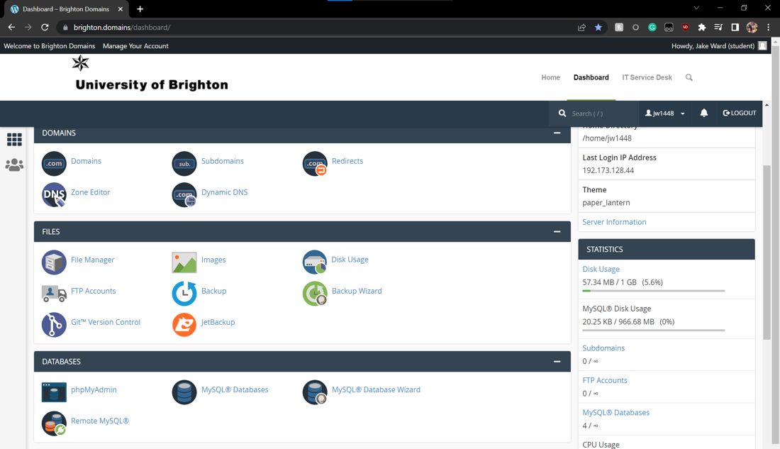

*Figure: 9: Brighton Domains dashboard and supported applications*

There is support for automatically creating node applications that I would be able to create an API to communicate between the client and database. This service also allowed the various required packages to automatically be installed and was compatible with all packages I would be requiring.

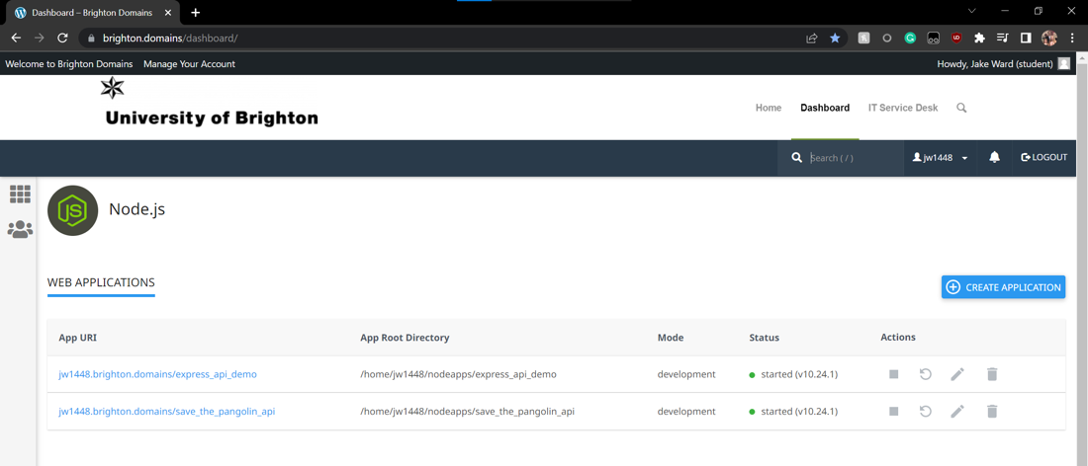

*Figure 10: Brighton Domains automated Node application creation UI*

Domains allowed a user interface to be publicly accessible through a repository labelled “public_html”. This would be the location I would upload the final version of the user interface to. Once the final version was uploaded it would be delivered as a functional web application via a link to this public directory. While files could be uploaded to the domain via the FTP protocol through applications such as Filezilla, Brighton Domains also hosted a file manager that would allow the fast upload of all files as well as the ability to edit documents already hosted on the server.

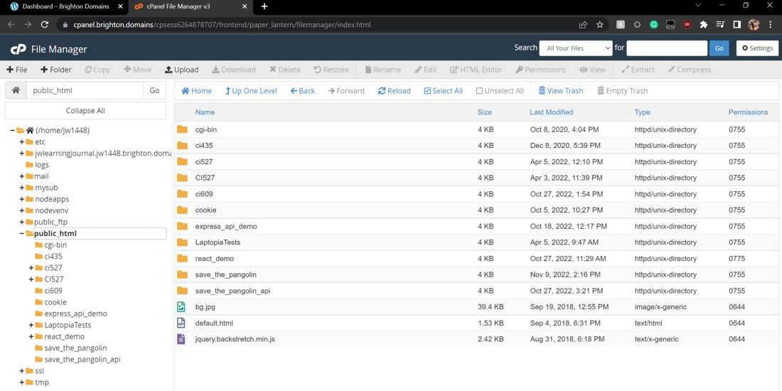

*Figure 11: Brighton Domains file management UI*

Brighton Domains allowed the automatic creation of databases and users with access to them. These databases could then be accessed and managed in phpMyAdmin. This would be where is would design and manage my database.

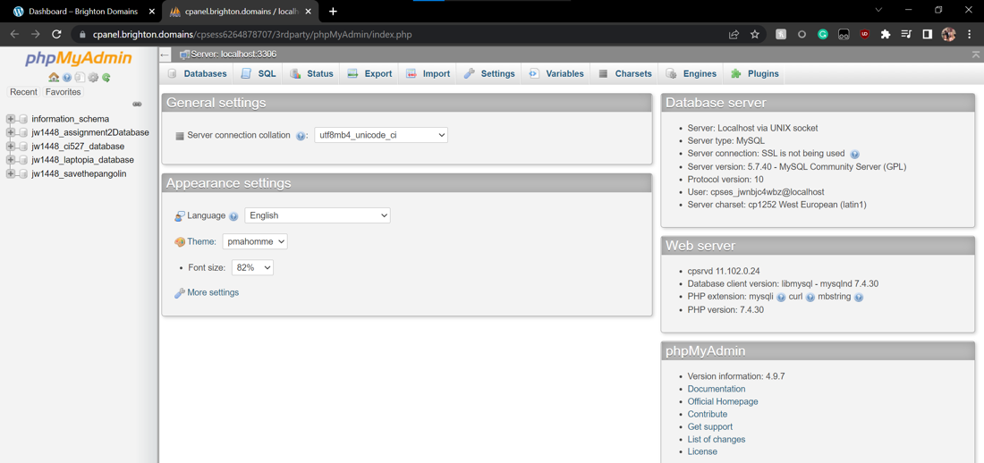

*Figure 12: phpMyAdmin UI featured on Brighton Domains*

Brighton domains also supported the creation of subdomains, but I decided not to use this feature due to a lack of necessity. Domains also supported the use of git and automatic creation of other types of applications such as python. I decided not to make use of git via domains because I would already be programming everything through VS Code which was already linked to GitHub.

By setting up back-end services on Brighton Domains it is inexpensive to me and I need not concern myself with running my own server constantly once the product is finished.

### Frameworks

A framework is defined as a platform for developing software applications. They are used as foundations for developers to help kickstart projects and increase development time. There are different frameworks for different languages and purposes, but I decided to investigate frameworks compatible with Node in compliance with the “JavaScript Everywhere” mentality. I chose to use investigate Node frameworks because of their wide variety, accessibility and large community support. Frameworks are often tested and updated frequently to ensure they are stable and up-to-date for modern developers. Frameworks are not all community-made as some frameworks are produced by corporations, like how Angular is built and supported by Google. Node frameworks are installed via NPM and included as dependencies in the package file.

Frameworks and libraries are not the same things despite many using the terms interchangeably. Libraries are sets of code to be used wherever a developer feels appropriate, in whatever way they want. Frameworks require a pattern to be followed in order to function. In this way, the framework holds control over an application's functionality and the developer just adds to correct parameters. Frameworks a written for front-end services, back-end services, tooling and many other purposes. A framework can be installed locally or globally alike any other packages seen in the npm repository.

Frameworks are used to reduce any potential errors in code as the pre-built code will have already been tested. Because of this, code is often more secure and efficient than anything written from scratch. Developers can focus on writing code specific to their application if all generic code has been written as part of the framework.

I decided I would use frameworks for the back-end processes and tooling, but I documented the research I did into all types of frameworks nonetheless.

#### React

The React framework is a free-to-use front-end open-source library used for building interfaces based on UI components. React was released on the 29th of May and is maintained by Meta (formally Facebook) as well as a community of individual developers. Jordan Walke created the JavaScript component-based library after being inspired by XHP (PHP’s HTML component library). While React is not technically a framework as it is only concerned with UI rendering, it is still treated like one and named as one by many. React is one of the most popular front-end frameworks/libraries with more than three million active users and more than one million web applications have been made with it. React is used for the development of both the Facebook and Instagram UI.

A proprietary language called JSX is the language used as the primary language in React. It incorporates elements of XML and HTML into base JavaScript. Toolchain is utilised to transpile JSX code and virtual DOM is utilised to improve rendering. Babel is the JavaScript compiler/transpiler used in React to transpile JSX to JavaScript. Conditional rendering is a useful feature of React that allows a component to render or not depending on the application's state. React is a large package with over 200MB of code that most developers will barely use, this is a lot of wasted space for development but only the relevant content will be featured in the deployed application. The React developer tools are also available as browser extensions.

It can also be noted that React is the base used for the development of the popular framework Next.js. However, Next.js has a very lacking ecosystem which would mostly hinder development rather than help it.

|  |  |
| --- | --- |
| Advantages | Disadvantages |
| SEO friendly | Lack of documentation |
| Useful for creating dynamic pages | Constantly moving ecosystem |
| Simple testing | JSX must be learnt |
| Reusable UI components | Only concerns the UI |
| Easy to learn |  |
| Rendering enhancements |  |
| Developer tools available in browsers |  |

#### Angular

Angular is a free TypeScript-based open-source web application framework maintained by Google. Angular is a rewrite of Angular.js which was made by the same team and recently discontinued. Many developers have expressed a lack of interest or aggravation in Angular due to its major differences from the previous deprecated version.

Angular’s rewrite consists of four major differences. Angular introduced a command line interface that wasn’t present in Angular.js. Angular.js used JavaScript whereas Angular uses TypeScript. The use of TypeScript allows for scalability, clean code and better tooling. Angular.js used directives whereas Angular has component-based architecture, increasing development time and code quality. Angular is designed to include mobile-friendly features whereas Angular.js was less concerned. It can also be noted that up until the previous versions’ deprecation Angular was known as Angular 2. Despite controversy amongst the community Angular is currently the fifth most used JavaScript framework worldwide with 20.39% of web developers using the framework.

Angular allows two-way data-driven access to the DOM meaning there is no need to manually access it and manipulation of the DOM is easier. Angular is said to be useful in creating aesthetically pleasing UIs with a powerful ecosystem at its disposal. It makes use of the RxJS library to allow asynchronous programming. The framework comes equipped with CPU performance-enhancers ensuring faster performance than native frameworks. This fast performance allows tests and changes to be seen in real-time to ensure continuous development. It uses plain HTML templates instead of custom versions of them to help ease the task of development.

Angular is part of the MEAN stack framework, an acronym representing the technology used for each major area of web development: MongoDB for databases, Express for the back end, Angular for the front end and Node for the web-server. MEAN is not a concrete industry standard as variations such as MERN exist, wherein React is used in place of angular. While Angular was designed for the MEAN stack and performs well within one, it was not designed to be integrated with other resources like MySQL.

|  |  |
| --- | --- |
| Advantages | Disadvantages |
| Supported by Google | The ecosystem is divided between versions |
| Two-way data binding | Complexity makes it hard-to-learn |
| Component-based | Migration from legacy is time-consuming |
| TypeScript | Databinding decreases performance |
| Asynchronous programming supported | Heavy framework |
| Creates attractive UIs | Designed for MEAN stack |
| Powerful ecosystem | Both TypeScript and RxJS must be learnt |
| Fast (Server) Performance |  |
| Plain HTML |  |

#### React vs Angular

|  |  |
| --- | --- |
| React | Angular |
| JavaScript Library | Full framework |
| Supported by Meta/Facebook | Supported by Google |
| Uses JSX | Uses TypeScript |
| Used for creating UI with varying data | Used for creating progressive and single-page web applications |
| Moderate learning curve | Steep learning curve |
| Used to create reusable front-end elements | Used to create dynamic sites compatible with the MEAN stack |

Overall, I decided that it would be best to create the UI without the use of a front-end framework or library. This is because I didn’t want the client to be reliant on many libraries as well as the fact that learning to use another new framework would dramatically increase development time when I only had a limited amount of time to complete the application. UIs are easy to design in base HTML, CSS and JavaScript anyway and overcomplicating the process needlessly wouldn't be a good management decision. While I acknowledge the potential usefulness of having components premade for my UI, I would sooner design elements myself to show my competency in the area. It should be noted that my decision was made by weighing all advantages, disadvantages and features listed above. There would not be many disadvantages by building the front-end independent of a framework as many modern browsers automatically provide the support frameworks advertise such as browsers APIs like Fetch.

I knew that I would be using a framework for back-end processes as PHP is an outdated method of handling these processes and the newer JavaScript frameworks are the most efficient modern equivalents. Node is also designed to allow server processes and so would be made better use of on the back end. So, I decided to research the most popular back-end-oriented frameworks next.

#### Express.js

Express is a free back-end web application framework for building REST APIs within Node.js. It can be installed like all other Node packages through the NPM registry. Express is so conventional that it is named by many developers as the de facto standard server framework for Node. Express is part of the MEAN stack and often its alternative counterparts like the MERN stack. Its conventional and widespread nature ensures great documentation and tutorials to help learn the framework. Express is designed to not obstruct any functionality from base Node. Express isn't tied to any one specific front-end or middleware allowing for greater freedom in the choice of tools when designing a web application. Feathers, ItemsAPI and KeystoneJS are just three examples of frameworks built upon Express.

Express advertises the use of its application as opposed to being installed as a dependency/package. However, the application is designed to create web applications as opposed to simply APIs. Because I wish to design only the back-end API with express the package is the more relevant resource to install. Express allows access to all elements of a given request allowing for greater control over the application and its chosen responses. Express makes use of routing both static and dynamic, this enables the modularization of code as well as adding or adjusting the default behaviour of the API. Express allows for the communication between API and database that was to be used in my project, but only supports communication with SQL and NoSQL databases. For an Express server to communicate with a MySQL database a middleware like mysql2 would have to be used.

Callback hell can be an issue but is easily avoided with the use of Nodes' asynchronous functions. While middleware is a very useful tool to be made use of in Express, some middleware can result in client request issues and so the relevant handling must be put in place. Unlike I/O operations, CPU tasks are not executed in parallel and so if run on the server will result in a blockage, it is for this reason express is highly recommended to not be used for CPU applications.

|  |  |
| --- | --- |
| Advantages | Disadvantages |
| Decreases development time | Callback hell |
| Enables simple server scripting functionality | Middleware integration can cause issues |
| Efficient handling of I/Q requests | Not efficient in running CPU tasks |
| Simple learning curve |  |
| Large ecosystem |  |
| Large community and useful documentation |  |
| Simple middleware integration |  |
| No extra cost |  |

#### Django

Django is a free open-source web framework using a mixture of Python and HTML. It follows the model-template-views architectural pattern and was released on 21st July 2005 by the non-profit Django Software Foundation. Its objective is to ease the formation of multifaceted database-oriented websites. It has a pragmatic and clean design which is also made use of with machine-learning. It is preloaded to care for content management, RSS feeds, site maps and user authentication. It is versatile enough to be used for both social networks and calculators and scalable enough to handle large traffic. It allows simple integration with

MongoDB databases and takes security very seriously.

|  |  |
| --- | --- |
| Advantages | Disadvantages |
| Active Community | Not suitable for small projects |
| Flexible | Lacks conventions |
| Speeds up development | Difficult to learn |
| Versatile and scalable | Cannot simultaneously handle requests |
| Secure | Not JavaScript-based |

#### Express vs Django

Node/Express is faster than Django and is more compatible with the other resources I was likely to use. It was for this reason that Express would be the obvious choice of framework to design my middleware/API. JavaScript being Express’s language is an advantage as I would have to be competent in the language to use the other resources. On top of this Django's functionality is available as a package in npm to be used in conjunction with Express. Express is the conventional standard and so holds a large supportive community and easy-to-use documentation.

### Toolkits

#### Gulp

Gulp is another popular package available through the NPM registry. Gulp is a free JavaScript open-source toolkit used as a streaming build system in the area of front-end web development on Node.js. It was released on the 26th of September 2013 and was created by Eric Schoffstall. Gulp is based on Node streams and isn't tied to any one framework or application type, making it a very flexible and versatile toolkit. Gulp is still a popular JavaScript toolkit despite the rising popularity of webpack.

Gulp is used for:

* Automating the workflow and build processes
* Transpiling
* The concatenation of library files
* Compiling SASS
* Bundling JavaScript and CSS
* HTML, CSS, JavaScript and image minification

Gulp is useful because of its wide ecosystem of plugins as well as its easy installation and use. Gulp is conventionally installed via NPM globally but can be installed locally. To function for my purposes, a file named ‘gulpfile.js’ houses all tasks to be executed and are executed upon the ‘gulp’ commands use in the relevant directory. This would be a useful toolkit to optimise the front-end UI upon completion. Gulps' use of back-to-back processing of multiple files ensures fast processing. The automatic configuration of files allows developers to focus on functionality. The debugging process is reported to be unreliable on occasion and so additional validation maybe be required as well as manual debugging. Gulp is currently on version 4.0.2 with an unpacked size of 20kb and nearly 1.5 million weekly downloads.

|  |  |
| --- | --- |
| Advantages | Disadvantages |
| Versatile/Flexible | Unreliable debugging |
| Vast Ecosystem | Limited documentation for plugins |
| Able to process multiple files back-to-back | Concepts can be confusing |
| Configures code for the developer | Third-party libraries can cause dependency issues |
| Only four functions |  |

#### Webpack

Webpack is currently the most popular JavaScript toolkit as it took the title in 2020 by overtaking Gulp. It is classified as a module bundler with its main purpose being to bundle JavaScript files for usage in a browser. It is also able to transform, package or bundle a wide range of other assets and resources. Its sponsored by large companies like Discord and Trivago a indirectly supported by Google through the development of the Google Web Toolkit. Webpack is highly popular with over thirty million weekly downloads. It is currently running on version 5.75 and has an unpacked size of 4MB (a heavy size when compared to Gulp).

Webpack has an entry point in the form of a dependency graph, it will follow this graph to know what to bundle. Its output is defined as the location and format of the desired bundle. Loaders are used to convert different types of files into modules before adding them to the dependency graph. Plugins are used for functionality like modification and optimizing bundles.

Webpack has to bundle all modules when starting a development server. This means it typically takes 30 – 150 seconds to finish booting a web server. It is also infamously hard to learn how to configure. Pages in webpack do not need to fully reload when small changes are made. It also saves time by reducing the load time of websites during debugging. Webpack provides a module system based on ECMAScript. Files are treated as modules and the features of one file can be used in another. Minification of assets are available like in Gulp and it also supports feature flagging.

|  |  |
| --- | --- |
| Advantages | Disadvantages |
| Decreases development time | Heavy for a toolkit |
| Minification | Confusing documentation for newcomers |
| Feature flagging | Hard to configure |
| Modularised code | Slow developer mode speeds |

#### Gulp vs Webpack

|  |  |
| --- | --- |
| Gulp | Webpack |
| Easy configuration | Difficult configuration |
| Efficient and fast execution | Slow compared to other toolkits |
| Difficult to rerun tasks | Easy to rerun tasks |
| Stable due to less memory required | Tendency to crash |
| Less popular with less support | Good community support |
| Lightweight and simple | Heavy and complex |
| Controlled process flow | Less controlled process flow |

While webpack is designed specifically for bundling and configuration, its harsh learning curve leaves Gulp as the more viable choice due to its ease of use. Because the development time is limited the easier the tooling process is, the more features I can focus on developing. However, due to gulps' difficulty with rerunning tasks if an error occurs, it would be best practice to only initiate a build when a backup has been created via GitHub or Similar. I decided not to completely discount webpack and would consider using should I become adept at handling the difficult configuration.

### Database Management

#### MySQL/phpMyAdmin

While SQL can be written in many different iterations of the language such as SQL server and NoSQL, I decided it would be best to design, create and maintain my database backend with MySQL. MySQL is a free open-source relational database management system released on the 23rd of May 1995. I already have free access to the automatic creation and maintenance of a MySQL database via Brighton Domains phpMyAdmin UI. By making use of this free resource available to me I can host a database constantly with no budget. It is important that the MySQL database can be run constantly on the University provided server because my web application would need constant access to a database in a real-world scenario. I had also learnt MySQL over the course of my two years at the university and so was confident in how to use the resources with relations, constraints and all other functionalities. While I was committed to using MySQL because of these advantages unique to me, I decided to justify my decision further with research.

While I can write and design tables using MySQL script I can also design and alter tables with the tools provided in the phpMyAdmin UI to increase development time and productivity. MySQL boasts strong security, being used by companies such as Meta and Twitter. MySQL supports continuous uptime and on-demand availability which is functionality the design of my application would be reliant on. There is no cost for the software and for me, there is no cost to run it on a server as it is already covered by the University of Brighton as one of their resources available to me. MySQL is advertised as efficient in its execution and handling of queries so much so that it is reported that a database can handle millions of requests per day. phpMyAdmin allows the import and export of SQL in the form of script, this allows me to present the code for my designed table with ease.

Disadvantages can present themselves in certain scenarios. Certain SQL commands are not present in older versions of MySQL, however, I am aware of all commands and constraints that I will need to use to successfully design my database. Some functionality of MySQL can be dependent on certain add-ons but the University will not be removing any of the add-ons their database is reliant on any time soon. MySQL can have trouble supporting large databases with efficiency but the database I would be designing would not be complex or large enough for this to be a legitimate concern. MySQL, while widely supported, isn't community driven and so can become outdated while relying only on the developers for updates. This shouldn't be a problem as the functionality of the database is simply to insert, alter and query results in tables. This basic functionality will not require any new updates so long as I make use of the relevant middleware to communicate between the client and the database.

### Middleware & Packages

#### cors

The cors package is a piece of middleware required to allow Express to enable CORS with various options. This package's inclusion in an API prevents most errors which can happen concerning cross-origin requests. It is because I have encountered these types of errors on multiple occasions that I am aware that its inclusion will be useful. The other method for avoiding CORS errors is by using a proxy which could cost money, so the use of the cors package is a much more efficient workaround. It can be installed via the NPM registry, consists of 20kb and is currently on version 2.8.5. To prove the integral use of this package it can be noted that it has over nine million weekly downloads.

#### mysql2

‘mysql2’ is a middleware package available for installation through the npm registry. It is a database driver that can be used for communication between Node servers and MySQL databases. It is simple to use with extensive and understandable documentation. It is a continuation of MySQL-Native and was rewritten to be in its current state. It is free from native bindings so can be installed on windows, mac and Linux. It supports prepared statements, compression, SSL and non-uft8 encodings. In order to communicate with my database from my API I will need to make use of this package. The current version and version I will be using is 2.3.3. It has an unpacked size of 454kb and over one million weekly downloads.

#### body-parser

The body parsing middleware is used to parse incoming request bodies into a single type of parameter saved under a singular property. The developers note in the documentation that because the body parsing of the package implies that it is used accepting for user-controlled inputs. As such any inputs should not be trusted and should be validated before use in an API or Node application. The body-parser middleware available via NPM includes parsers for Raw, JSON, Text and URL-encoded request bodies. It is currently on version 1.20.1 and has an unpacked size of 60kb. It is a highly popular and useful package with almost thirty million weekly downloads. The use of this package would allow me to accept varying types of request bodies and well as simplify the process of accepting and validating request bodies.

#### express-fileupload

The Express middleware ‘express-fileupload’ allows for the easy upload and handling of files on an Express server. I investigated the use of this package in case I decide to accommodate profile pictures but the use extends to all types of files. The package can be installed via NPM and wraps around the Busboy middleware. It has a small size of 1.22MB and is currently on version 1.4 with an average of two hundred thousand weekly downloads due to its specific nature.

#### ejs

Allowing for the creation of dynamic pages to be returned by an Express API, ejs is a node package as well as a simple templating language. It is very popular with average weekly downloads of above eleven million. It has an unpacked size of 140kb and is currently on version 3.1.8. EJS is a language that allows you to generate HTML markup with plain JavaScript. EJS stands for embedded JavaScript templates and is used to create templates to be populated/rendered by a Node application (namely using express). EJS and its corresponding package allow an Express server to generate and respond with dynamic pages created via templates written in EJS and populated by Express. It has a large and active community and is easy to debug. This simple SSR solution allows for my Express API to create dynamic pages created from MySQL database responses e.g. article pages made dynamically using an EJS template. EJS can be installed through npm like any other Node package.

#### nodemailer

Nodemailer was a plugin I researched during my implementation to send confirmation emails. It is still a very popular method of sending emails with a reported 3 million weekly downloads on npm. At the time of writing the latest version is 6.9.1 with an unpacked size of 487kb. It is designed to be a reliable and flexible solution for sending email messages from Node.js applications. With Nodemailer, developers can easily send email notifications, confirmations, newsletters, and other types of messages to users or customers. It's easy to use as it provides a straightforward API that allows developers to send emails with just a few lines of code. Nodemailer supports a wide range of email services and protocols, SMTP, IMAP and more making it highly versatile. It is one of the current industry standards for its purpose and so was chosen to be used on the Express API. It offers functionality with templates as well making professional and dynamic emails easy to implement. It is reliable as it has been highly tested regularly.

There was an inconvenient downside to using this plugin's regular method in conjunction with google mail which can be seen in the documentation dated 07/03/23. The details will not be listed here as they are not specific to Nodemailer.

### Testing

#### Postman

Postman is a free API platform built in the Electron.js framework designed for developers to help build, test and iterate their APIs. Initially released in 2012, the application has reported that it remains the world's largest API hub with over twenty million active users and seventy-five thousand APIs. I decided to use the service for testing my Express API as well as helping generate and learn new types of request-sending techniques.

The UI is incredibly user-friendly with a simple interface using templates to create requests. Postman is highly accessible with easy installation via the application or browser extension. It makes use of basic request tracking abilities to notify users about the responses and status codes as well as supporting all HTTP methods. A specifically useful function of Postman is the ability to generate code based on a template, allowing for faster development.

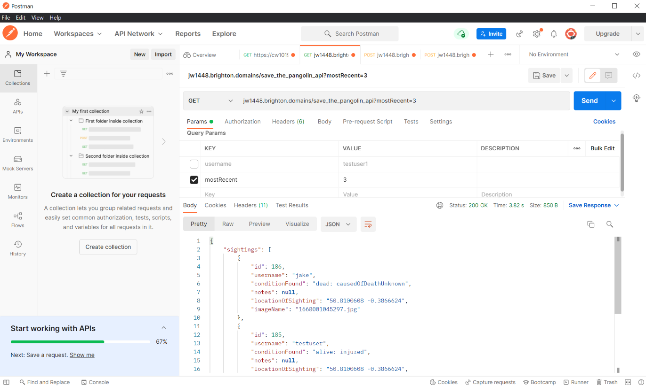

*Figure 13: Successful postman GET request made with a template*

While postman is highly suited to my needs in this project there are limitations that I must acknowledge. Postman is designed for testing REST APIs but is ineffective in testing other types such as SOAP APIs. Postman does not have much in the way of integration capabilities and users are unable to reuse their pre-written scripts. Alternatives for if the postman application were less applicable to my plan would include Katalon Studio and SoapUI.

I would be using the postman application but would avoid using the chrome extension due to its recent deprecation. I would use it due to its help in speeding up development time as well as simplistic testing with the use of templates. Postman would only be used for testing my Express REST API due to its applicability and its generation of code to speed development rather than writing fetch requests and the like entirely manually.

#### Browser Dev Tools

Google Chrome, Microsoft Edge and Mozilla Firefox are all highly popular and supported web browsers with industry-standard developer tools. I would mostly be testing my applications' UI in   
Chrome with its developer tools as Chrome is the leading internet browser with 65.52% of the global market share as of August 2022. Apple’s Safari is the second most popular with 18.78% however has little support for developers on windows. Because of this, I would only be able to test manually via a small apple device for safaris compatibility. Edge is the third most popular with a market share of 4.29%, it does support the majority of industry-standard developer tools and would demonstrate the UIs compatibility with the browser when used for testing. Firefox is the fourth most popular browser with a 3.15% global market share and would be the final browser I would be using to test compatibility with. Firefox supports all industry-standard development tools and would be used to check the UI's compatibility with the browser. The compatibility of the web application would be prioritised according to the global market share.

*Figure 14: Global market share of Internet Browsers*

As well as checking for various browser compatibility, the use of browser developer tools allows me to:

* Test compiled JavaScript and view errors in the console
* View network activity such as requests and responses
* View and edit some source files
* Limit and view performance for testing purposes
* View, create and edit assets in the application settings like cookies and session variables
* Customise keyboard shortcuts for faster testing
* View the browsers analysis of the application's security
* Record performance
* Generate lighthouse reports

#### W3C Markup Validation Service

To maintain accessibility with screen readers and other technology reliant on HTML standards I would be making use of the W3C Markup Validation Service for testing the UI. It is a validator made by the World Wide Web Consortium allowing users to check HTML/XHTML documents for markup against the document type definition by entering its URL, file or script. W3C also provide markup for CSS documents as well as mobile-optimized validation. This would be used for basic error checking in the final stages of the UIs development and would ensure accessibility. By fitting all conventional standards any extensions reliant on these standards would also be supported by the site without error.

### APIs

#### Fetch API

The fetch API is a browser API capable of sending HTTP requests utilising promises. While this is an external API, I didn’t consider it as such as it is seen by many as a normal part of a JavaScript developer's toolkit. This would be vital to the functionality of the web app as the architecture required constant requests and responses to be shared between the client and server sides. The Fetch API is included with all major browsers by nature of being a browser API and is the modern standard due to promises greatly simplifying code (especially in conjunction with await/async). Requests in this format are not only simple to write but can also be automatically generated through third-party apps such as Postman. Its other advantages include that it supports cookies, custom request methods and headers, giving flexibility for what is possible with only HTTP requests. The disadvantages are that it can’t be run on my server-side API due to the fact it is a browser API. It also has no support for reactive streams and requires a lot of configuration or handling when using CORS requests.

#### YouTube Player API

This API was researched at a much later date and during the development of the application itself. It was initially designed to be used as a placeholder method for showing videos but after learning of its easy usage and inherent support of my requirement I decided to continue using its support. This is the only external API I made use of during the entire project as I was planning on making all features myself until I realised the plan's inefficiency. The YouTube Player API is an API which can be called to embed iframes into a page with the majority of features of YouTube including but not limited to; Changing the video quality, casting the videos with Chromecast, enabling users to skip ahead or return back to a previous point in the video, Fullscreen, volume control, sharing and playing and pausing.

The only prerequisite is the use of a browser capable of sending POST messages which could easily be done with the aforementioned Fetch API. It has a few drawbacks in that the size of the video can only be defined as real numbers meaning that making them responsive would require extra CSS. I discovered the API could also place listeners on events such as when the video playback ends which was one of my initial pitches as a requirement. To fit conventions and be proper the iframe would need to be contained within a container to control the video’s UI. It is extremely mobile-friendly and only requires the video ID and dimensions of the video. Videos generated with the API can use input player variables to customise the player and events to place listeners and code on certain events, a good example is it can be set to autoplay once the video has loaded.

Due to the videos being hosted on YouTube, the content can be kept safe by the design of YouTube itself. YouTube allows videos to be unlisted from the public so unauthorised access cannot be had but still have the site access and display the video contents with the uploaded videos ID. In this way, there is no security issue with the uploading and displaying of potential private/sensitive training videos.

### Primary Research

The goal of primary research is to define user characteristics and/or user requirements which will help define other requirements later on. For primary research to be ethically sound there must be anonymity or written consent. While I could have used the consent forms provided by the University I decided that I would reach more potential users and thus get more accurate and varying answers if I instead used an online platform emphasising anonymity like Google Forms. The disadvantage of this method is that anonymity makes the potential to be spammed dramatically increase, this is a manageable concern as spam can simply be removed by the creator upon reflection and reduced by linking the form in more professional circles. If the form became the subject of spam Google Forms also supports the rejection of responses should it be enabled. Another advantage of Google Forms is that questions could be slightly altered or added by myself later on should additional information be required/desired. The questions in the questionnaire would have to be designed so as to make the potential users unidentifiable, because of this there would a lack of long open-ended questions. The form would be submitted via a link upon permission from an administrator or linked on social media. For ethical reasons, the potential users were allowed to edit or rescind their responses via the same link. I used Google Forms as it is secure, efficient and was used for my group project in 2021-2022 for the CI536 module.

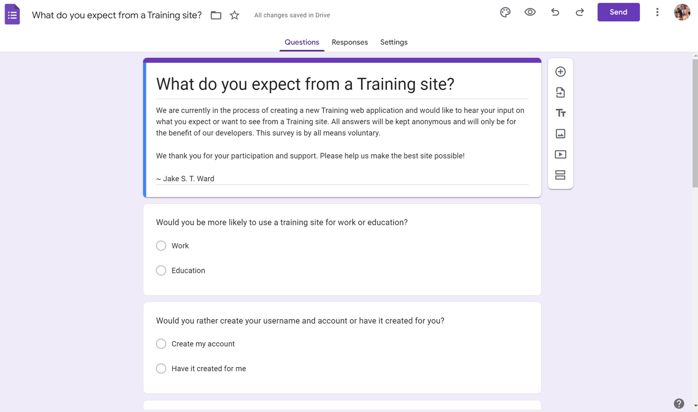

*Figure 15: Google Forms UI creating the survey*

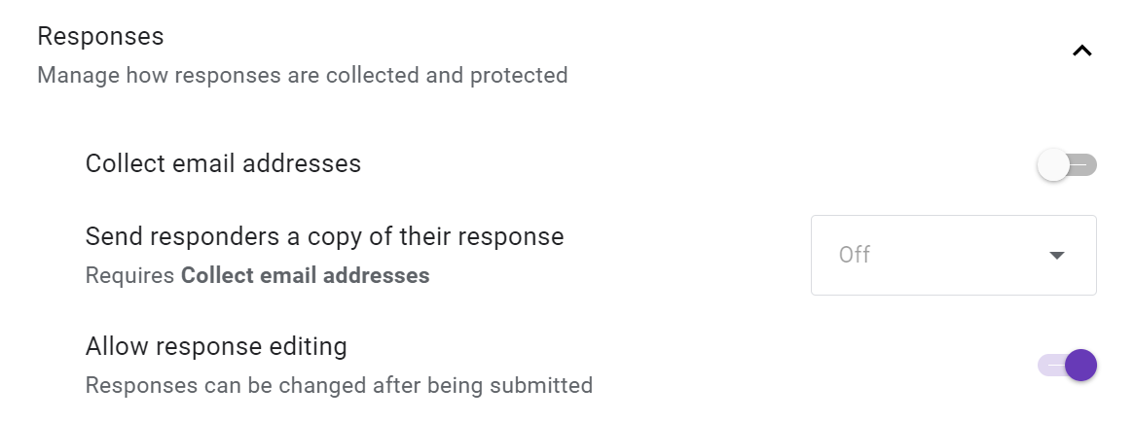

*Figure 16: Google Forms survey settings*

The form is no longer available for ethical reasons as I cannot guarantee the safe storage of the data recorded if it was stored on my Google account. The data was then removed from the form and stored securely on the university OneDrive.

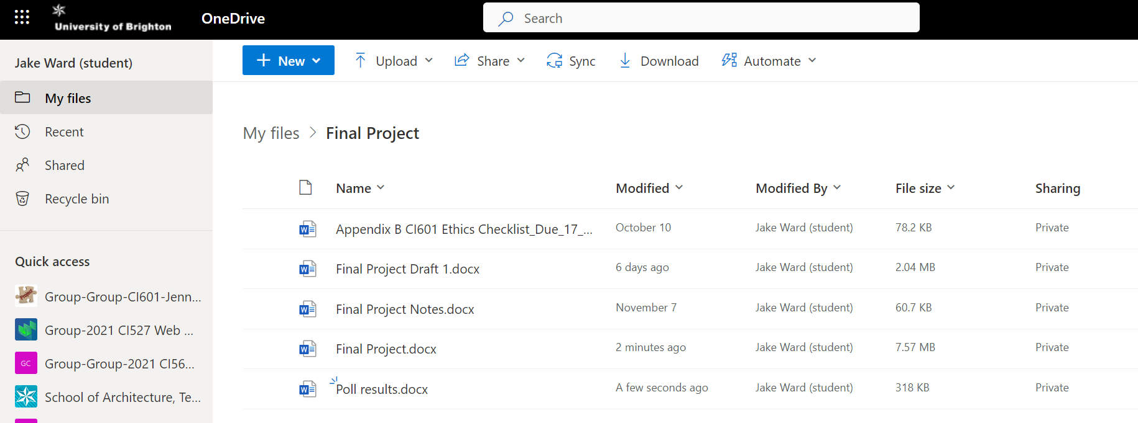

*Figure 17: Storage location of gathered research data*

The results of the questionnaires multiple-choice questions are as follows:

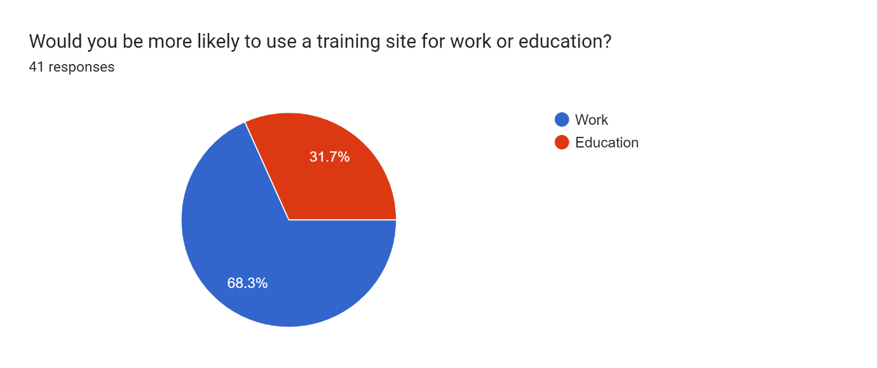

*Figure 18: Survey question 1 results*

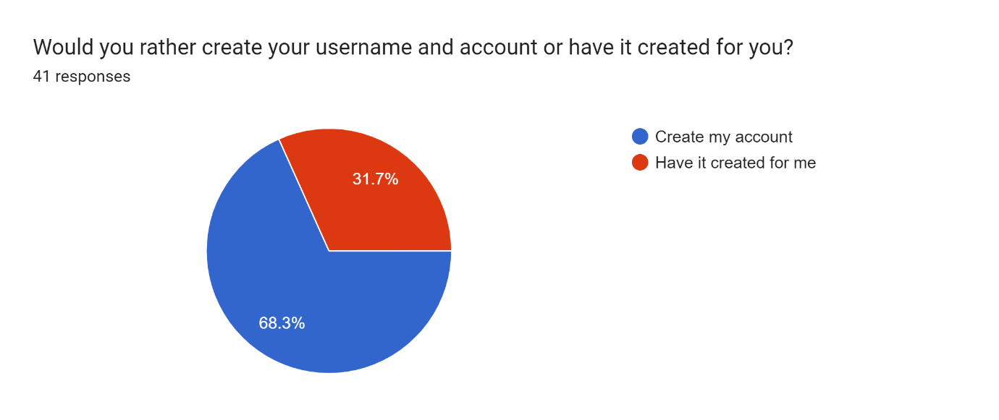

*Figure 19: Survey question 2 results*

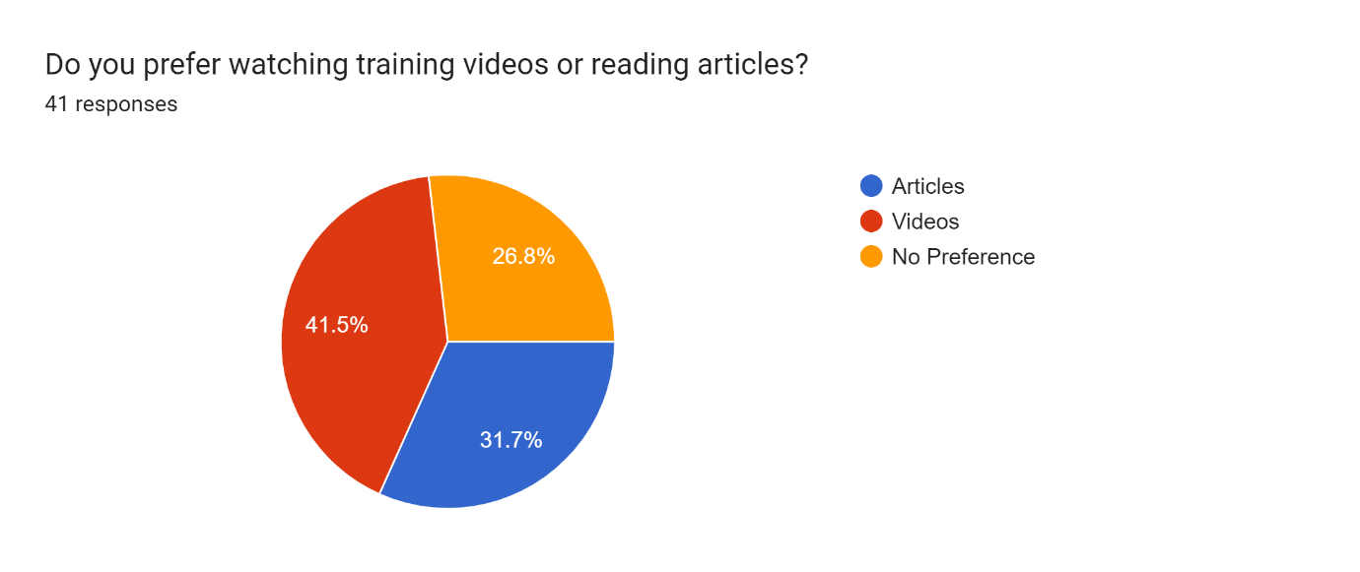

*Figure 20: Survey question 3 results*

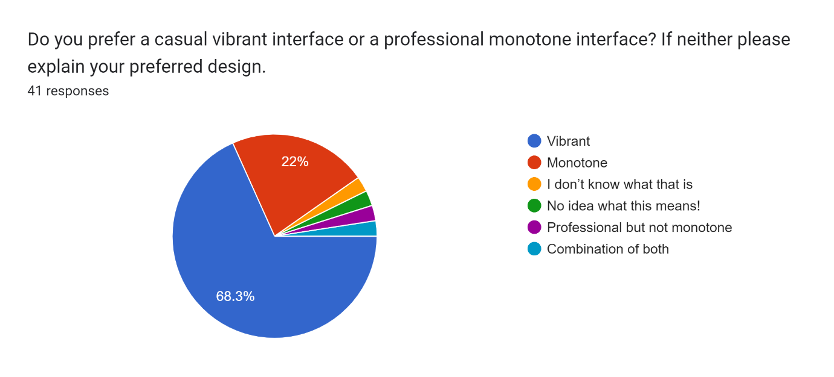

*Figure 21: Survey question 4 results*

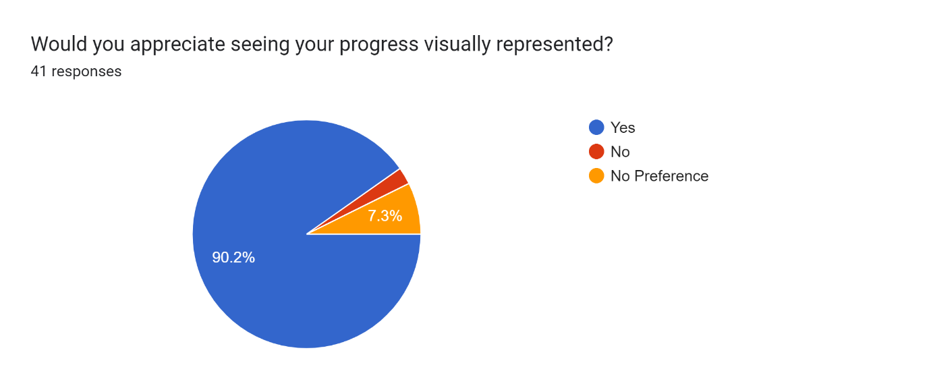

*Figure 22: Survey question 5 results*

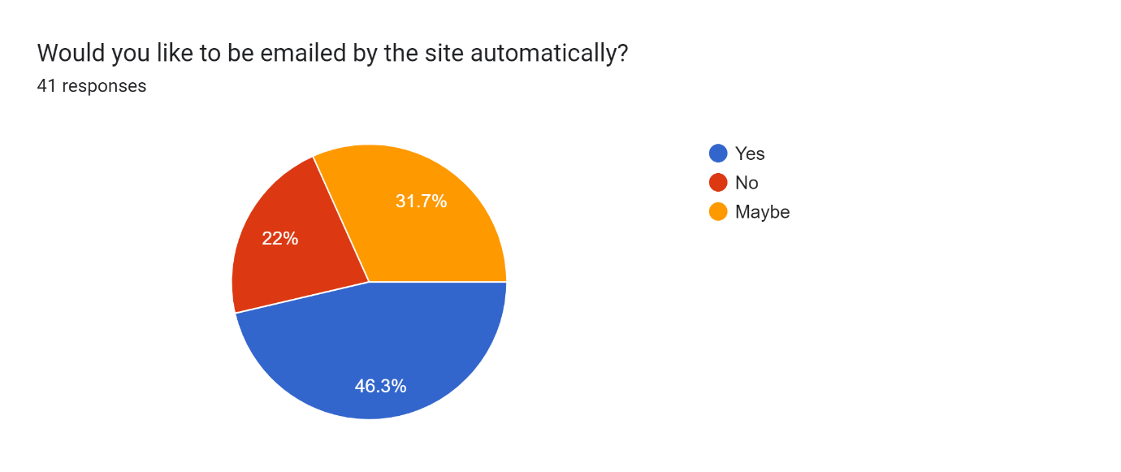

*Figure 23: Survey question 6 results*

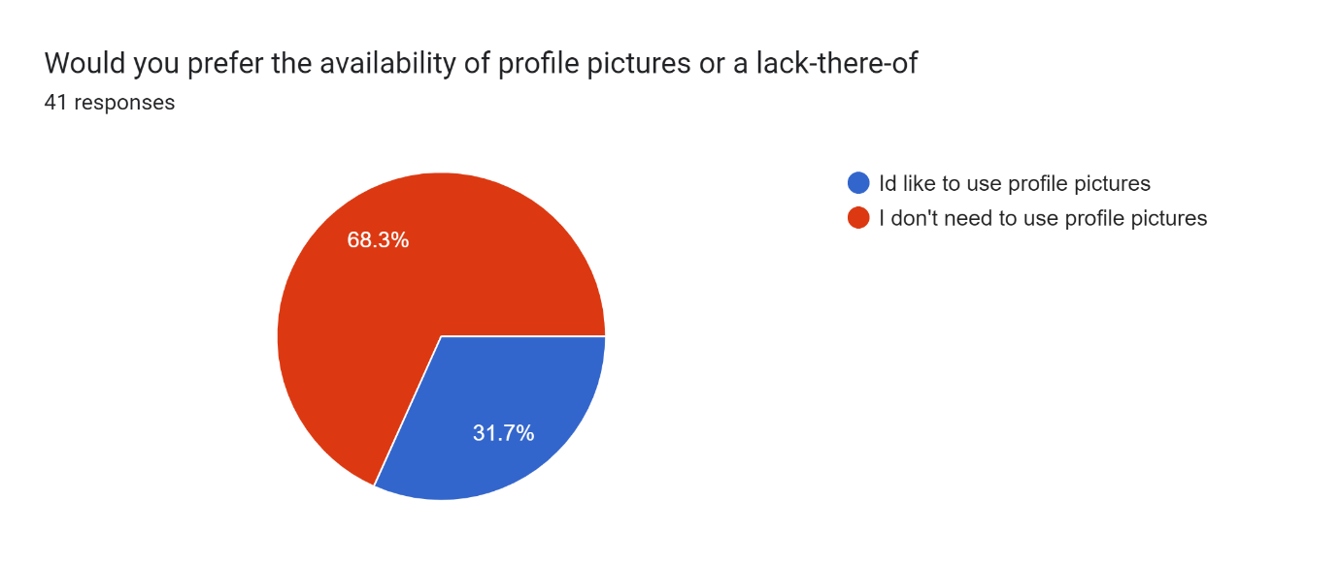

*Figure 24: Survey question 7 results*

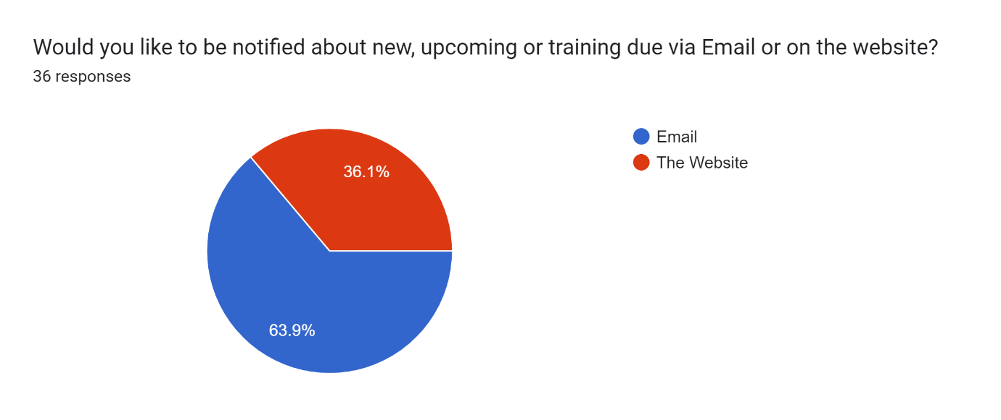

*Figure 25: Survey question 8 results*

The final optional open-ended questions results are as follows:

* Id like a site of this kind to notify me if some training is due soon
* Nah
* Helpful stuff
* Different colour backgrounds as a setting for people who prefer to read on a for example green background if dyslexic and dark mode . Also option to change the size of font
* Be able to record it for later reference
* No
* Make it easy/inexperienced pc user friendly The only reason I would be using it is because it was a mandatory work requirement.
* If it's a subject that I'm genuinely interested in further reading would be good but appreciate there are rules around sharing other organisations info.
* Dates and duration of training and who aimed at, email contact if unable to make.
* I like interactive graphics. I learn better by engaging with something that I have to read or short animated clips diagraming a process. People talking is the worst for online training.
* Saving part way through and a test at the end
* If appropriate for the type of system you were training on it would be good to be able to key in sample data so it can be followed through the system, including creating deliberate misposts and errors in order to learn how to correct them. If it was not that type of training then it needs to be engaging and progress through the training needs to be recordable.
* No thanks
* Yes, testimonials about the courses and trainer profiles of online training.
* Email confirmation of completed training in order to save
* A sandbox-type section for applying learning. For example, if learning about for loops in coding, having somewhere to create a for loop as part of your progress (see codewars or pluralsight for examples)
* Score table
* People learn in different ways - reading, and from videos with a practical representation. Using a combination of the two would be great - maybe videos with subtitles and a transcript to refer back to, and a summary. Colouration has an impact as to how much information we absorb, so worth looking in to that.

There was no initial desired target audience as training web applications can be used by varying groups of people from students to employees. It was by publishing the form that I would be able to refine my user characteristics. Any potentially identifying features about participants I was aware of cannot be featured in the report due to ethical issues. Overall, I can say that the target audience varies highly in age but consists mostly of employees rather than students in full-time education.

The main potential additional requirement gained from primary research was the notification recommendation. Potential users who used the open-ended question to make suggestions first suggested that they would appreciate being notified about training. Because potential users suggested they had no preference on whether they were emailed by a training site I added an additional question to clarify which approach to take. Once the wireframe models were finished the form or a new form would have the addition of these potential UIs and allow potential users to pick a preferred one.

After the form was taken down and its results stored securely, I analysed the final results to decide on requirements and their priority. The appropriate listed changes were made as a result.

* The first conclusion I drew was that the train site's audience consisted mostly of employed adults. It was for this reason that I would design the application to be specific to a company. I would not attach myself to a given company but would instead design the template/architecture for this type of training application.
* The second conclusion was that users would prefer to set up accounts themselves to allow more control over their details. While some preferred the ease of access of having details made for them by an administrator, I would now be supporting a signup feature as well as a login system.
* Overall, there was a lack of consensus on whether Articles or Videos would be better for training, so both would be supported equally and videos would potentially have extra features like the change in video quality found on YouTube.
* I found that the majority of users preferred to have an eye-catching/colourful design as opposed to a conventionally professional design. This means when I came to designing the UI I would use a more laid-back modern design as opposed to a rigid more conventionally professional design. The corresponding question had an alternative option to leave another type of design but few users used this feature.
* The overwhelming majority of users favoured having a visual representation of their progress leading to a progress bar or the like being given high priority in the requirements.
* The majority of people stated that they were not opposed to being emailed by the site after they had been signed up so the use of email would be listed in the requirements and emails would be stored in the user's table of the back-end database.
* Most people were surprisingly uninterested in the use of profile pictures. This was surprising due to their conventional use online. This result didn’t lead to the delisting of the profile picture requirement but did significantly reduce its priority.
* Many potential users stated that they would rather be notified by the website via email as opposed to on the UI. This meant that if a notification system were to be put in place because of due dates then the notifications would be handled over email.
* The use of themes like dark mode was suggested for accessibility as well as change in font size, this was considered and added as a high-priority non-key requirement as it would require little effort in the form of CSS changes.
* User-friendliness was mentioned which would have always been a priority for design.
* Further reading was suggested as a potential feature and so this would be a feature potentially added to the articles. This would not require the changing of requirements but would factor into how the example articles were designed. Contact information for training would also come under this category.
* Interactive graphics were another CSS-based element that was suggested and would be included alongside the other small visual elements. Alongside this suggestion was the emphasis on reading being better for learning which factored into both videos and articles being supported.
* Saving states of a page were a good suggestion which would be added potentially due to my understanding of saving information like this in internal storage or as cookies. This was added as a low-priority requirement due to its lack of suggestion but useful nature.
* Tests at the end of articles were suggested which reinforced their inclusion in the project and raised their priority.
* Testimonials and author profiles were suggested which would be a feature potentially added to articles upon their design.
* Testing was brought up which would be followed up by using the resources listed in the testing section of the research.
* A very advanced feature was suggested in the form of a sandbox section for testing coding should the training involve that. This would not be added to requirements yet but would be added if more features were required to add complexity. It was not added as a requirement as after researching how to accomplish this goal it seemed to be too time-consuming to add it in time for the due date.
* Results were suggested to be visible which would be covered by the “stats” requirement.
* It was reinforced by the final suggestion that the combination of both language and video would be the most effective tool for learning/teaching.

### Secondary Research

For the most accurate secondary research, I studied the layout of my employer's training site however because of legal and ethical reasons I cannot display any screenshots that disclose any identifying information in my report.

As a substitute, I also analysed and annotated a similar type of web application which is public. While the type of training I was going to make would be exclusive to one company there are sites that allow the purchase of training for education purposes. This is the closest type of site I can display analysis of in the report without obscuring features as any site exclusive to a company is said company’s intellectual property. I analysed the UIs of all my chosen sites in desktop and mobile views for a full grasp of the designs and features.

First, I analysed the signup method for new employees. The method involved emailing the employee with a temporary password to be used alongside their email to log in. This implies that accounts were already made for employees. This is a good security measure to ensure only employees have access to the site. This is an approach I could have taken but due to my survey finding that most users would prefer to make their own accounts, I decided that a similar method would be to have them use a separate code similar to a temporary password that would be used as validation for account setups. All defining features that could disclose the site's identity have been obscured in the examples below.

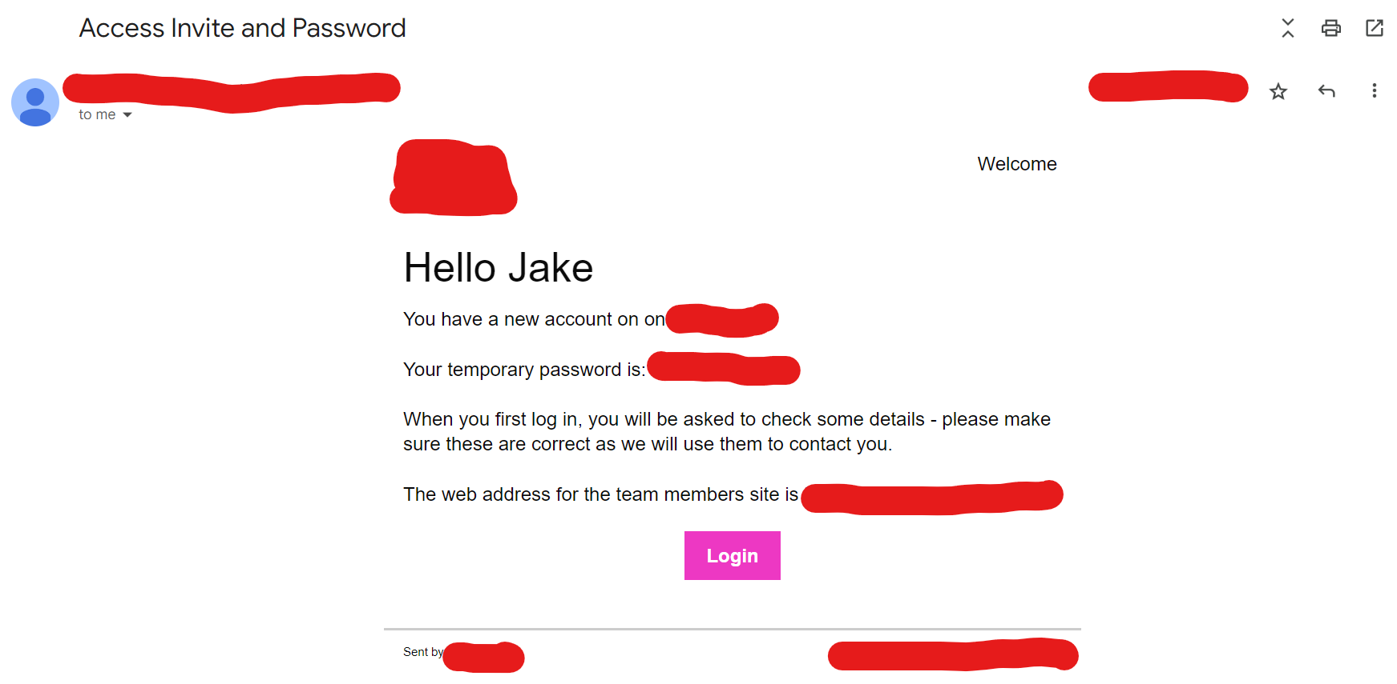

*Figure 26: Invite to analysed site*

The login page of the site resizes to look the same on both desktop and mobile views. It gives errors when a failed login occurs to help the user understand why they haven’t been given access, this would be adopted by my site as it is a convention of login pages integral to the user experience. The user logs in with their email and password, but I decided I could make use of usernames for login as well. Upon an unsuccessful login attempt, the error message allows the user to reset their password, in this case, their password is set to a temporary password again and emailed to the user, allowing them to log in and change their password. In my case, I would address this feature similarly by sending the current validation code to their email and redirecting them to a part of the site allowing them to directly change their password. If an email doesn’t suffice a second option could be the use of texting, however, this would involve the use of a budget to which I do not have access. The site has a feature to remember login details which could be saved in local storage or as a session or cookie value. The page is colourful with a large logo which could be a style adopted in line with the results from the survey. Passwords are hidden upon typing them in but a button to reveal what’s been written is missing, this is a feature I would use to raise security but mitigate the amount of accidentally failed logins

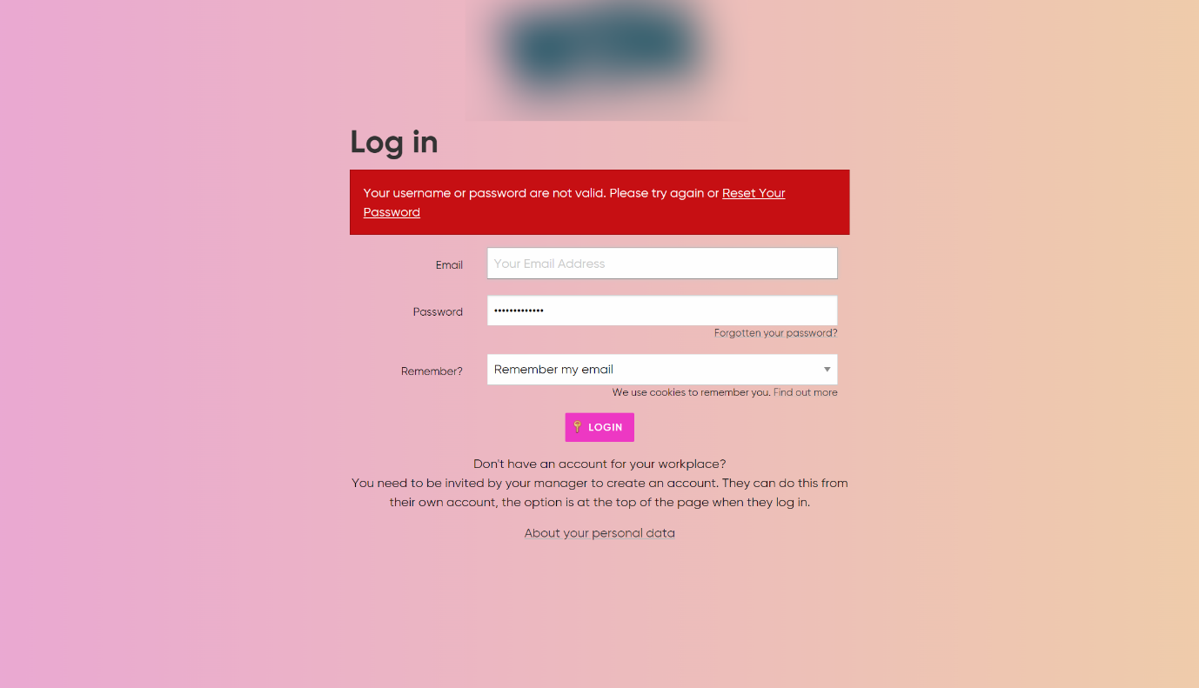

*Figure 27: Login page of the analysed site*

Upon successful login, the page you are directed to is the dashboard. It features a dropdown top navigation bar on desktop views and a side navigation bar on mobile views. The user's profile picture and username are featured in the top left corner of the page above the navigation beside the logo. The navigation also features a search bar (which I would integrate to search through assigned training) as well as the employee's job title. The page is a PHP page meaning that it is a dynamic page rendered with details from the database, this is an alternate option for dynamic pages on my own site but I will attempt to integrate it with my API so users won't have access to the database credentials.

Notifications are kept as separate boxes/elements below the page title, these are notifications for mandatory training and missing profile information. I will make use of these elements but will only notify users about training with upcoming due dates as I would assume that all training assigned would be mandatory and so would overwhelm the dashboard. The dashboard's two columns of elements merge into one on mobile views. News is featured on the dashboard which I could integrate but I decided that it’d be better to introduce a similar window with the due dates of assigned courses instead. Information about shifts is present on the dashboard but this isn’t relevant to my application as it is designed for training only. Current courses you are signed up for as well as certificates earned or progress towards them are all featured on the dashboard, these could be inclusions to my homepage/dashboard but would be more integral to a page dedicated to assigned training. The site maintains its colourful design to attempt to remain visually interesting. There is only one CSS animation which is the extension of the sidebar on mobile view. All of these elements would be considered when designing the homepage of my application.

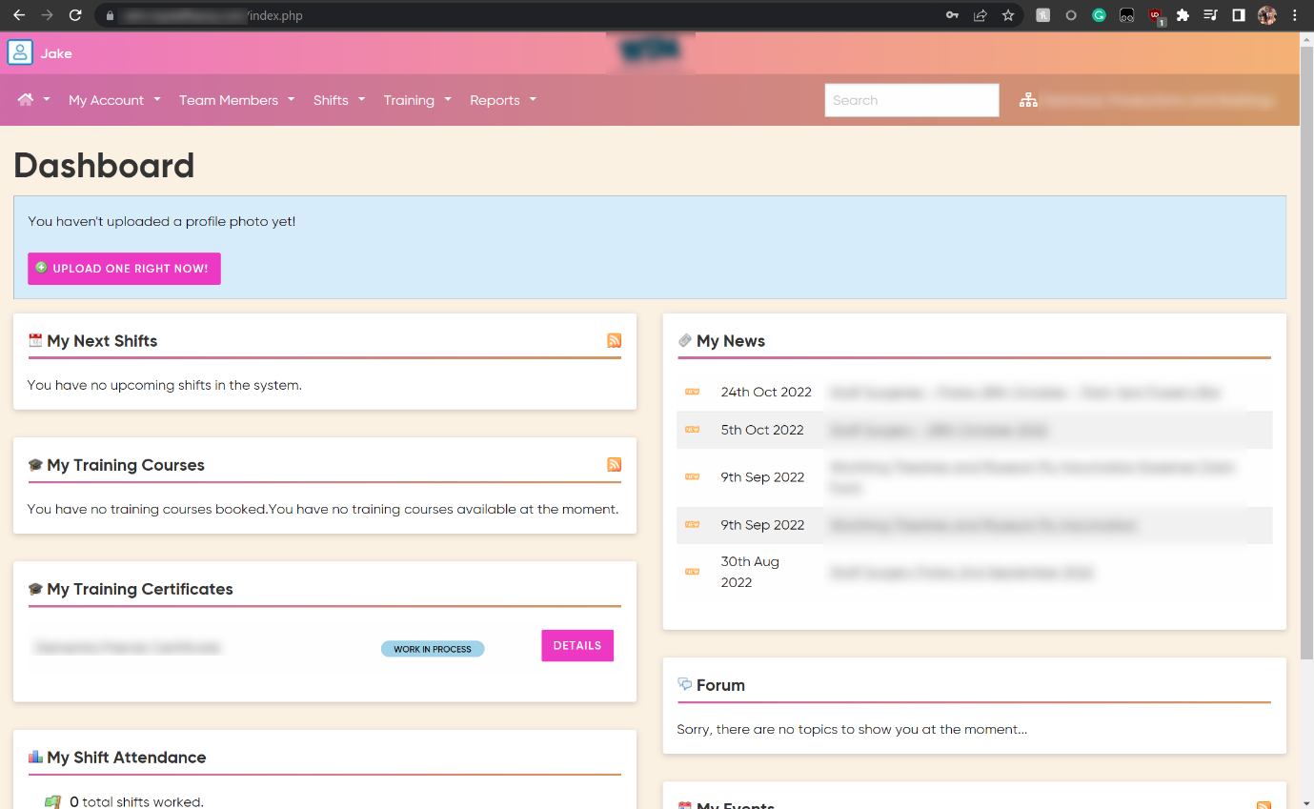

*Figure 28: Dashboard/Homepage of the analysed site (desktop view)*

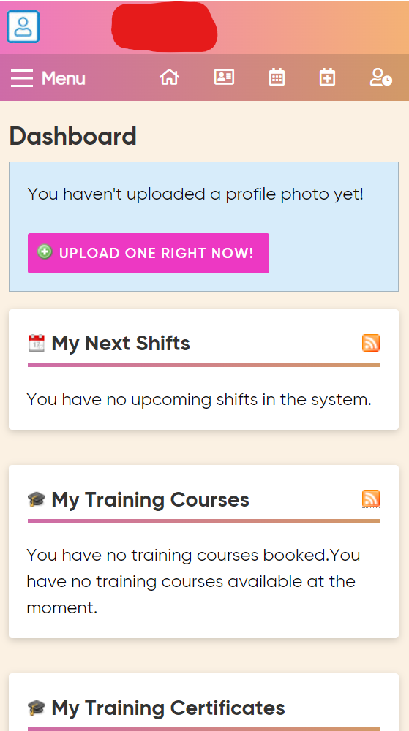

*Figure 29: Dashboard/Homepage of the analysed site (mobile view)*

The training pages were separated into the employee's status, assigned courses, resources and forums. While I wouldn’t be planning on adding any forms a resource library would be a possible section to consider. The resource library isn’t unique to any one user but is instead a list of all resources used for training, this could be implemented along with a search bar for navigation to aid those who want further reading. The employee status could be where statistics are displayed as well as results from training. The courses page itself would feature all assigned courses as well as past courses, this can be used to navigate to the training in need of completion and revision of old work. There is a copyright statement at the bottom of the page which I would integrate with an automatically updating year.

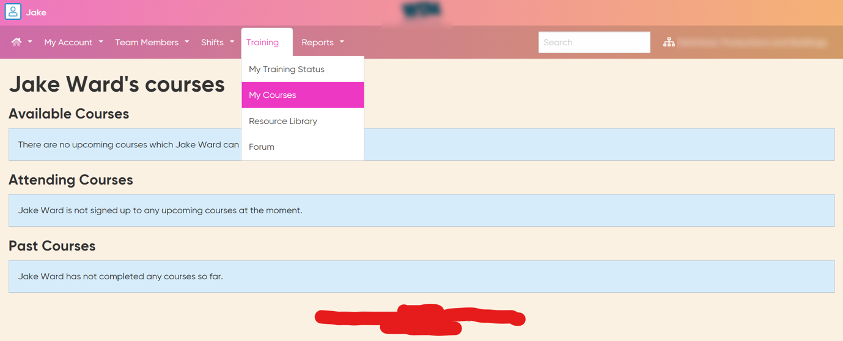

*Figure 30: Training section of the analysed site (desktop view)*

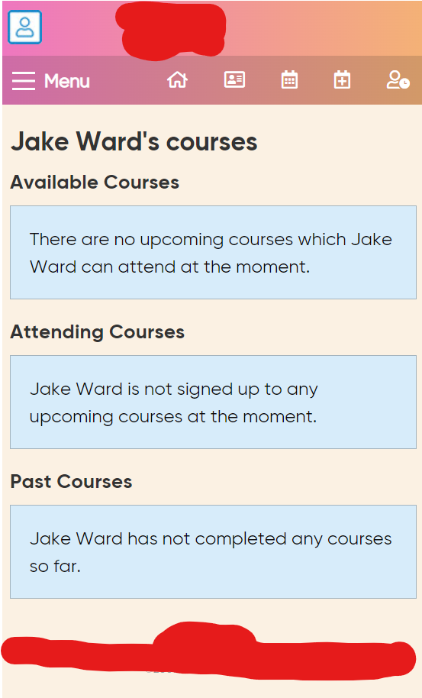

*Figure 31: Training section of the analysed site (mobile view)*

The navigation opens and extends sideways in both views. There are options to update information about the profile from the navigation as opposed to navigation via the profile page. The use of quick links for every part of the application would be a good inclusion to enhance the user experience. The mobile view introduced a phone-oriented element on mobile view in the form of the lock screen button, this could be another simple extra inclusion in my application. The mobile view also incorporates icons in place of links to take up less space and be more readable on smaller devices.

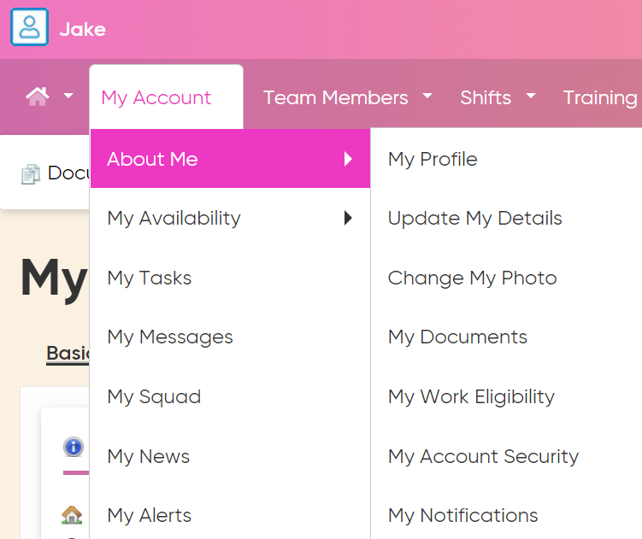

*Figure 32: Navigation bar of the analysed site (desktop view)*

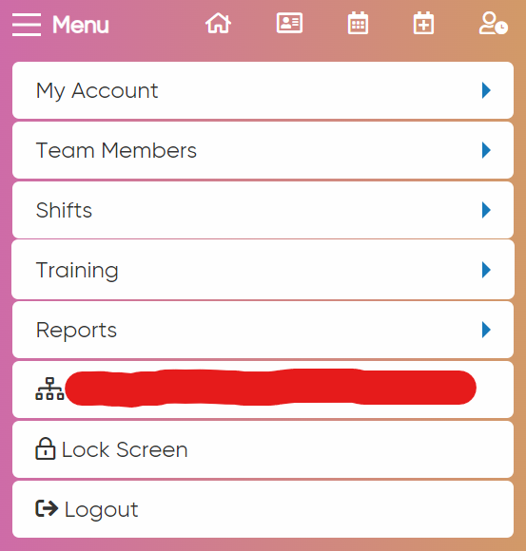

*Figure 33: Navigation bar of the analysed site (mobile view)*

The profile page itself is also a dynamic page generated with the use of PHP. It houses information about the user taken from the database separated into three sections: basic information about the employee, contact information including an email and phone number and a customizable ‘About Me’ section. All of these can be edited but some fields are mandatory. Profile pictures and the ‘About Me’ section are optional. All profile elements are edited from a separate page and are altered upon clicking a button labelled ‘save’. There are again other extra details exclusive to work that I would not be incorporating into my site due to lack of applicability, like the ability to see documents submitted for work and reporting an absence. The extra navigation on mobile view takes up an unnecessary amount of space which I would avoid by using a side-scrolling element to ensure they only took up one line of space.

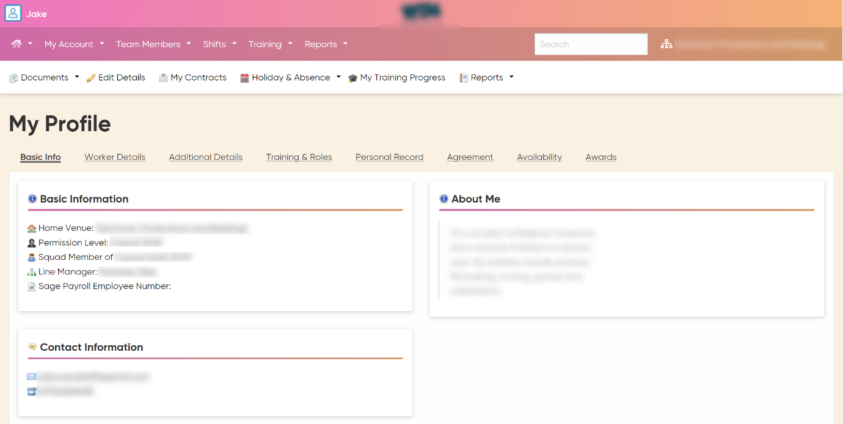*Figure 34: Profile page of the analysed site (desktop view)*

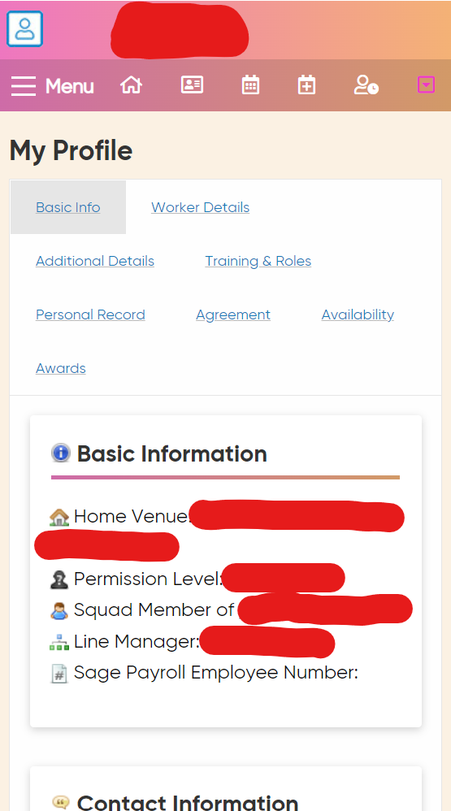

*Figure 35: Profile page of the analysed site (mobile view)*

All elements discussed would be considered upon the design of the site via wireframe models. Below can be found examples of the other sites which I’ve analyzed and annotated. These sites were researched for possible alternate designs. No extensive revisions were made due to these analyses, but these inclusions are evidence of the time put into research as well as the conventional design I would be adopting.

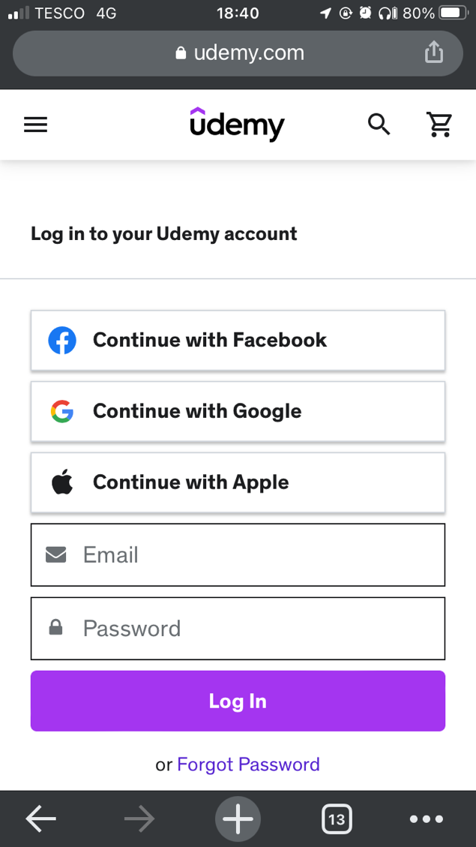

Change password

Email and Password login

Social Media login

Search courses

Side nav-bar

Logo/Home

*Figure 36: Annotation of Udemy login page*



Horizonal scroll of courses

Courses filtered by Theme

*Figure 37: Annotation of Udemy homepage*



Side nav-bar

(preview) Video

Description

Rating

Course specific stats

Purchase

Logo/Home

*Figure 38: Annotation of Udemy course-specific page*

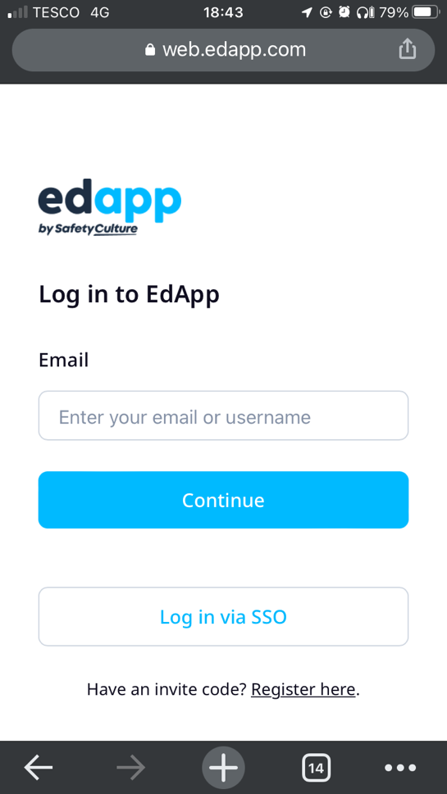

SSO Login

Create account with code

2-step email-password login

Logo/Home

*Figure 39: Annotation of Edapp login page*



Top nav-bar

Filters

Logo/Home

Horizontal scroll of courses

Search through courses

*Figure 40: Annotation of Edapp homepage*



Logo/Home

Top nav-bar

Title

Start course

*Figure 41: Annotation of Edapp course-specific page*

# Design

## Architecture Design

Before designing the UI elements, I felt the need to demonstrate the aforementioned overall/architectural design. Below can be seen the visualisation of the client-server model I intended to create along with the resources I planned on using to create it in the form of a top-level diagram. The justifications for each decision can be found in the research section of the report under “structure and resources”.

HTML Client

Node Application

MySQL Database

Express API

WEB

Server

Database

Node Application

*Figure 42: top level diagram of project architectural design*

Below can also be found the designed architecture of the project in the form of a class diagram. While this design would always be subject to change it would serve as a pitch to the supervisors and in a real-world scenario, would do the same for the company the app was designed for. The class diagram is a lot more in-depth than the top-level diagram helping both developers and management to understand the system and its components. It demonstrates the communication between elements and can often help identify potential problems before development. This plan serves as a blueprint for how to implement the system which would speed up development and would also help in a scenario where there is more than one developer as they could all refer to this diagram for an understanding of the desired structure. This design went through many iterations before the finalization, this demonstrates how its usage did prevent errors down the line and thus did save time. While class diagrams are often reserved for showing classes with a single application, they can be repurposed to display multiple components and languages with cross-device communication.

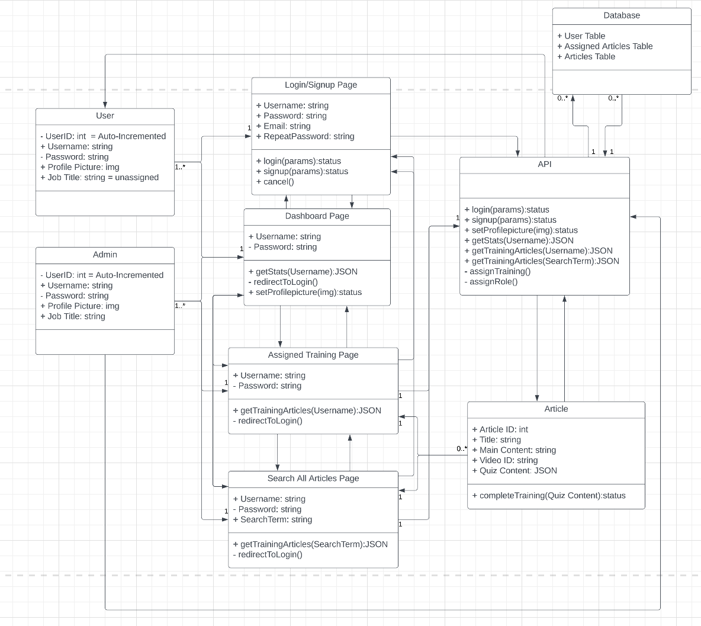

*Figure 43: UML class diagram of project architectural design*

## Database Design

I then saw fit to design a simplistic version of the MySQL database that would be used for storage for the web application. The Diagram below displays a user's table, showcasing how I planned on using usernames and passwords to validate a user's authenticity, email for sending important messages to users and the type of employee they were in the company so they could all be assigned the work/training at once.

It also shows how a training table would contain the training article’s content to be displayed on a dynamically generated page. As well as video paths to generate the iframes and containers needed to display training videos. Finally, a question and answers section to store a JSON object containing the questions, answers and correct answers to be used to dynamically generate the quiz as well as validate the users answers were correctly answered and thus they had completed the training.

The database would be relationally connected through a table connecting the previous two with primary keys. It would do this to assign training to users was well as keep the results to tick content off as completed and be used in other features like calculation of progress for the progress bar and stats.

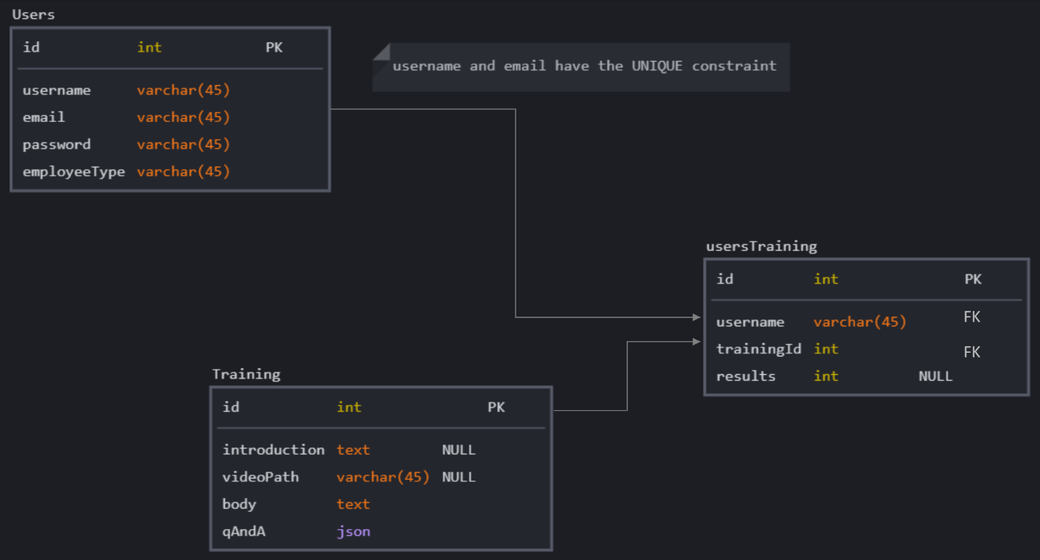

*Figure 44: Diagram of project MySQL database design*

## UI Design

I created various wireframe models based off both my secondary research and my knowledge of what was possible to create with JavaScript, HTML and CSS from the advanced web development module I had taken earlier that year. I have displayed a series of the most important drafts below as these were the designs I moved forward with. I always planned on using a flexbox design so that when the dimensions fit those of a mobile device then the columns could all meld into one. The login page would be a separate single-page application that would swap between states displaying either the login or signup form. A cancel button would remove the user from the domain and a successful submission of either form would take the user to the homepage with a form of authorisation to make sure they could access the site without having to enter details again.

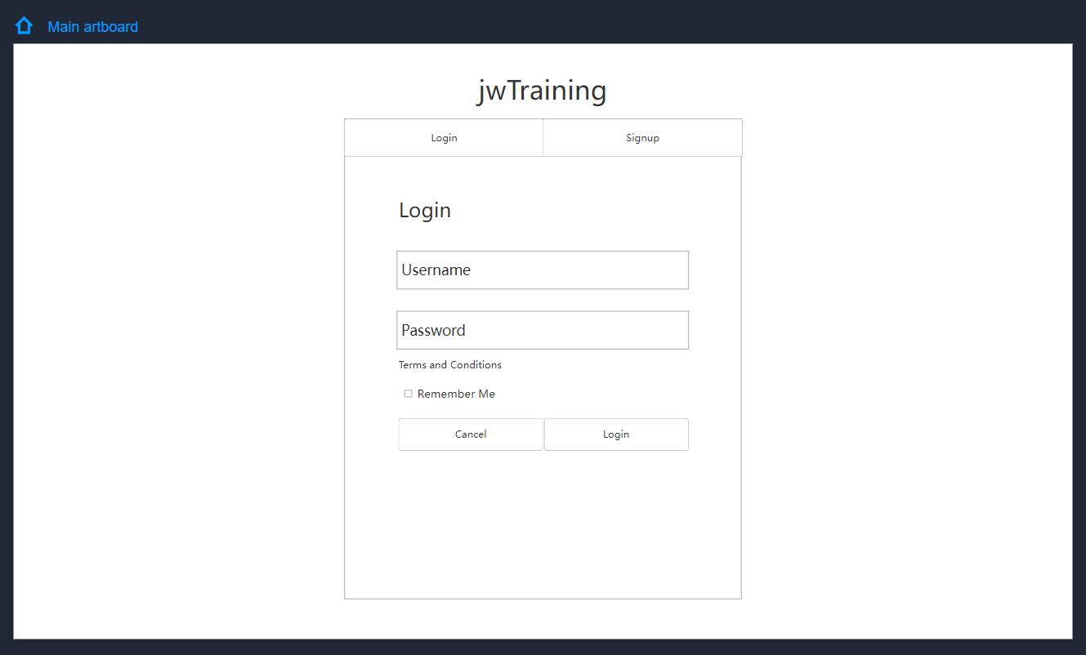

*Figure 45: Wireframe model of project login/signup page in login state*

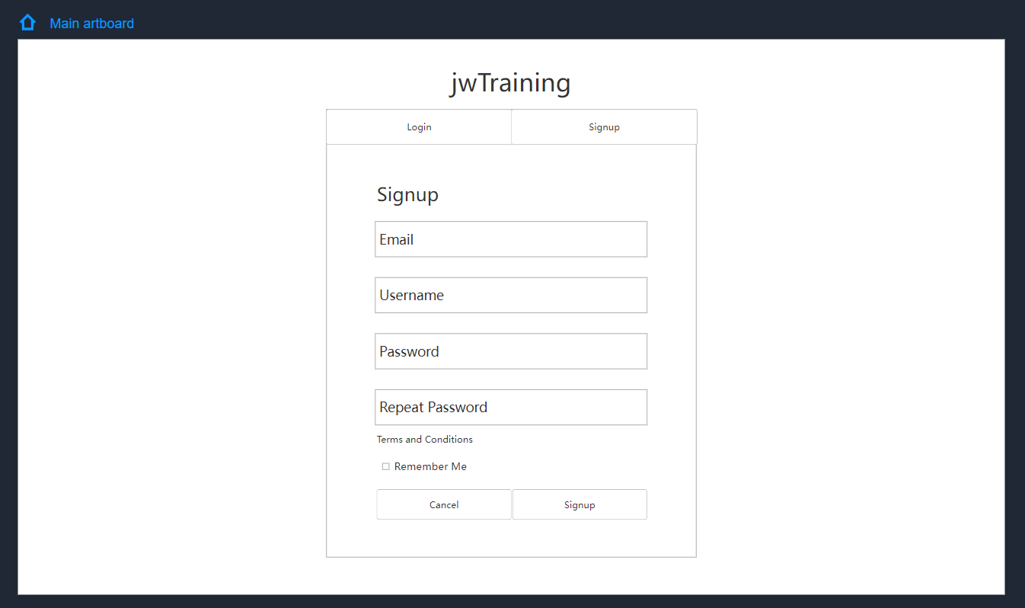

*Figure 46: Wireframe model of project login/signup page in signup state*

Using the flexbox design again for the same purpose I would also be using it to transform the navigation bar into a more mobile-friendly format. The rows and columns I set up in CSS and assigned in the HTML would allow me to keep a different margin on different pages as well as remove some of the margins for mobile view. Once logged in a dropdown menu would reveal a link to the profile if I decided to implement it and a logout button which would remove the user’s current authorisation and return them to the login page. The basic design would be split into three types; a design unique to the login/signup page, a design unique to the dynamic articles and a generic design for all other pages such as the dashboard, the users training and a contact page. There would be a visual display in the top corner of the screen to show who was currently logged in.

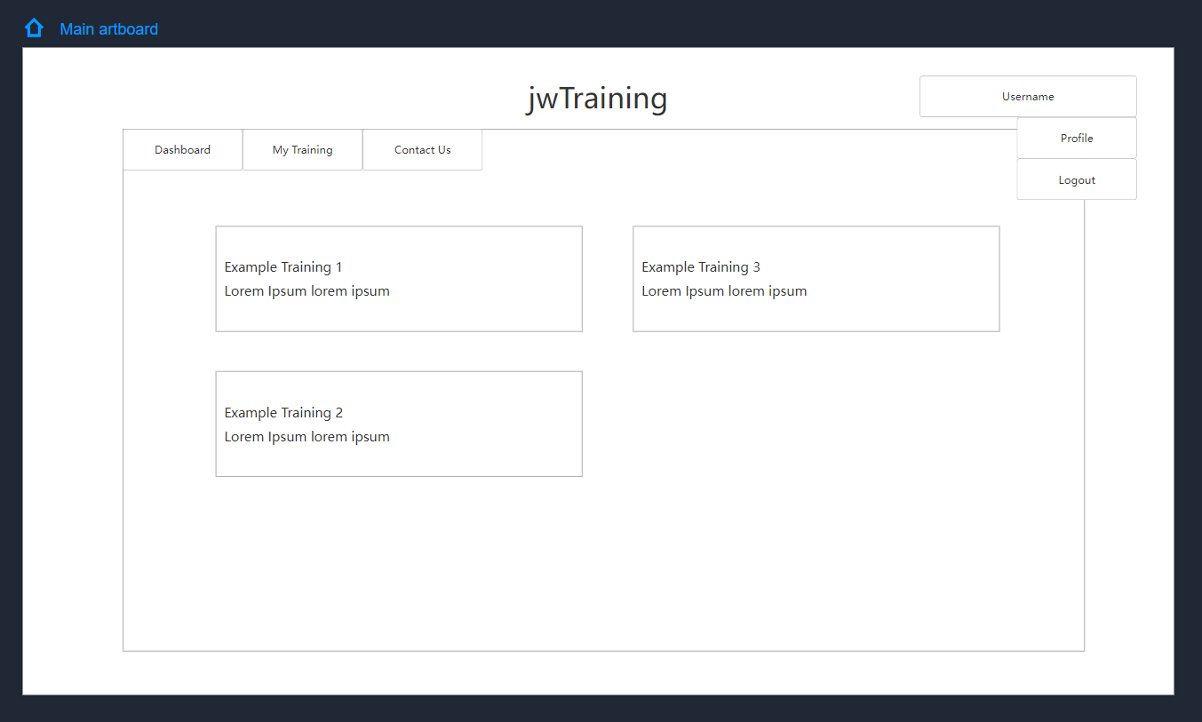

*Figure 47: Wireframe model of a generic project web page desktop view*

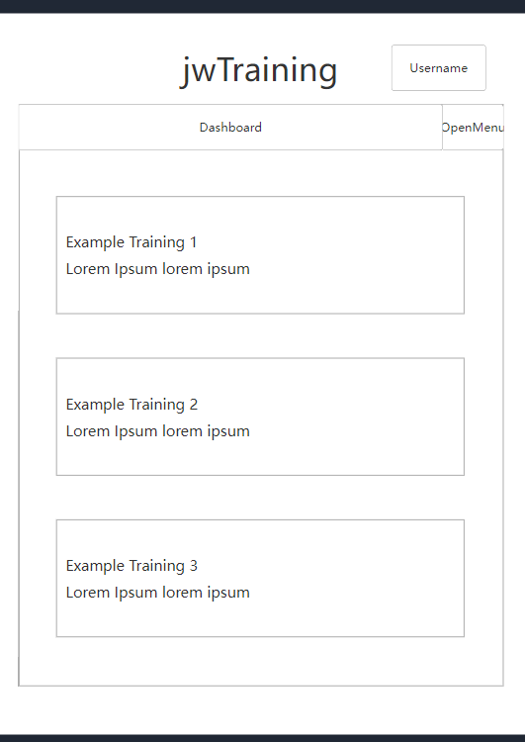

*Figure 48: Wireframe model of a generic project web page mobile view*

The biggest difference between the dynamic articles pages and all other designs was that they would exclusively have a single column display potentially hosting a video and quiz. All other elements would be the same as the generic pages but less restrictions were to be put on the pages as the content could be as long or short as the server-side restricted.

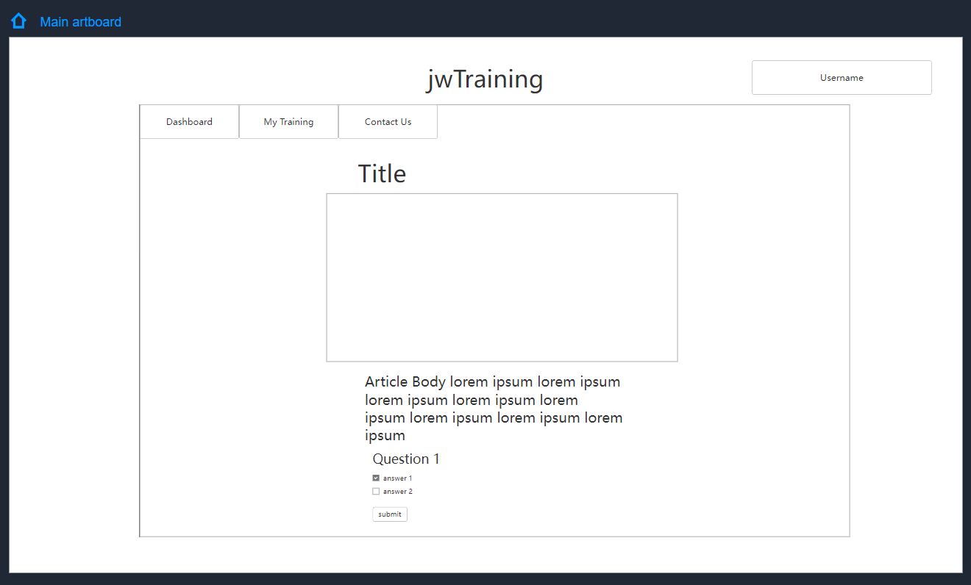

*Figure 49: Wireframe model of a dynamic article page desktop view*

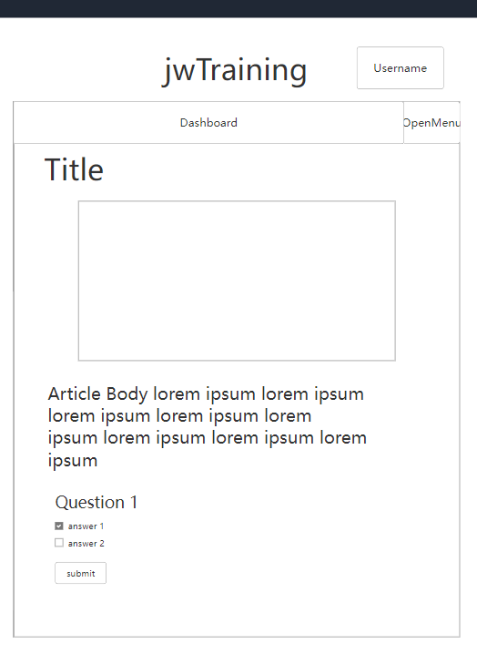

*Figure 50: Wireframe model of a dynamic article page mobile view*

Overall, all the UI designs had to be flexible and devoid of absolute positioning due to the dynamic content on most pages and the need to make the design modern with mobile friendliness. I made the designs simplistic and clear so that all users could easily navigate and use the web application. I knew this design was possible as I had achieved similar results in the past with the use of flexbox which I knew would be supported by all modern browsers and thus hold high compatibility.

Design decisions were made based on the results of research but would be subject to change depending on the results of the observational method testing I would be carrying out alongside the regular user testing. Usability would be tracked in this way and the results would be used to inform the decisions made on the rest of the site or revisions that would need to be made.

## Use Case Table

|  |  |  |  |  |  |  |  |  |
| --- | --- | --- | --- | --- | --- | --- | --- | --- |
| Use Case Name | Actors | Description | Pre-conditions | Steps | Post-conditions | Error Handling | System Response | Components Used |
| Signup | New User | User creates an account to access the web app using the signup form | None | User filles out the signup form and clicks submit | New user is created in database | Display message and prevent signup if; username already exists, email already exists, passwords aren't the same, details don’t fit the appropriate regex | User is taken to the homepage with credentials saved in browser.  User recieves confirmation email. | Web app: login/signup page  API: signup endpoint  Database: Users table |
| Login | Valid User | User submits the login form with valid credentials to access the web app | User has used the signup form to create an account | User filles out the Login form and clicks submit | User credentials are validated with the database | Display error message if credentials do not match an entry in the database | User is taken to the homepage with credentials saved in browser | Web app: login/signup page  API: login endpoint  Database: Users table |
| Access Web App Homepage Unauthenticated | Unauthenticated User | User attempts to access the web app homepage without being logged in | User is not logged in | User navigates to the web app homepage and System detects that the user is not logged in | User found to be invalid after failed login attempt | N/A | User is directed to the login page | Web app: Homepage  API: Authentication/login endpoint |
| Navigation to Training page | Authenticated User | The user navigates to the training page which immediately loads all of that user’s assigned articles/ training | The user has been authenticated | After logging in User clicks on training in the navigation of any page | All assigned articles are got from database alongside their progress as a percentage | If there are no results, then system display progress as 100% and message is displayed stating that there is no more work | All user's assigned training articles are displayed as cards with titles, links to the articles, due dates and descriptions | Web app: training page API: training endpoint  Database: Users table,  Assigned articles table and Articles table |
| Search through Articles | Authenticated User | After navigating to the search page, all articles will automatically be displayed but all articles can be searched through via the search bar and keywords | The user has been authenticated | The user must navigate to the search page then enter a keyword into the seearchbar and click search | All articles are got after page load and all articles containing the keyword are got after the search button is clicked | If there are no results, then the displayed results are not updated, and an error message appears | After page load or search, the articles retrieved information are displayed as cards containing; titles, links to the articles, tags and descriptions. | Web app: search page  API: search endpoint  Database: Articles table |
| Navigate to article | Authenticated User | After using a method to display a list of training articles the user can navigate to an article where it contents are loaded in | The user has been authenticated and a method to search for training articles has been used | The user must use the notification on the dashboard, search page or training page to find an article and click on the link, then wait for the page to load. | The page is rendered using the articles information on the database and the article template | If there is no video ID for that article then a video isn't loaded. | The article is displayed with its title, main content, a video and a quiz used to complete the training | Web app: search/training/dashboard page and EJS articles template  API: articles endpoint  Database: Articles table |
| Complete training article | Authenticated User | After watching and/or reading the learning material the user | The user has been authenticated and the article has been assigned to them | The user must fill out the quiz at the bottom of the article and click submit with a score of above 70% | The quiz answers are graded and the article is marked as complete in the database | If the article is not currently assigned to the user then they are graded locally and the database isn't altered.  If the quiz was graded below 70% nothing is submitted and the training remains incomplete | The user is notified of their success and score and is redirected back to the training page | Web app: any article page  API: article submission endpoint  Database: Users table,  Assigned articles table and Articles table |
| Logout | Authenticated User | The user has their credentials removed from the browser and is redirected to the login page | The user has been authenticated | The user must hover over the username card then click the logout button | The cookies or session values containing the credentials are removed | N/A | The use is no longer authenticated and is redirected to the login page | Web app: any page except the login page |
| Upload profile picture | Authenticated User | The user uploads their profile picture | The user has been authenticated | The use must click the button to upload an image, select the image from the device, then click apply. | The image is sent to the API and is set as their profile picture | If the image is in the wrong format nothing will happen | The user has a new profile picture | Web app: profile page page  API: profile picture upload endpoint  Database: Users table |
| Download profile picture | Authenticated User | The profile picture is displayed | The user has been authenticated | The user must be on a page with a profile picture | The image is got from the API | If image doesn’t exist display default icon | The image is displayed on the page | Web app: any page after login  API: profile picture upload endpoint  Database: Users table |
| Assign users Role | Admin | The admin user assigns a target users role/ job title | User has a way of sending HTTP requests like Postman | The admin must send a post request to the endpoint with their credentials, target user and role to assign | The role is assigned in the database | If the user isn't an admin functionality is denied | The target user can now easily be assigned work | API: assign role endpoint  Database: Users table |
| Assign work to users by role | Admin | The admin user assigns a target training article to users via role/ job title | User has a way of sending HTTP requests like Postman | The admin must send a post request to the endpoint with their credentials, target role and article ID to assign | The work is assigned in the database | If the user isn't an admin functionality is denied | The users have been assigned the work | API: assign training endpoint  Database: Users table and Assigned articles table |
| Assign work to specific user | Admin/ User with access to database | The user inserts an entry into the database that assigns an article to them. This is not the designed method of setting work but is still availible. | User has access to the database with a tool like phpMyAdmin to easily alter or add entries | The user simply adds an entry to the assigned articles database that uses the users ID, articles ID and due date | The database is updated | If completed is not set as 0 it will default to 0. If another element is missing then the entry wont be made. | The work is assigned | Database: Users table,  Assigned articles table and Articles table |

Seeing as how the profile picture functionality was only partially implemented the only difference Is that the request cannot be sent from the website and must be sent from an application capable of sending HTTP requests like Postman.

# Implementation

In this section, I’ve detailed the implementation and entire practical elements of the project from start to finish. In this section of the report I’ve written more informally to give a greater insight into my process behind development as well as why decisions were made on how to implement certain system requirements. The implementation section serves as the documentation of all practical work and is written in a diary-like format to show how the schedule progressed. Screenshots are included of all relevant code at the time of writing which is evidenced by the entries uploaded to the GitHub repository on the same days with the same edits made. The schedule represented may be inconsistent with the original Gantt chart due to external and unforeseeable factors such as other projects, personal issues and hardware issues. While commenting was used in code, they were often removed from screenshots to maintain the readability of the code and display professionality. This was because the comments would often be short and nonsensical to anyone other than myself as the sole developer. If I had been working in a larger team I would have been leaving more comprehensive notes but I've instead displayed my evidence of understanding in this section through my entries.

After every feature was added whitebox testing was carried out to test that the feature was functional, and at the end of every significant addition blackbox testing would be carried out. At the end of every sprint the observational method would be used to see if any revisions or extra features would need to be made. All regressive tests done alongside implementation can be found in the test-table excel file submitted alongside the documentation/report.

## Sprint 1: Set-up

Before the web application would start development, I needed to prioritise some other studies and business for various reasons. So, before I took a break from the project to manage my other project for the year I decided it would be most responsible use the first short sprint of the project to create the basic work environment I would be using to serve as proof of concept.

### 15/11/22

I first logged into Brighton Domains and used their resources to create a new MySQL database hosted on their server. I named it “jwTrainingDatabase” so there was no confusion about the database's purpose or association. Alongside it I created a new user that would be used by the API to make alterations to the database. I assigned the user to the database and granted it all privileges. This account would be used by the API to ensure it could do anything, but not all users would be able to abuse this as the API itself would restrict who could use it and for what.

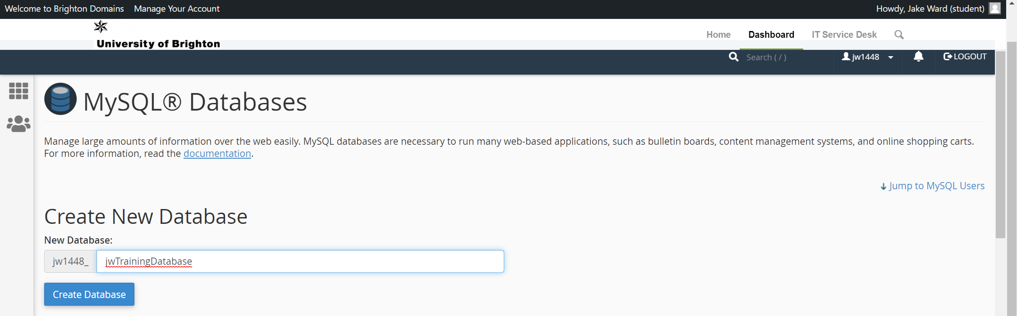

*Figure 51: Creation of database via Brighton Domains UI*

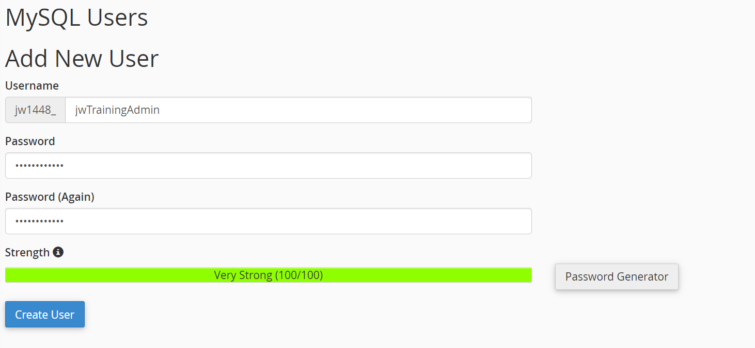

*Figure 52: Creation of MySQL user via Brighton Domains*

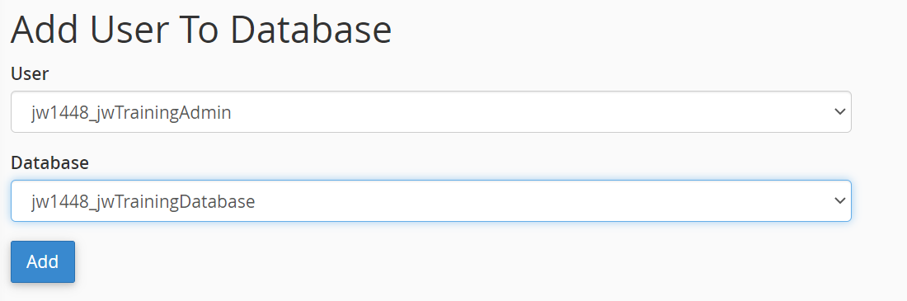

*Figure 53: Assignment of MySQL privileges via Brighton Domains*

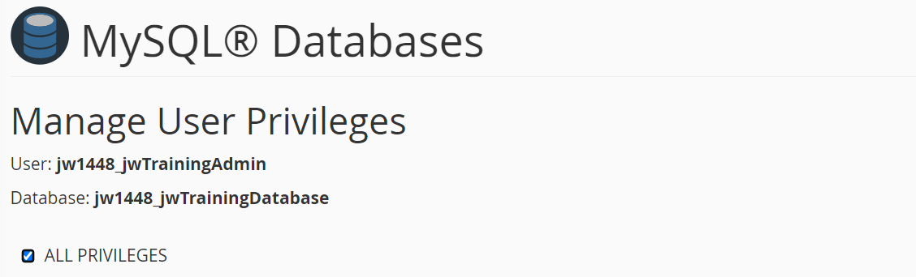

*Figure 54: Assignment of all privileges to MySQL user via Brighton Domains*

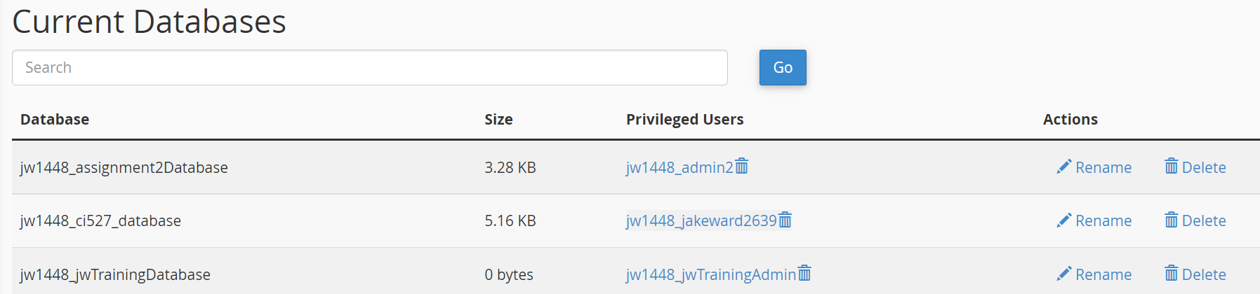

*Figure 55: Evidence of successful database creation*

Next the Node.js application needed to be created for the REST API to be created on. I again used the Brighton Domains UI to create it. I set the Node version as 10.24.1 as it was the most recent stable version available. I set the rout in my node application folder I had been using for all node applications I had previously made and experimented with in the year. The URL was named after the project so as to to confuse users and the startup files was named as app.js as per convention. A passenger log file was specified at the root to help diagnose problems as they would be logged there instead of a console. The file would stay there without alteration to provide evidence of the problems that arose and were overcome during the course of development. After the application was running with its default generated code the sprint was to be put on its hiatus.

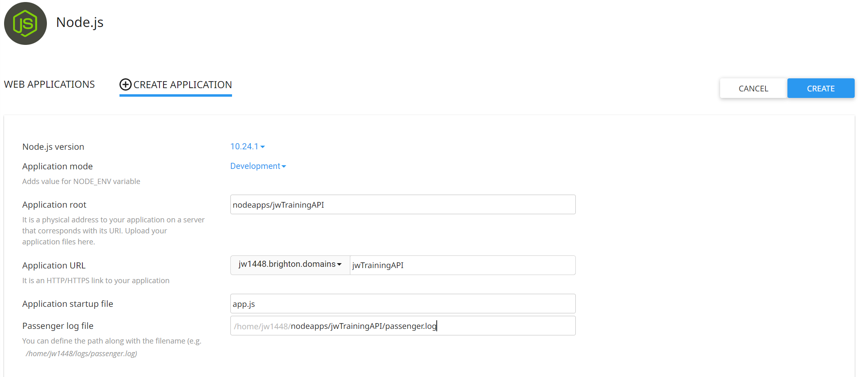

*Figure 56: Creation of Node API via Brighton Domains*

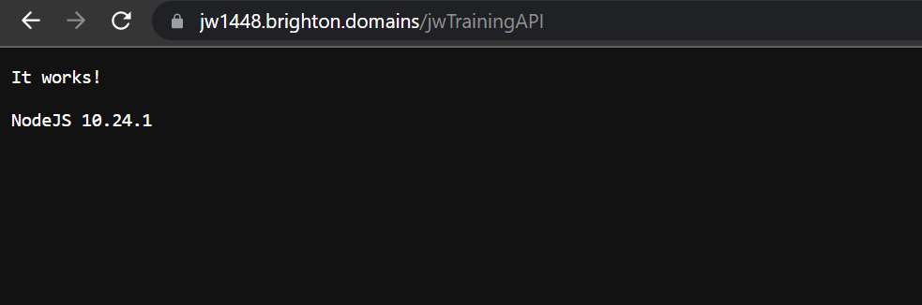

*Figure 57: Evidence of successful Node application creation*

Just before ending the set-up sprint I decided to install all plugins/dependencies that would be needed for usage in the Node.js API. In while some of these would be in use immediately others were only reserved for features that would or could be added later. To install the dependencies would normally require the installation of packages via npm, however, I found that with the way the Brighton Domains system had been set up that I would only need to write the name and current version of a plugin into the package file, upload it to domains and use the “Install NPM Packages” button.

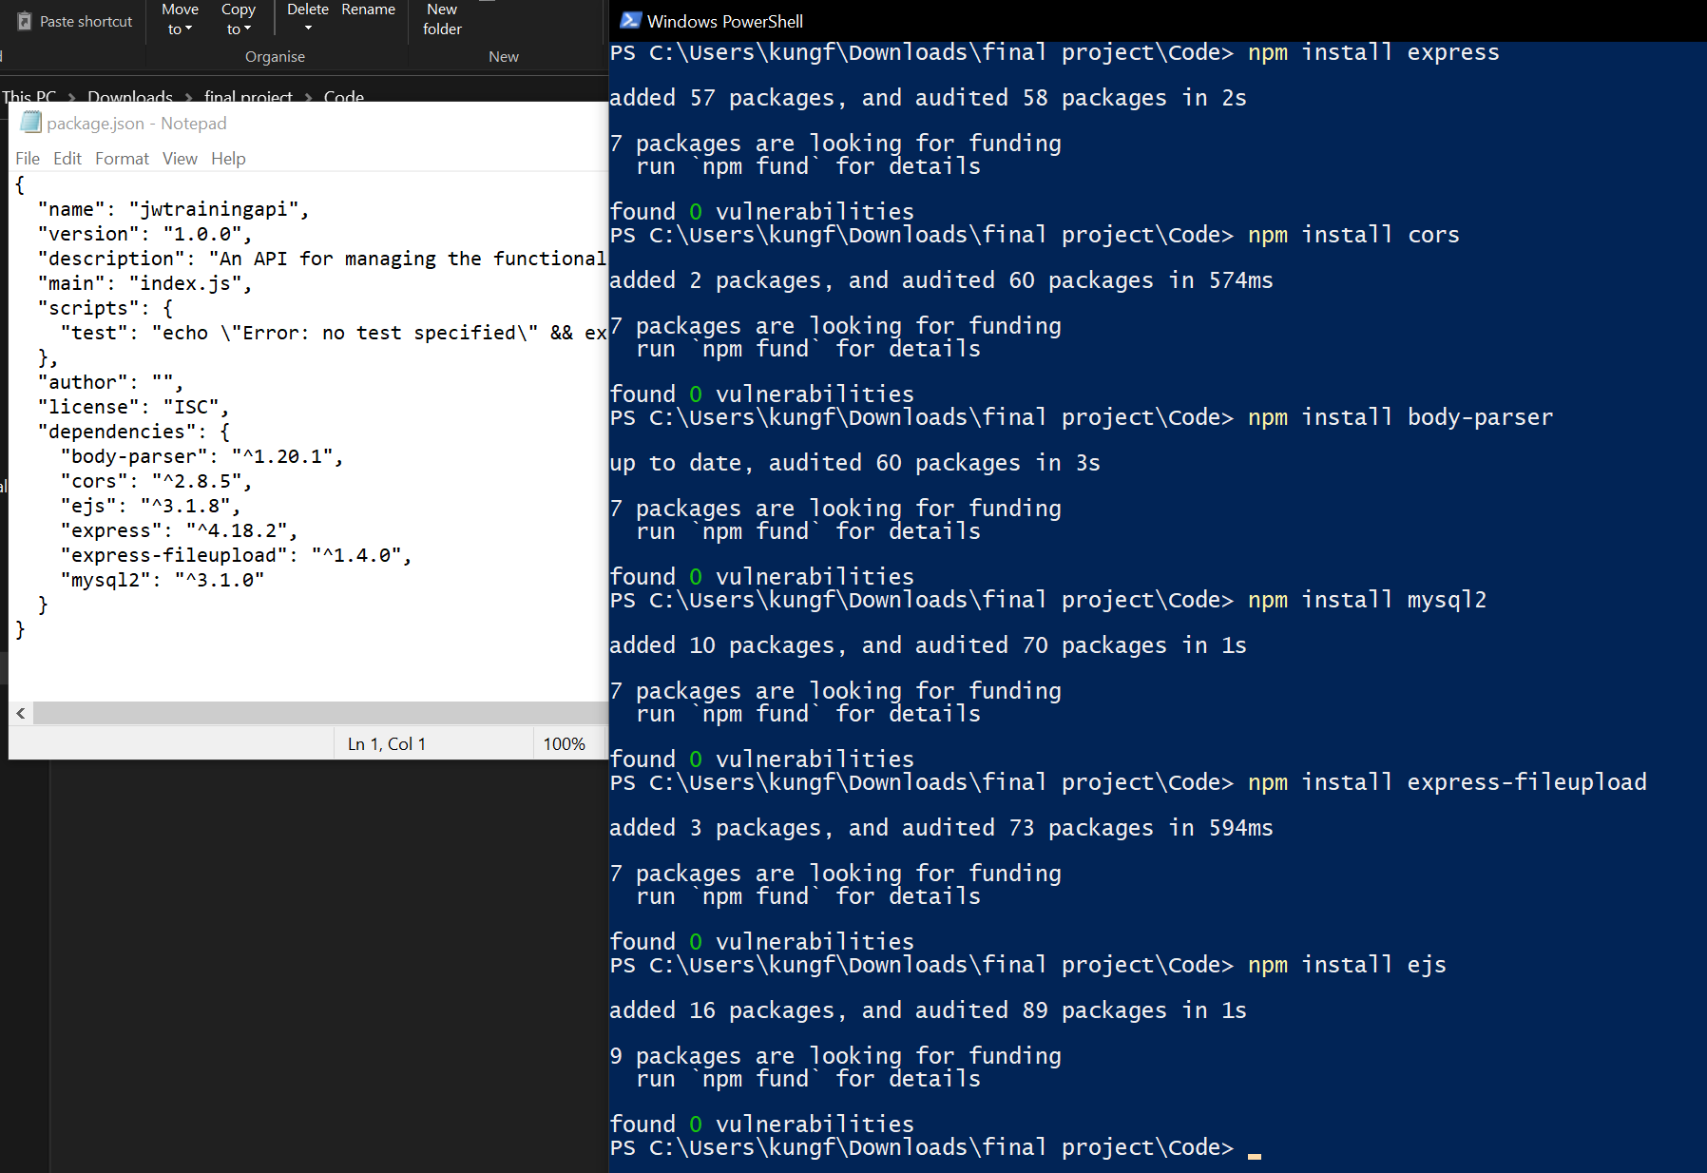

*Figure 58: Installation of dependencies via npm and package file used for domains*

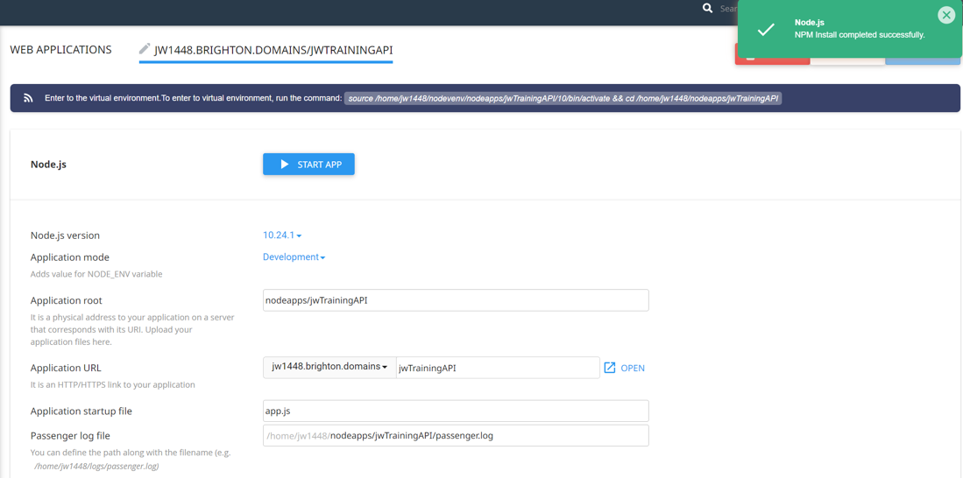

*Figure 59: Installation of dependencies on Brighton Domains after package file upload*

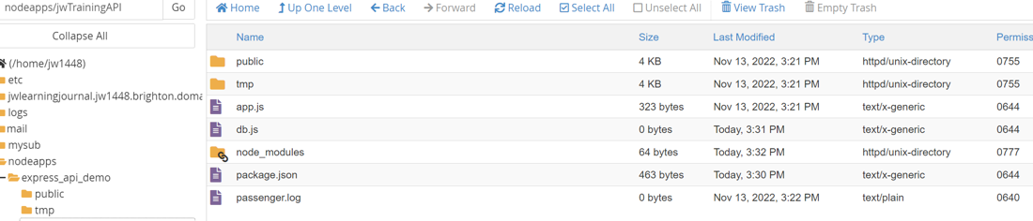

*Figure 60: File manager view of node application root after all setup*

The final part of the set up was to create a file called db.js that would contain all the credentials used to access the database so that they weren't present in the API itself. This also meant that the file could be used as a dependency with an async function “query” able to be used to query the database helping to simplify the code. All code was briefly tested, and the project was placed on its hiatus at the end of its first and short practical-based sprint.

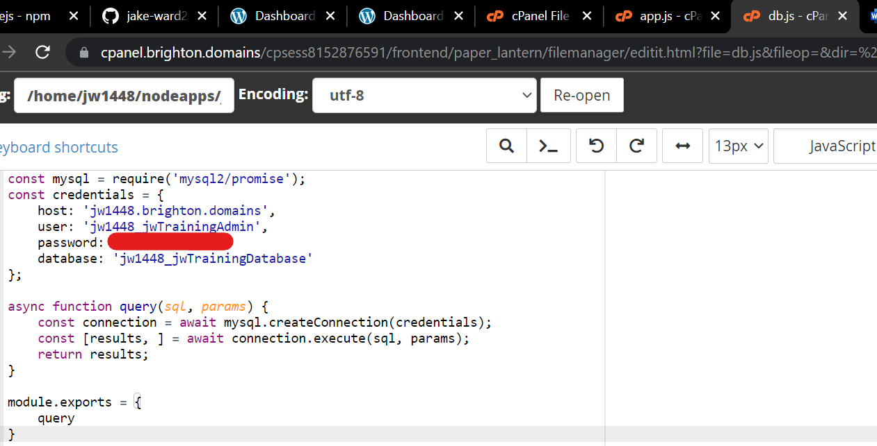

*Figure 61: db.js file containing authentication information and outputting a method to query the MySQL database*

## Sprint 2: Basic Layout & Login/Signup System

Before returning to the daily entries I must mention that before the beginning of the second sprint I places all files previously made into a folder separated between server-side API files and client-side web application files. This folder was then synchronised with a GitHub repository so that previous versions could easily be returned to as well as doubling as evidence for the coding seen I screenshots. After every new addition was complete a new commit would be made and synced with the GitHub repository.

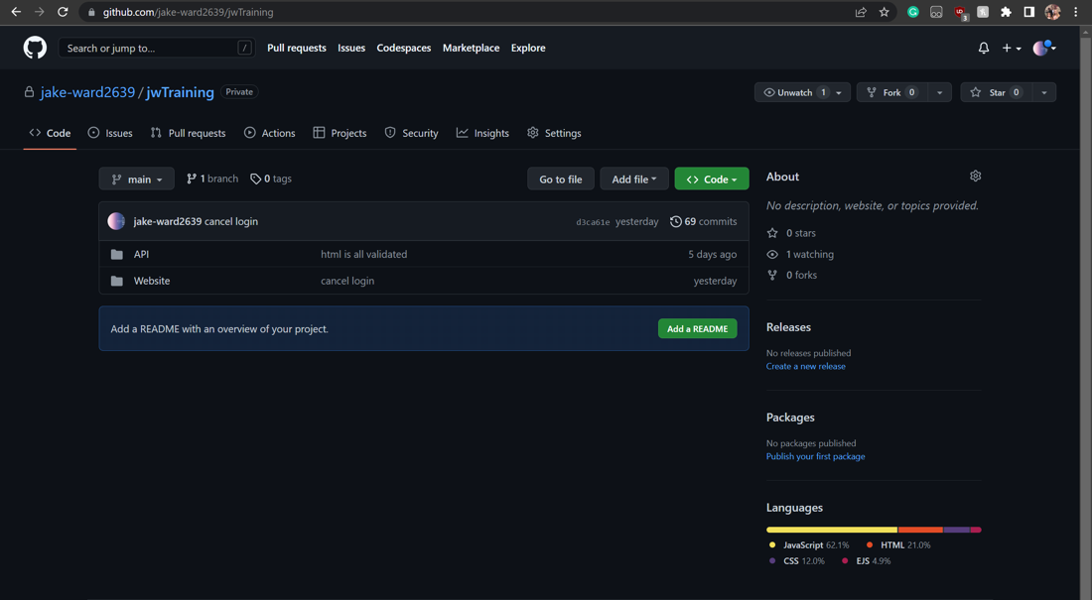

*Figure 62: projects GitHub repository as of 15/03/23*

### 07/02/23

The first UI element to be created was the login/signup page. I refreshed my knowledge on flex box and defined columns and rows to separate the page into the layout I had previously designed. Once I had used CSS to segregate the different sections I placed the signup and login forms in the middle section. Both forms were present in this section but the signup form would have its display set to none by default. It would be setup so that when the signup button was clicked it would show the signup form and hide the login form (as per usual SPA design). The CSS was designed so that on a mobile view (or when the width was small enough) then the side columns being used as margins would be hidden to make it more mobile-friendly. The entire page was uploaded to the domain and run through HTML validation to ensure that there would be compatibility with screen readers and similar applications dependant on conventional standards like adblockers. A link to where terms and conditions in a real-world scenario was placed on the signup form but seeing as how I am not especially versed in law I elected not to fill it out and to leave it as a placeholder instead. A remember me button was implemented on both forms as well as a cancel and signup/login button. For testing purposes the forms were designed to send their contents to an API that would echo back what was sent. This process of design was the product of much trial and error in CSS to see what looked appealing. The goal was to make a functional page as opposed to a very visually appealing page as I myself cannot make design decisions of that nature due to my colour blindness.

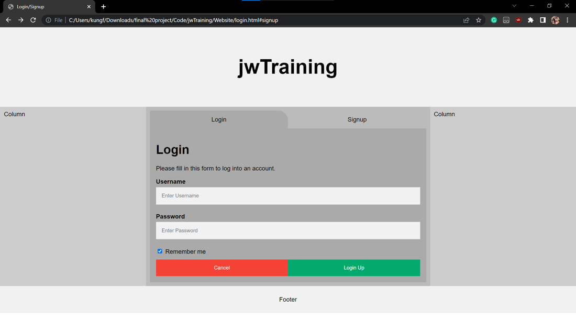

*Figure 63: basic login page layout in desktop view*

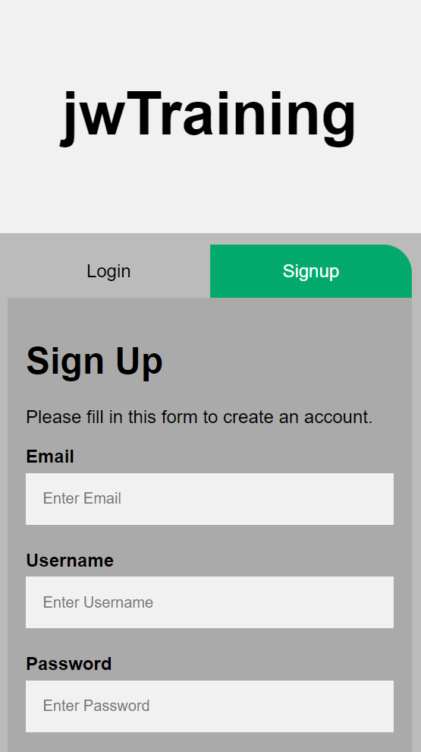

*Figure 64: basic login page layout in mobile view*

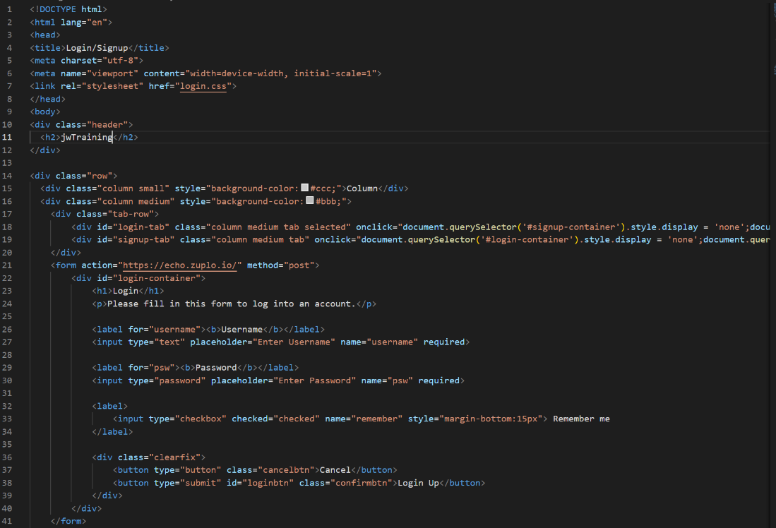

*Figure 65: HTML of basic login page part 1*

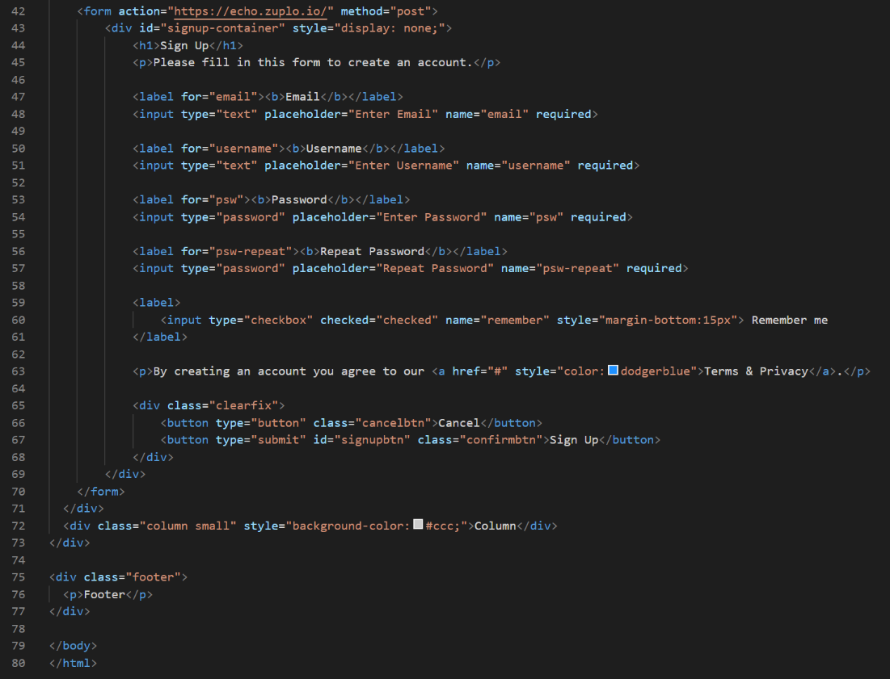

*Figure 66: HTML of basic login page part 2*

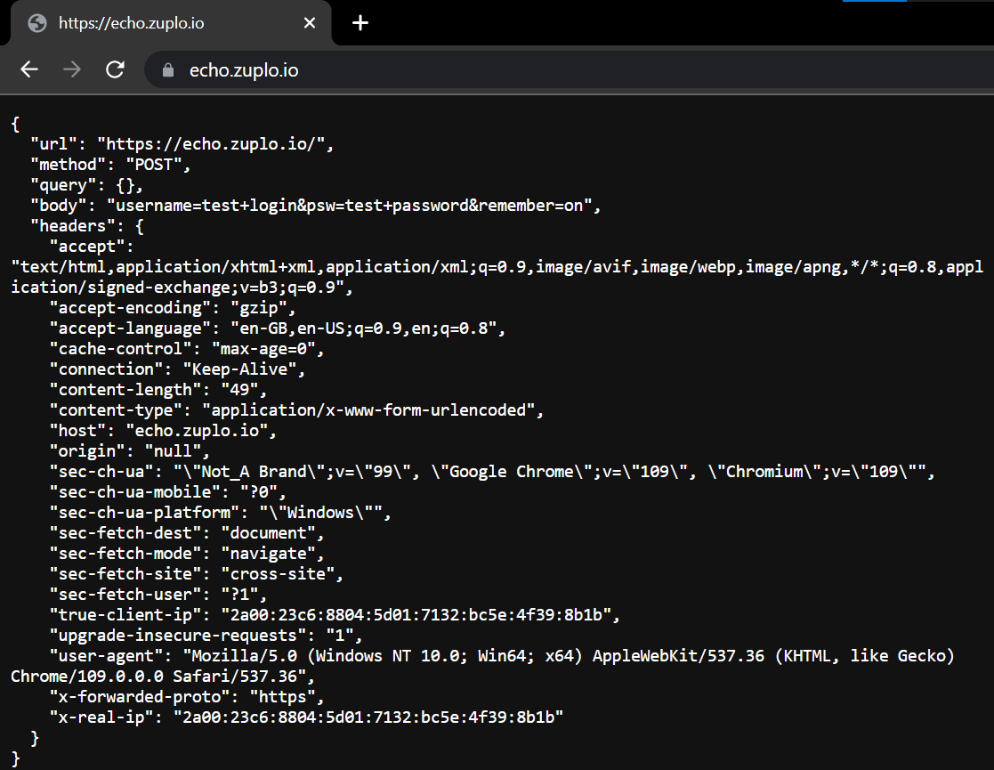

*Figure 67: Echo of request sent by form*

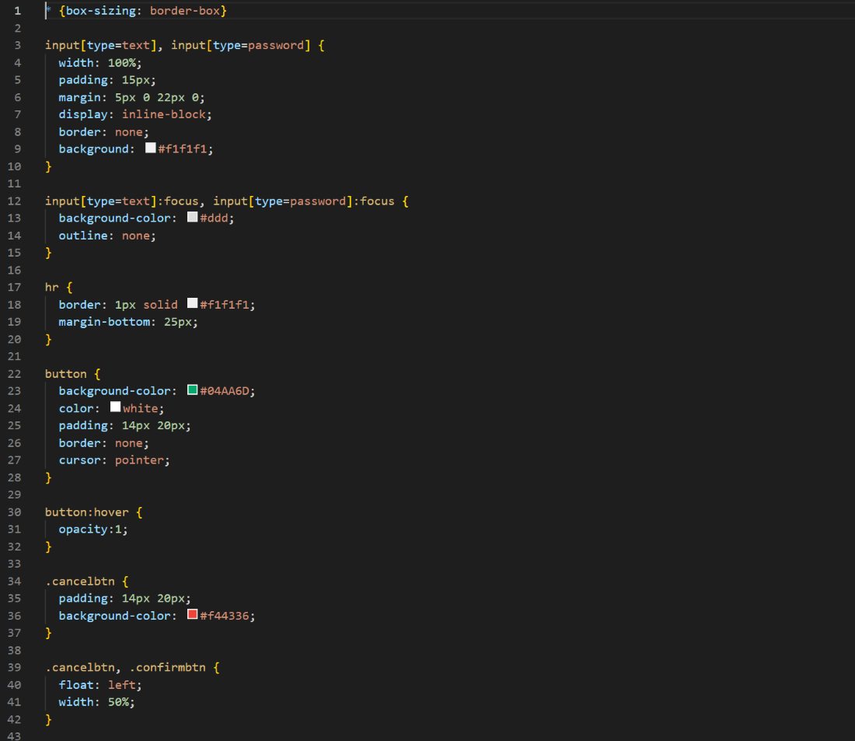

*Figure 68: CSS of basic login page part 1*

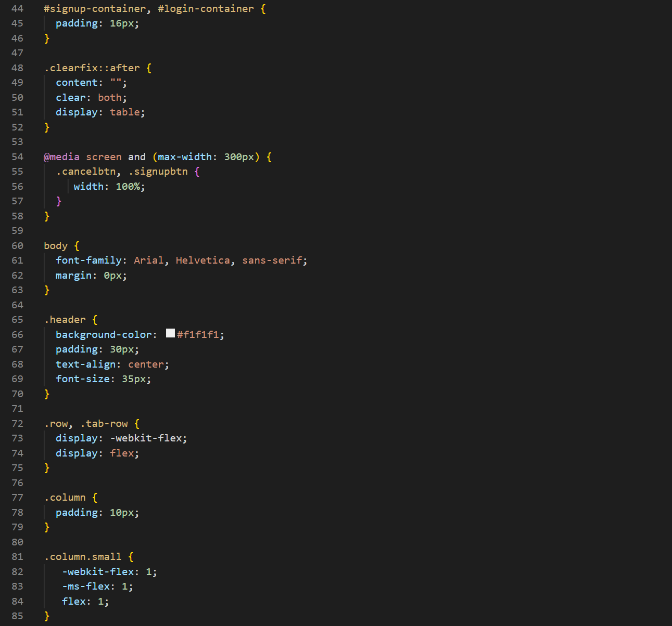

*Figure 69: CSS of basic login page part 2*

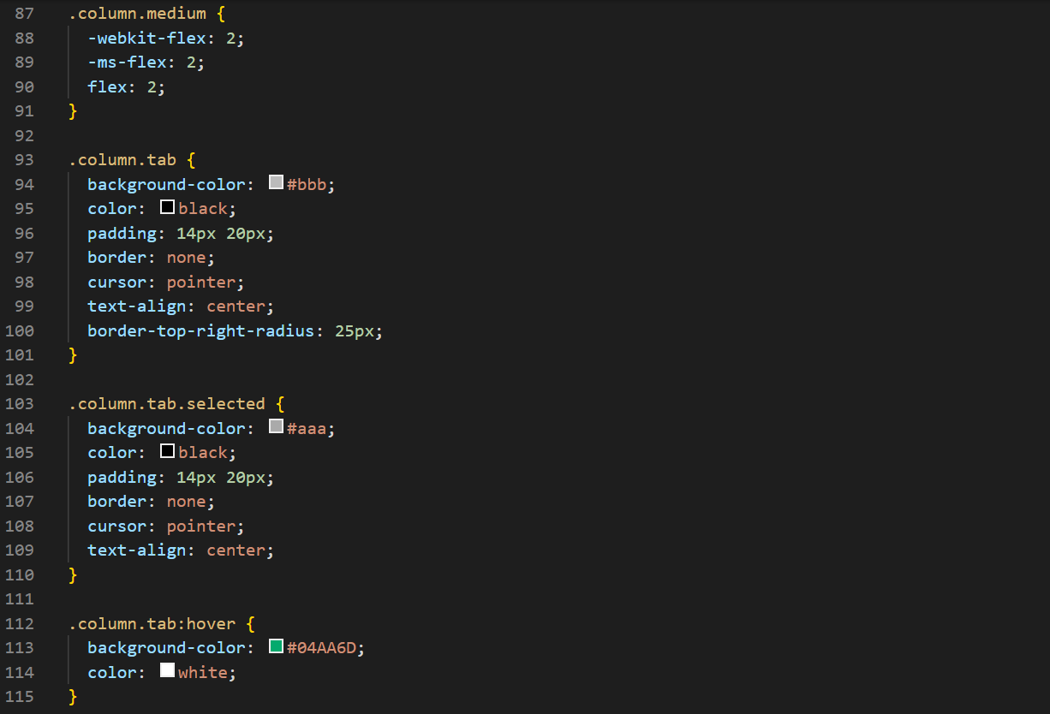

*Figure 70: CSS of basic login page part 3*

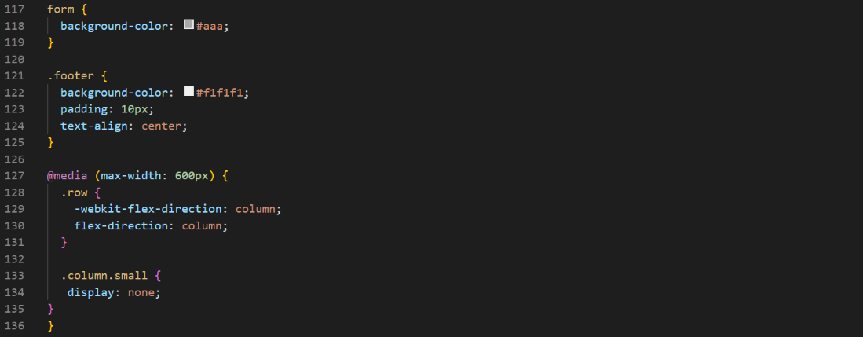

*Figure 71: CSS of basic login page part 4*

### 08/02/23

While I could have moved onto the next UI page that needed developing I decide to focus on getting the basic functionality done alongside any of the pages that were constructed. So I used a MySQL query to create a users table with an auto incremented key and basic information needed to signup like username, password and email.

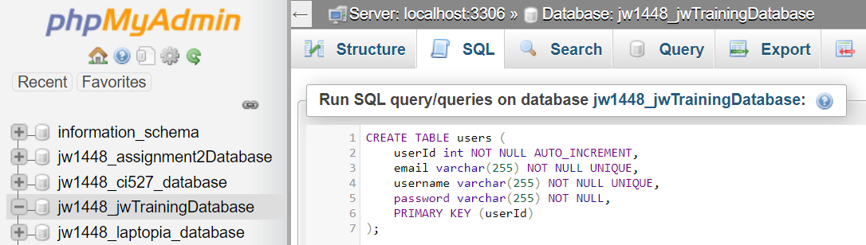

*Figure 72: MySQL query creating the user table*

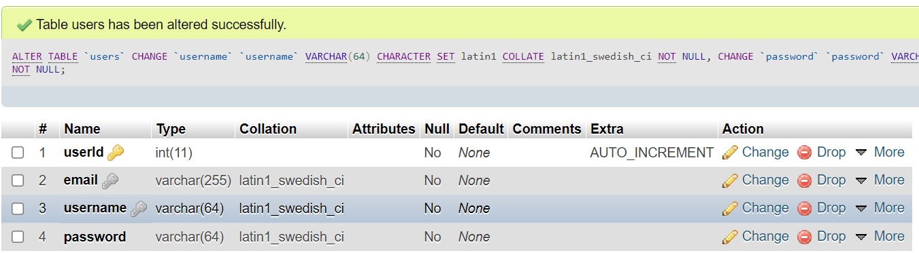

*Figure 73: the MySQL user table displayed in phpMyAdmin*

I then went about adding code to the Node Express API by inserting the dependencies I would be using throughout the project and using body-parser to simplify the handling of parameter input via requests. I used Express to reject potentially dangerous requests like PUT and DELETE and used a login and signup route for the GET request form the login page and for POST requests from the signup page. I referred the requests with their bodies to async functions of similar names to work better with promises as per convention.

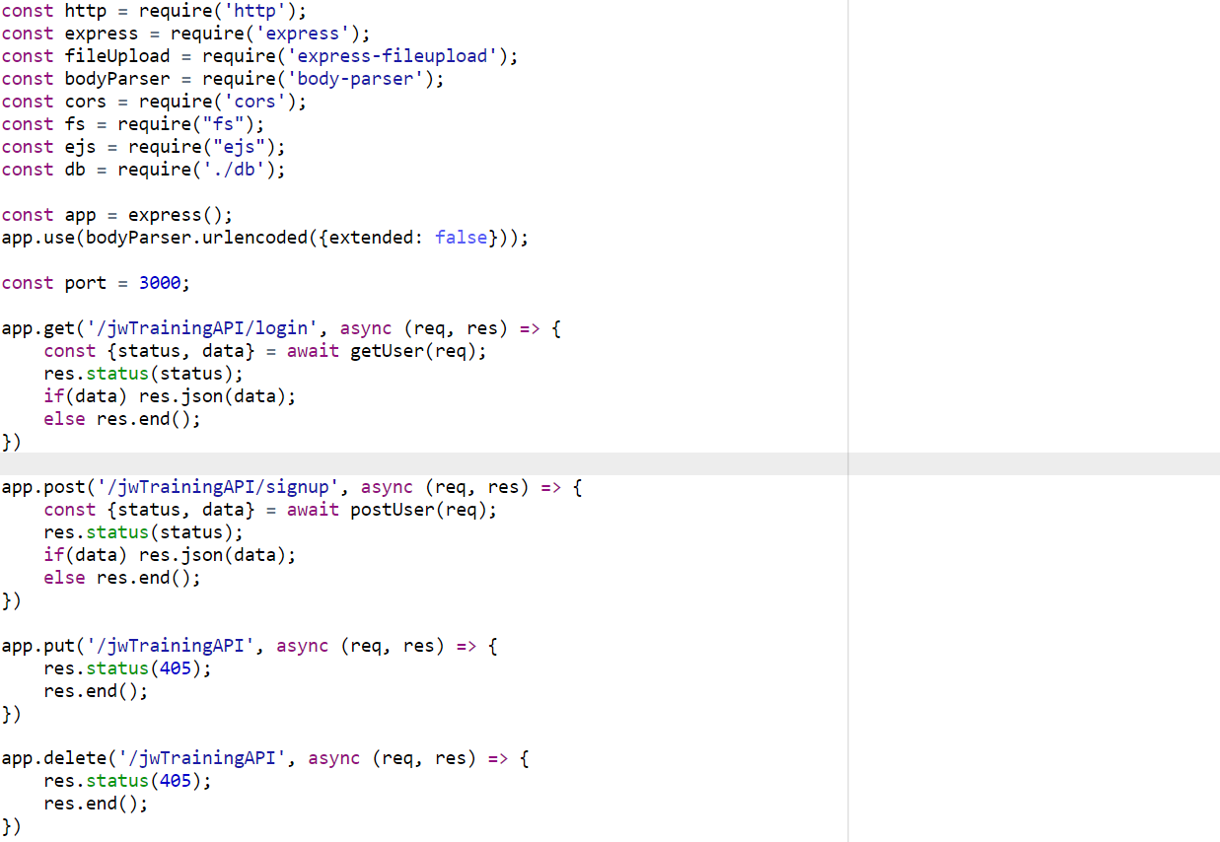

*Figure 74: Node.js Express API handling GET, POST, PUT and DELETE requests*

The “getUser” function uses regular expressions and parameter validation to ensure that the request is valid and prevent injection. The query function from the database JavaScript file I made is then used to return all users that match with the input username and password. If the user exists then their information will be returned to prove that the function worked. The status to be set by the initial request handling code is sent back along with the Json data to be set as the response.  
  
The “postUser” function acts in the exact same way except for more regular expressions for the validations of emails, a query to insert an entry into the users table rather than to get them and to check affected rows in the database as opposed to whether or not any results exist. Both these functions were tested through both the Postman application and the login and signup forms that were adapted to send the requests to the API via the Fetch API with the data found in the related form. Examples of all testing can be found in screenshots below. To show a post message was successful I've output the auto incremented ID of that new user.

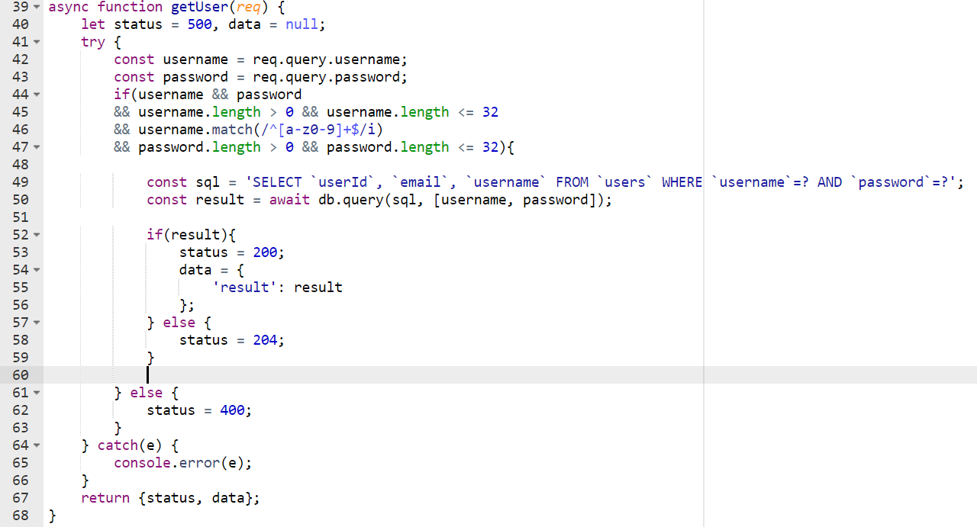

*Figure 75: Node.js Express API handling GET login request by querying the database for the user*

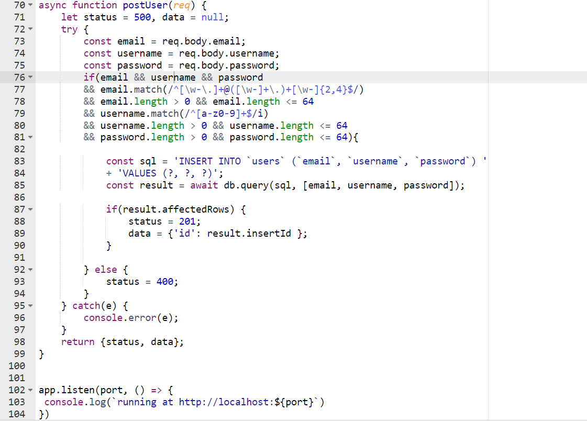

*Figure 76: Node.js Express API handling POST signup request by adding a new user to the database with regular expressions for security*

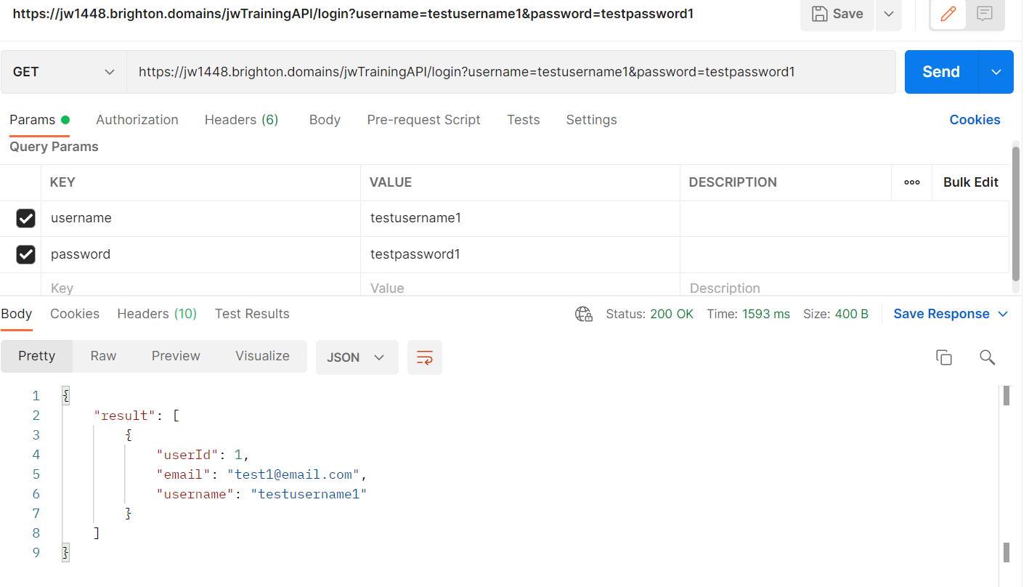

*Figure 77: Postman sending valid GET login request and response*

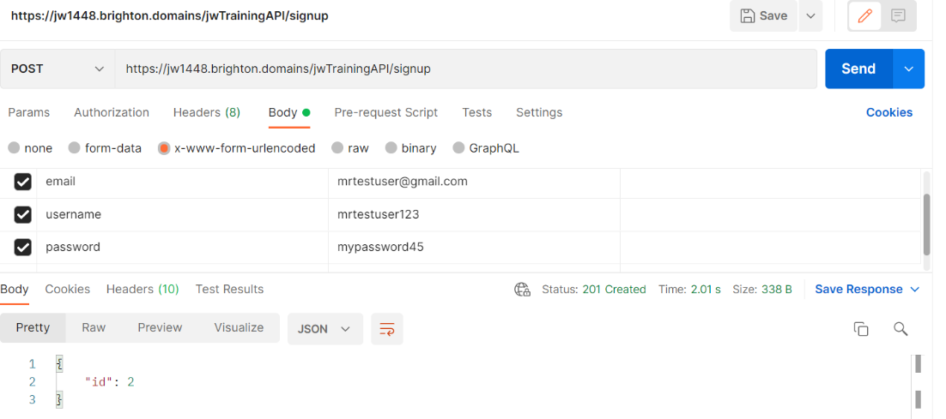

*Figure 78: Postman sending valid POST request and response*

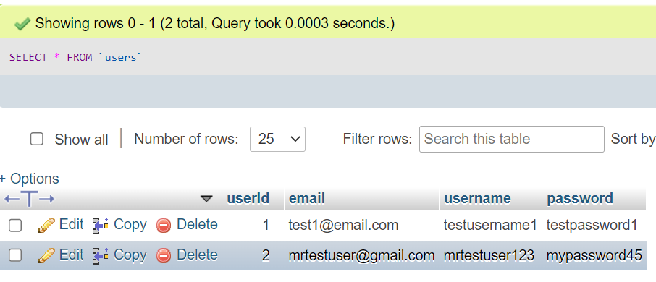

*Figure 79: Result of signup request in database users table*

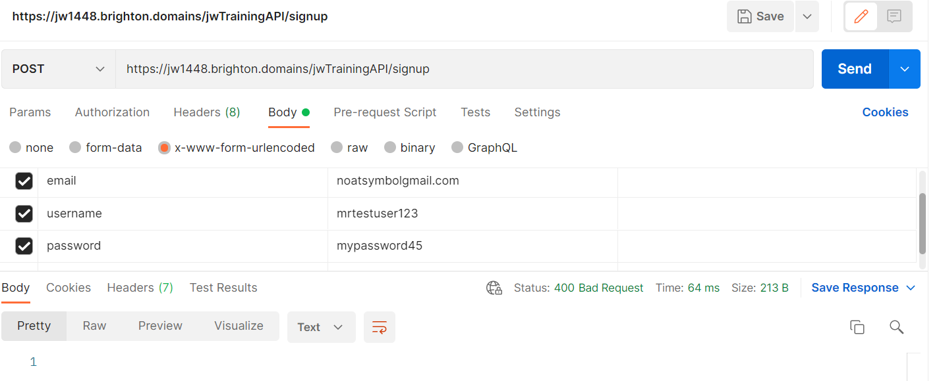

*Figure 80: Postman sending invalid POST request and response*

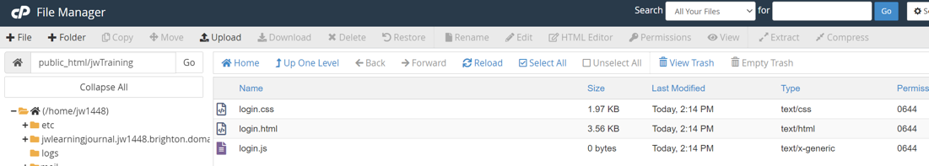

*Figure 81: structure of client-side login system in file manager*

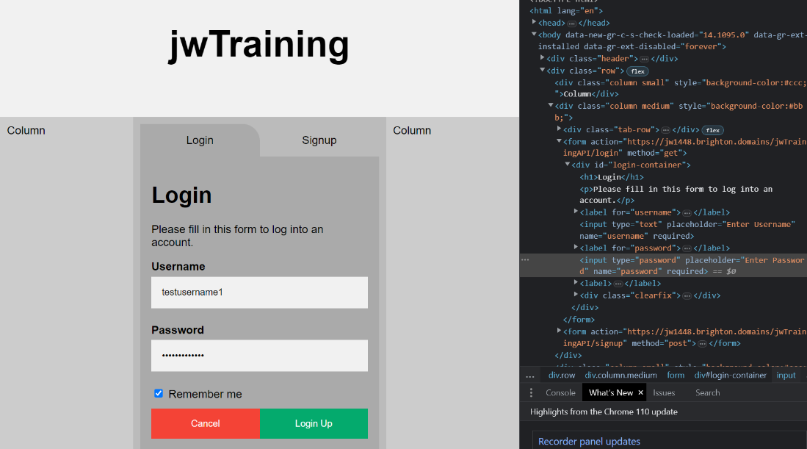

*Figure 82: login page sending valid GET request via form*

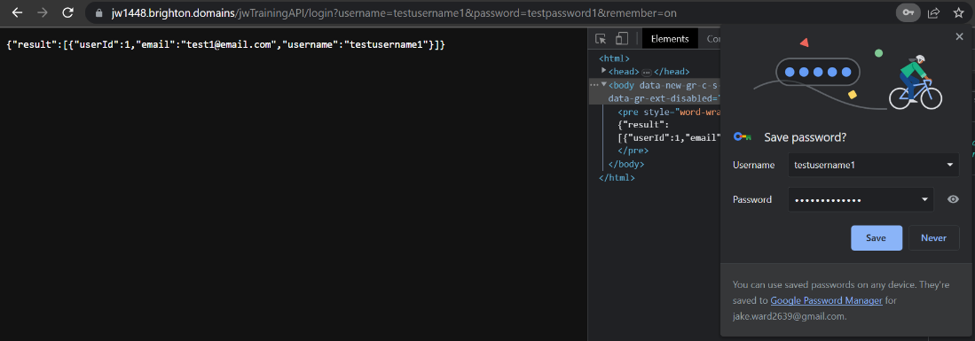

*Figure 83: login page sending valid GET request via form response after submission*

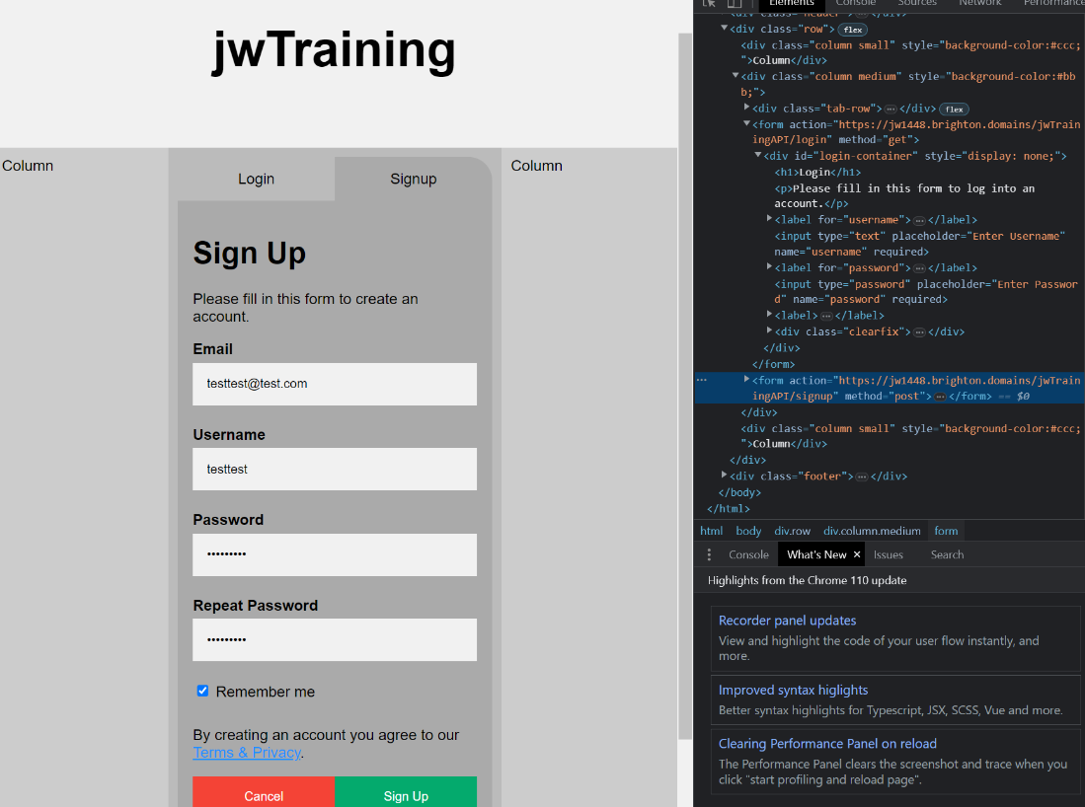

*Figure 84: signup page sending valid POST request via form*

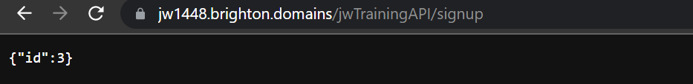

*Figure 85: signup page sending valid POST request via form response after submission*

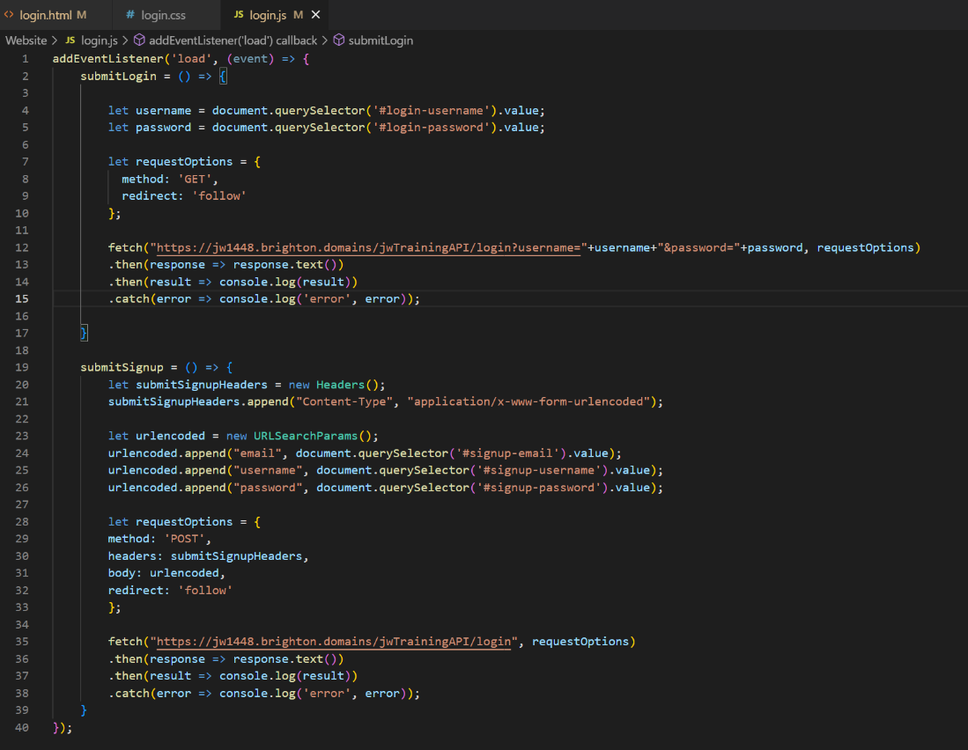

*Figure 86: login page JavaScript created to handle the submissions of forms*

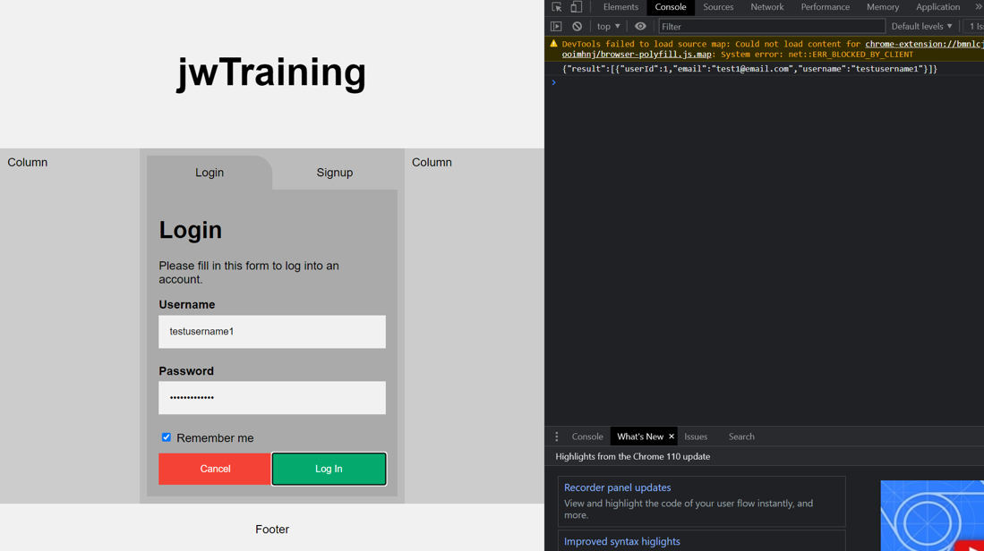

*Figure 87: login submission results in console*

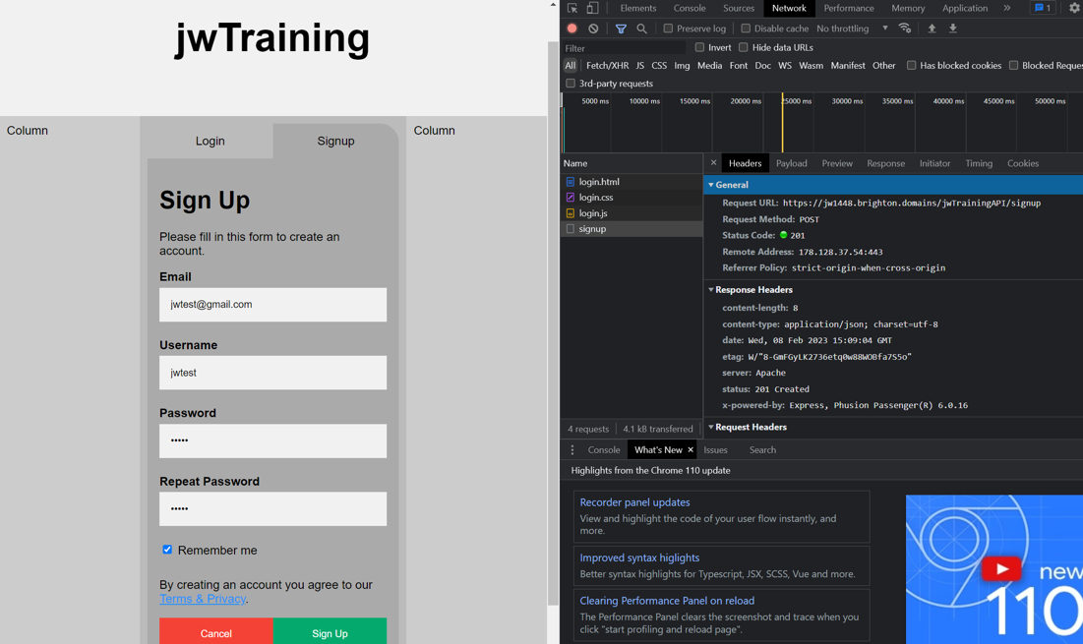

*Figure 88: signup submission results in developer tools*

There was a small logic error on my part which I noticed through personal testing and had to fix. I was only checking is the results from the query of the login function existed to see is I should send the status of 204 or 200. However, the way mysql2 works is that the query results count as existing even if it is an empty array. So, the code was adapted to check the length of the results to ensure that if a valid username and password wasn’t present in the database then an appropriate status of 204 would be returned.

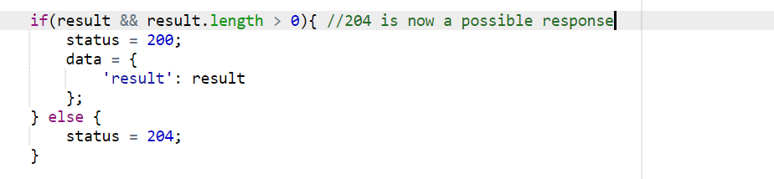

*Figure 89: edit to API to allow status code 204 response if no user is found*

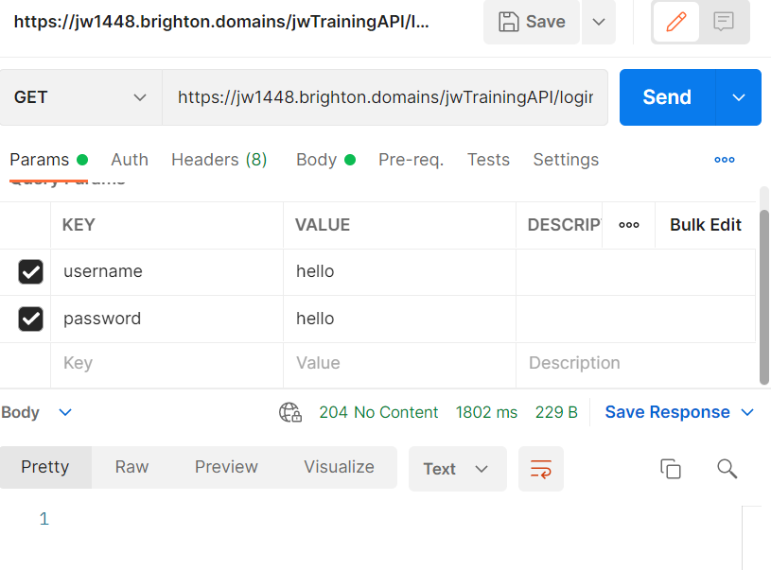

*Figure 90: Postman displaying results of valid but non-existent user*

### 09/02/23

Shortly after the previous addition I decided to handle the responses from the database properly. I thought thoroughly about to safest way to log users in and stay logged in until I analysed how a few other applications do it. I realised that by saving the username and password as cookies on the users browser then every page could secretly attempt to log them in ensuring that no one could falsely access the site. By doing this no one could fake a login by creating their own cookies as they would be logged in on every page and if the results were anything but valid then they would be redirected back to the login page. While cookies would normally have these in an encrypted format this would not be necessary for the site as it would never be holding or displaying any sensitive information for hackers to get at. However, I acknowledge that a future addition would be the encryption and decryption of these cookies to further enhance security. In addition to this, it’s often only very insecure if the cookies don’t have a removal date as they can be accessed at any time, so by using one it further increases security. The same login request could always be used for this enhancing efficiency, and the site would be used in a work environment anyway, making the chance of an attacker accessing sensitive information even less. So with this method of security decided upon to kept unauthorised access at bay, I changed the JavaScript of the login and signup so that upon a successful response then the cookies would be set for one day exactly. I tested to see if it would work and found that the cookies were successfully saved in the browser. By setting the cookies on the domain they would also be accessible by any page on the site including the dynamic pages that would be rendered and displayed by the API at a different root.

Overall, by using this method of security, no unauthorised access could be gained and even if a users credentials were taken (which would be difficult to do in the first place) then all they would have access to would be training videos. So in the worst case scenario there is minimal risk. While security was never the focus of the project this would maintain an efficient solution that could be enhanced at a later date through encryption.

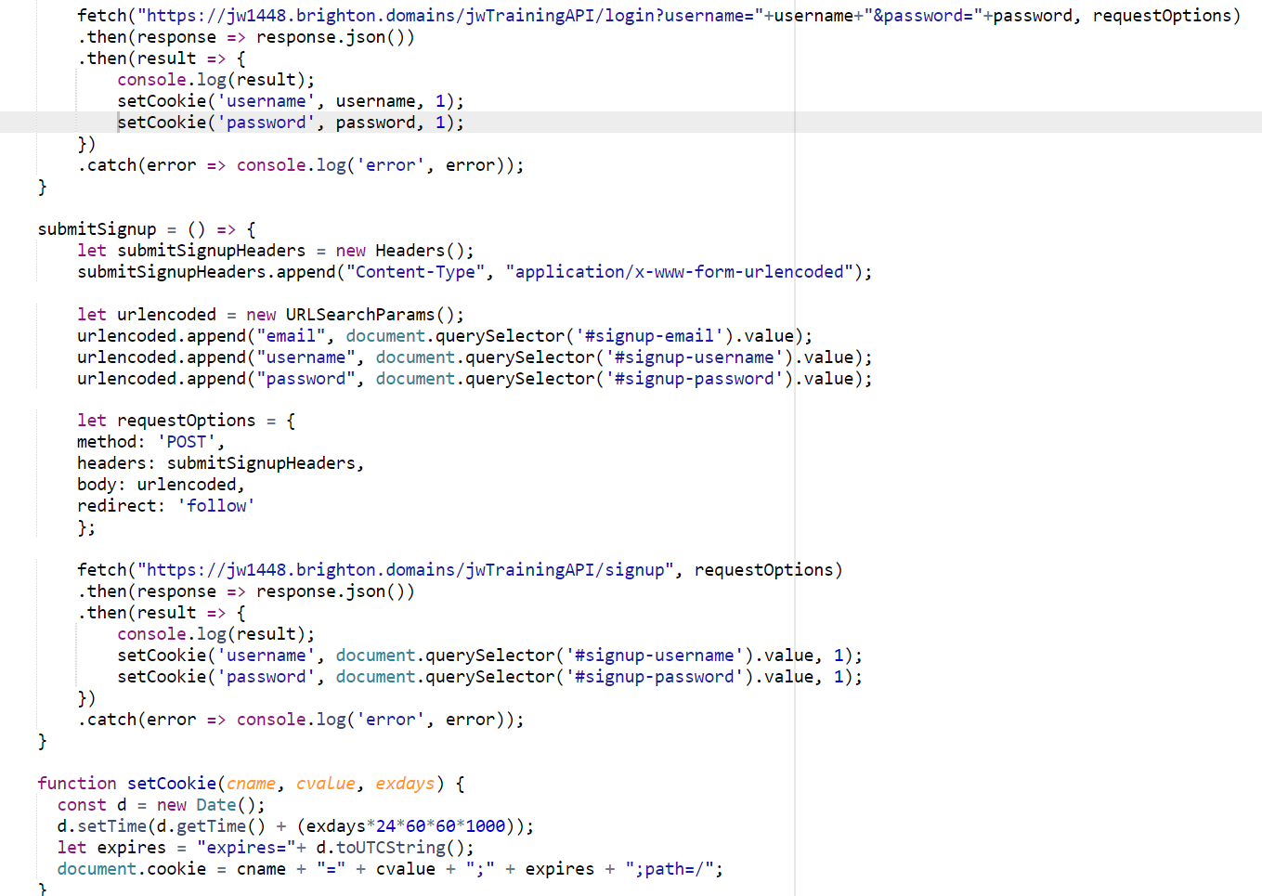

*Figure 91: setting cookies upon fetch response*

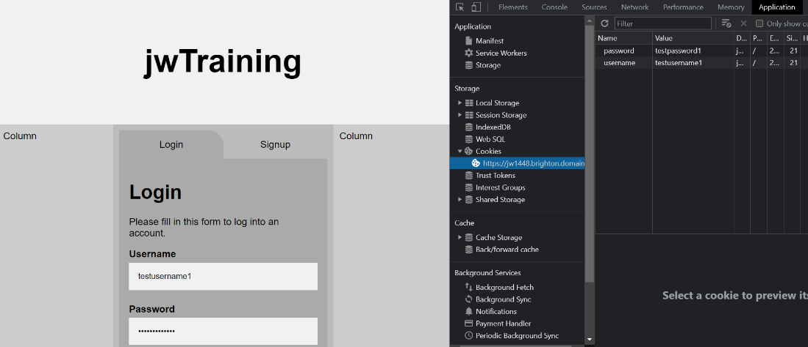

*Figure 92: set cookies displayed in browser*

### 10/02/23

As part of setting up the signup/login system, I decided to also create the homepage/dashboard to have a location to redirect to and to demonstrate how I would be handling the login cookies on the other pages. In this case, I used my flexbox design again but with the use of cards separated into two columns that would merge upon conversion to mobile view. I also placed a smaller card specifically for a username so in the header of the page to display who was currently logged in and to later house the logout functionality. A navbar was also created that with JavaScript and CSS would swap between a mobile-friendly design and a desktop-oriented design. It was made up of three files to house the different languages supporting the page and made use of font-awesome to create the menu bars and other icons by referencing it as a stylesheet. The cards were put on the page as placeholders with no functionality or meaning yet but more so because they would be a reoccurring design amongst all pages. This design would be shared with all pages and so the index CSS file would need to be referenced in all of the and the CSS would need to mostly generalise using classes as opposed to specifying with ids. The CSS was designed in a way where the columns in the middle section could easily be increased of decreased without error. The reason the CSS for login wouldn’t be shared with the others was to give a visual indication that the user is logged in or out. The homepage was named index so that the URL would default to the page. If the login page was the default page then it would be an inconvenience to those who where already logged in. By having the homepage serve as the index meant that if the user wasn’t logged in then they could be redirected to the login page.

It should be stated that the design adopted for the homepage is akin to a dark mode so as to be more accessible. This negates the immediate need for a dark and light mode feature. It was also a safe move as I am colourblind and so cannot wholeheartedly make decisions regarding colour schemes.

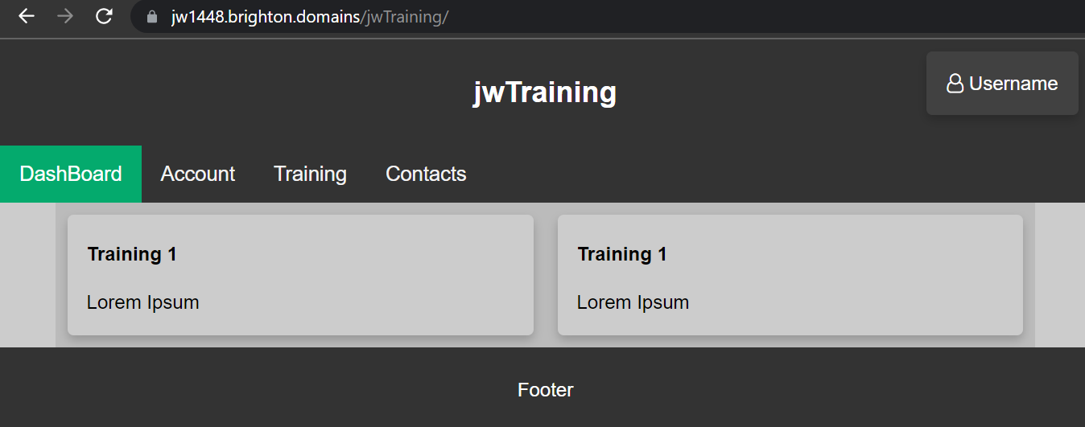

*Figure 93: basic index/homepage UI desktop view*

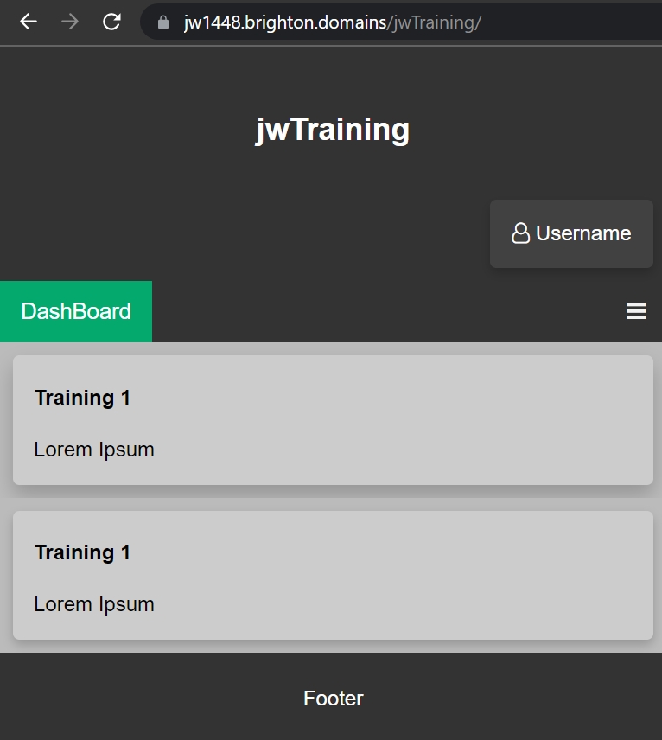

*Figure 94: basic index/homepage UI mobile view*

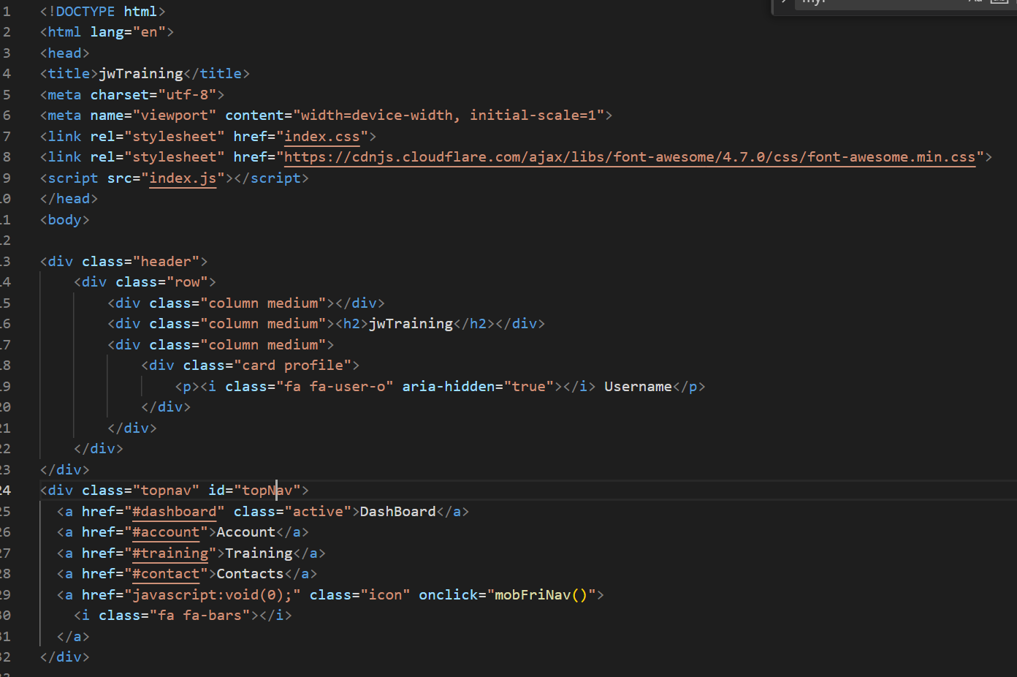

*Figure 95: basic index/homepage UI HTML part 1*

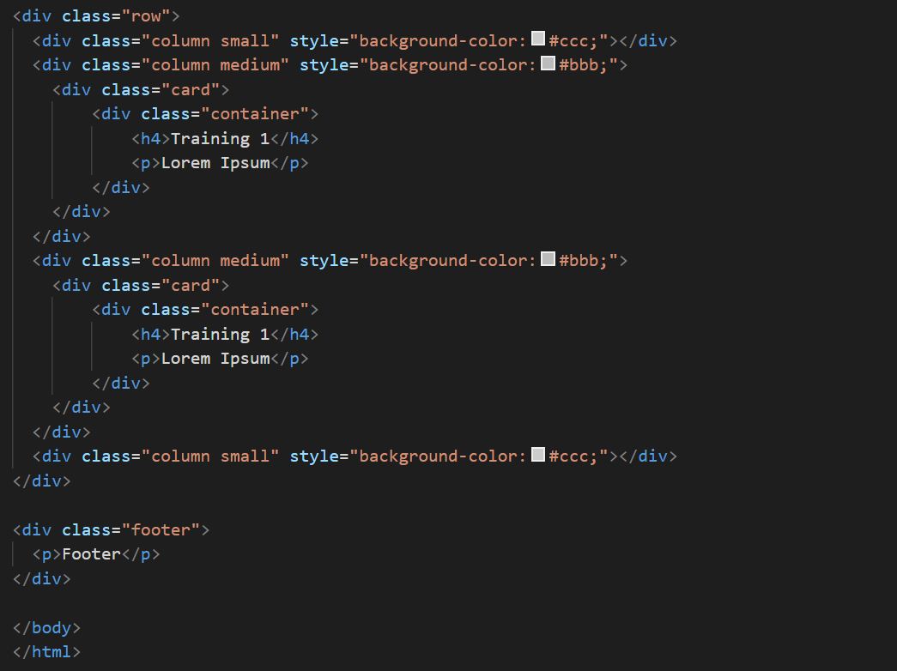

*Figure 96: basic index/homepage UI HTML part 2*

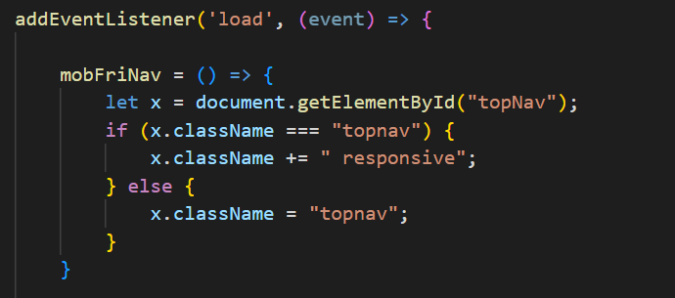

*Figure 97: basic index/homepage JavaScript (Navigation Bar)*

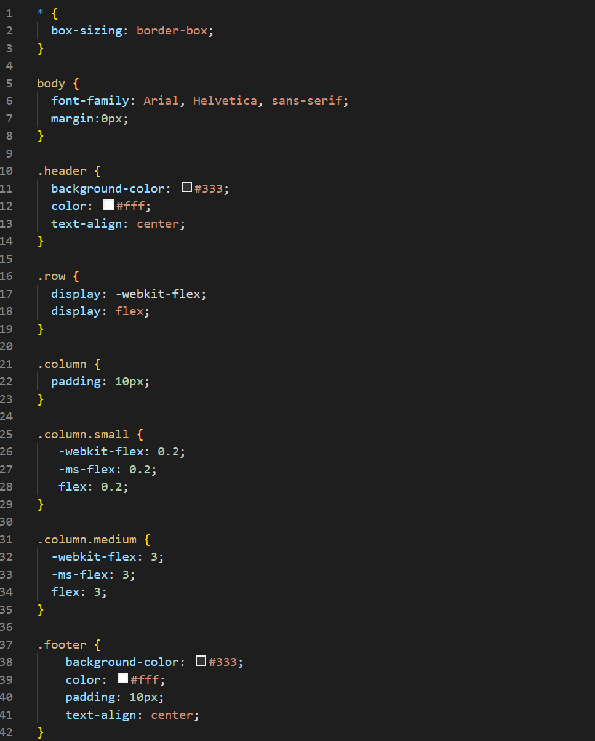

*Figure 98: basic index CSS for all generic pages part 1 (basic layout)*

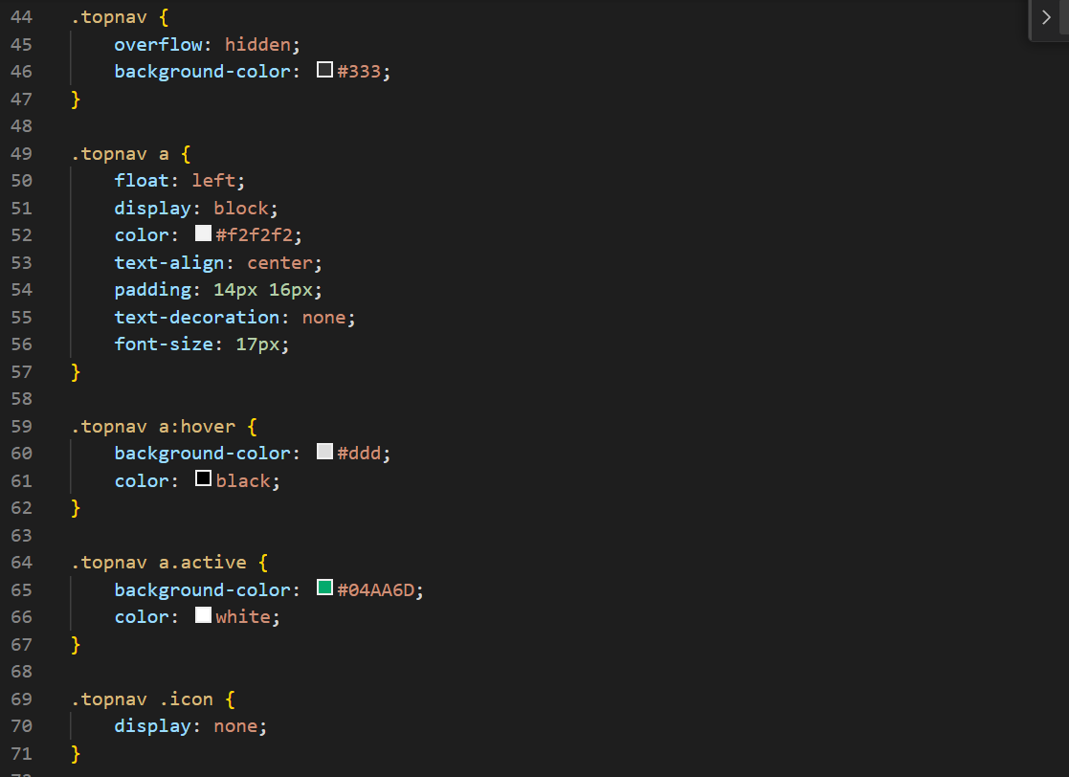

*Figure 99: basic index CSS for all generic pages part 2 (navigation bar)*

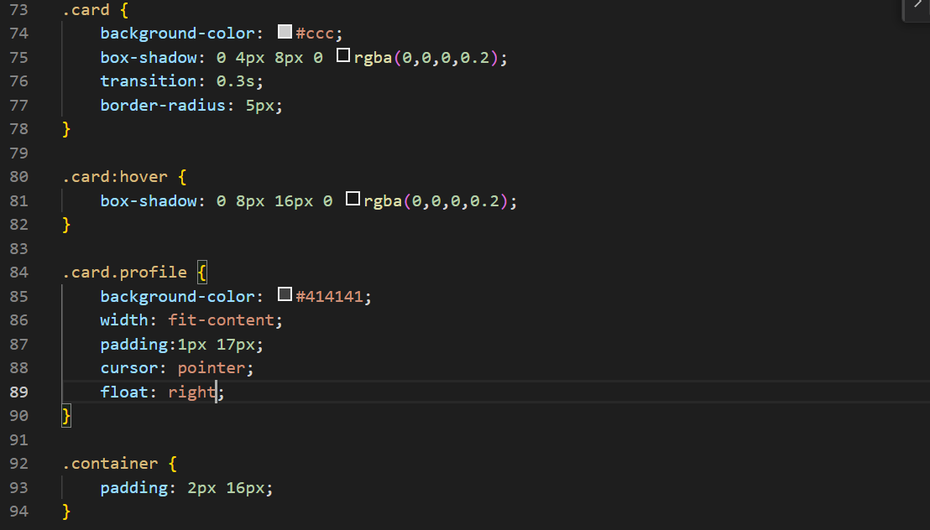

*Figure 100: basic index CSS for all generic pages part 3 (display cards)*

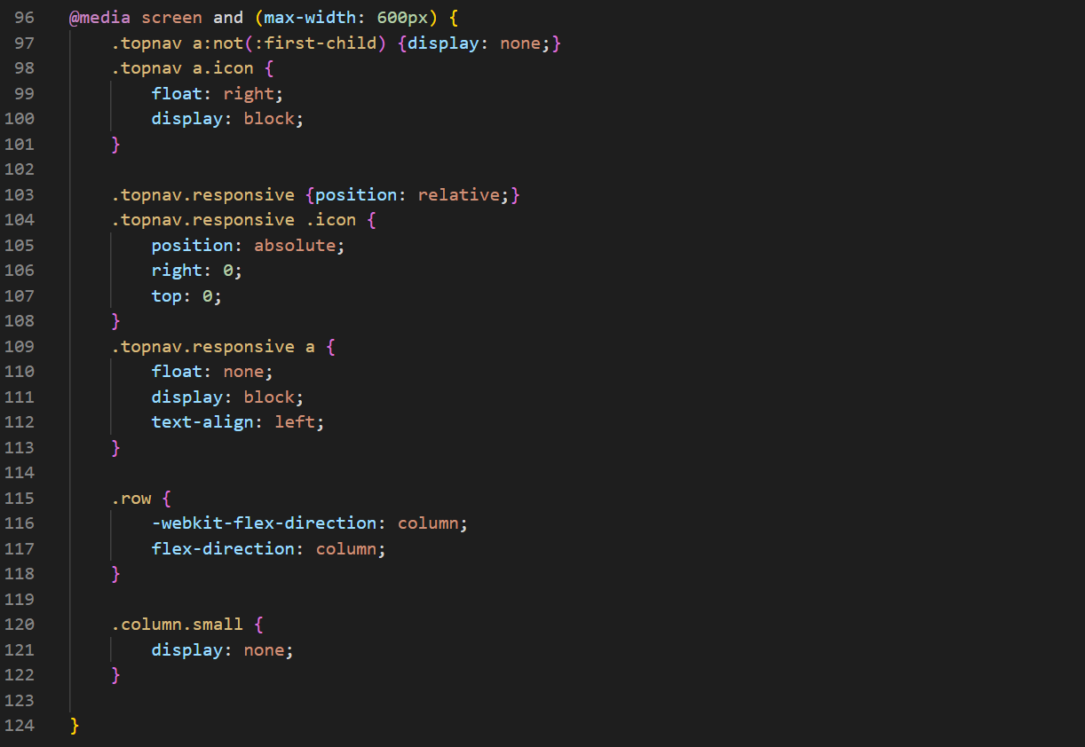

*Figure 101: basic index CSS for all generic pages part 4 (mobile view)*

To ensure that the other pages could access the cookies I added the respective cookie-handling functions to the JavaScript and tested them from the console. After I knew that they functioned I added code that would check if the username cookie existed, and if so then replace the word Username in the profile card, with the contents of the cookie which would be the actual username. This profile card would later display the two profile options in a dropdown menu, the link to the profile's information and a logout button. However, the profile page was to be a low-priority feature as there was not much information gathered from the users to display to begin with and asking for more information than necessary would be increasing security risk for no reason. I decided to keep the profile link under this card as a placeholder for the feature in the future should I have extra time in my schedule to implement it.

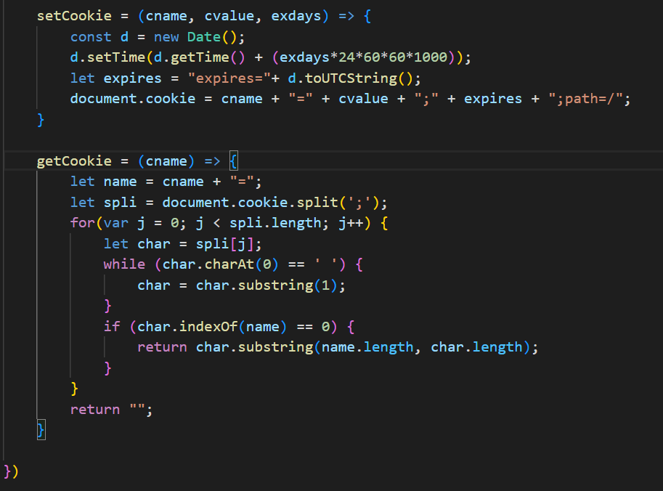

*Figure 102: basic index/homepage JavaScript (Cookie Handling)*

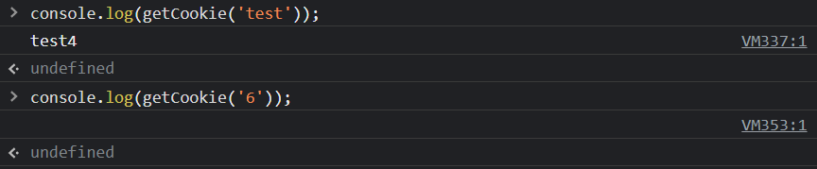

*Figure 103: testing cookie handling in browser console*



*Figure 104: setting users name in profile card (JavaScript)*

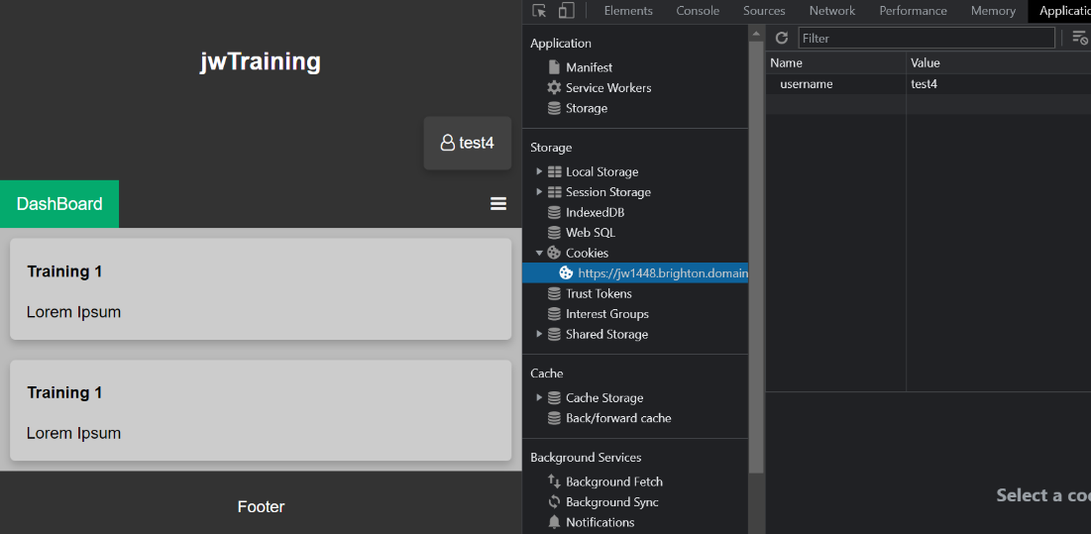

*Figure 105: setting users name in profile card (results)*

### 13/02/23

The next thing I implemented to ensure a functioning login system was implementing error reporting by having the API specify necessary details about the error so that the client could report it to the user. I did this by having the status still be set to an error connoting status code but returning JSON alongside it with an error message contained within. This also meant adding separate queries beforehand to check if the email or username already existed and returning the appropriate message if so. This restriction would only need to be implemented in the signup function because a user cannot exist without first being signed up by nature of the design. A password can be repeated in the users table but the same shouldn’t be the case for usernames and passwords as users need uniquely identifying features. While this restriction is enforced on the database side, the check needs to be made on the API to return the correct error message, as otherwise the database simply not execute the query and the reason will be unknown.

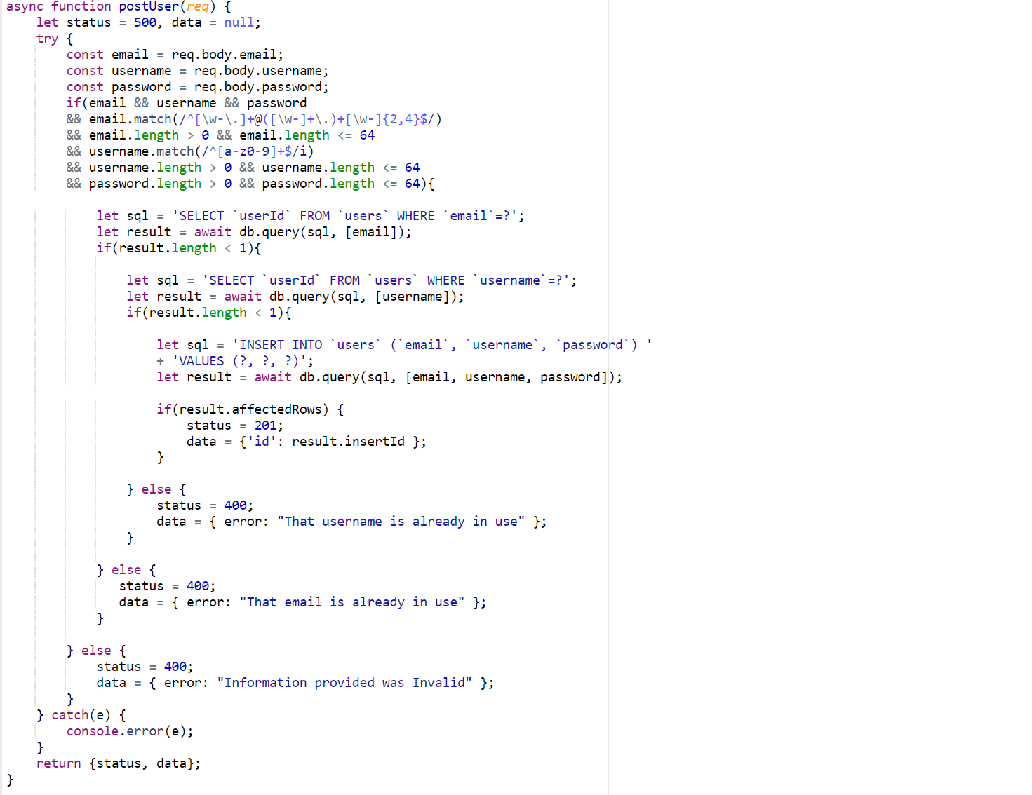

*Figure 106: API with specific error messages returned on signup*

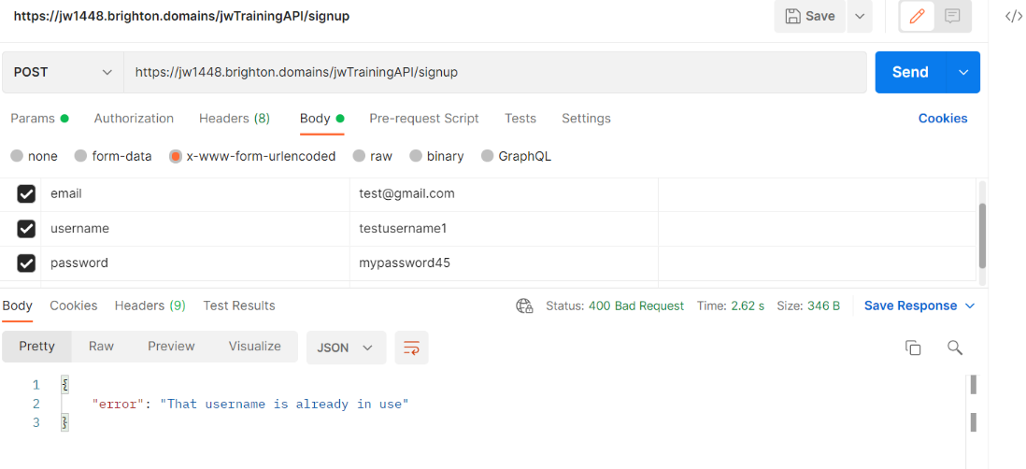

*Figure 107: API response to signup with existing username*

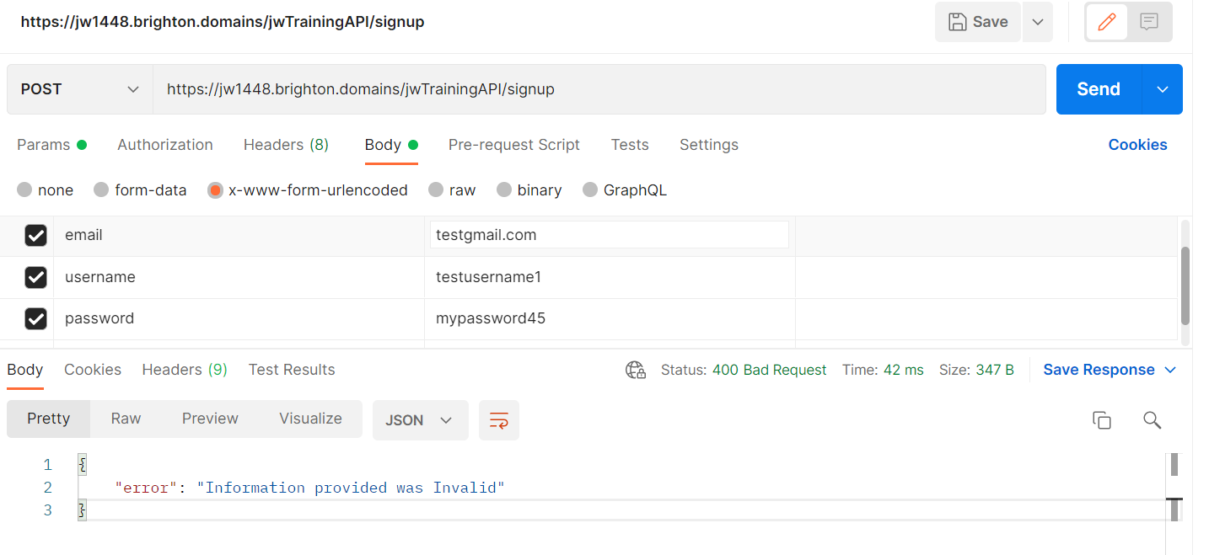

*Figure 108: API response to signup invalid email*

With the error messages successfully being sent from the server the only task left to do was to handle it on the client. The code previously only handled requests without regard for if it were successful or not. I changed the code in the JavaScript code for the signup fetch requests to that it differentiated between a successful request (which would execute the code id already written) and an unsuccessful request (which would log the error message received from the API)

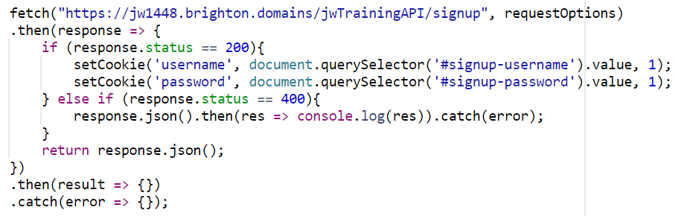

*Figure 109: signup fetch request receiving and displaying error message in console (code)*

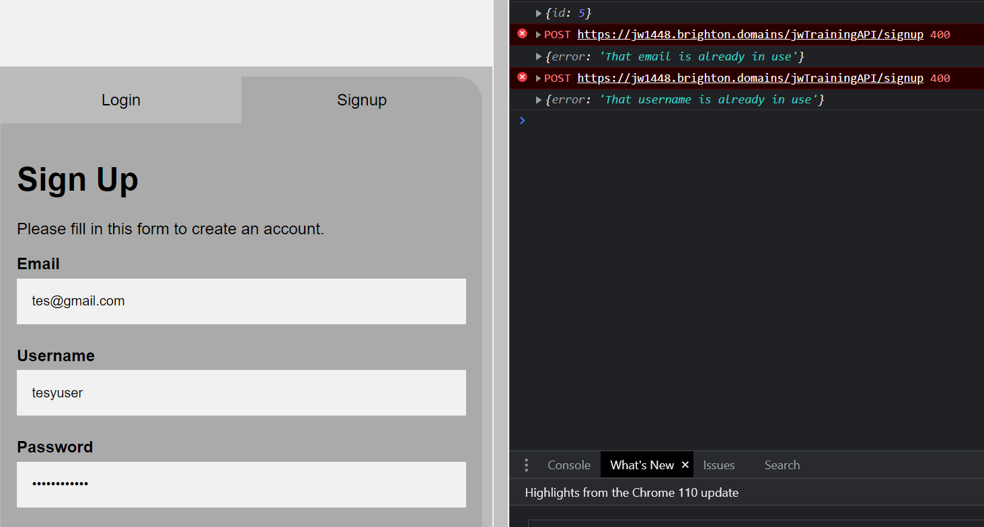

*Figure 110: signup fetch request receiving and displaying error message in console (console)*

A similar message would be displayed on a status 204 for the login request as it would mean that user doesn’t exist. These messages couldn’t be any more detailed or else potential attackers could more easily learn logins via trial and error. Again this message was only temporarily logged to the console until I had a message-displaying method in place.

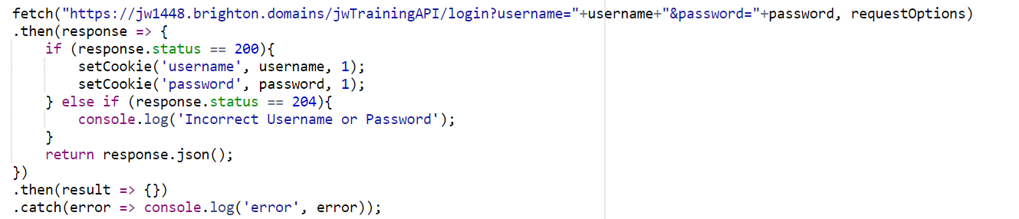

*Figure 111: login fetch request receiving 204 status and displaying error message in console (code)*

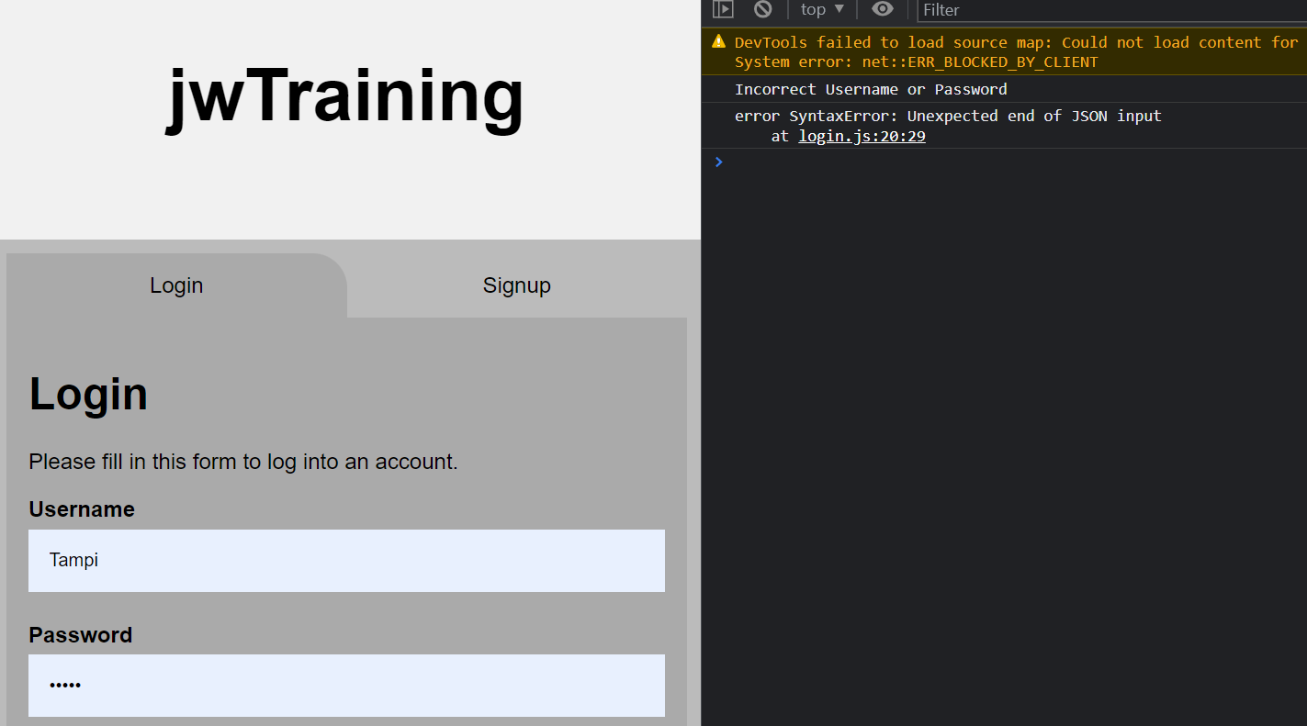

*Figure 112: login fetch request receiving 204 status and displaying error message in console (console)*

Next, I decided to put the system in place to actually display the errors in a user-friendly manner. From this point onward I would be screenshotting code for evidence in VScode to display what edits had been made to the code via the different coloured lines in the left hand margin. A login alert section was added to the page that would have CSS assigned to it to make it fit the conventions of an error message. It was designed to be closed with an X button in the top corner and would only be displayed when the JavaScript set its display to block and assigned its text content. There were two of these error message containers both with either the login or signup containers so that if a user switched between the two forms then only the relevant error message would remain displayed.

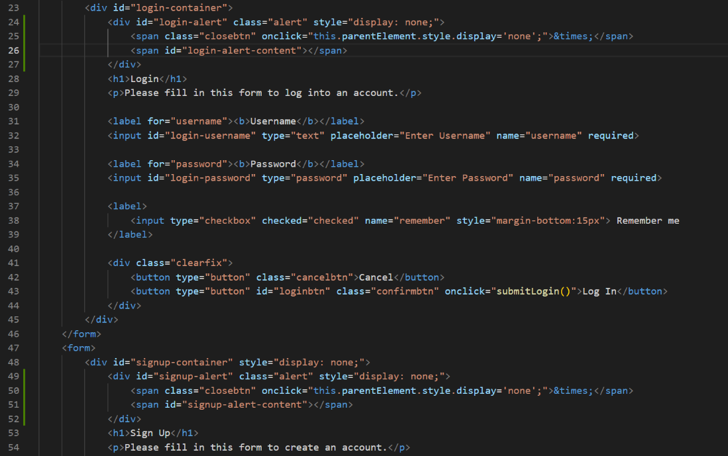

*Figure 113: creating error alert containers for login and signup forms*



*Figure 114: CSS for error alerts*

I assigned the JavaScript fetch requests with their code to set the text contents and displays of their respective error containers. The same error messages that were being logged to the console were now being presented in a conventional way that users could immediately understand. These were all tested in every scenario before I moved onto the next task.

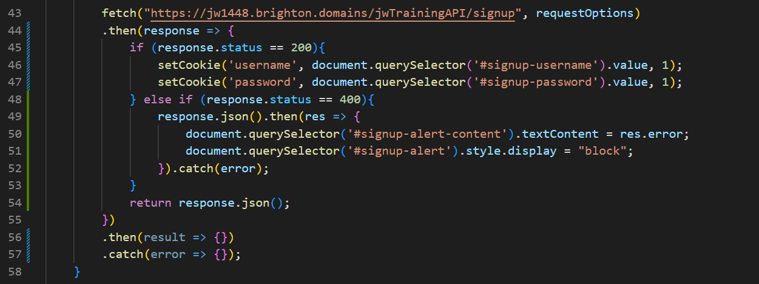

*Figure 115: signup Fetch request handling updating and displaying error message (code)*

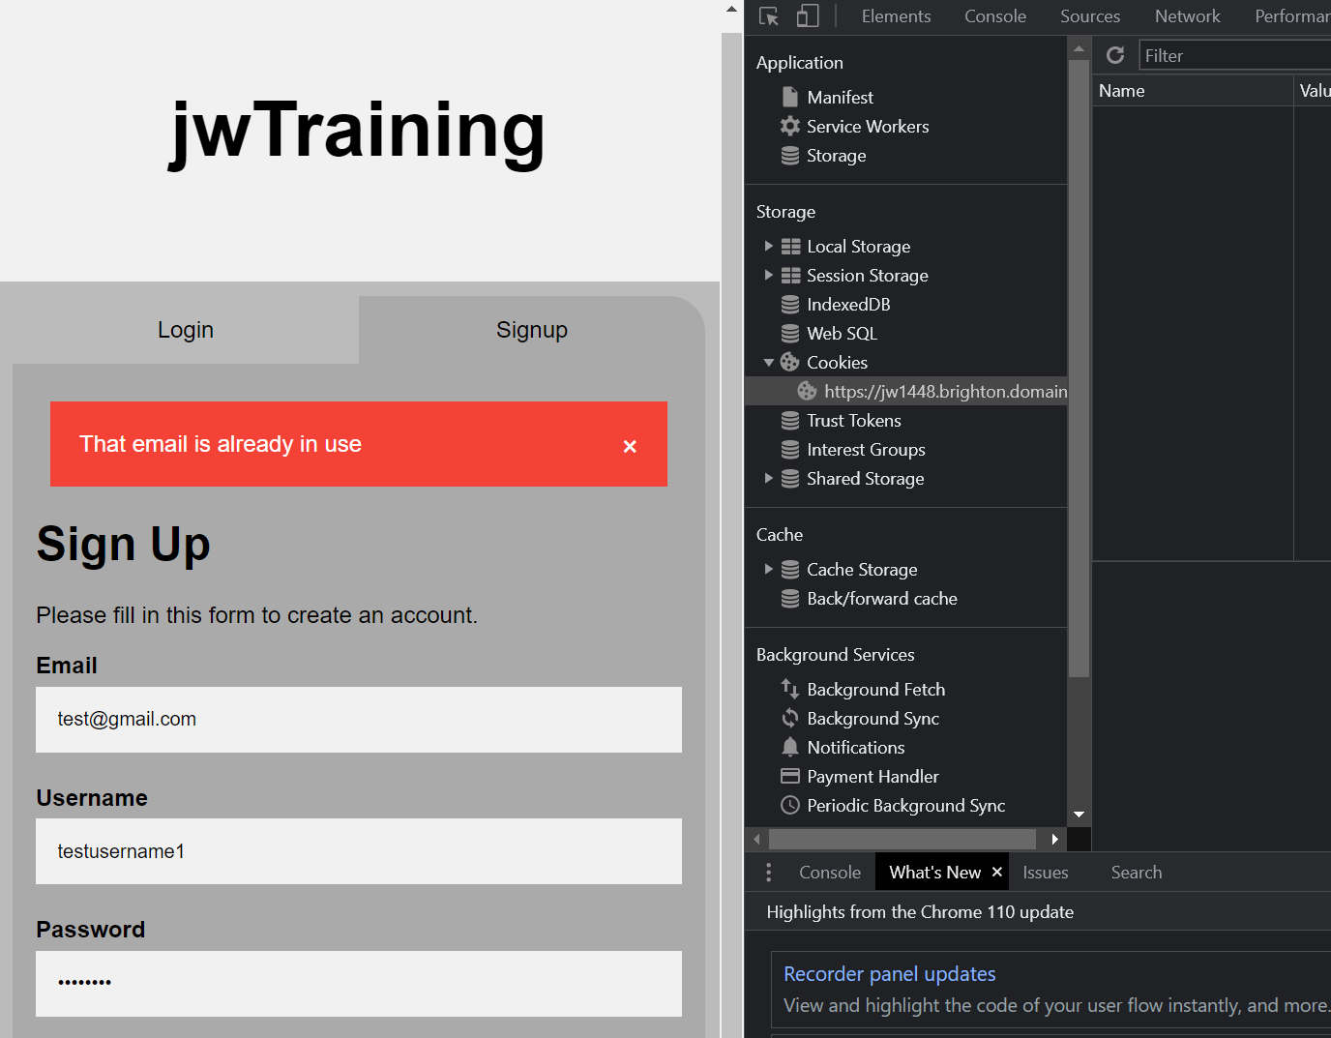

*Figure 116: signup Fetch request handling updating and displaying error message (UI)*

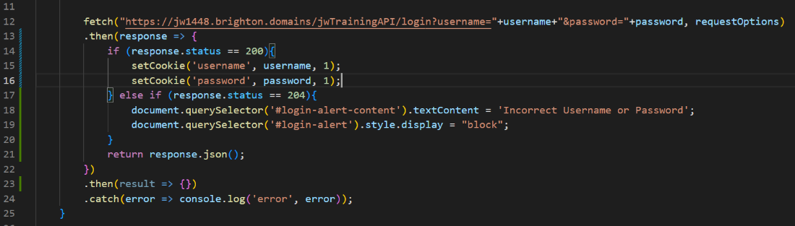

*Figure 117: login Fetch request handling updating and displaying error message (code)*

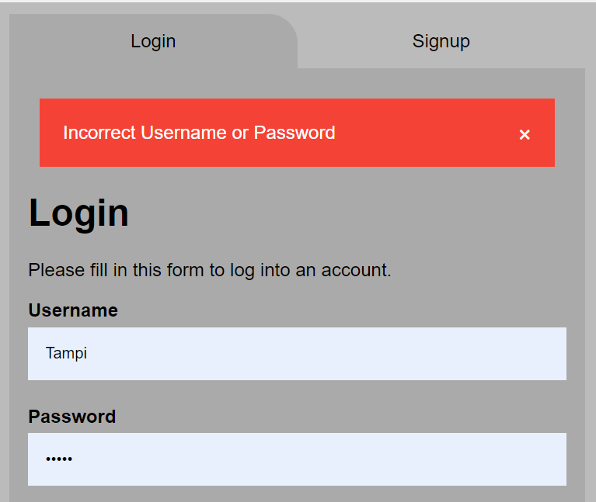

*Figure 118: login Fetch request handling updating and displaying error message (UI)*

Redirects were then next task to be done. I implemented it so that if a user had successfully signed in then they would be brought to the homepage. This was a very simple addition and I decided that the reverse was also a good feature. By adding a redirect to the JavaScript that would be inherited by every page other than the login, no user could access the site without the valid login cookies being in place. Instead of being redirected to the page the URL would replace the current one. This was so the login page couldn’t be returned to easily while logged in, as it wouldn’t appear in the history and would no longer be of any use to the user until they logged out or the cookies were removed. By redirecting from the login page by entering a username and password Chrome and other browsers detect a conventional login and offer to save the login information.

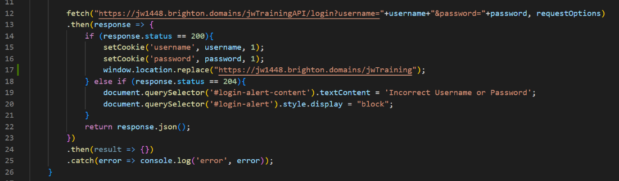

*Figure 119: code redirecting to dashboard on successful login*

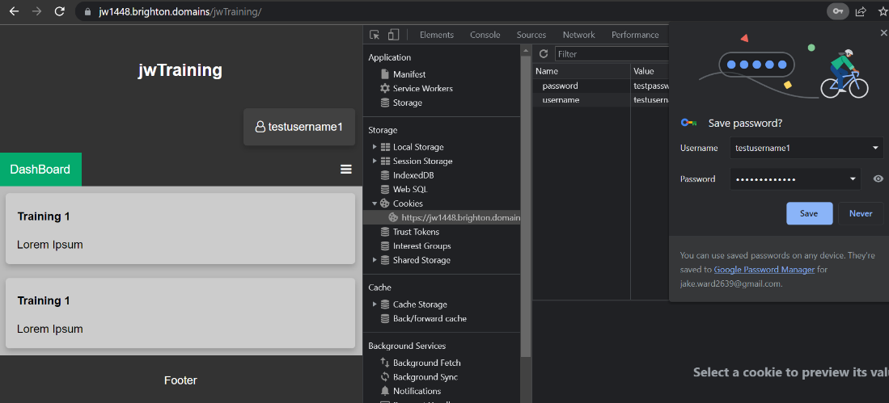

*Figure 120: result of successful login request with redirect*

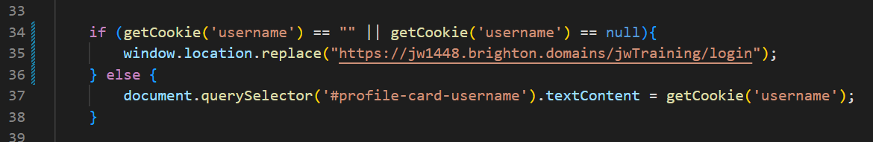

*Figure 121: code checking if attempt to login with cookies fails and redirecting to login page if so*

The second to last feature I added this day was checking if the input password and the repeated password were the same and if not then not sending the request and displaying an error instead.

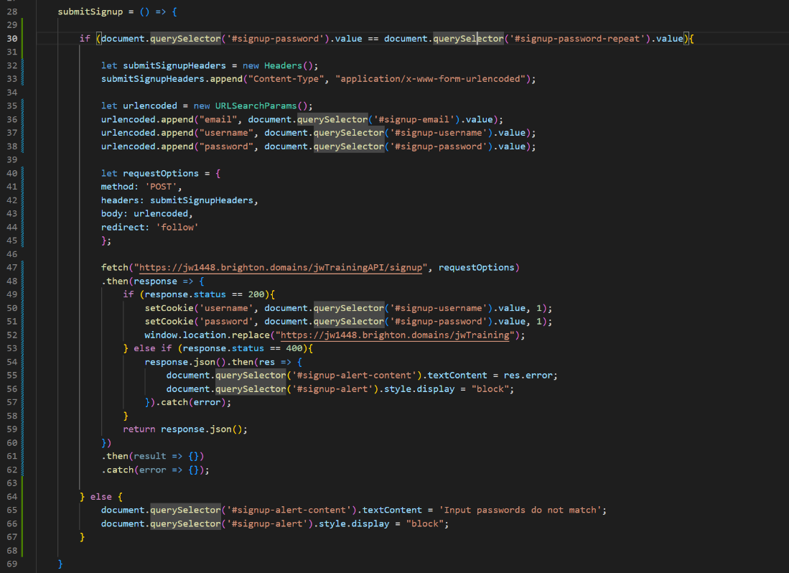

*Figure 122: signup JavaScript altered to ensure passwords match before submission and displaying error if not*

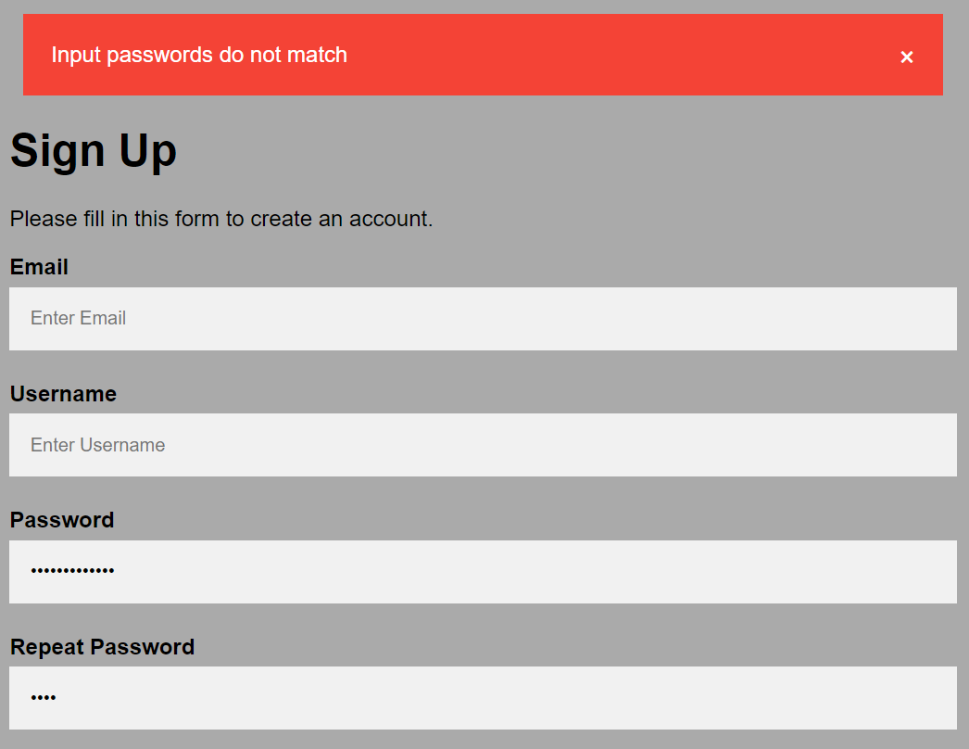

*Figure 123: error displayed after password don’t match on submit*

The last feature I added this day was an Icon for the website. I used photoshop to briefly design an icon that was simplistic and included a combination of J, W and T for “jwTraining”. I saved them as a PNG and ICO file, uploaded them to an assets folder and used the icon in the tab display of all pages.

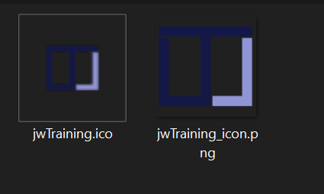

*Figure 124: both versions of the site's icon in an assets repository*

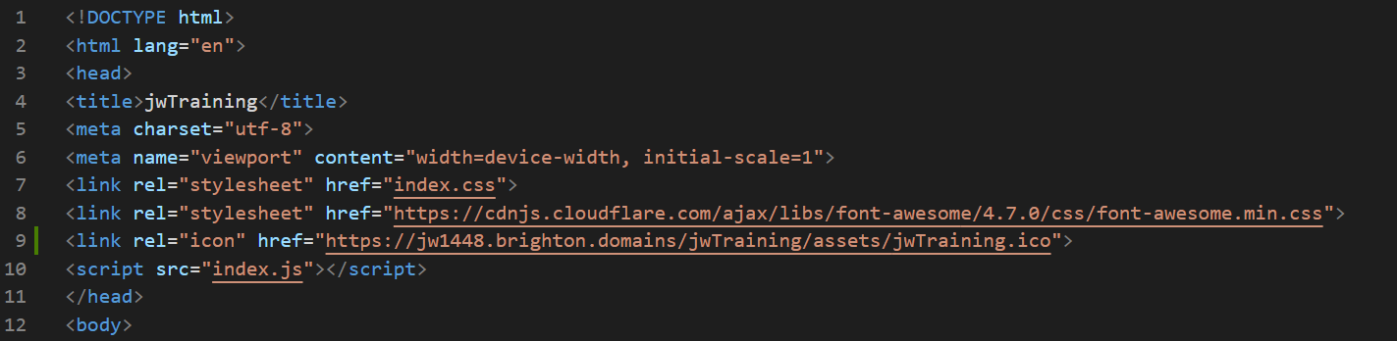

*Figure 125: referencing the icon in the head of all pages*

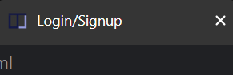

*Figure 126: Icon visible on all pages*

## Sprint 3: Dynamic Pages/Articles

### 14/02/23

Now that I had a fully functional login system I could focus on the point of the application which was to use dynamic pages to display educational content. I was going to use EJS to render these dynamic pages with training content but this meant I first needed to prove that EJS would work in my environment. After study of how the language worked, I created a new route on the API for rendering training articles and passed in a simple parameter before rendering a simple example. The experiment was successful and so the actual design was moved forward with.

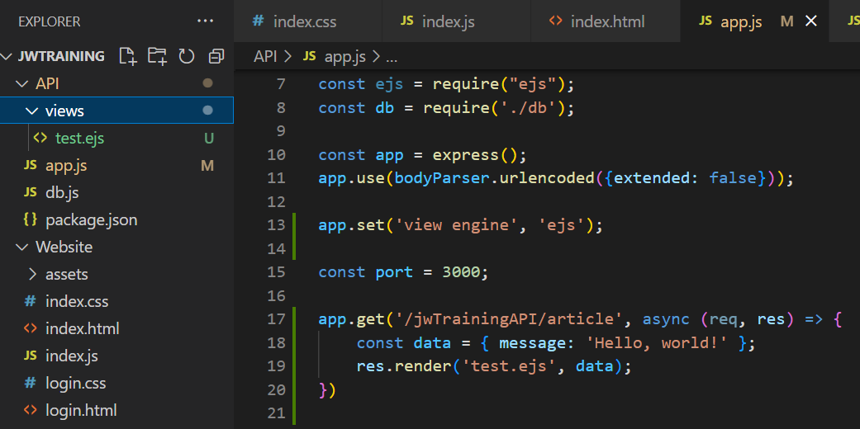

*Figure 127:*

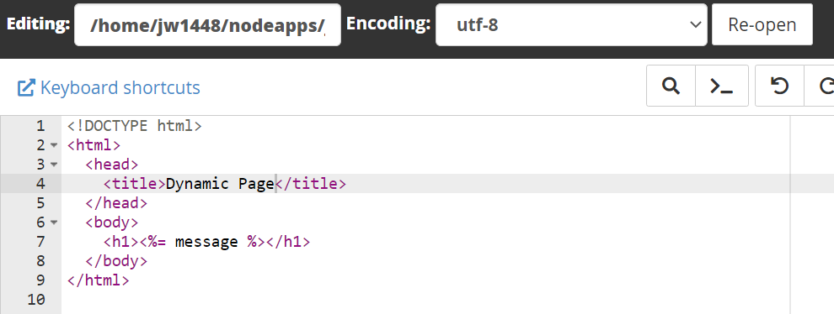

*Figure 128:*

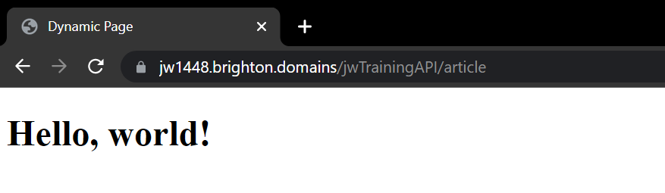

*Figure 129:*

I adapted the EJS file to reflect the standard of index page as it would be the same as all the pages to follow. By doing this there is a visual indication that you are on the same site. Knowing that this page would only have one large card I altered the design from the index page and used the message being passed in to confirm that the passing of parameters from the API would still work.

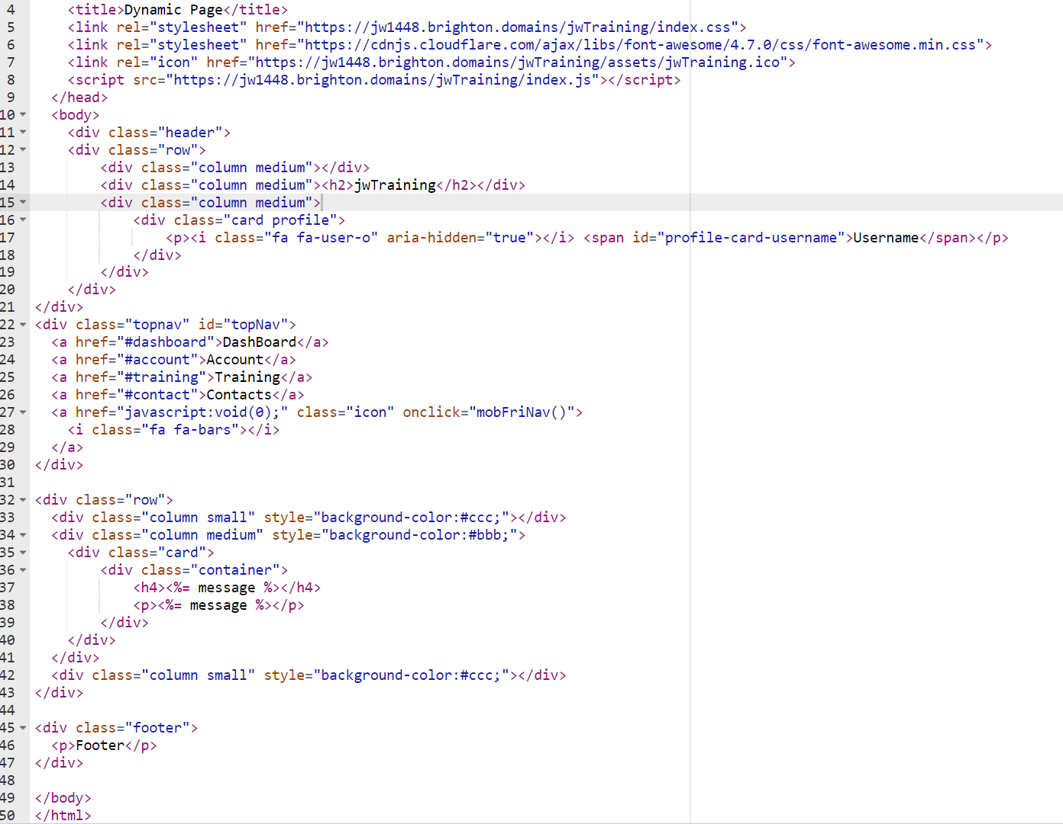

*Figure 130:*

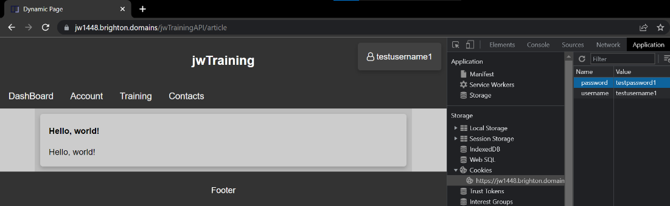

*Figure 131:*

I considered moving all pages to the API because of advantages such as less explicit URLs (no .html on the end of some pages URLs). However, I opted not to do this as it would require additional processing time (slowing the app as a whole) and would overcomplicate some simple processes. This would not be a good choice when the only visible advantage would be a more professional looking URL.

I created the MySQL table of articles to contain all the appropriate elements that would need to be dynamic for the training articles. The table was designed with an auto-incrementing ID. I then added to the API the code to retrieve all the information by the articles ID and then passed the results into the EJS template. I tested this out by displaying the title and main content in the EJS template and found that the entire process was successful. If the article ID didn’t exist then the user wouldn’t be redirected to any page and the status could be viewed in the networking tab as 204. If an ID was never given then the user wouldn’t be able to access the EJS template and so couldn’t cause anything error-some once the quiz function was implemented.

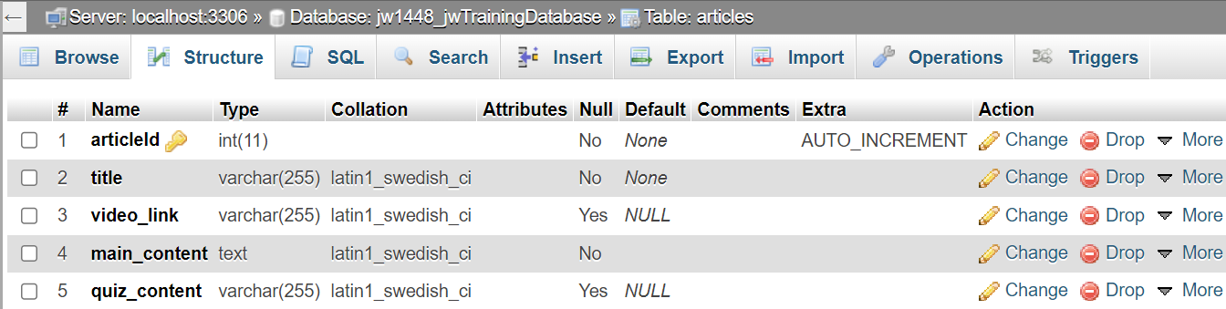

*Figure 132: details of the design of the articles table in phpMyAdmin*

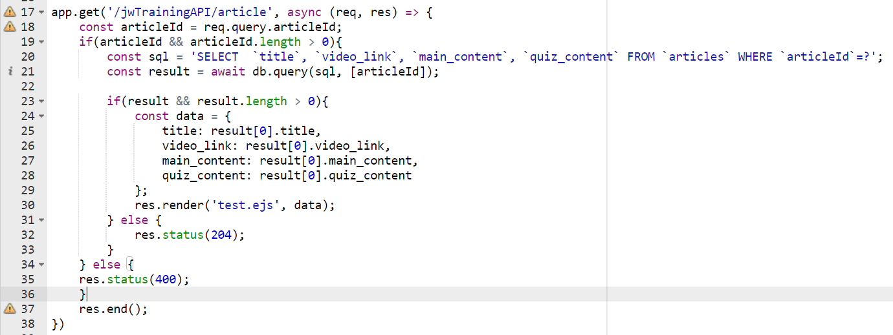

*Figure 133: querying the database and inserting the results into the EJS template before rendering*

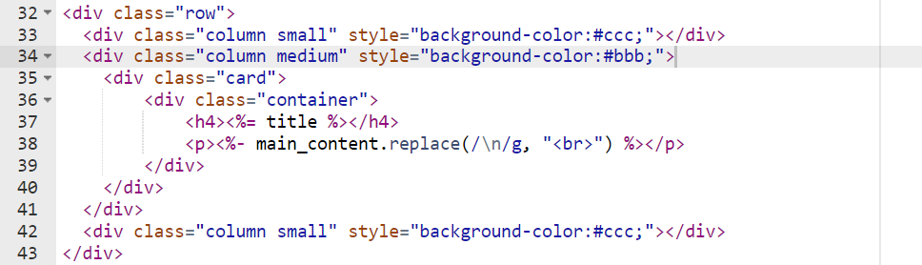

*Figure 134: EJS template displaying the input parameters from the articles database entry*

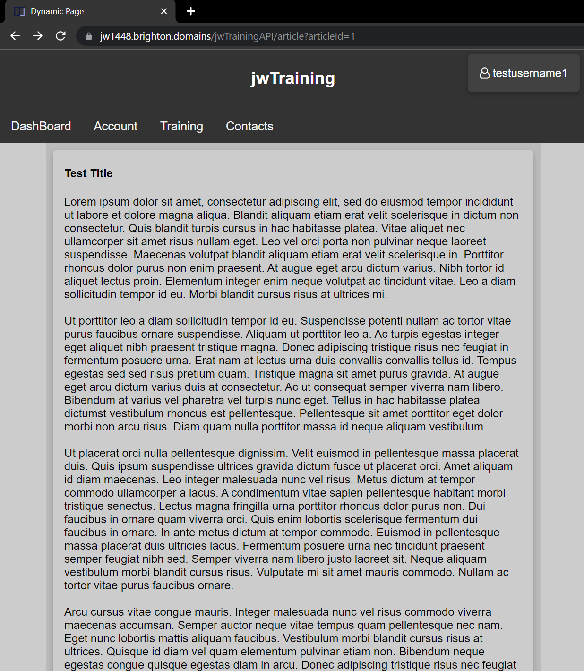

*Figure 135: functional dynamic page displaying training article content*

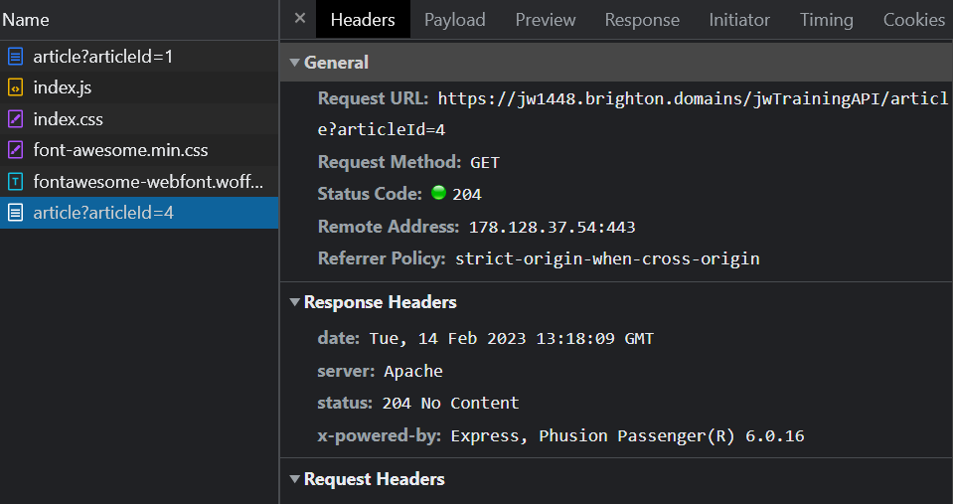

*Figure 136: result when article is navigated to, but input id doesn’t exist in the database*

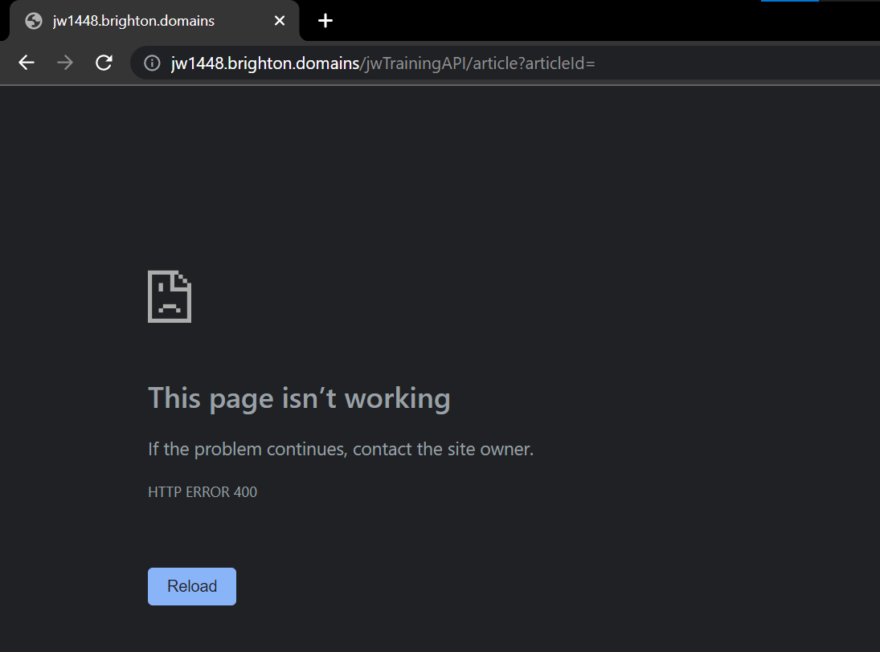

*Figure 137: result when article is navigated to, but input id isn't provided*

There was a brief issue where the new lines in the articles were not being implemented properly. This was because the new lines were signified by the string “\n”. the code would replace a new line in the text with the break tag and not the characters "\n". i adapted the sql backend to use newlines as opposed to the characters and everything started working perfectly. This is a great example of how different systems can have different formatting requirements, and how it's important to make sure that data is formatted correctly before passing it between systems.

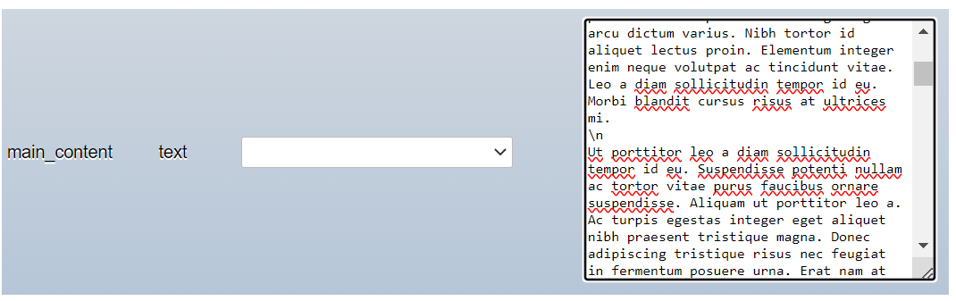

*Figure 138: Incorrect storage of main text content*

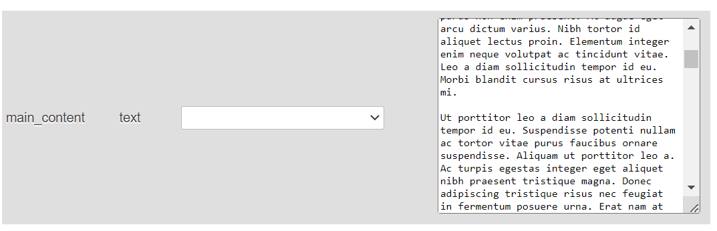

*Figure 139: correct storage of main text content*

### 15/02/23

Debating the best way to store the quiz elements, I decided on a single text element in the table which is converted to Json. This way I can store the answers, questions and correct answers in a single column of the articles table and use the Json to easily navigate and generate the quiz. Before implementing I sought proof of concept and tested it successfully using an online IDE.

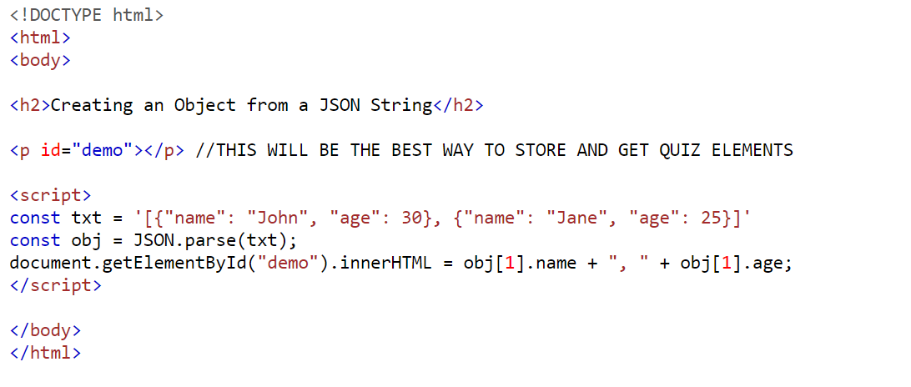

*Figure 140: proof of concept for storage of quiz elements*

Before moving on to the next part of creating the dynamic pages functionality I realised that I had not yet implemented the usage of session values in place of cookies if the user had opted for their login information to not be remembered. By using session values instead of cookies the username and password can still be used to keep the user logged in but they will expire the second the session is ended. This meant that all code needed to be adapted to accept session values instead of cookies and the stat of the “remember me” check box would determine whether or not the cookies or session values were used.

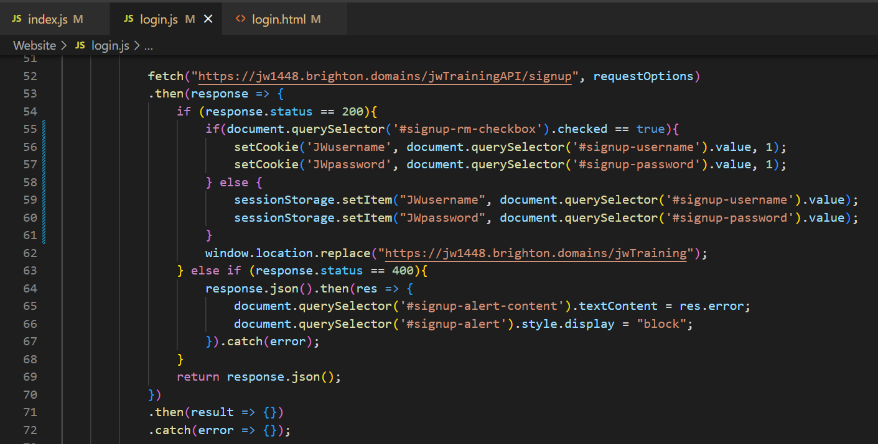

*Figure 141: fetch requests altered to account for session values instead of cookies*

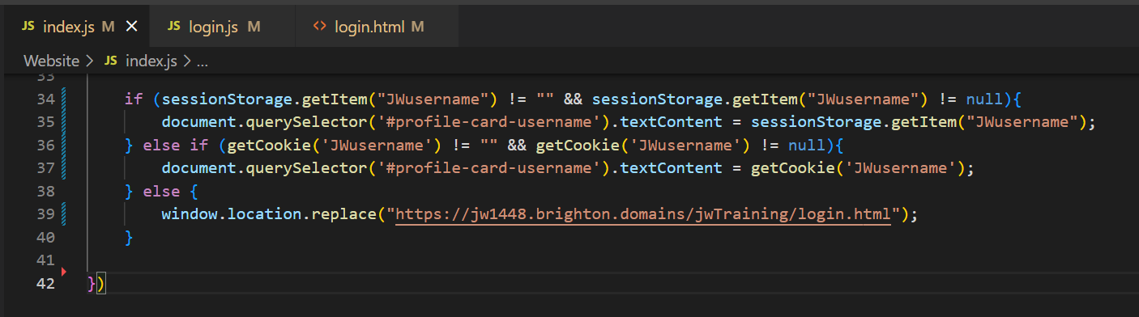

*Figure 142: example of other code accepting session values or cookies*

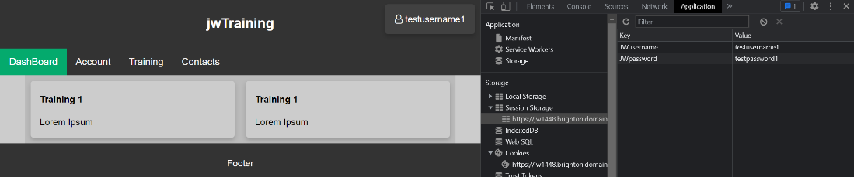

*Figure 143: example of site using session values instead of cookies*

### 17/02/23

There were a couple small changes that I needed to make before moving forward with the development of the dynamic pages. I used the file manager on Brighton Domains and locally to organise files by their type and group them into folder. By organising these files I also had to revise their links to one another as they would have changed.

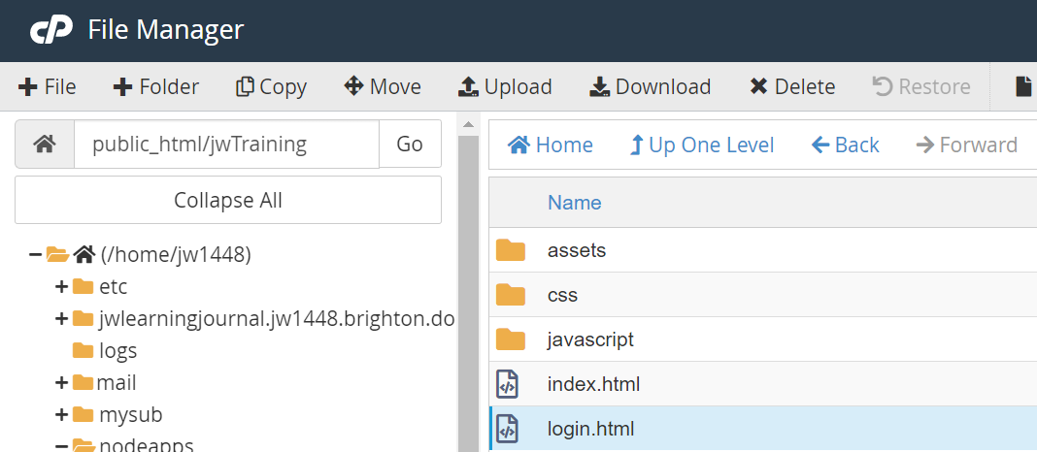

*Figure 144: organised structure of the web application*

There was a bug where the screen wouldn’t shrink for mobile view because viewport was accidentally removed so this was quickly remedied. This served as a valuable lesson as I had never created a page without one and I learned more about it purpose.

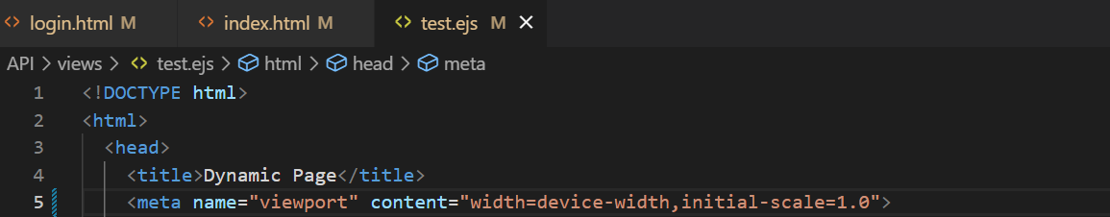

*Figure 145: viewport having been added to the EJS template*

Next was the implementation of the YouTube API player. I followed its documentation and defined a container a div element to be replaced by the iframe that would contain the video. Only the height and width as real numbers can be input to scale the player and so a container is required to add CSS to target the iframe with CSS to make it scalable.

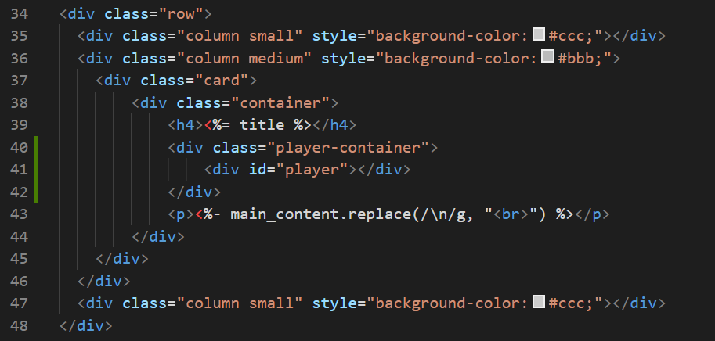

*Figure 146: adding the HTML elements required to create and control player to HTML*

I first tested it out by inserting all the code in script tags of the EJS template. I hard coded the video ID and set the events so that the video would autoplay upon loading as well as sending an alert once the video had finished. All of these worked flawlessly.

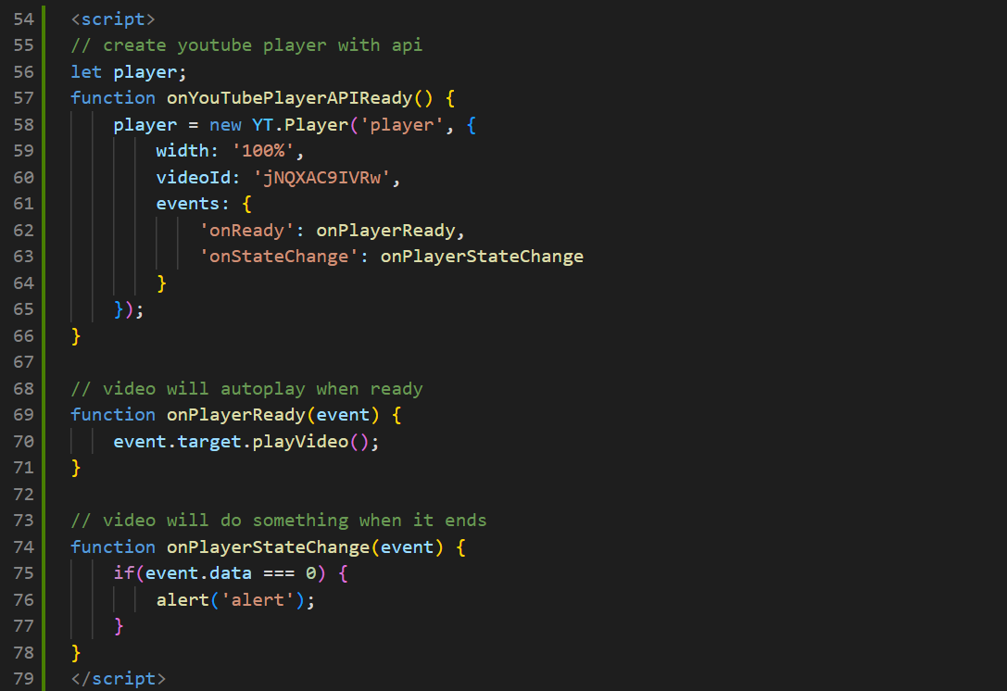

*Figure 147: JavaScript related to player creation and control*

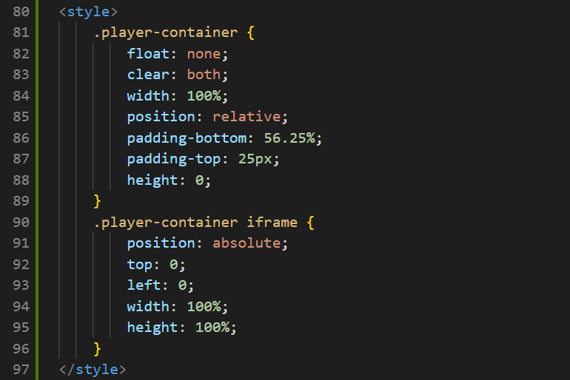

*Figure 148: CSS related to player*

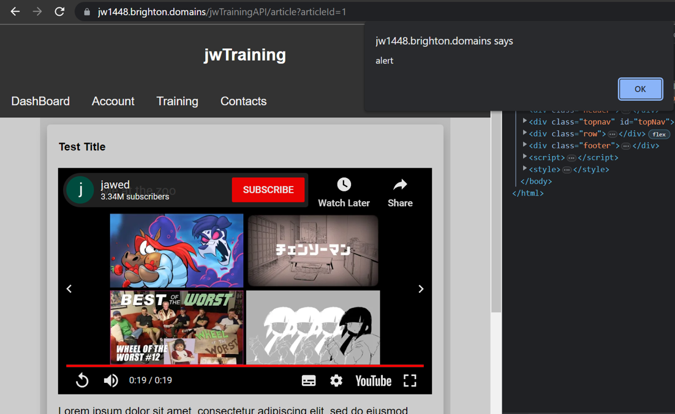

*Figure 149: example of all player-related elements successfully running*

It was once I tried to externalise the JavaScript code that I ran into issues. The correctly working code can be seen below, the page load event listen that I usually used had to be excluded as it prevented the player from loading for some reason. I attempted to find out why this was the case but found no answers so simply accepted the fact. There was also the issue of the code loading before the API and so the script tags were rearranged to prevent this issue. I designed it so that the video ID would be a hidden element in the page that would then be picked up using querySelector by the JavaScript as the API could only pass parameters to the EJS not to the external JavaScript.

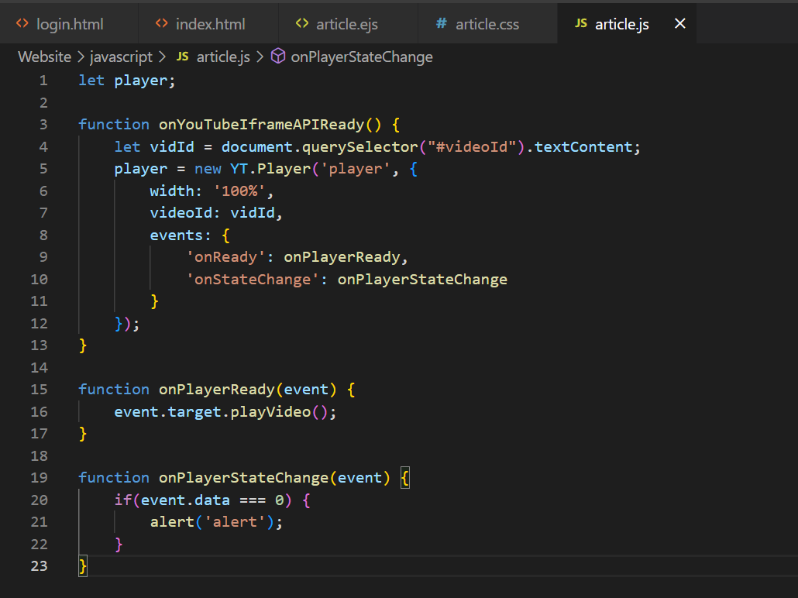

*Figure 150: externalised JavaScript for player*

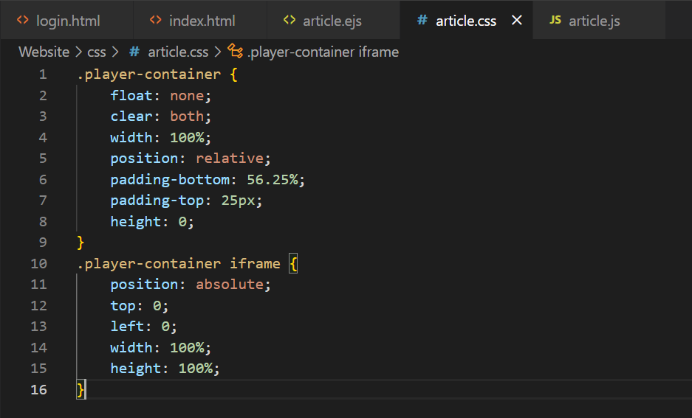

*Figure 151: externalised CSS for player*

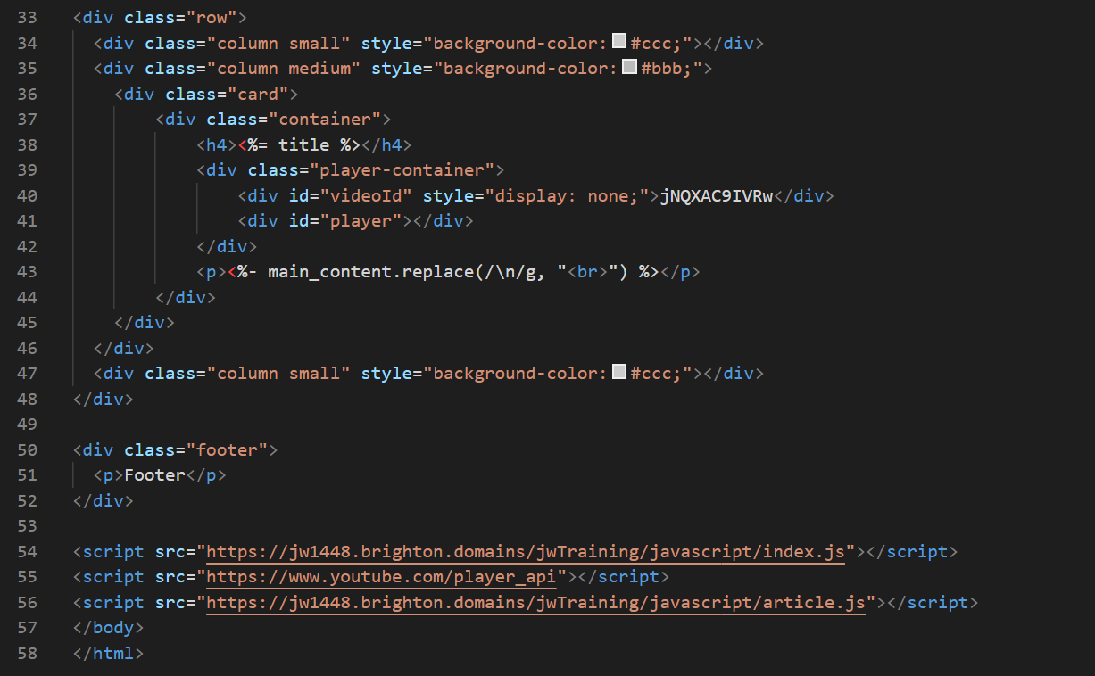

*Figure 152: final design of HTML*

The code below displays the code that wouldn’t run due to inclusion of the usual load listener. While this would have made it so that the code wouldn’t be run until the API had loaded as well, the fact that I halted progress also caused another problem in the form of the code being ran before the API code had run.

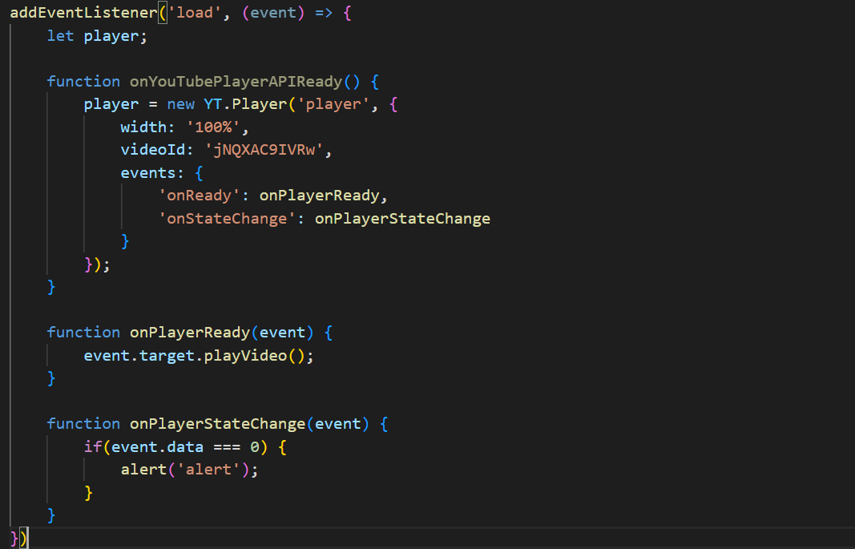

*Figure 153: non-functional player code due to load listener*

The final error was unrelated to the previous two. I was attempting to get the video id that had been passed into the page and use it externally to create the player. I wanted to externalise so as to make the code itself less accessible to the public, make it so it could be cached by browsers and would speed up page load times. However, the video id couldn’t be used before initialisation and was reporting so in the console, so the video id had to be initialised within the function to create the player. After these fixes the code was executing properly but I decided to place all script calls at the bottom of the page body tags to avoid further potential errors of this nature.

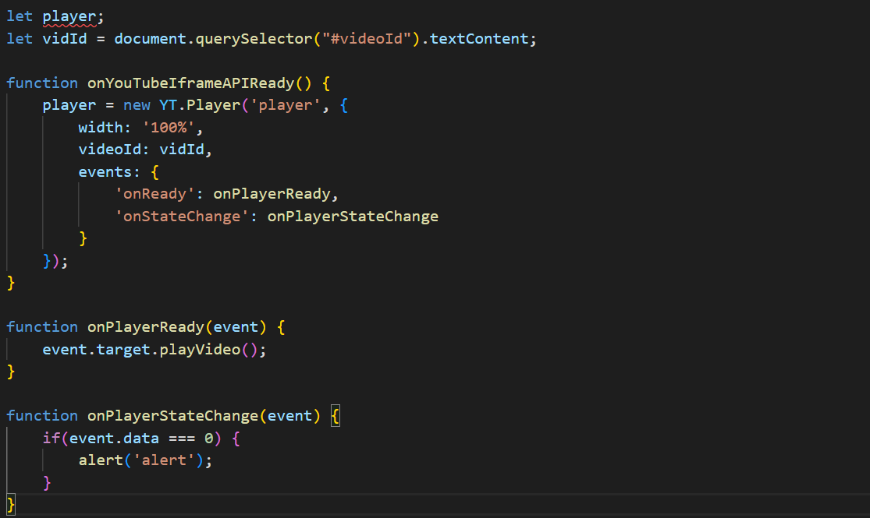

*Figure 154: code non-functional due to initialisation outside of function*

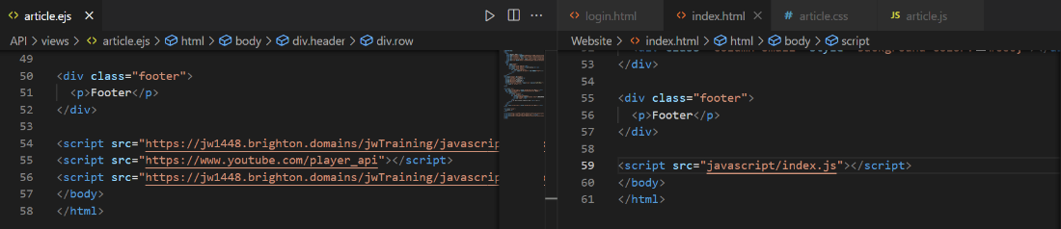

*Figure 155: script tag being moved to the bottom of code on every page*

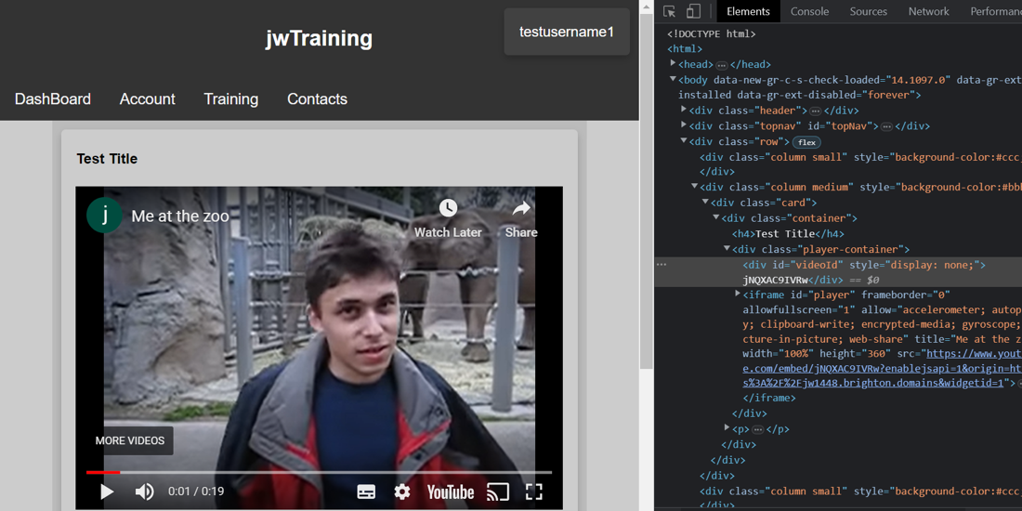

*Figure 156: full functional player with external JavaScript*

The CSS I had already implemented was ideal for smaller screen but not for larger screens. While the user could always utilise Fullscreen mode on the player I decided to add CSS for the different screen sizes to make the player visually appealing when the page was of any dimensions.

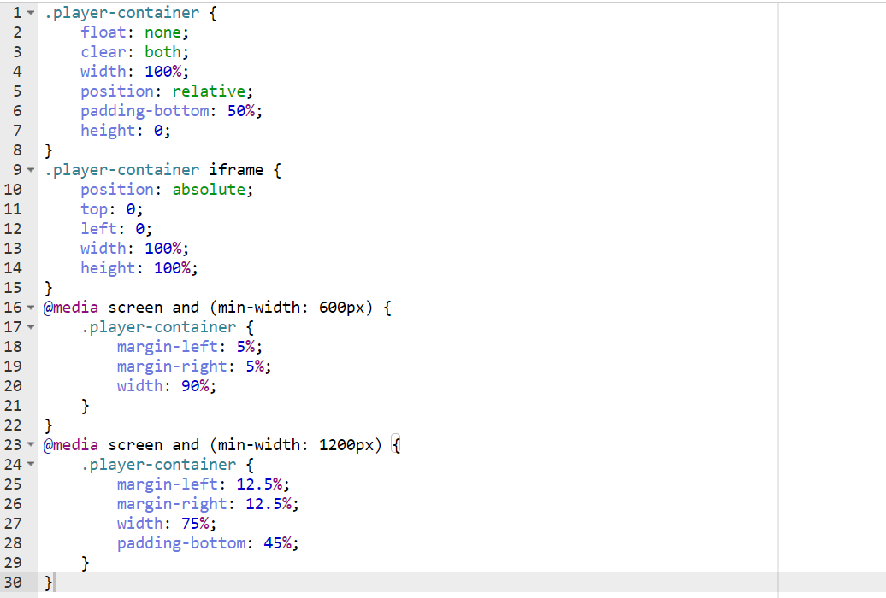

*Figure 157: CSS for larger and smaller screen sizes*

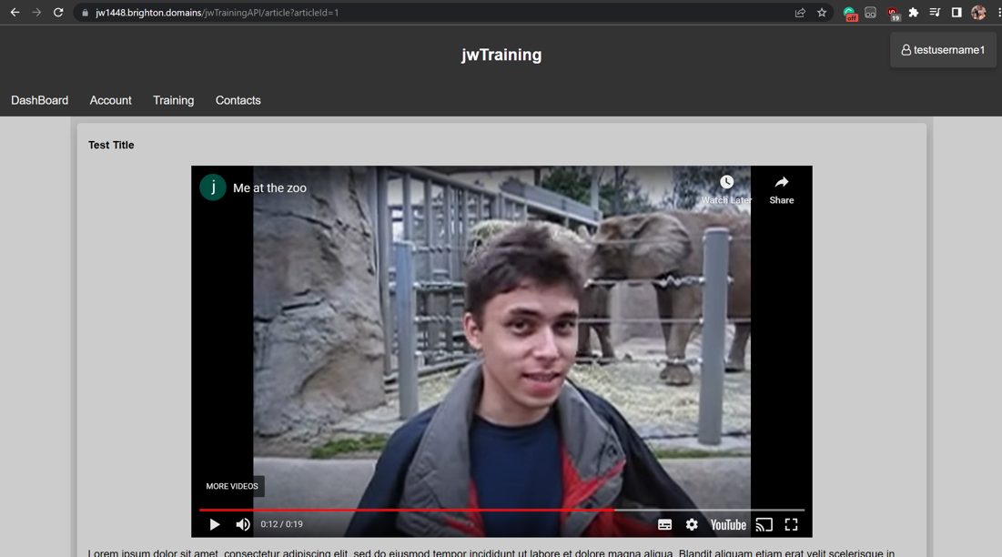

*Figure 158: fully functional player in desktop view*

### 21/02/23

On this day I added some new additions to the database to prep for the assigning of these newly developed articles. I first added a job title section to the users table so that it could be used later to assign training articles all at once by job title. I then added a table for storing the IDs of the articles and users to display what users had been assigned what training articles. Both ids were set as the primary key so that the same work couldn’t be assigned to a user twice by accident. This is a relational database and so both IDs were foreign key that connected to two previous tables. I then added a due date for the work alongside a Boolean column displaying whether or not the work had been completed.

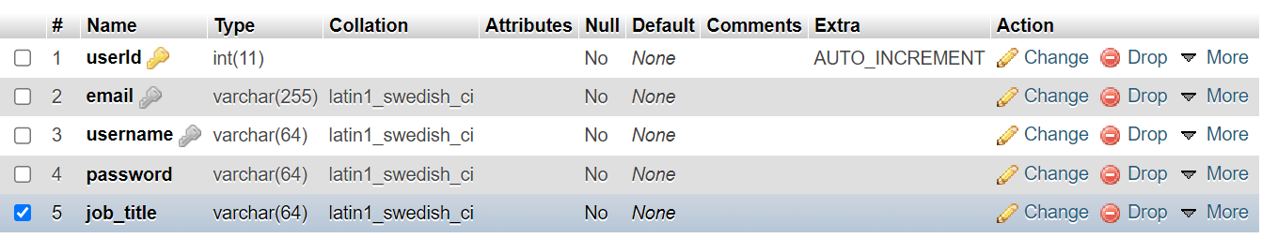

*Figure 159: adding job titles to user table*

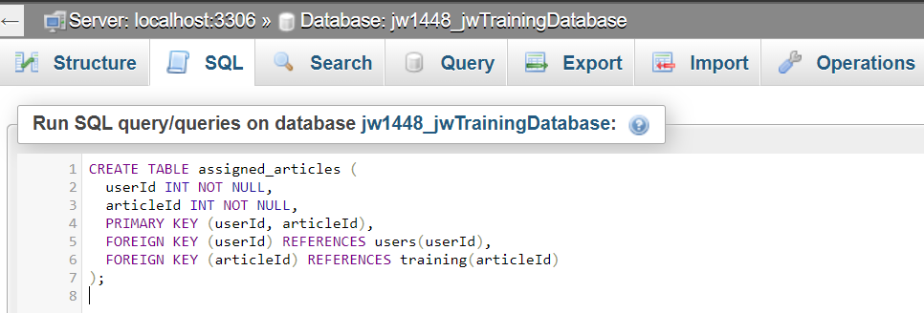

*Figure 160: creating assigned articles table to link users to articles*



*Figure 161: adding due dates and completion to the assigned articles table*

MySql doesn’t have a Boolean datatype so when I executed my code to create and alter the table the completion columns datatype was converted to tinyint, but the code still executes as expected.

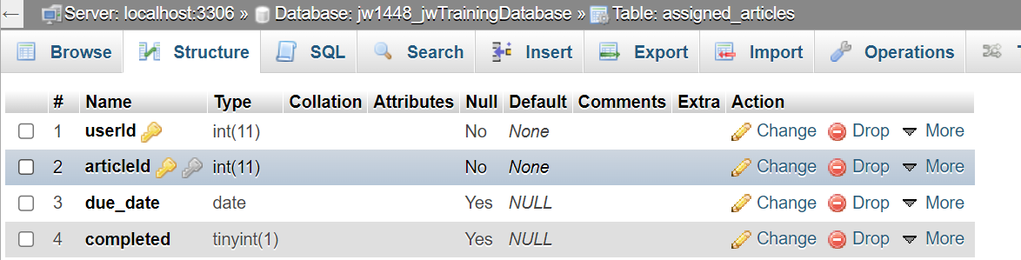

*Figure 162: phpMyAdmin overview of resulting assigned articles table*

A test query to assign only interns the 1st article was executed after I manually set the job titles of some users as interns. The code worked perfectly and so I knew which code to place into the API to query the database and assign training. The ability to assign training would be added to the API later but with security restrictions in place so only the admin could carry out this action.

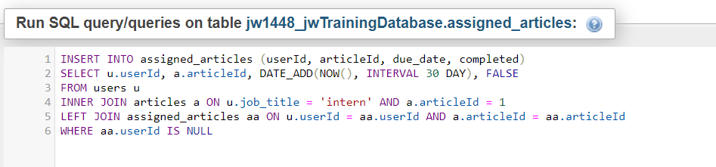

*Figure 163: test query for assigning training*

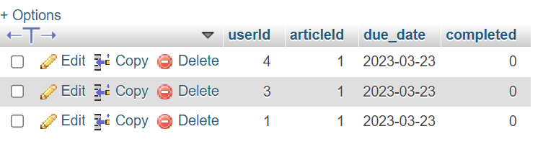

*Figure 164: results of test query assigning training*

### 22/02/23

In order to have the ability to assign job titles and users and have the function be restricted meant that I would need to create an admin account. So, I made a singular account under my name using my own information with the admin privileges. Admins would be told by their job title, this way other admins could be set by the function to assign job titles.

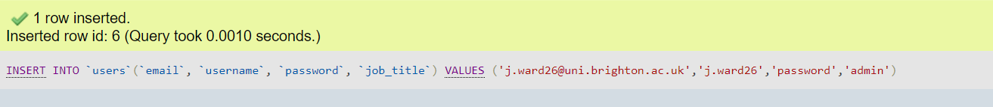

*Figure 165: MySQL query to create admin account*

It was at this point that I pondered whether I should be allowing and using null values in the database or 0 length strings. This was an important discussion as when representing data in tables there must be a clear definition between nothing and unknown. This taking point was prompted while discussing with another software developer where I learned that in their experience of the industry, they were always expected to avoid the allowance of null. The reason for this being that if data got corrupted then there would be a way to differentiate between the corrupted data and data that was always null. However, nulls are ignored instead of being treated as 0s and so have their functionality by representing nothing more appropriately then a zero-length string. I came to the conclusion that I should avoid nulls for things that would change to become something but use them for things that may always be nothing (like an articles video ID if that article had no video). I also concluded that I should be assigning default values to elements that were yet-to-be-set, and so added the string “unassigned” as the default value for job titles of those users that had signed up.   
  
Now the topic of setting the job title requires some explanation behind the reasoning. While it may seem inefficient it is the most secure way with very little alternative. Users cannot be allowed to set their own job title as this is a system that could be abused to access information above their position or to simply lie about their position. As such the admins must be the ones to set the job title which begs the question why have a signup feature in the first place. However, the signup feature allows the users to set the email address they will be contactable on and the username and password they will be most comfortable with. So, by having the entire set-up of accounts be a two-part process starting with the user and ending with the admin, the users input the information they are comfortable, and the admins can maintain proper security and organisation. This meant I would need to notify users that this would be happening behind the scenes, which I planned to do with both email and on the site's homepage. After more research I found that having admins create and alter accounts is a common practice at small companies which is who the web application was aimed at for its usage.

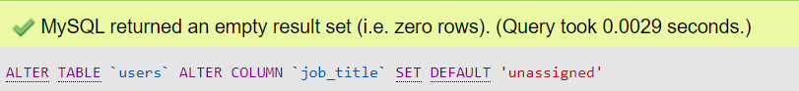

*Figure 166: MySQL query for setting job titles default value as “unassigned”*

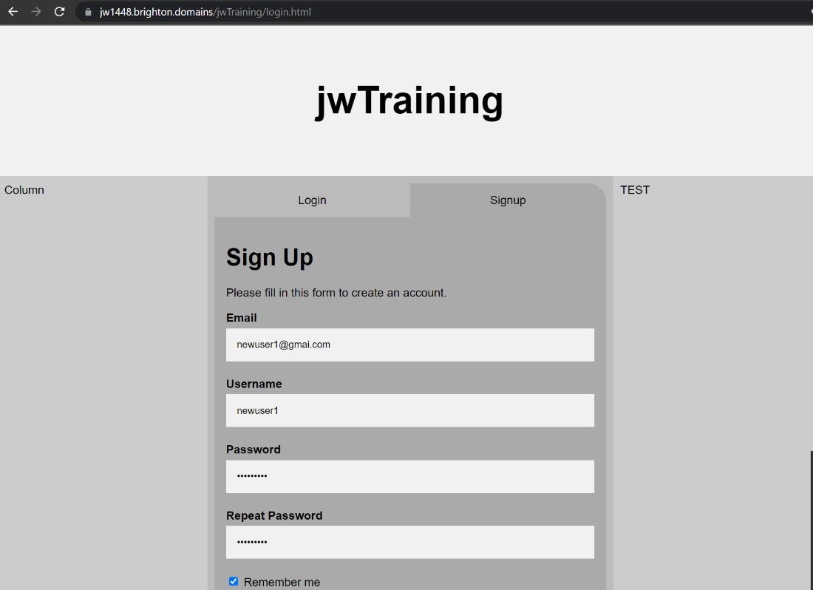

*Figure 167: creating a new user via form with adjusted MySQL database*

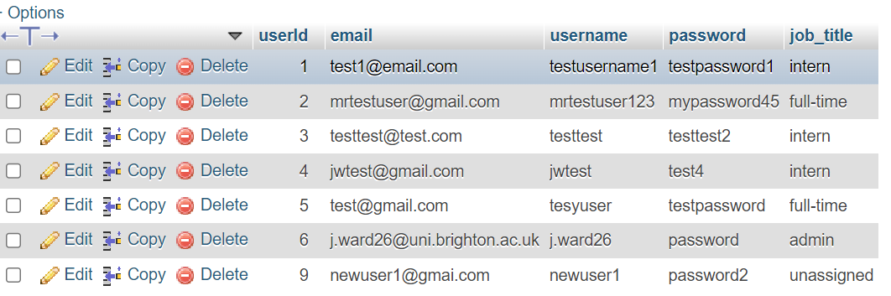

*Figure 168: results of creating a new user adjusted MySQL database*

I realised I had made a small logic error and quickly fixed it. I had 200 set as the predicted response status code from the signup fetch request which I then rightfully replaced with 201.

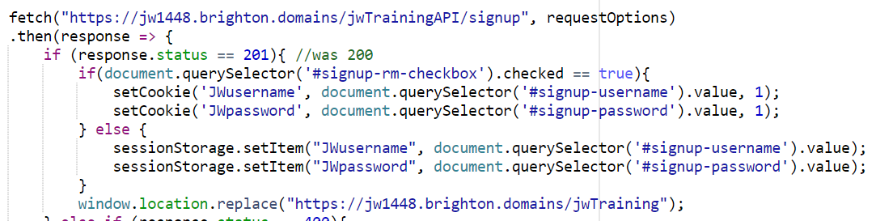

*Figure 169: minor bug fix in signup function due to wrong status check*

I placed code on the API to handle post requests from the admin to assign job titles to other users. Like all other request handling besides the rendering of EJS, I had the request be redirected to an async function so that the handling of promises would be made easier but also to now fit the convention of the rest of the code. It now occurs to me that I may not have specified which I didn’t do this for the EJS rendering route on the API, but that was done because it would only be executing one query and wouldn’t be returning a promise. For this new function I added a new route.

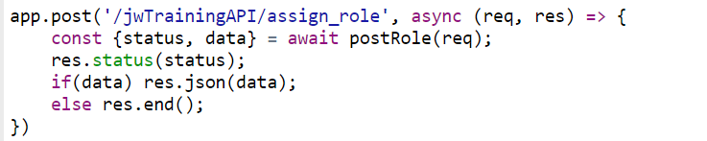

*Figure 170: handling post requests for assigning users roles/job titles*

I changed the regular functions to allow for more in usernames, I realised that I was being to restrictive on usernames and doing so would actually decrease security, as passwords would be more predictable.

When designing the new function, I needed to verify that the user was an admin and did so with a MySQL query as well as all the regular expressions. I returned the job title to ensure that it had gotten the information I would be verifying from the database.

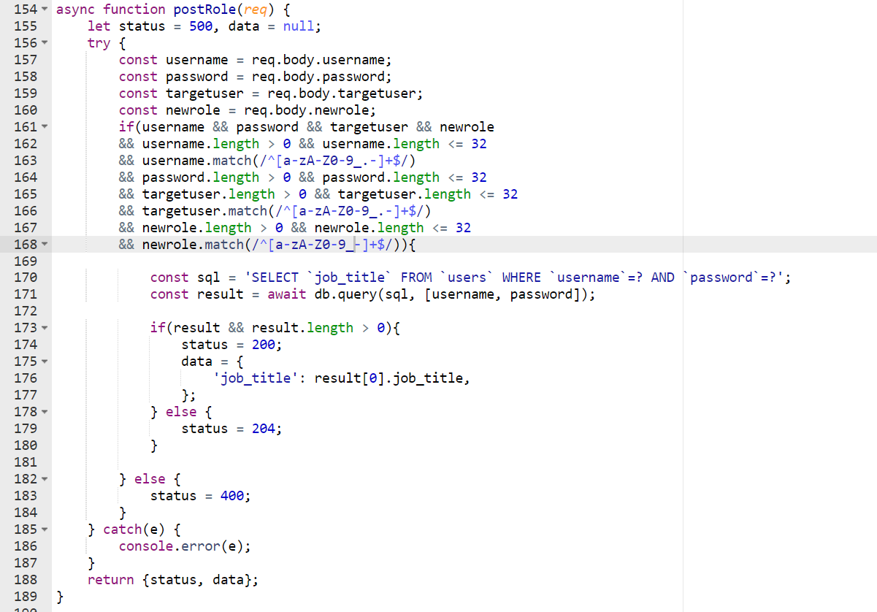

*Figure 171: post role function checking for admin authentication with new restrictions on usernames*

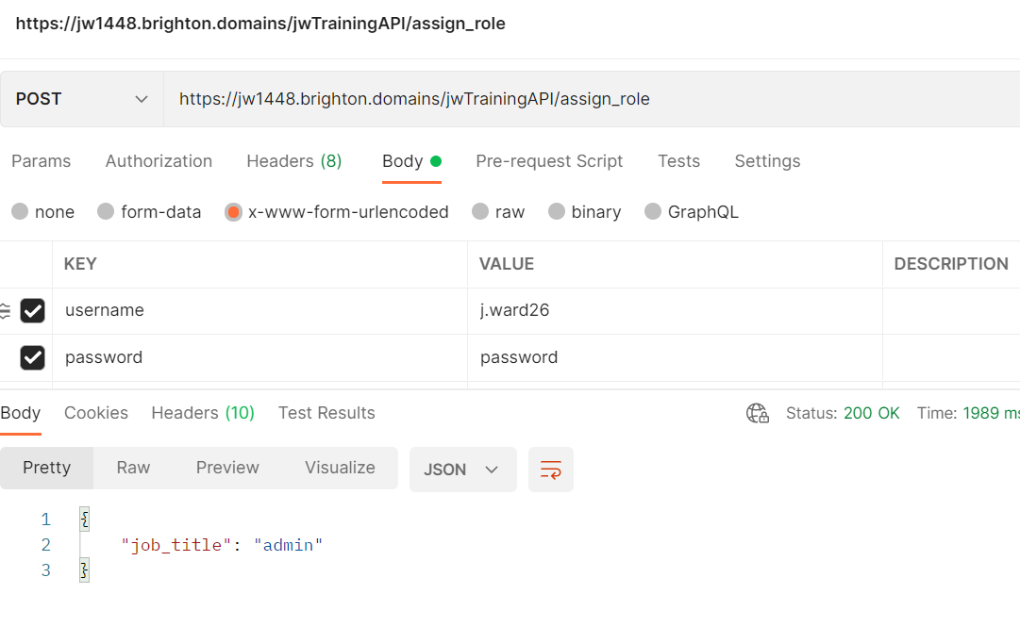

*Figure 172: assign role function successfully having identified admin job title*

I then set the function so that if the returned job title from the users table was an admin then the altering of the target users job title would be changes. This meant that the job title and target user would have to be the input parameters alongside the username and password to verify the user had permission. I returned the affected rows to confirm that it had worked (although you would always expect no higher than 1) and accounted for if nothing was changed by returning a 204 status code to show that the user didn’t exist. I also returned a status code of 401 if the user was valid but wasn’t an administrator.

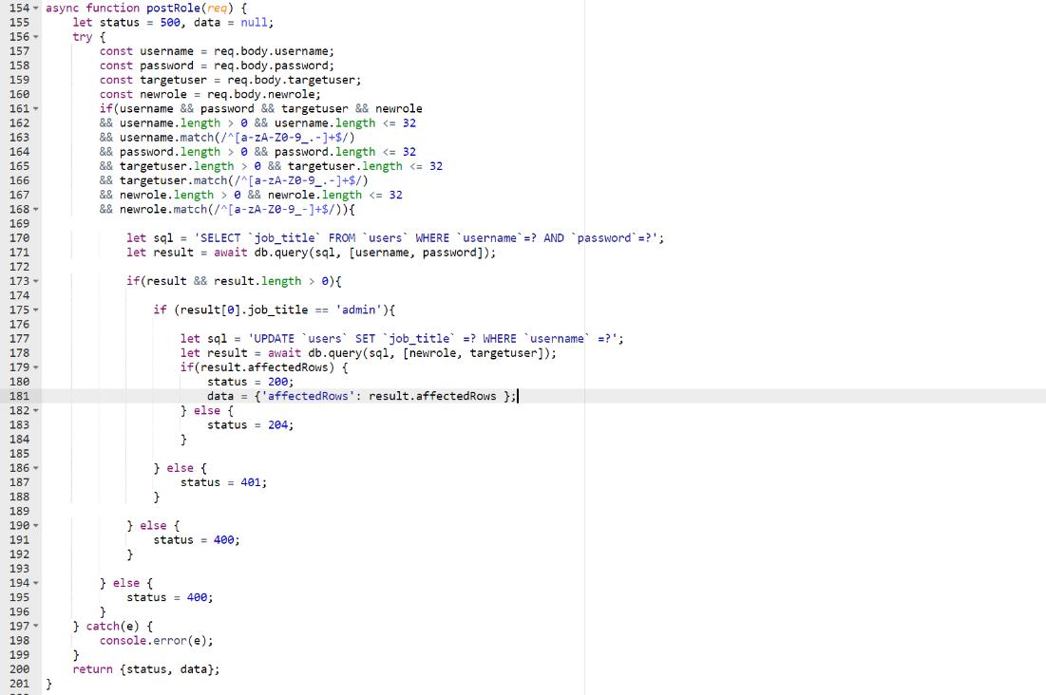

*Figure 173: full post role function to authenticate admin and update job titles*

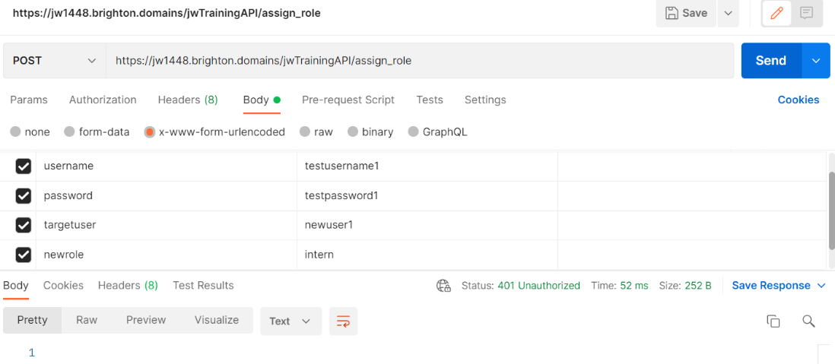

*Figure 174: assign role endpoints response when credentials are unauthorised*

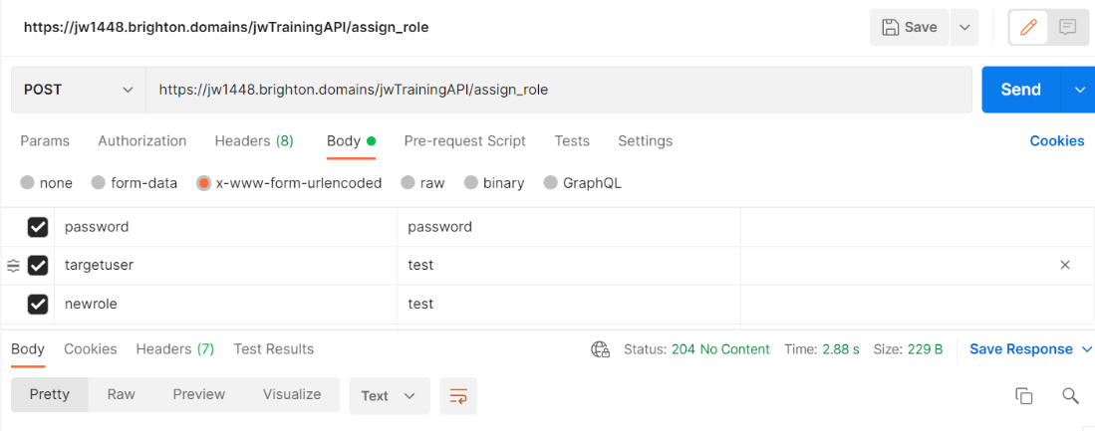

*Figure 175: assign role endpoints response when target user is non-existent*

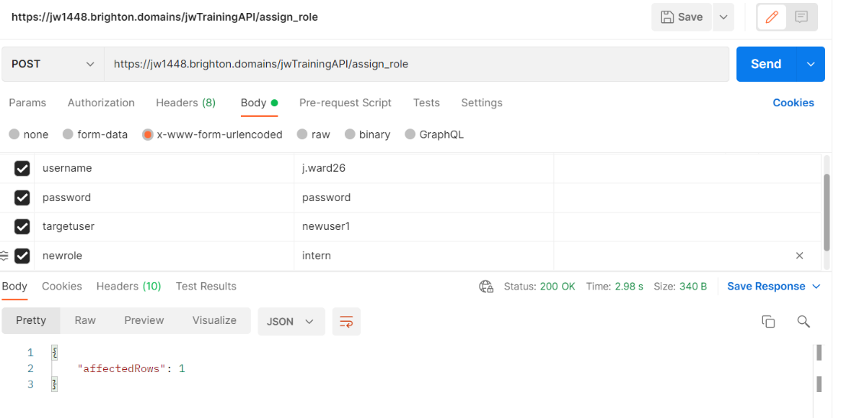

*Figure 176: assign role endpoints successful response*

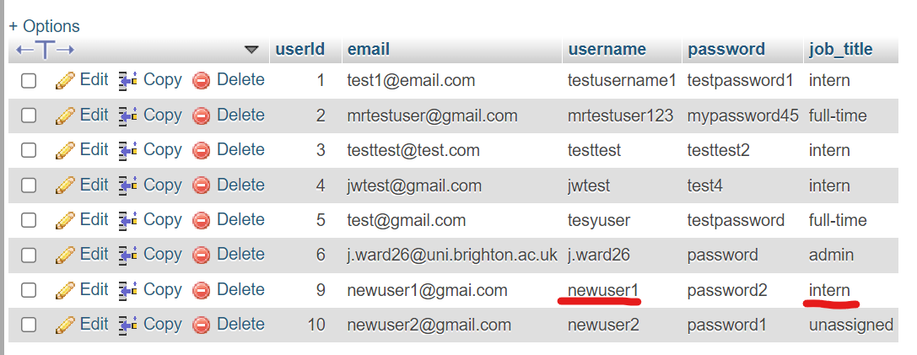

*Figure 177: alteration to database made by assign role endpoint*

The next and final feature of the day was adding the ability for administrators to assign training using the SQL I had already designed. Again, I set up another route and async function that would verify the user was an admin (in the same way as the previous function) before executing the query for as it should be a restricted feature. Assigning training must require admin privileges as otherwise someone could abuse it to set work for others when it isn't required or valid. I handled the status codes in the exact same way as the previous functions.

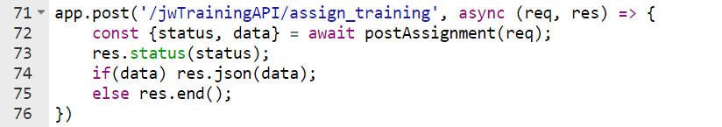

*Figure 178: handling assign training endpoint*

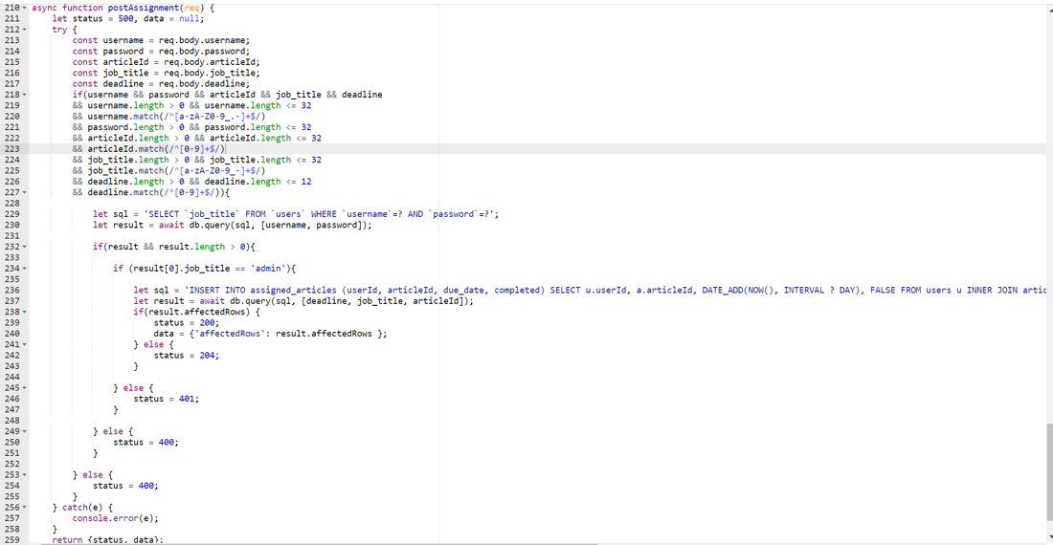

*Figure 179: post assignment function used to assign work to users by job title*

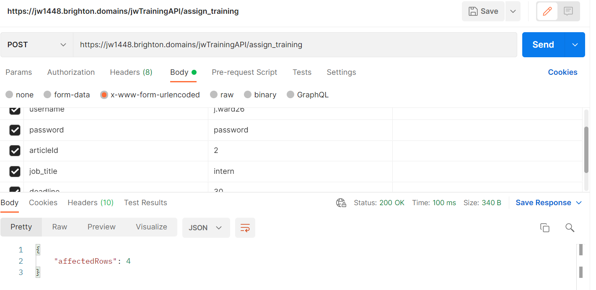

*Figure 180: successful response from assign training endpoint*

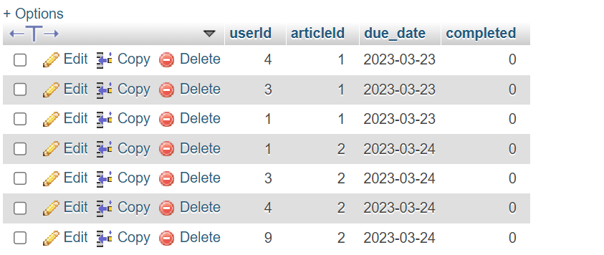

*Figure 181: alteration to assigned articles table from assign training request*

Then because of the joint primary keys the same users can't have the same work set twice meaning that new employees could be set old work without bothering the others. This is perfect as it allow new employees to easily run through basic training without bothering the other employees in the same role. This can be seen as I return the affected rows to show if and how the request was processed.

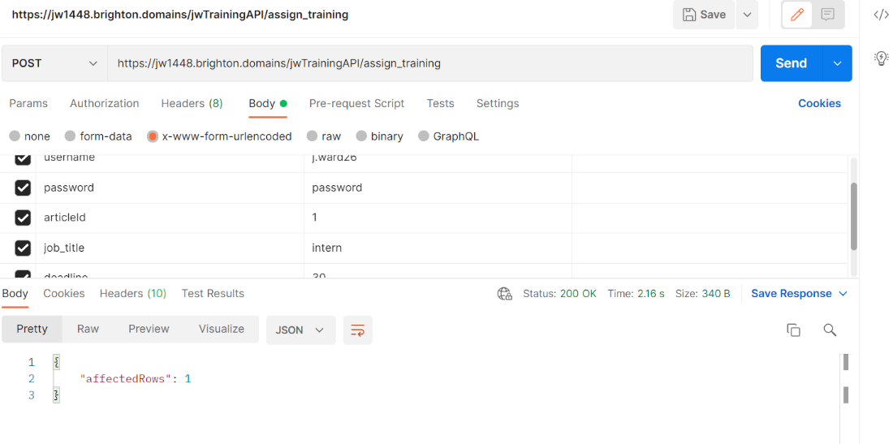

*Figure 182: example of attempting to set work when users have already been assigned it (request response)*

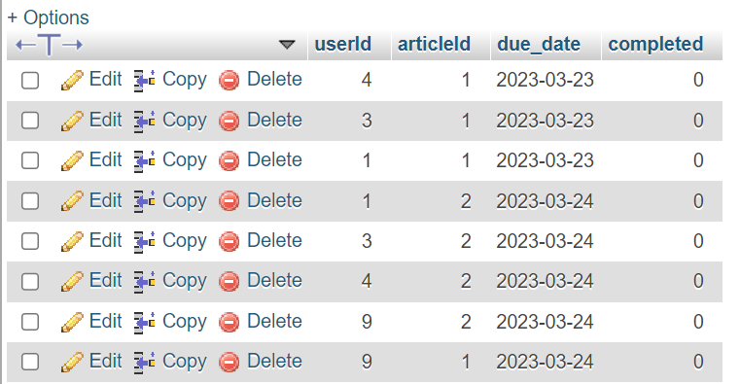

*Figure 183: example of attempting to set work when users have already been assigned it (database content)*

### 27/02/23

I needed to account for training which didn’t include a video as otherwise a player would be generated but without a link. I tried the below approach until I realised that it seemed unprofessional as the player CSS would load and then disappear.

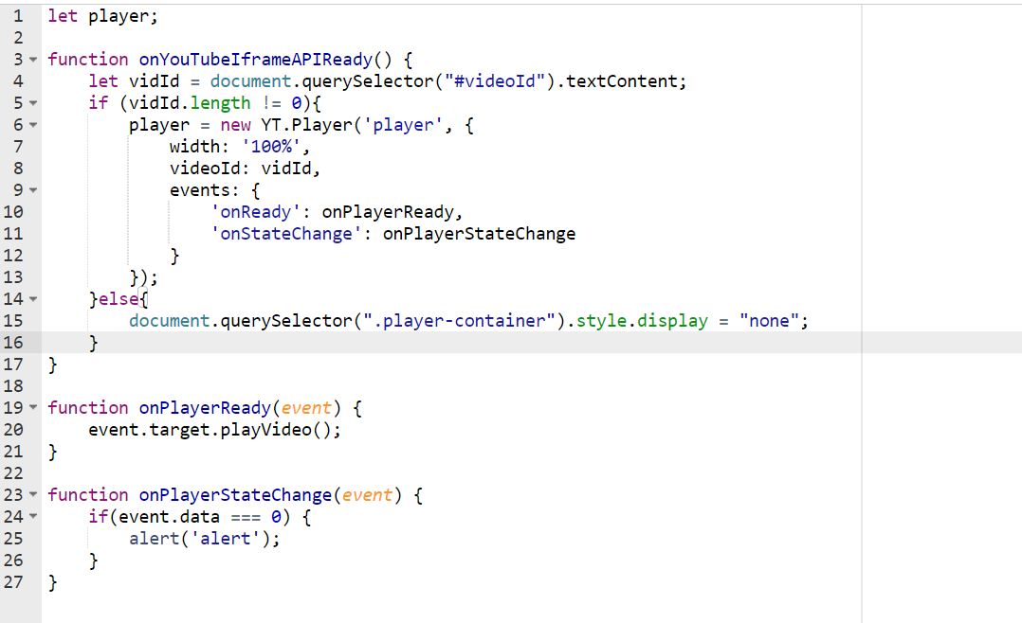

*Figure 184: unused handling of article without video ID*

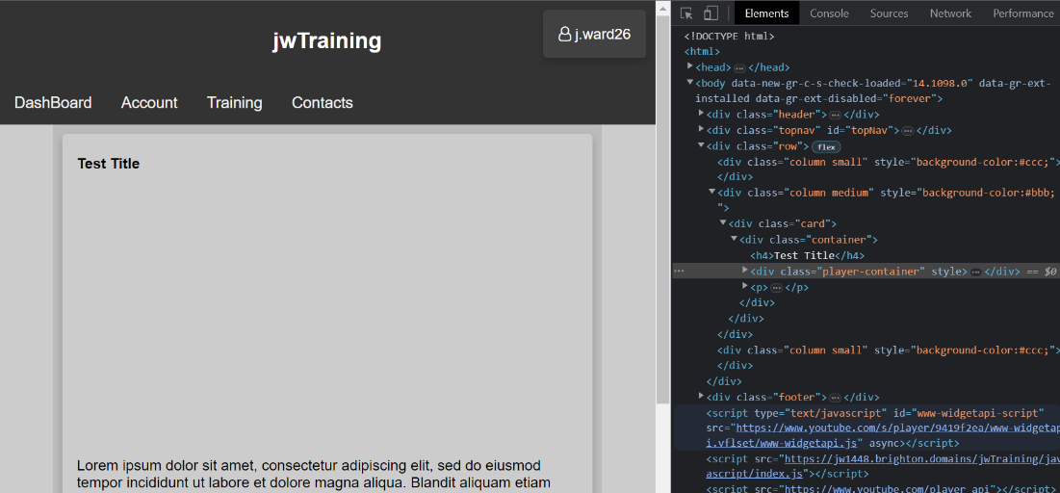

*Figure 185: unused method of handling articles without video ID (upon load)*

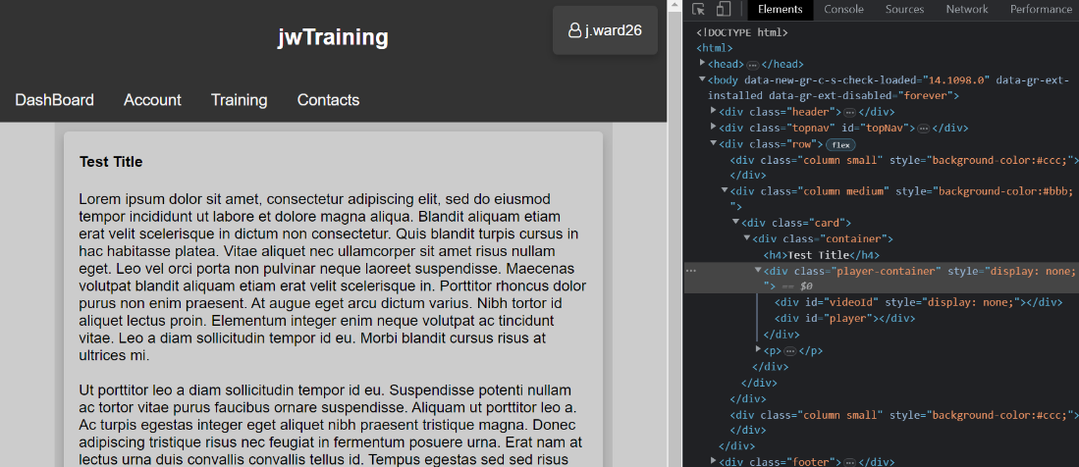

*Figure 186: unused method of handling articles without video ID (after player hide)*

So instead, I removed the class with the player containers assigned CSS from the html and had it so that it would be added before the player was initialised.

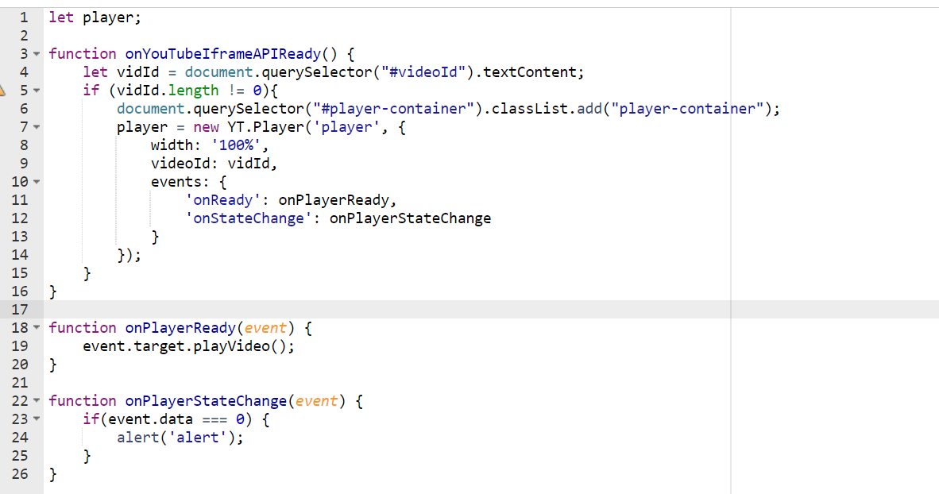

*Figure 187: JavaScript method to handle articles without video IDs*

I decided to switch from the hardcoded video id to the id given from the database as it was a simple task I had already designed the code in mind for and would need to be done eventually anyway.

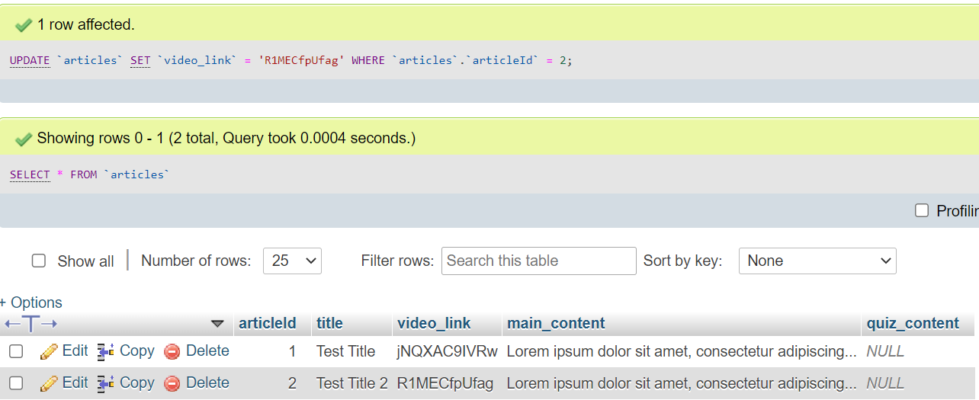

*Figure 188: adding video links to articles in database*

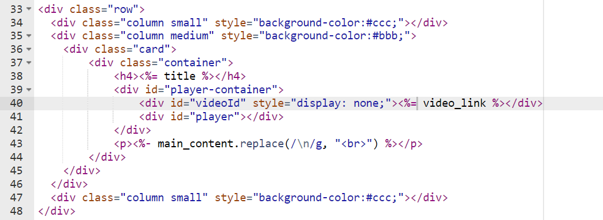

*Figure 189: replacing hardcoded video link with dynamic input from database/API*

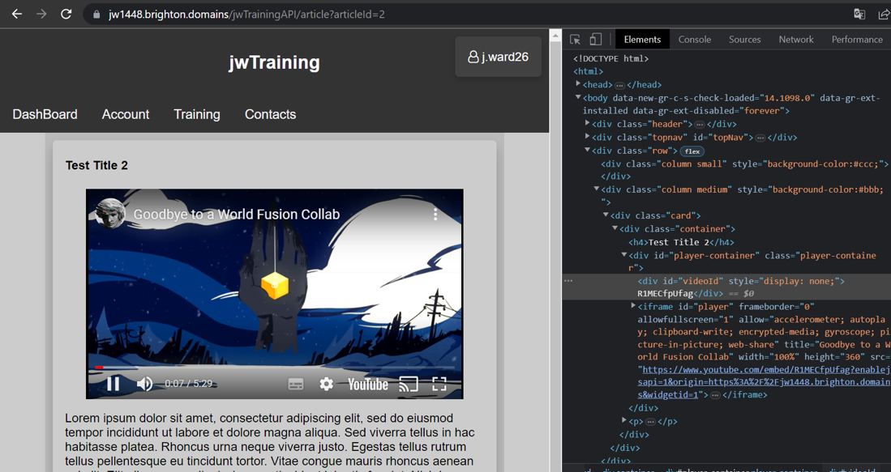

*Figure 190: displaying of dynamic articles without hardcoded ID*

## Sprint 4: Displaying & Completing Training

### 28/02/23

Before any more new implementations I realised that the user ID was still being returned from the getUser function. I decided to remove user id from the login return because users shouldn’t have information about the database structure.

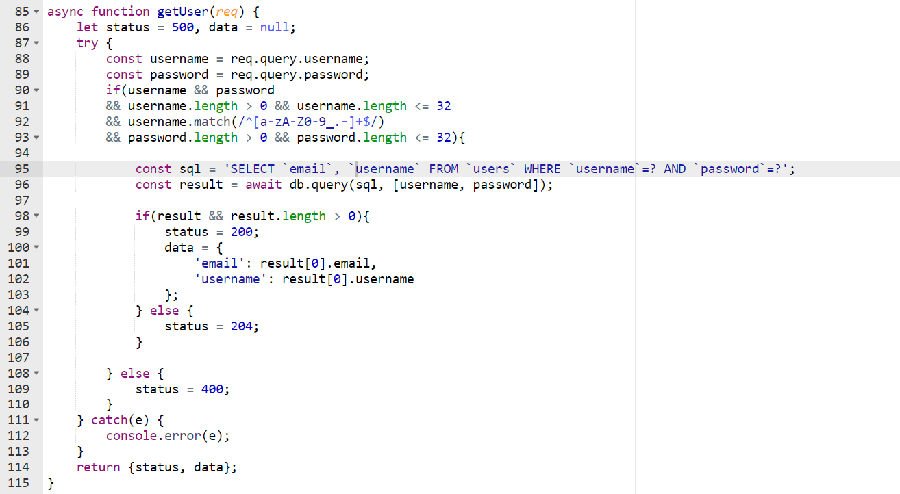

*Figure 191: removal of user ID output from API (code)*

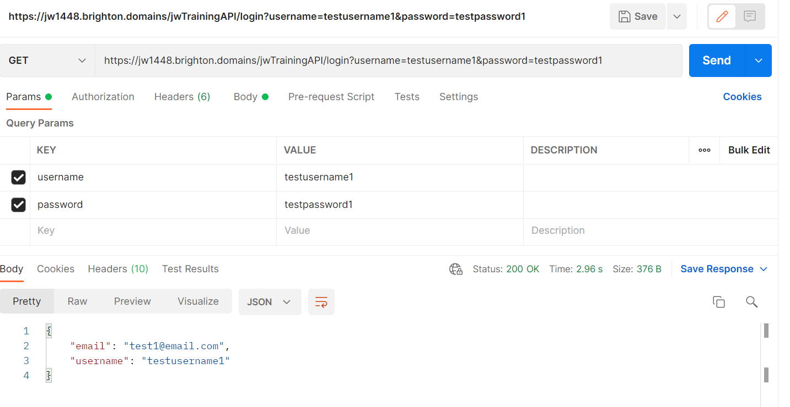

*Figure 192: removal of user ID output from API (request response)*

Now that the users could have their title and training set by an admin the last step would be to create a function to get all content currently assigned to a user. The query was set to get all course IDs using the user ID which meant that the login query that was done to authenticate the user would also need to return the user ID. Using the user ID in the assigned articles table, the query would get all rows that were not completed (had their completed column set to 1/True) and not past their due dates. The query would then use this with join keywords to also get the title, descriptions and other elements for those articles that had their ids returned from the assigned articles table.

I added descriptions to articles in the database so that their results on a page could be generated with a synopsis for a more user-friendly design.

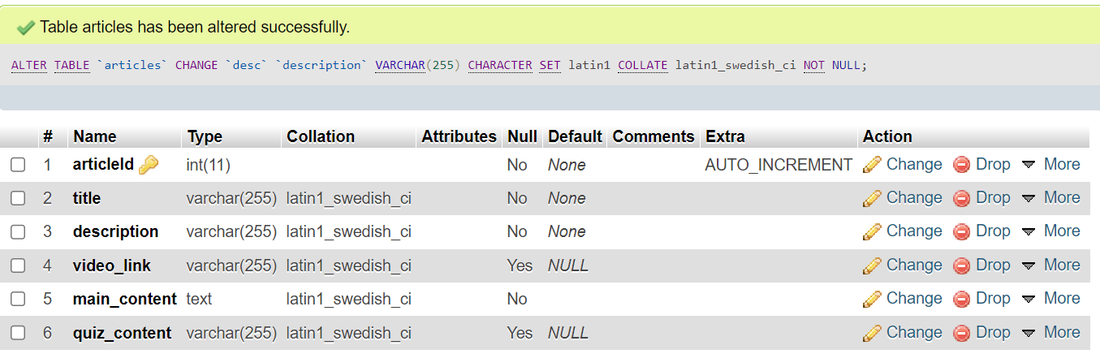

*Figure 193: adding descriptions to articles in database*

I set the querying function up in the same way as the previous, by using an async function and validating the user before performing the appropriate query. The results would be used to generate cards displaying work to-be-done, so whether a user had not been set any work, or had completed all their tasks, then a 204 status would be appropriate to both scenarios as there would be no reason to distinguish between the two. I decided that the would be no reason to add a restriction on these results to be used for pagination because any potential company using the web app would be unlikely to set an overwhelming workload for its employees.

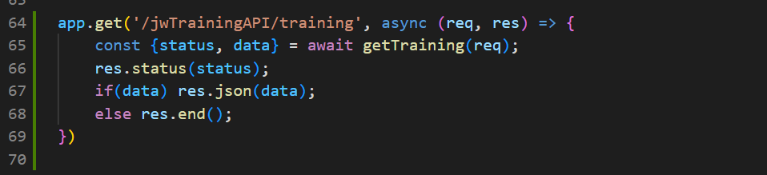

*Figure 194: handling of get training endpoint/requests*

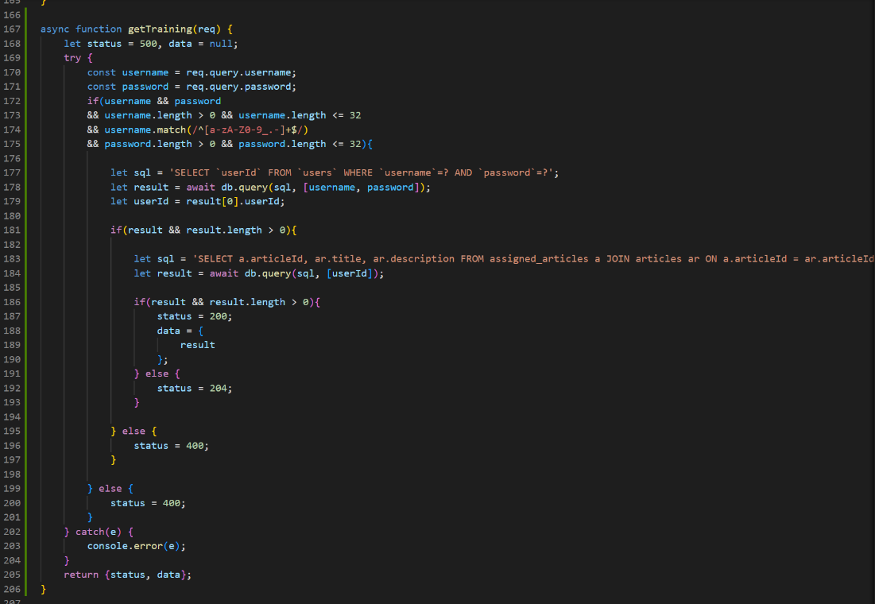

*Figure 195: function to return all articles assigned to a user as a JSON object*

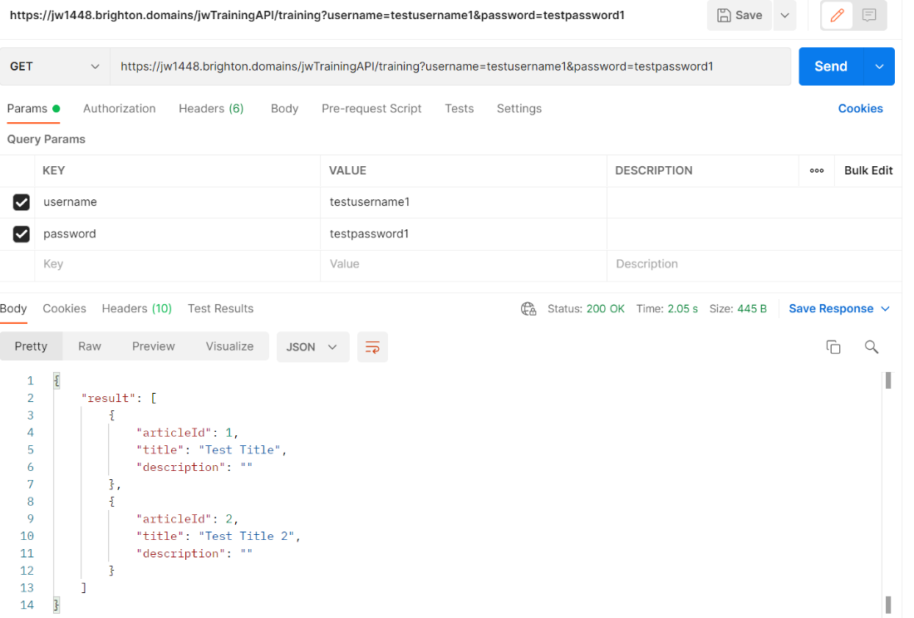

*Figure 196: JSON response from successful GET training endpoint*

The training page that would be displaying results was made by taking the code from the dashboard and altering its links as well as the structure of the navigation bar. The dashboard already had the templates of the cards I would be dynamically creating and so the only extra additions would potentially have been extra rows and columns (to hold other elements or alter the structure of the page) or IDs to target elements to append children to them or append them.

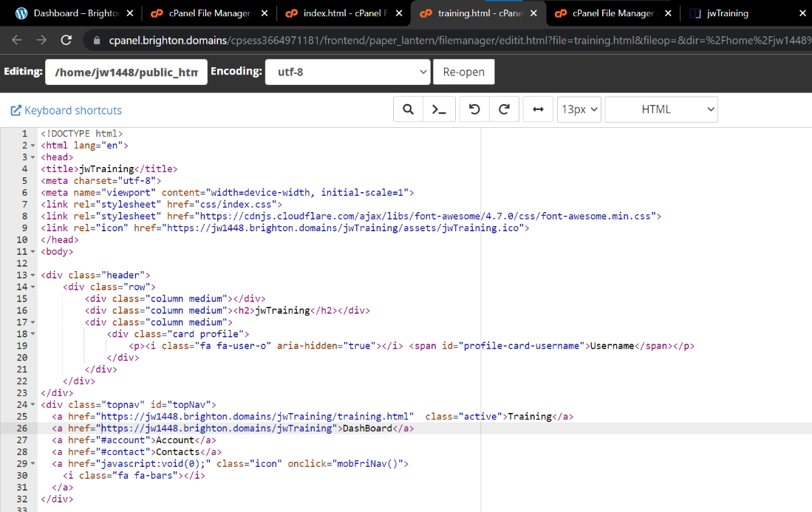

*Figure 197: creation of training page in HTML*

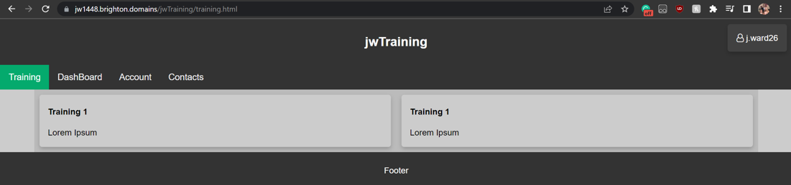

*Figure 198: basic train page UI layout*

After this set up it occurred to me that I would be needing to add the aforementioned progress bar to this page and so I would be requiring a percentage of currently assigned articles (not past due date) completed over incomplete. Adding a complete percentage for the progress bar to the response from the API would mean the bar could default to 100% until it is appended by the results from the database.

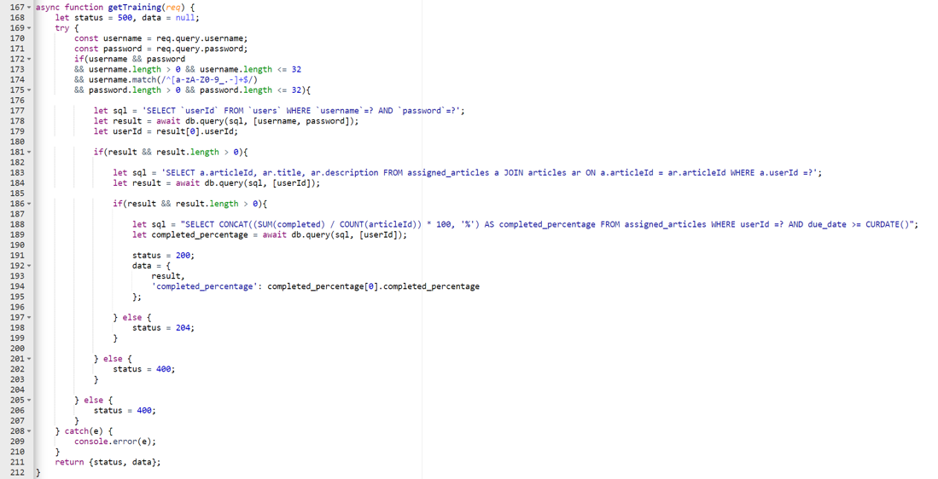

*Figure 199: get training function on API altered to include progress percentage*

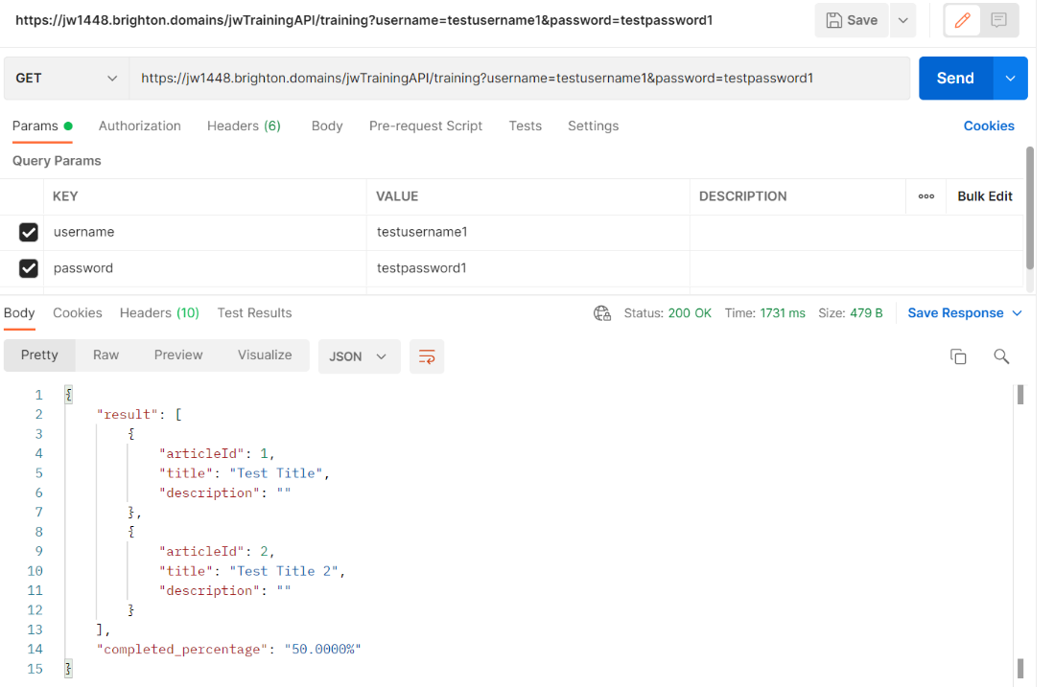

*Figure 200: get training endpoint response with progress percentage to use in progress bar*

### 01/03/23

An oversight was made on the get training function that was discovered during Whitebox testing carried out the day after. It was adjusted to exclude completed articles as I had forgotten to add that restriction to the MySQL query that was being executed. I also added more test entries to the database to aid in the demonstration of the training page, thus aiding in testing and debugging.

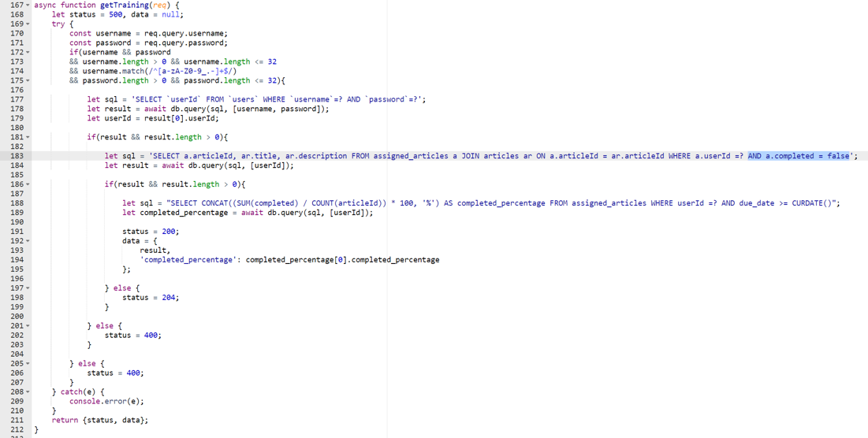

*Figure 201: excluding completed articles form assigned training results*

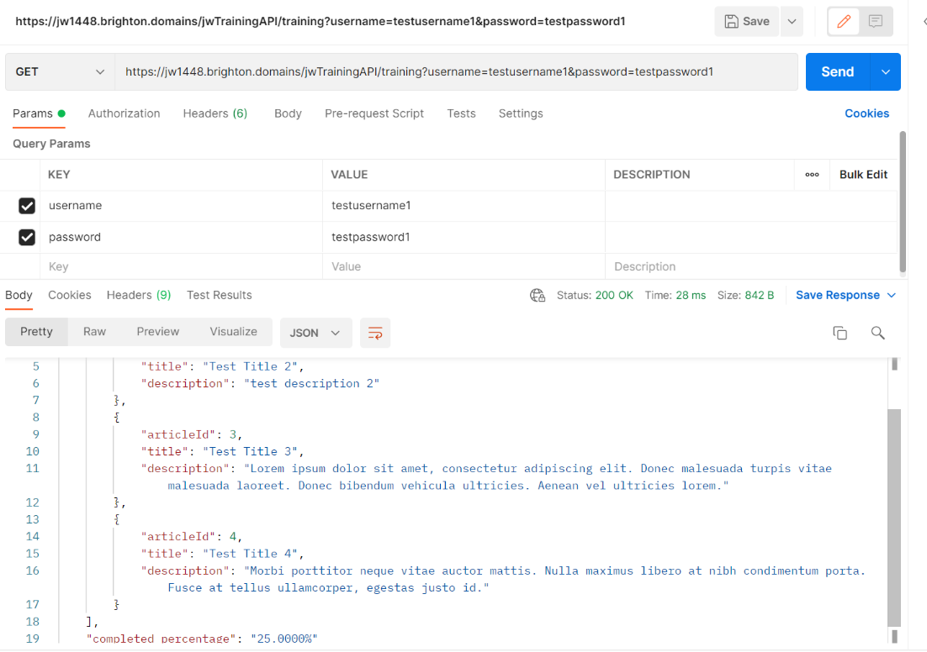

*Figure 202: get training request response with exclusion of completed articles*

I carried out a couple of tests to make sure the getcookie function from the index JavaScript could be called from training page JavaScript. This was successful so moved ahead with development.

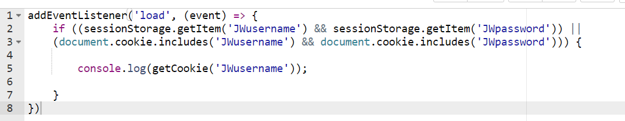

*Figure 203: using get cookie function from index.js in training.js (code)*

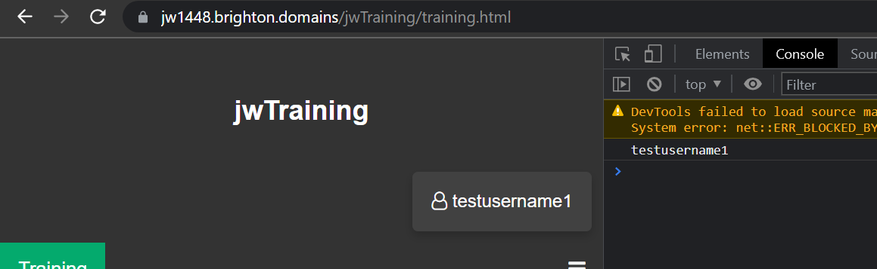

*Figure 204: using get cookie function from index.js in training.js (console)*

The next step was to carry out the use of this function using the fetch API on the training page. While this was a very easy task to implement, I lost the documentation screenshot for this addition and so needed to use one taken from the associated commit on GitHub. The JSON object was logged to the console so I could ensure it had worked and so it could be analysed to ensure the JSON could be navigated in the format I expected.

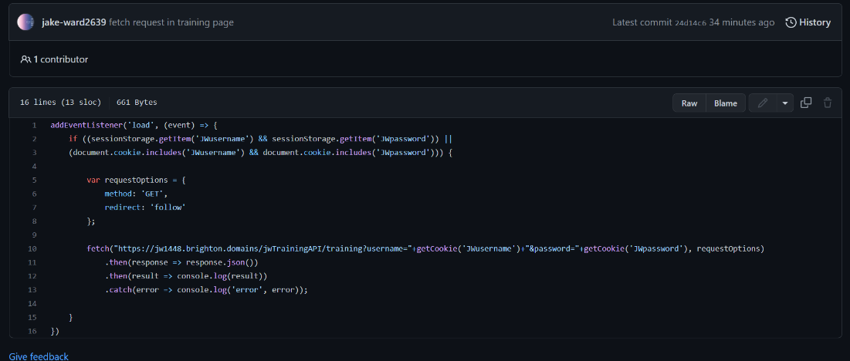

*Figure 205: GitHub documentation of fetch request to get training API endpoint*

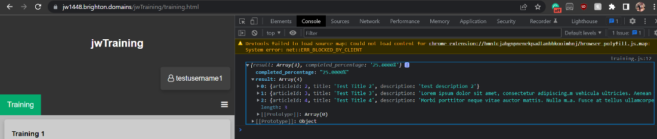

*Figure 206: results of get training fetch request in console*

Through the original research and reaffirmation with the observational method testing I decided that these results needed to be displayed over two columns to save space on the page and be visually appealing. Doing so would need the array to be split into two which could have either done on the server or client side. I decided to implement it on the client side meaning that I had to split the JSON array of results in half and populate page by displaying them in the separate columns. I created a function to create cards that could be called to simplify the code and used the slice function to split the array in half and display the results as cards. The cards would be dynamically generated by the JavaScript and so the columns were given IDs to target, but they were based on the template cards on the dashboard and would share all their CSS.

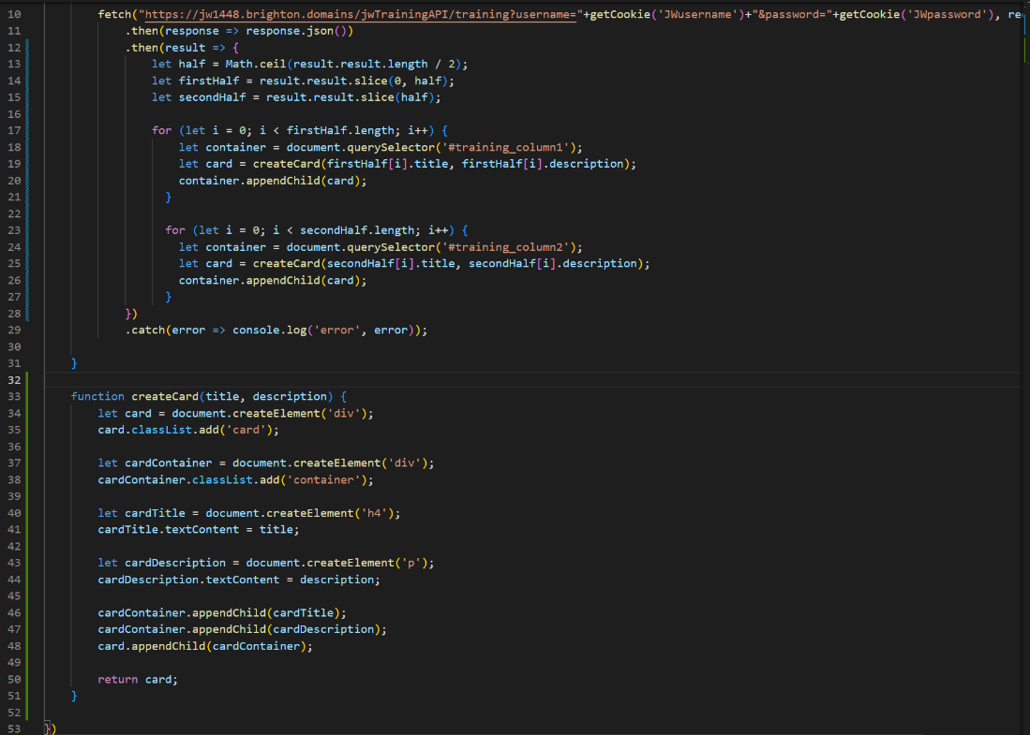

*Figure 207: dynamic creation of cards with JSON object from fetch request (code)*

As can be seen in figure 208 below, this functioned but the CSS would need adjustment to be visually appealing and not clash with/overlay the other elements.

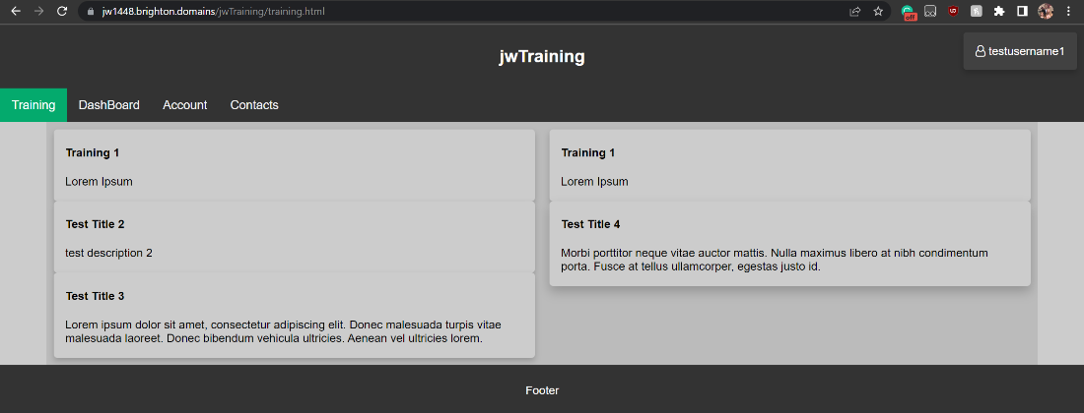

*Figure 208: dynamic creation of cards with JSON object from fetch request (UI)*

After experimentation and user input from observational testing, the implementations visible in figure 209 were decided as the best CSS alteration to accommodate generated cards. Margins were added to the bottoms of cards and paddings in the bottom of the first column and top of the second column would be set to 0 on mobile view to keep the margins the same instead of being extended. I reaffirmed the design with my potential users and found that with was both consistent, easy-to-understand and visually appealing.

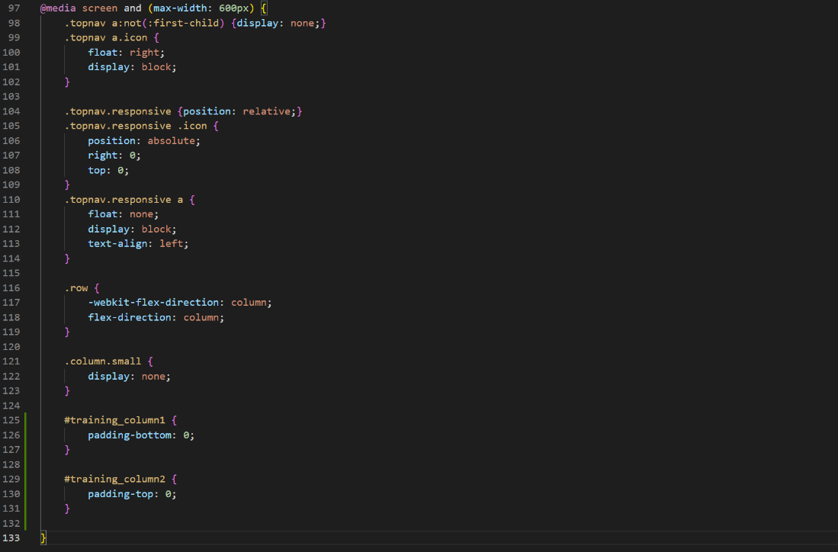

*Figure 209: CSS on mobile view to accommodate dynamic cards*

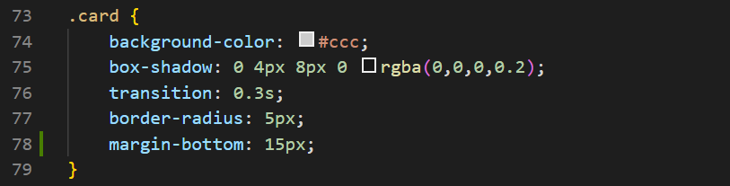

*Figure 210: CSS on cards to accommodate dynamic cards*

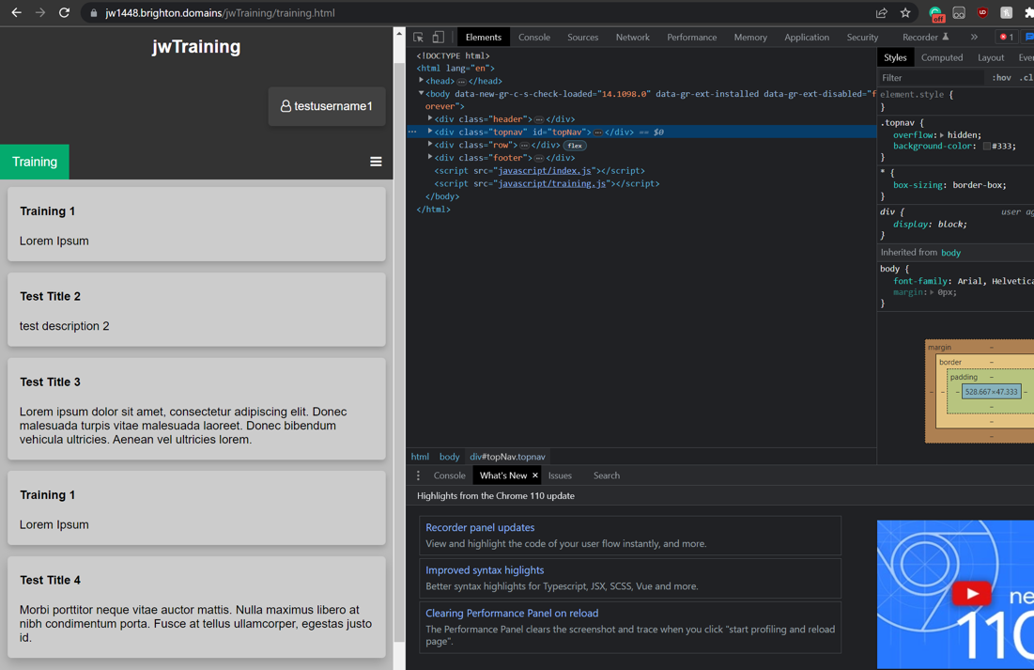

*Figure 211: UI of training page with updated CSS (mobile view)*

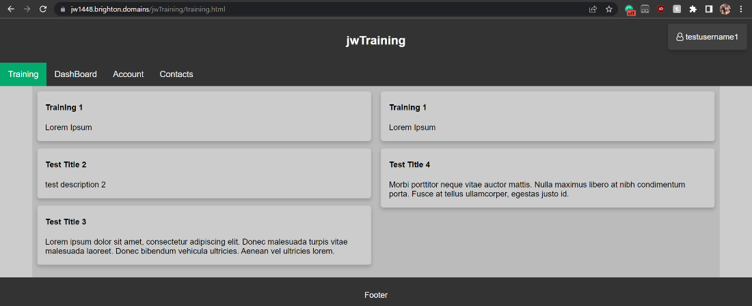

*Figure 212: UI of training page with updated CSS (desktop view)*

Now I had cards that were being generated with content from the database with their valid information and formatting. The last thing to do was make it so these cards held links to their corresponding articles so that there was a method to navigate to the articles other than manually with the URL. For this I made use of the article ID I was returning from the API and used it in the link I appended to the titles. This was the planned format from the beginning hence why the articles were navigated to with the ID that would be returned as search results. These links appended to the DOM worked without fault and so the training page basically was complete.

With all search results successfully being generated there was no longer any requirement for the placeholder cards and so they were removed.

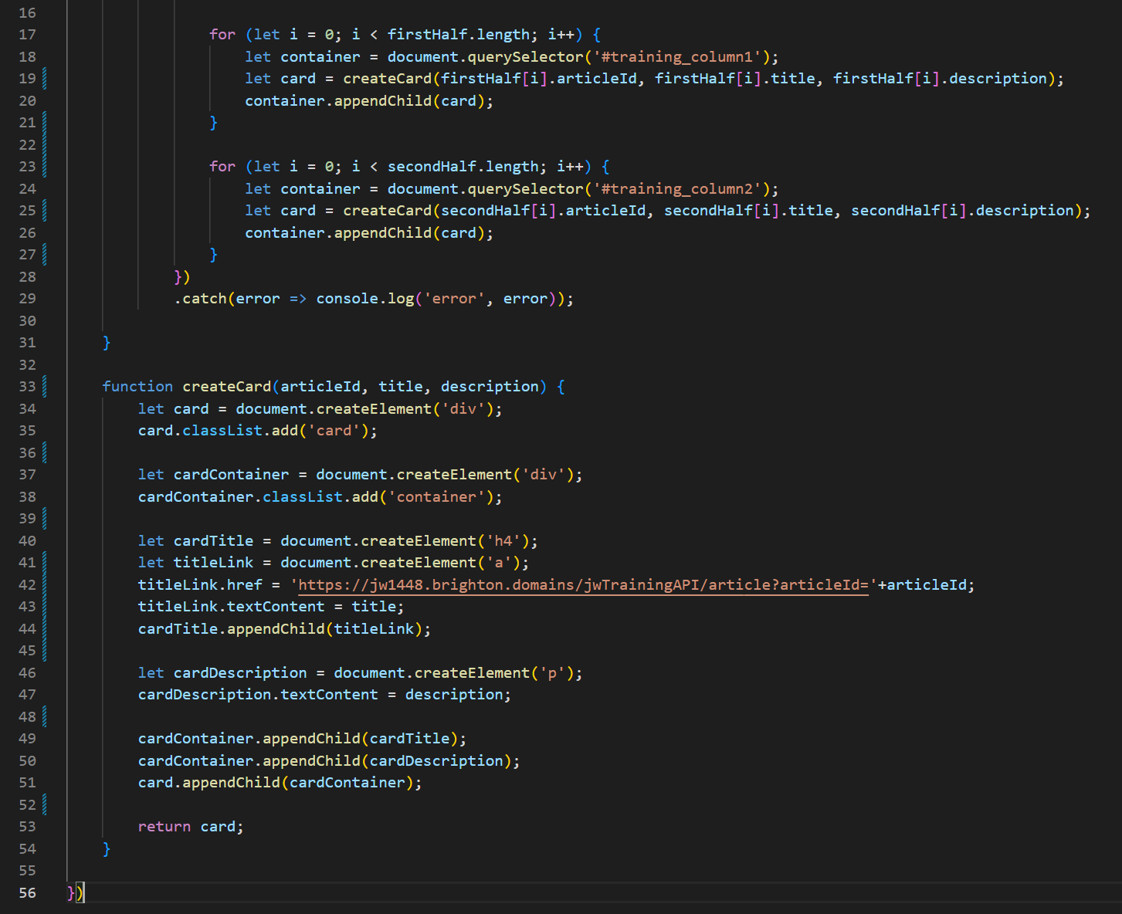

*Figure 213: dynamic cards creation and appending to DOM with links*

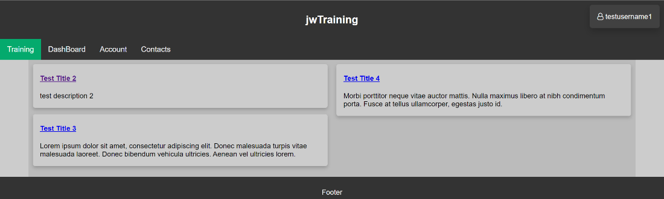

*Figure 214: training page UI with placeholder cards removed and links*

### 02/03/23

Next the progress bar needed to be added to the page to complete the layout. I created progress bar using basic CSS and HTML alongside a JavaScript function that would set the progress to the input percentage. This would later be used to update the progress bar to the users actual progress given by the API but for now I just set it to 50%. Other CSS and HTML elements had to be changed (such as the additions of more rows and columns) to divide the page appropriately with the correct formatting and structure, such as how the progress bar needed to be centred and outside of the two results columns.

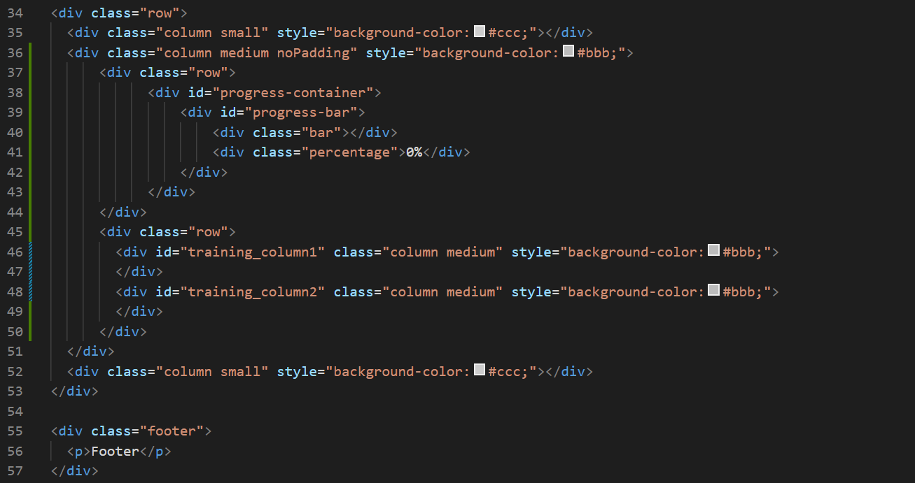

*Figure 215: creating progress bar in HTML*

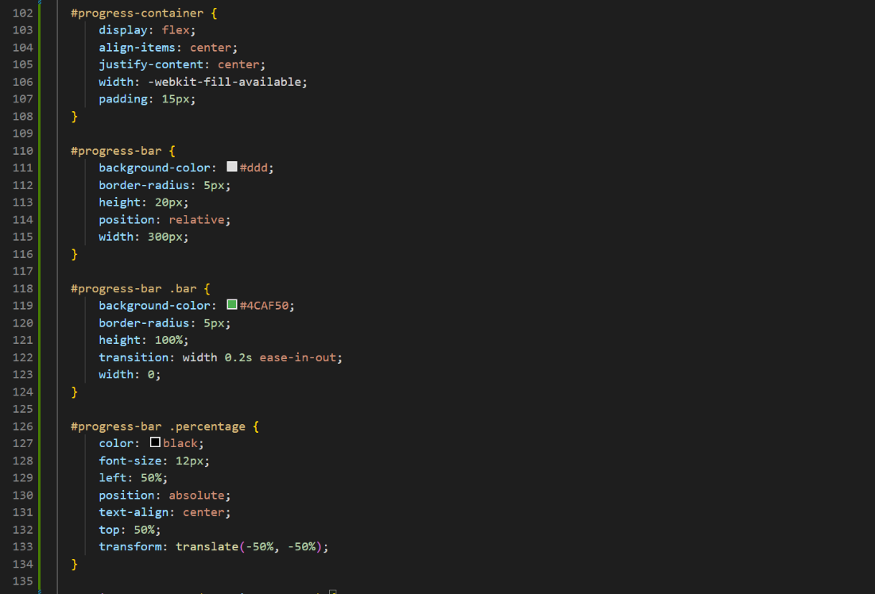

*Figure 216: CSS for progress bar*

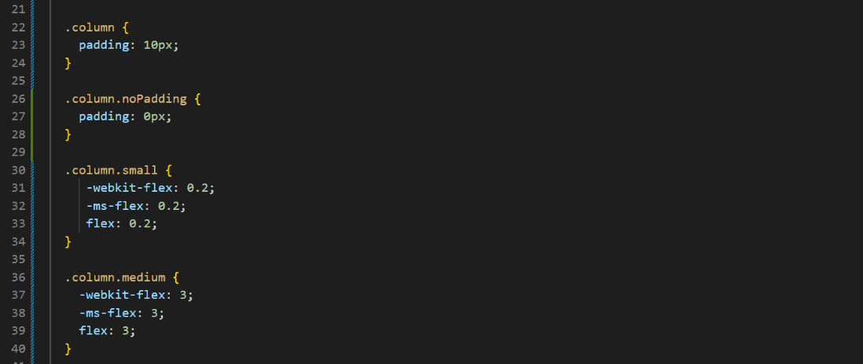

*Figure 217: CSS for adapting page for progress bar*

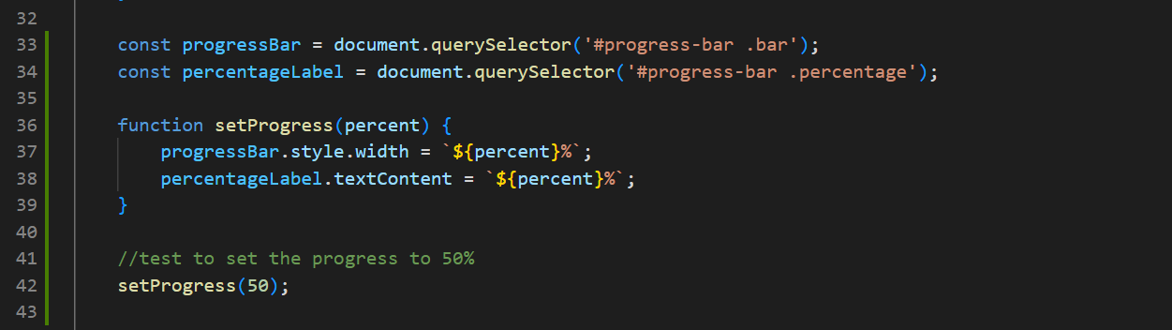

*Figure 218: JavaScript for setting the percentage of the progress bar*

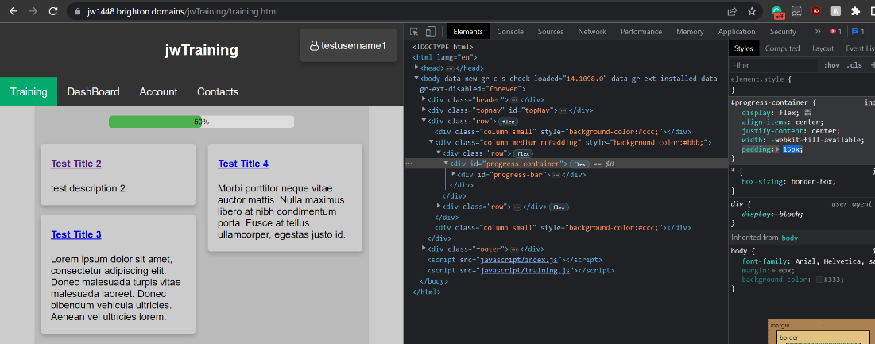

*Figure 219: training page UI with progress bar*

Below is an example of how I tested all functions on universities computers in different browsers to test compatibility. On this occasion all was functional but links needed to be added to ejs file as it was a small task that hand been neglected. I should mention that the site as a whole was also frequently tested on ios with Safari.

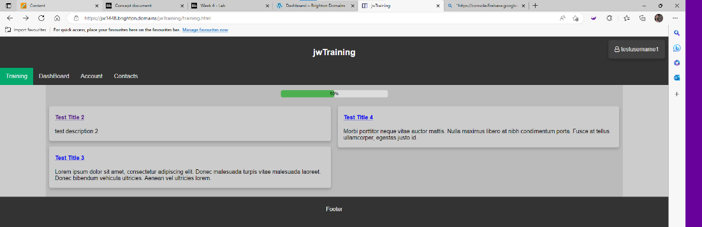

*Figure 220: training page UI with progress bar on Edge on different device*

### 04/03/23

Having already debated how best to store the quizzes in the database, I followed through on that plan by using a JSON object format and storing it in the quiz content column of the articles. For the time being, I've made the quiz using random trivia. The JSON object would always follow the same format, an array of quiz elements, each containing a question, an array of answers and the index of the correct answer. The restriction on length had to be lifted to hold this content but this isn't a security risk as there are no endpoint on the API that alters quiz content.

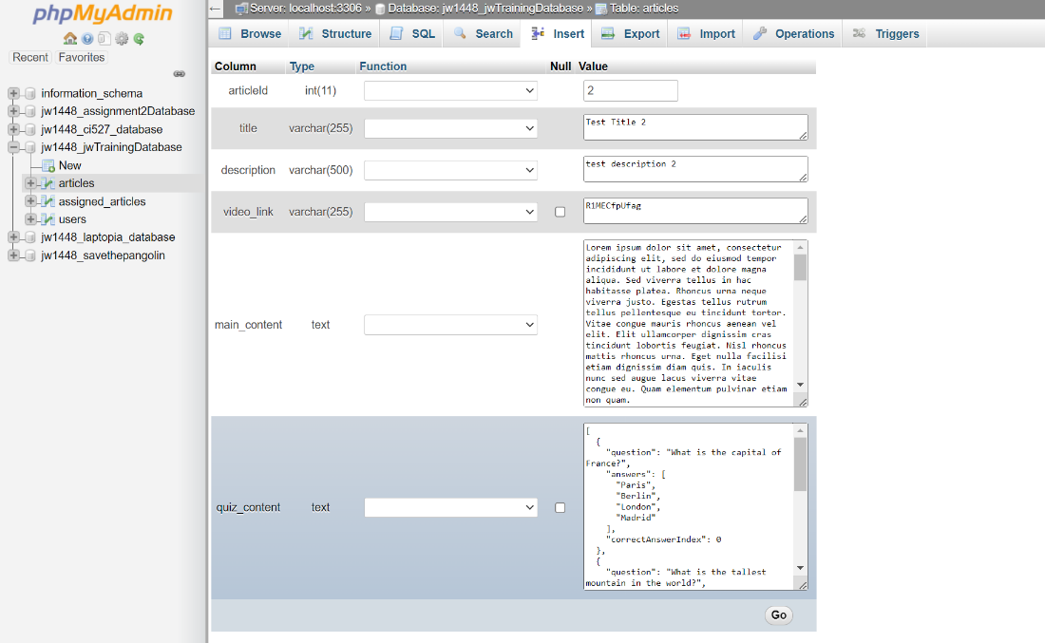

*Figure 221: updating article entries to hold quiz in JSON format*

I then altered the endpoint for rendering the dynamic pages to include the quiz content stored in the database. This would be passed into the EJS template as a parameter alike all the other elements.

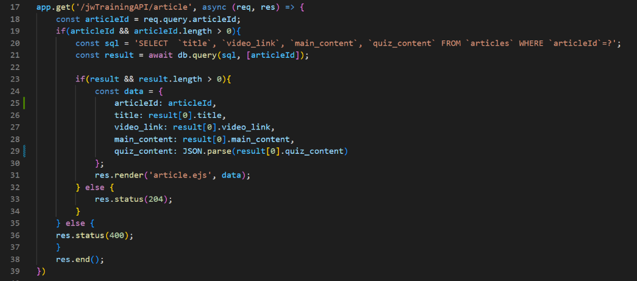

*Figure 222: rendering of EJS template including quiz content*

The EJS file then had to have JavaScript code implemented to generate the quiz. The code may look convoluted but its simply navigating through the JSON object and creating the amount of question elements listed in the array and all potential answers listed below them with their indexes to test them later. This took a while to design but it was due to not being able to decide on the best format to generate the quiz in.

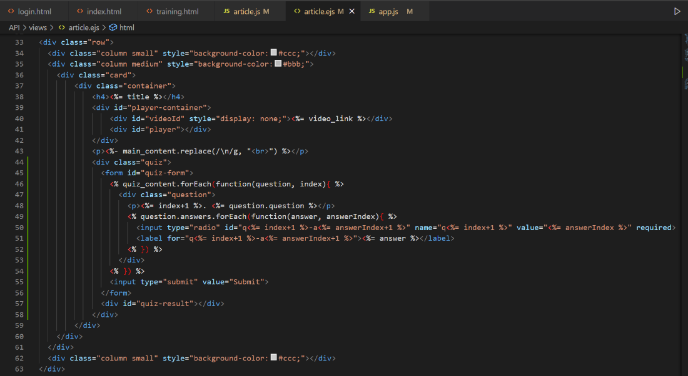

*Figure 223: EJS template dynamically creating quiz*

Accompanying JavaScript was created to grade the quiz using the index of the answers compared with the correct answers index. I decided to make it so that above 70% was a pass and would later add code to update the database if the grade was above this 70%. The results message would display onscreen, the code was designed for any given amount of questions and answers making it flexible and the quiz would refuse to be graded if not all questions had been answered. I had to use prevent default to prevent the page from reloading upon click of the submit button.

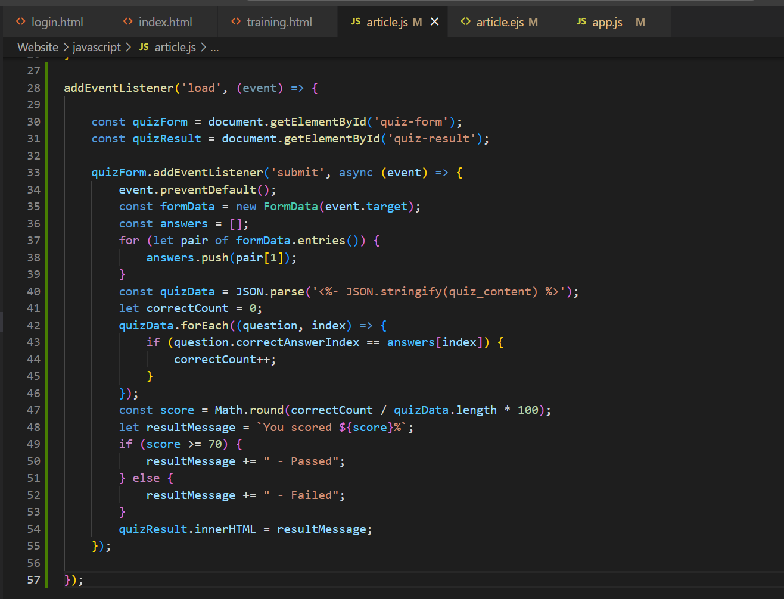

*Figure 224: JavaScript for grading the dynamically generated quizes*

A brief logic error was made as quiz_content was only accessible from the EJS file during its rendering, so to use it in the JavaScript it was declared as a global variable in EJS so that it could be called from elsewhere. After this error was fixed the pages for articles were successfully generating the quizzes that would be used to tick them off as completed. While they could have been added as a hidden element, those who have knowledge of the developer tools would then easily be able to locate it and cheat.

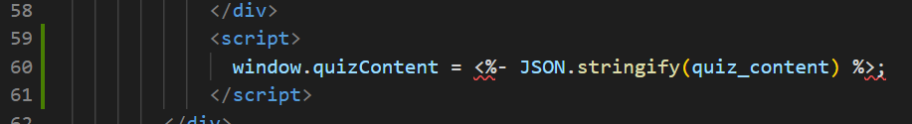

*Figure 225: EJS file setting quiz content as a global variable to be accessed by JavaScript*

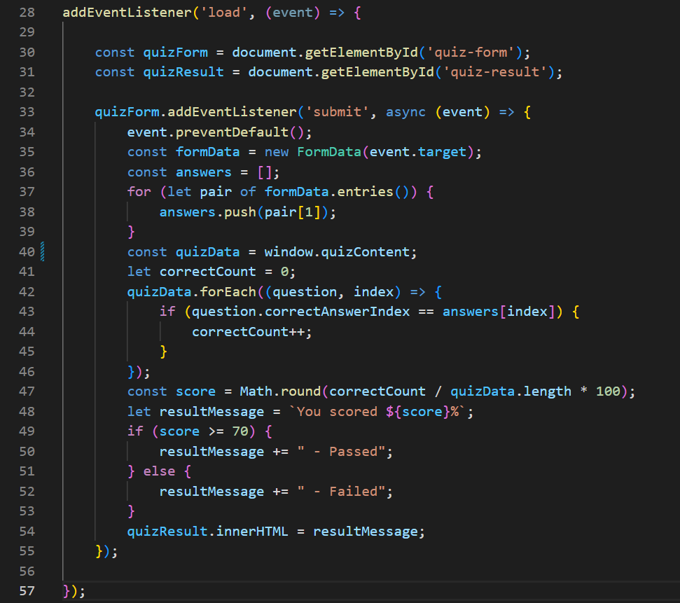

*Figure 226: JavaScript file accessing quiz content as a global variable*

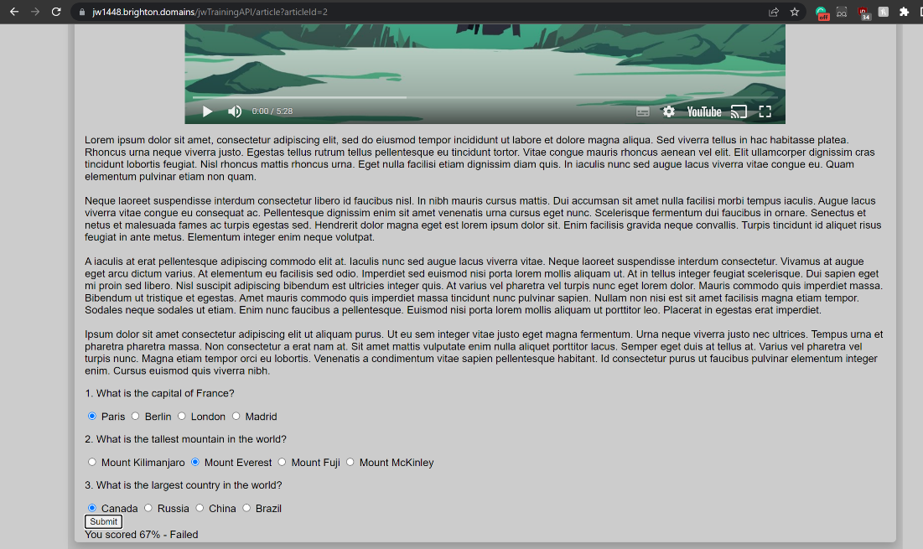

*Figure 227: basic quiz generated on UI displaying article*

Another logic error was located and fixed, as the get training method for displaying the cards onscreen would have only ever used cookies to get training cards despite checking if for session values or cookies. I changed it to account for session values as well and save either or under a variable that would be used in the request. This new format would be used for all similar code that would need to authenticate before the request could be carried out.

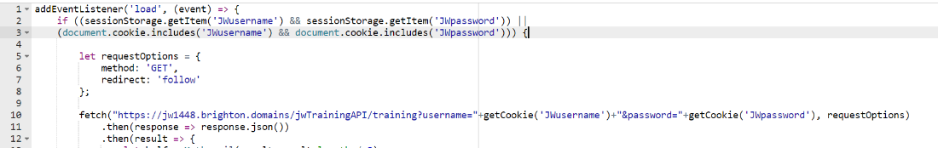

*Figure 228: erroneous creation of get training request*

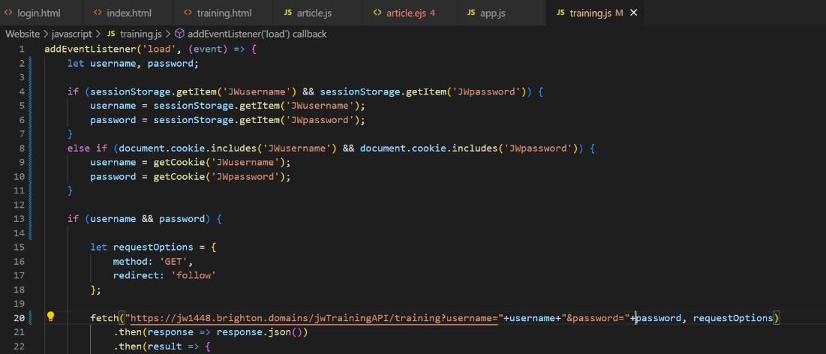

*Figure 229: creation of get training request altered to accommodate session values*

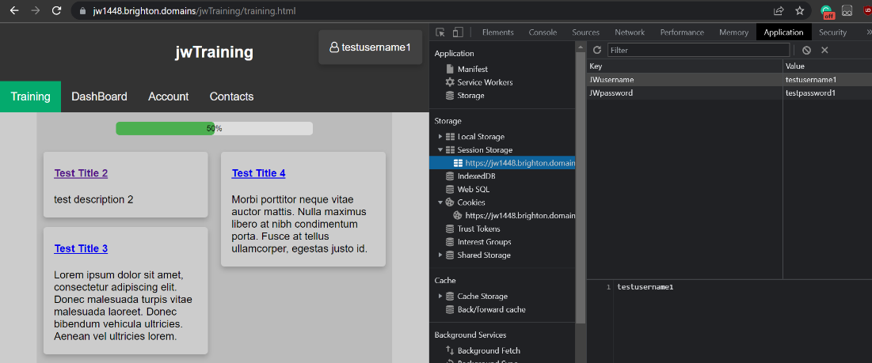

*Figure 230: training page now functioning with session values rather than cookies*

Now I had considered and practiced how I would have to set global variables in EJS or use them as hidden elements I set about setting additional global variables in EJS to be used by JavaScript. In this case I would need to use the article ID to update the database by marking the article as complete for the logged in user. I tested the global variables by attempting to access them in the console of the page.

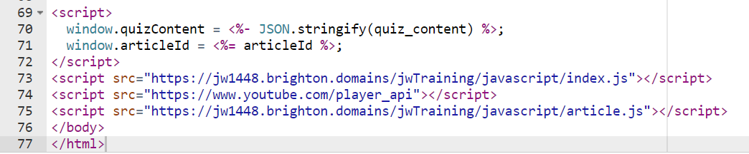

*Figure 231: setting additional global variables in EJS template*

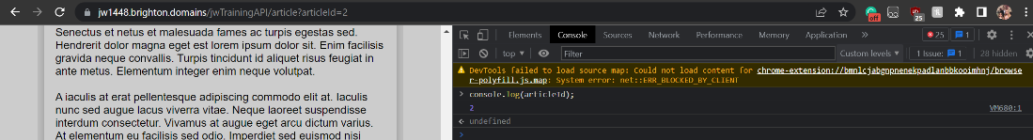

*Figure 232: logging global variable article ID in console*

While getting the JavaScript ready to contact API after the quiz I needed to add the code to get the authentication credentials. I reused the code I had early made to fix the logic error to make sure it would account for either format (cookies or session values).

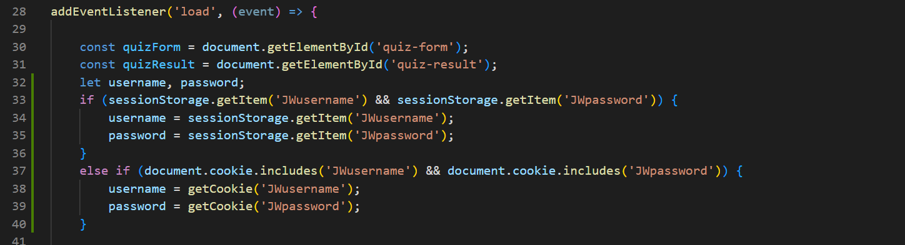

*Figure 233: getting users credentials before quiz submission*

I then added code to the JavaScript to contact then appropriate endpoint on the API after the quiz had been marked above 70%. While this endpoint had yet to be handled on the API, I saw no problem in setting up the client-side code before the server side in this case. I checked that the appropriate information was being sent in the network tab of the developer tools and moved on.

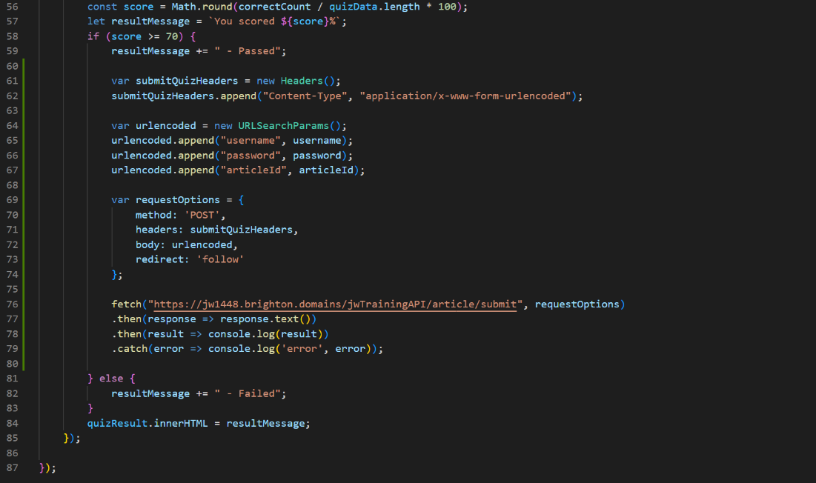

*Figure 234: code to send request to mark work as complete after quiz score is above 70%*

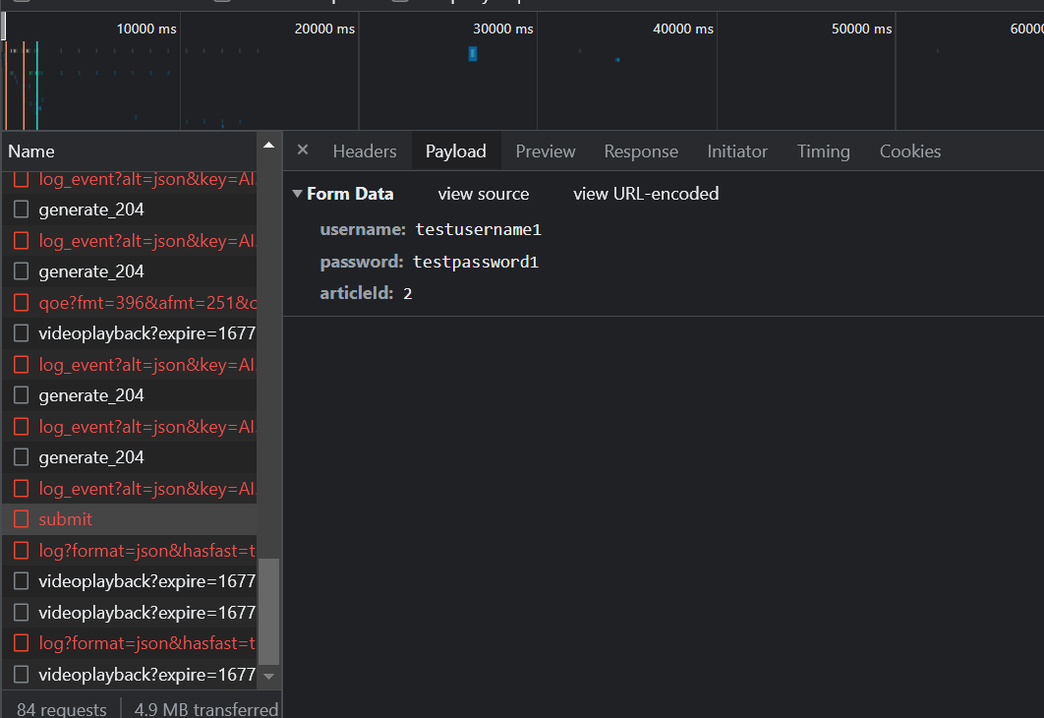

*Figure 235: network tab display of payload of submit quiz request*

I set about creating this endpoint in the same conventional method I had been using. This code would authenticated the user, get their ID and user it to alter the row in the assigned articles with both the user and articles ID in common. Altering this row by setting the completed column to true would mark the work as complete and the work would no longer show up as assigned on the training page (for this example shown below user 1 and article 2 are used). The test was immediately successful, but I manually set the altered row as incomplete afterward so that I wouldn’t need to keep assigning new articles just to test features.

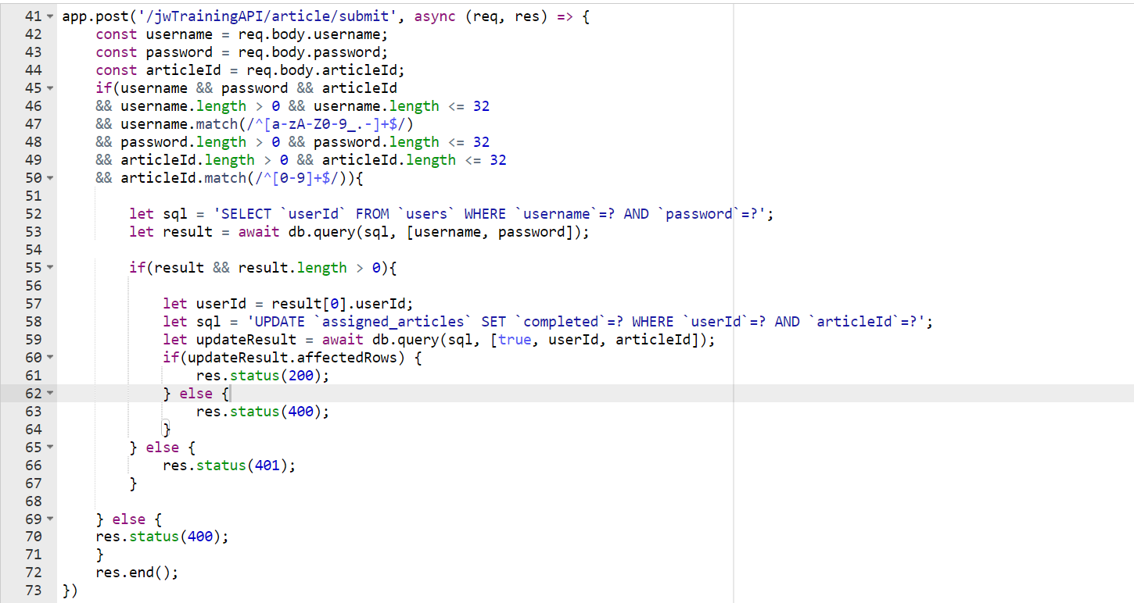

*Figure 236: API endpoint for setting work as complete*

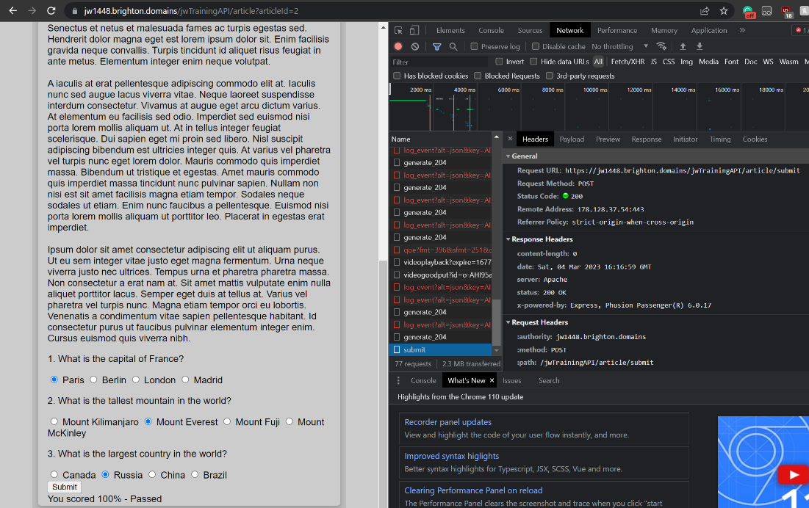

*Figure 237: request successfully sent from quiz on article UI*

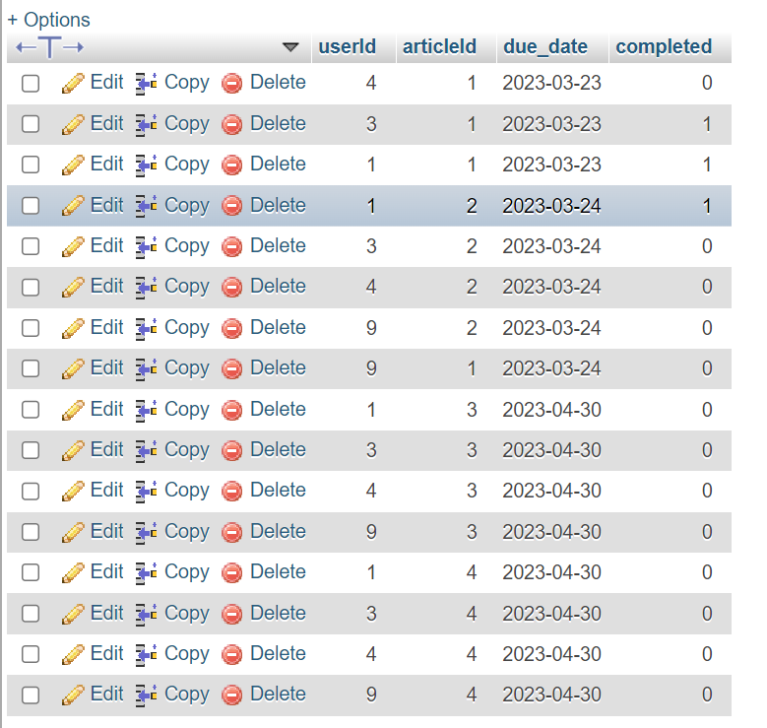

*Figure 238: row successfully marked as complete after quiz submit to API*

However, while this feature was currently successful I knew that if a user knew how to access and use the developer tools then they would likely be able to sign their work off without completing the work and so I wanted to verify their results on the server side as well. This way they couldn’t just access to API to complete work and would need to actually know the answers which proved they had completed the work. The post quiz handling code was converted to the usual usage of an async method for better error checking and to hold more control. The error checking comes in due to the fact that the request would simply say pending when unsuccessful, by changing the code I had an instant error status code to display what had gone wrong. I appended the answers from the user to the post request as an array to be compared with the actual answers.

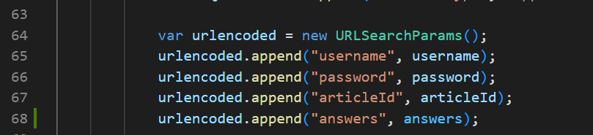

*Figure 239: appending array of users answers to post request*

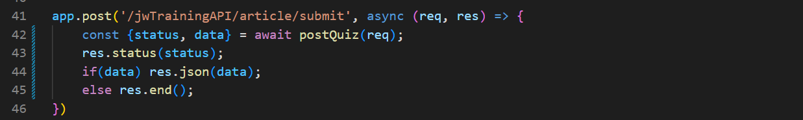

*Figure 240: converting quiz submission handling code to await/async method*

The code was changed to get the quiz content from the article that was about to be set as complete, compare the users answers to the real answers found in the quiz content and only set the work as complete if the percentage score was above 70% (just like on the client side). This code would not invalidate the checking on the client side as the client grading would efficiently inform the user instantly of their score. I returned the percentage score for demostration and testing purposes to show success.

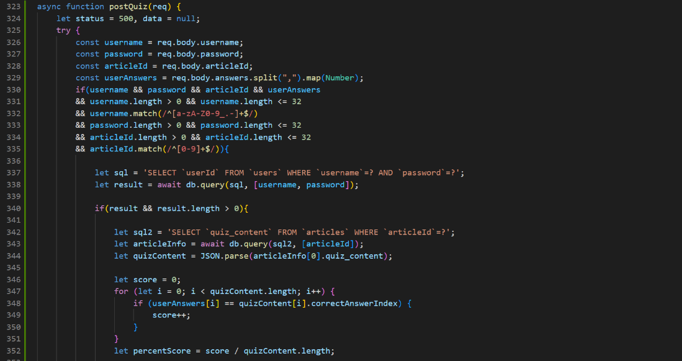

*Figure 241: function to grade quiz results and mark work as complete if score is above 70% (part 1)*

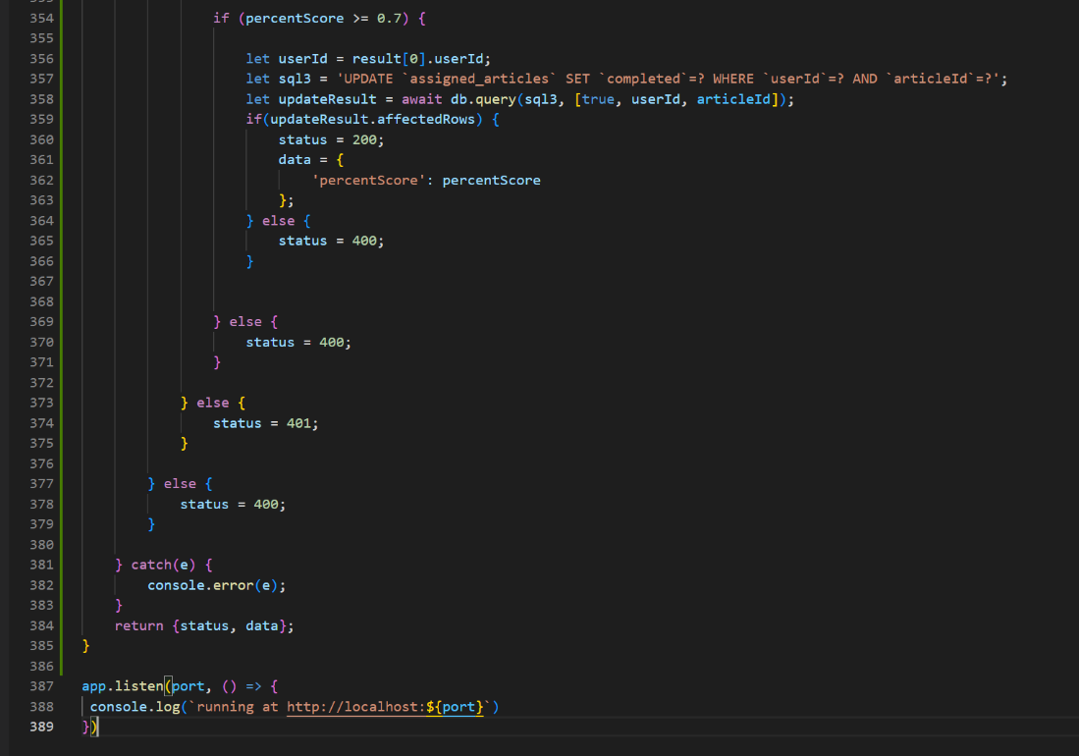

*Figure 242: function to grade quiz results and mark work as complete if score is above 70% (part 2)*

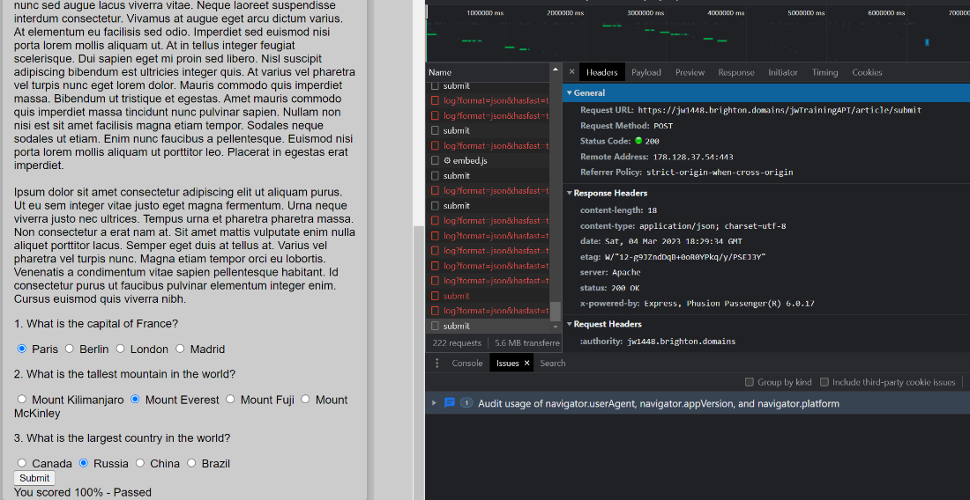

*Figure 243: new request being sent with successful response (UI)*

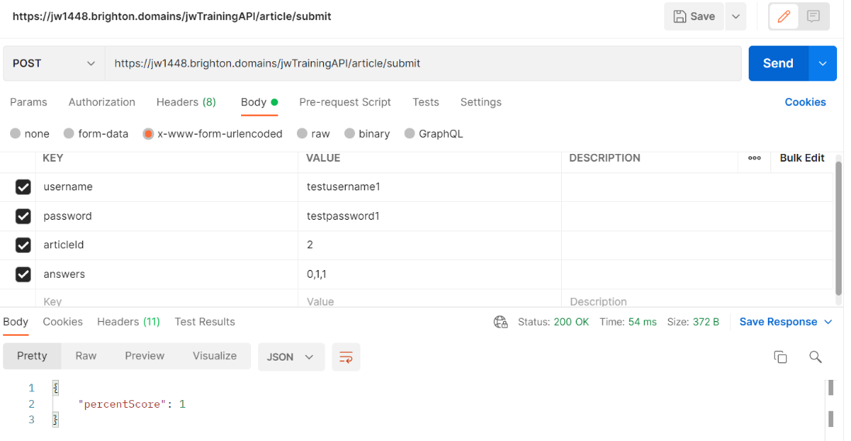

*Figure 244: new request being sent with successful response (Postman)*

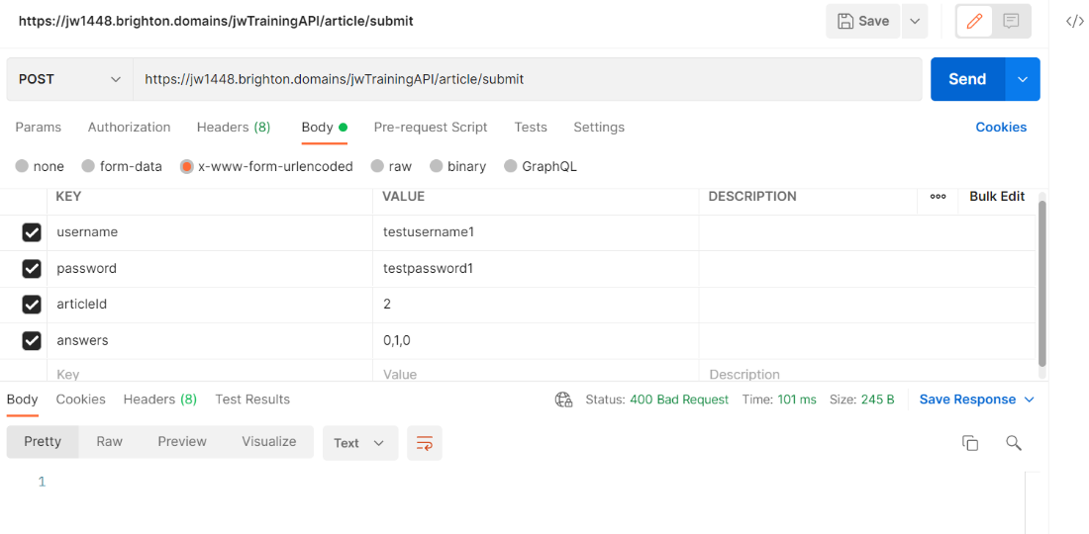

*Figure 245: new request being sent with unsuccessful response due to wrong answers*

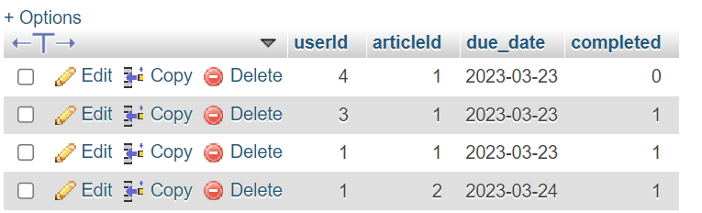

*Figure 246: alteration to database proving functions success*

One of the reason this feature took so long to implement was because an error was preventing the code from being executed after I was checking the answers on the server-side. For a long time I removed code until it was functional again and found that it was the comparison between the users answers and the real answers that was causing a status error 500. So I started returning all my variables in the response JSON object until I realised what was happening. At some point in the process of handing the answers array between the client and server side it was being converted to string and was no longer an array on integers. So, code was implemented to change them back to its original format and then the code was functional again. This debugging took a long time as I couldn’t visibly see a console as I was working directly on the server. This was remedied by using the JSON response and so there was no disadvantage to this practice. It was likely body parsers usage which converted the array to a string.

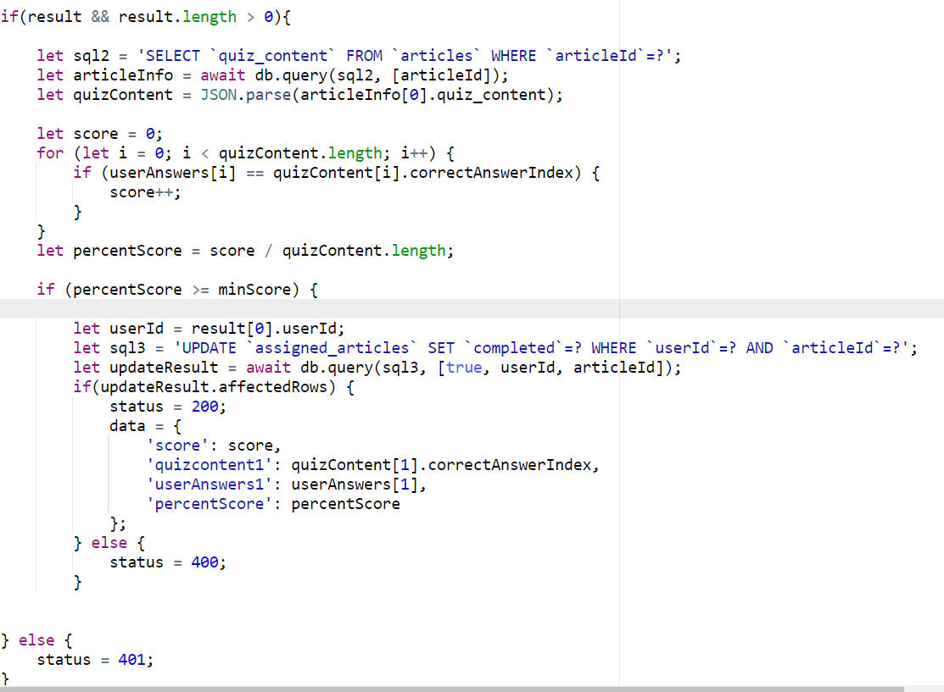

*Figure 247: code used to debug the submit quiz function*

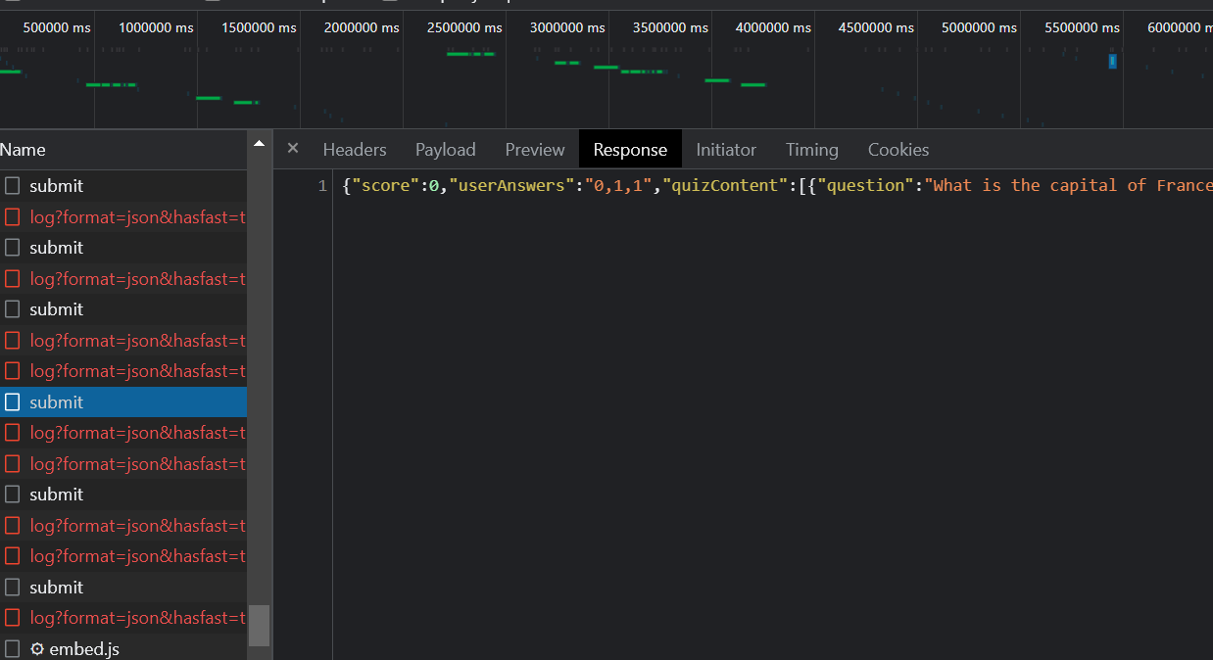

*Figure 248: response from debugging code 1*

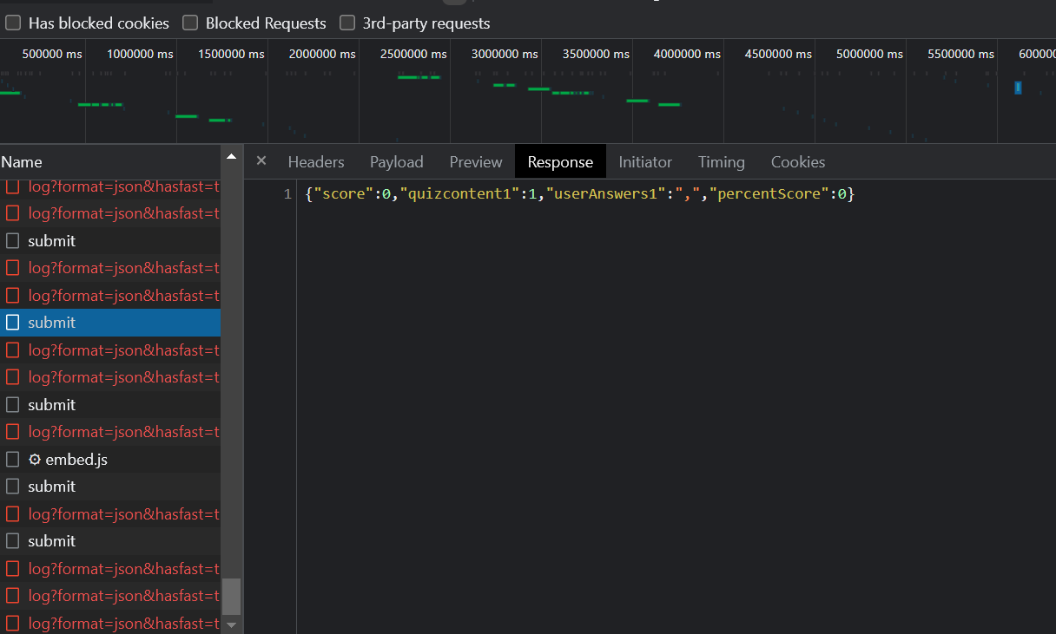

*Figure 249: response from debugging code 2*

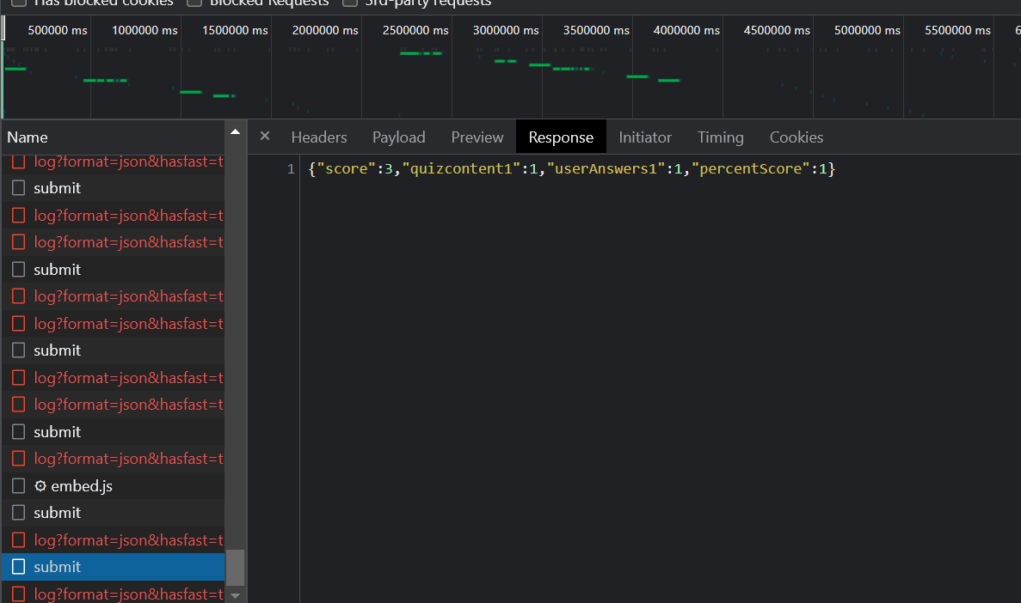

*Figure 250: response from debugging code 3 (using correct code)*

After all of this the only thing left to do was check if the training page was no longer displaying the assigned training as a result which it predictably was not.

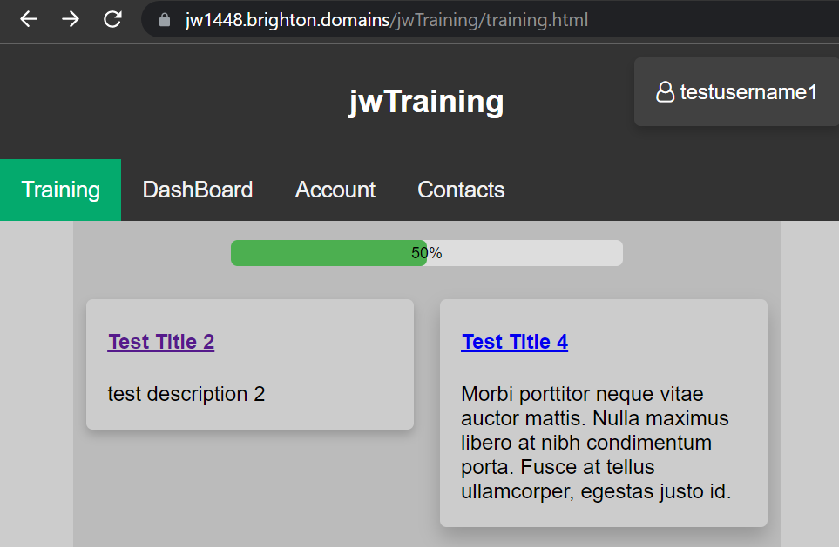

*Figure 251: result removed from training page UI results after successful quiz submission*

### 06/03/23

I included job_title in the response to the login function so a message could be displayed asking user to wait or contact administrator if the job title was the same as “unassigned”. I tested it in Postman as usual to confirm it still functioned in the intended way.

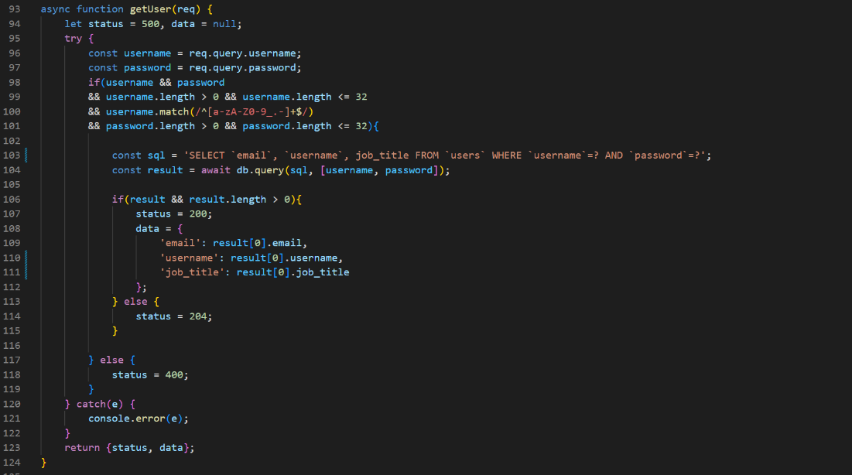

*Figure 252:*

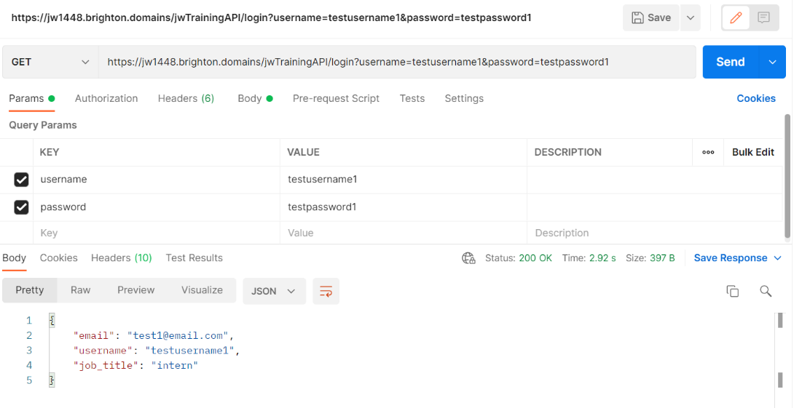

*Figure 253:*

As was noted as a task that need to be completed earlier on, the EJS template had it link attached to the navigation bar. This can be visually seen in the console displayed below.

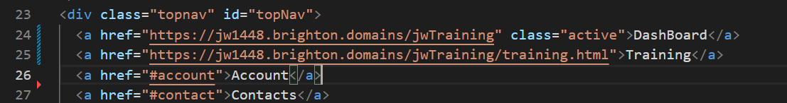

*Figure 254: adding links to EJS template navigation*

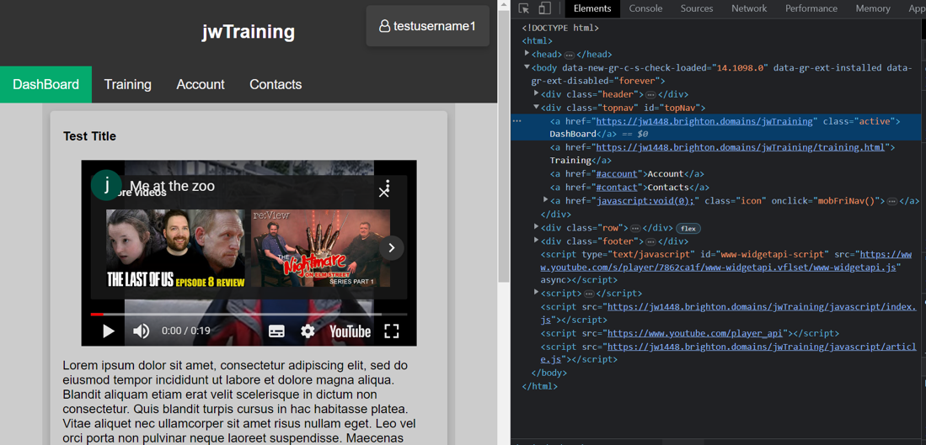

*Figure 255: articles with links in navigation bar*

I added a message to the dashboard that would have its visibility automatically set to null. It would then only shown if the job title from the authentication's response was equal to “unassigned”. This message would inform the user that they need to wait for their account to be validated by an admin and so must either wait or contact them.

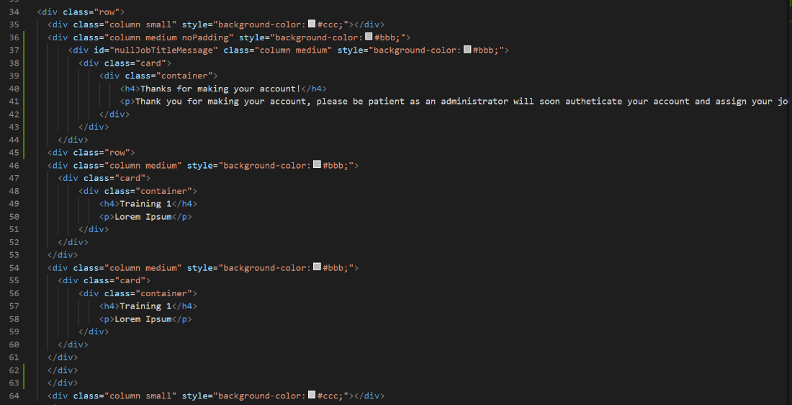

*Figure 256: unassigned job for account message added to html*

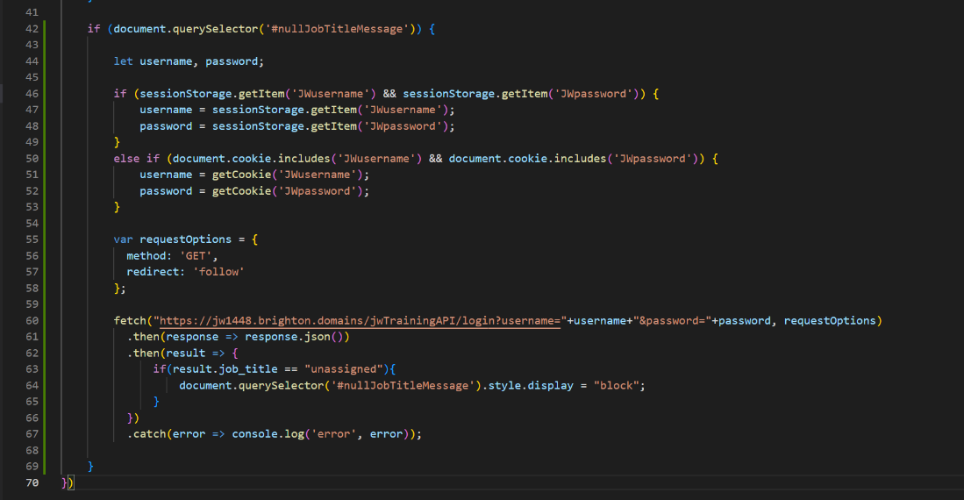

*Figure 257: display message if authentication holds “unassigned” as job title in response*

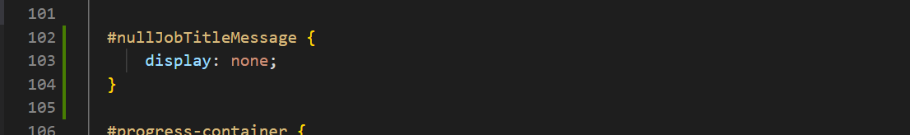

*Figure 258: automatically have message hidden*

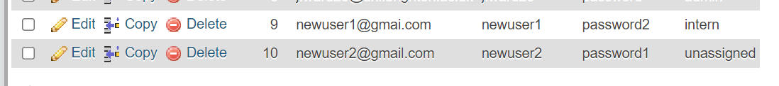

*Figure 259: unassigned user in database*  
  
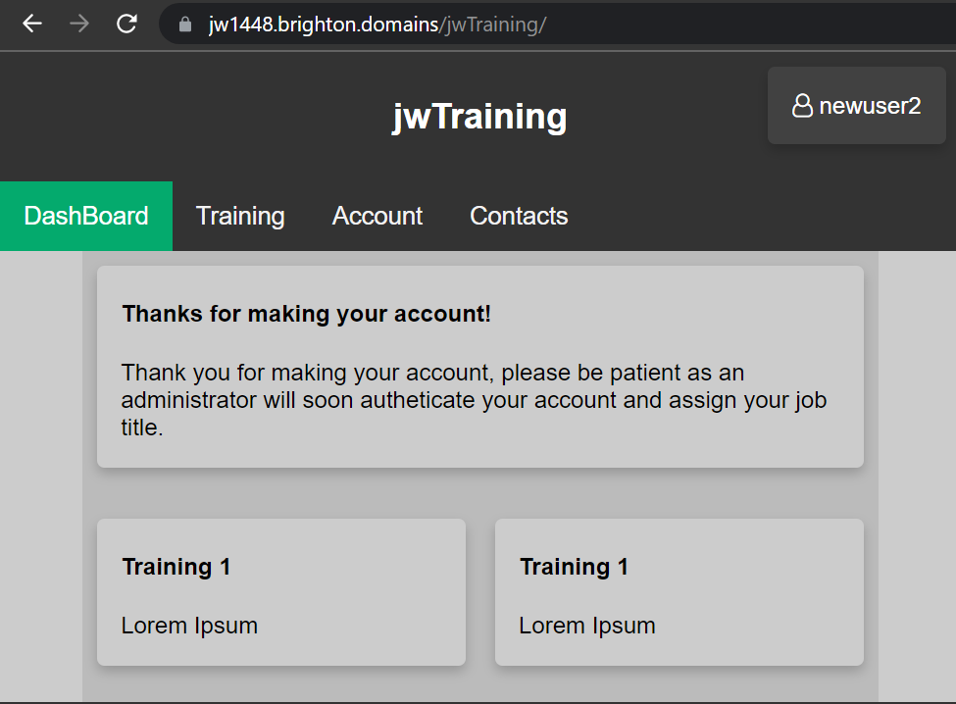

*Figure 260: unassigned users dashboard UI view*

I realised that I had yet to show the user any indication of what work should take priority. So, I went about adding dates to API and training pages. The only standout with this addition was that the date format had to be handled differently due to it being a different data type.

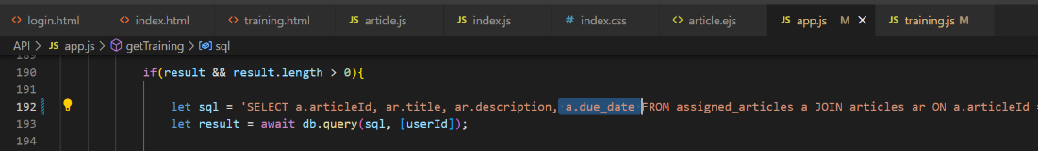

*Figure 261: adding due date to results of get training query on API*

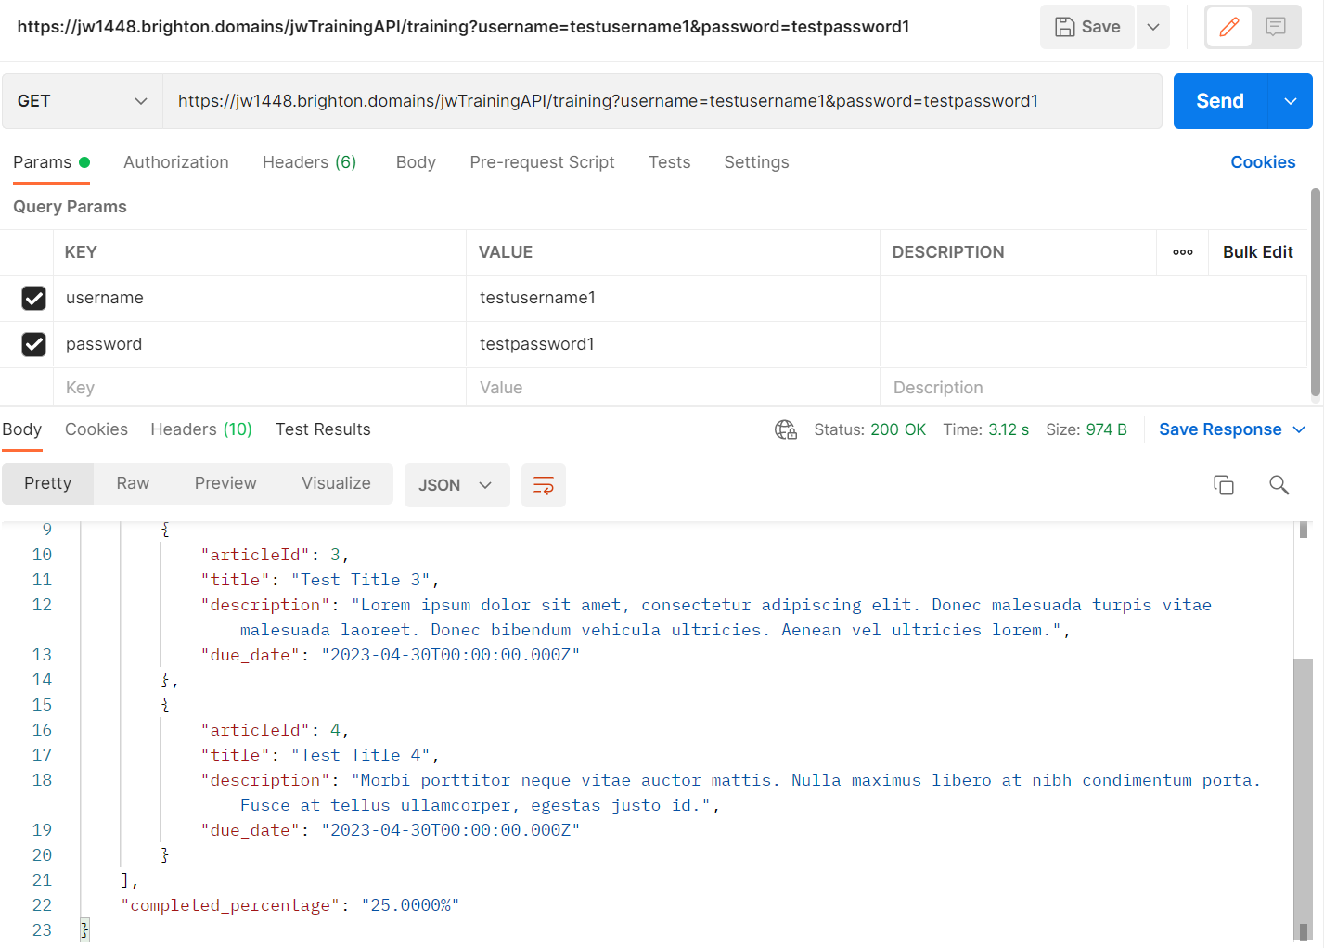

*Figure 262: due dates added to API get training response*

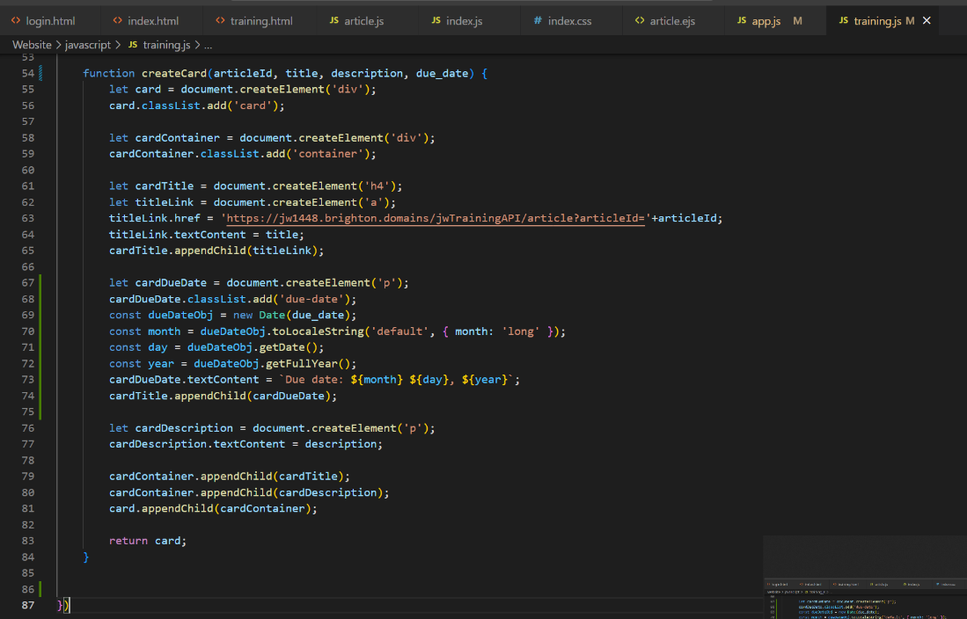

*Figure 263: create card function adapted to add due date to the DOM*  
  
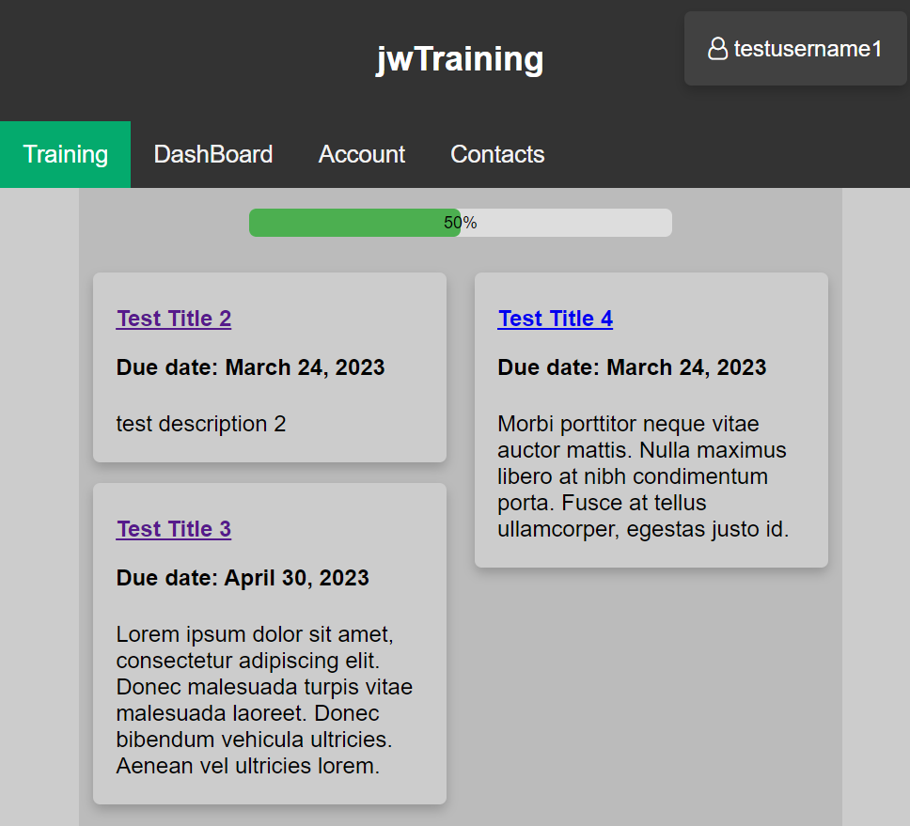

*Figure 264: due dates displayed on cards on training page UI*

### 07/03/23

A logout button was the first addition made to the project this day. Previously the only way to logout was to remove the cookies/session values or wait for them to time out which is both very inefficient and not user-friendly. I placed the logout button in the place I originally designed, a dropdown menu that would be displayed on hover of the username card. I also implemented a profile button in the dropdown menu to eventuate the fact that it is a drop-down menu and to act as a placeholder for a future profile feature if I had enough time to implement it. New CSS needed to be added to the index CSS file as this dropdown menu would need to be used on every page except for the login page. Similarly, the index JavaScript file would need to hold functionality to log users out as it would also need to be shared amongst all page which the index JavaScript file was. Removing cookies would involve setting their due date as a past date and removing session values is a simple function you can call.

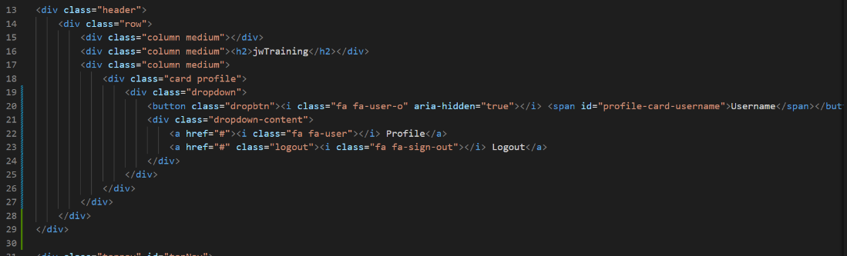

*Figure 265: adding drop-down menu to all HTML except login page*

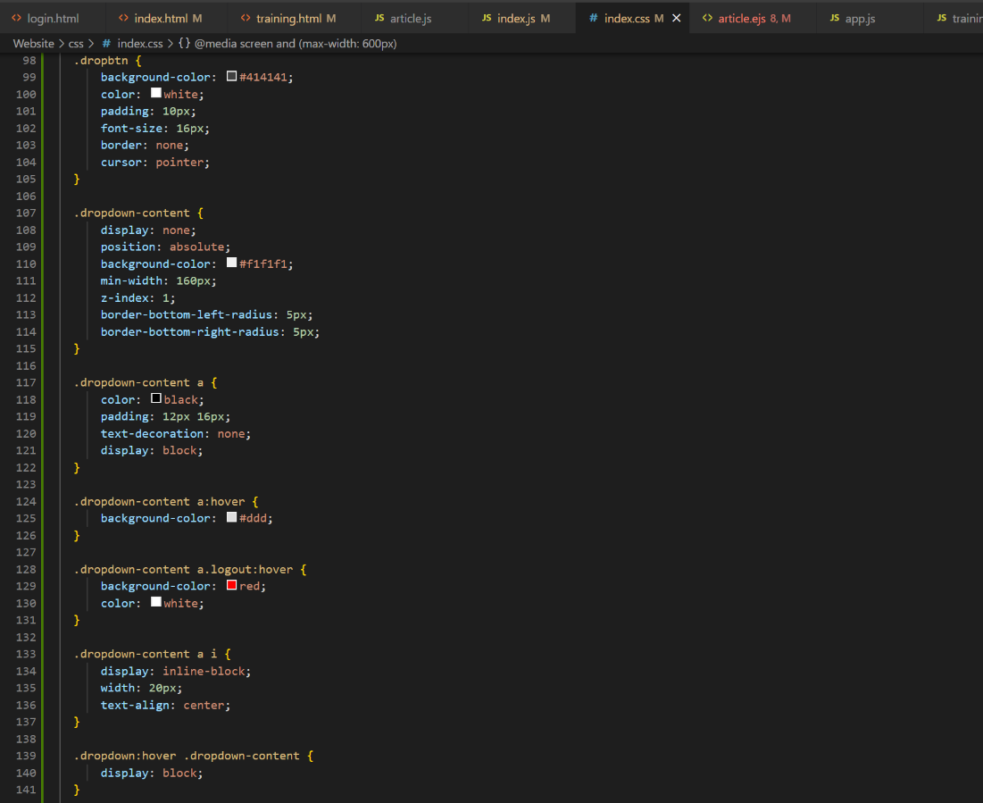

*Figure 266: CSS for dropdown menu and logout button*

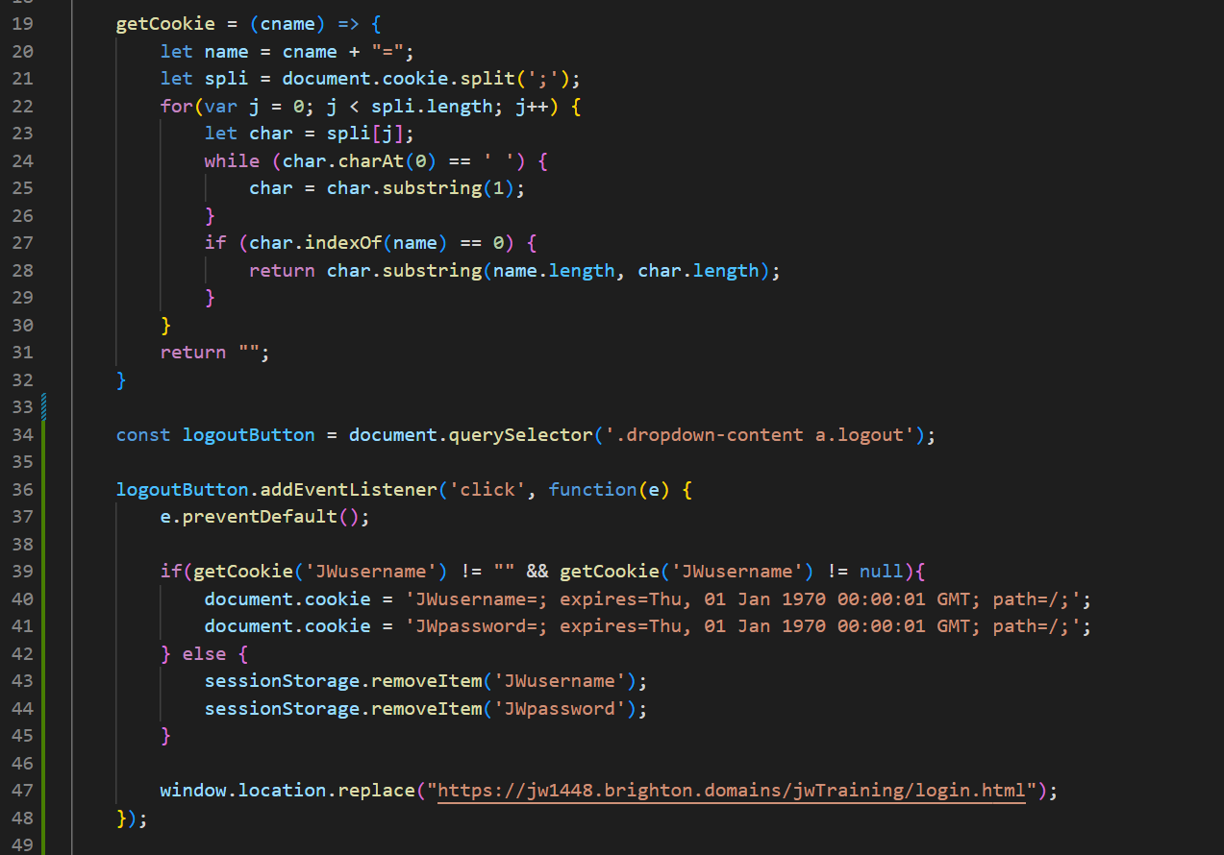

*Figure 267: JavaScript for logging out a user*

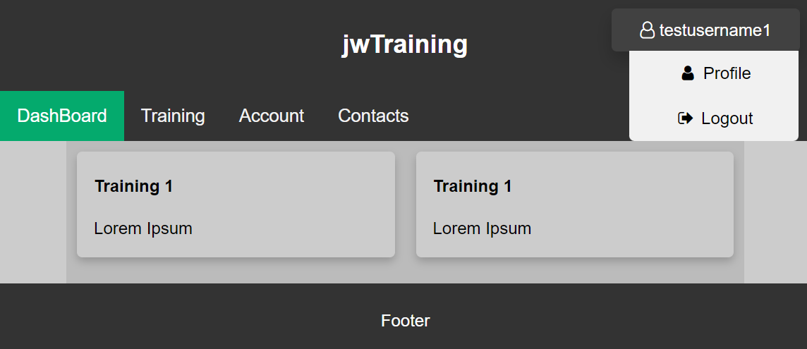

*Figure 268: dropdown menu displayed on dashboard*

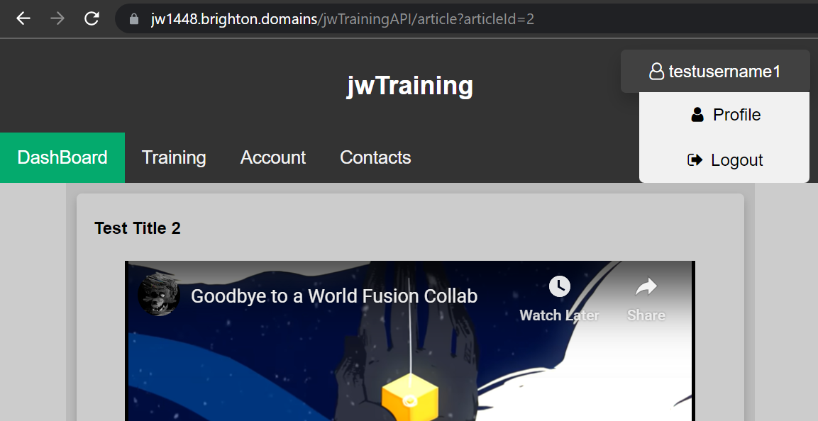

*Figure 269: dropdown menu displayed on article page*

Another minor visual feature to add to all pages was a footer with updating copyright. By adding this the copyright would always be up to date for whatever company currently owned the web application. While no company currently owned this project, I added the copyright as proof of concept using the name of the site as the owning compony. I also decided to change the div with a footer class to an actual footer element to fit conventional practices better. This would be implemented on the login page as well as all others.

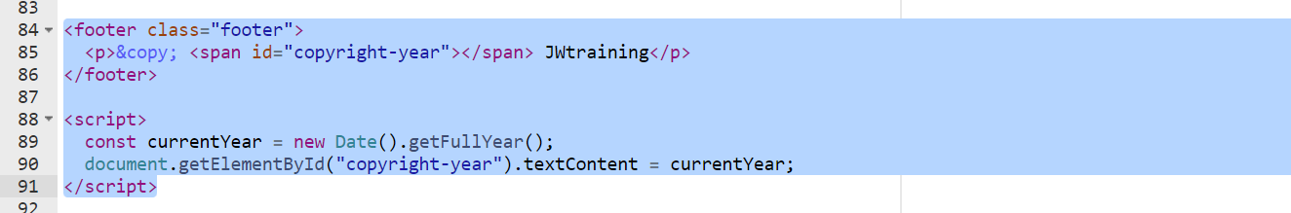

*Figure 270: footer with updating copyright (login code)*

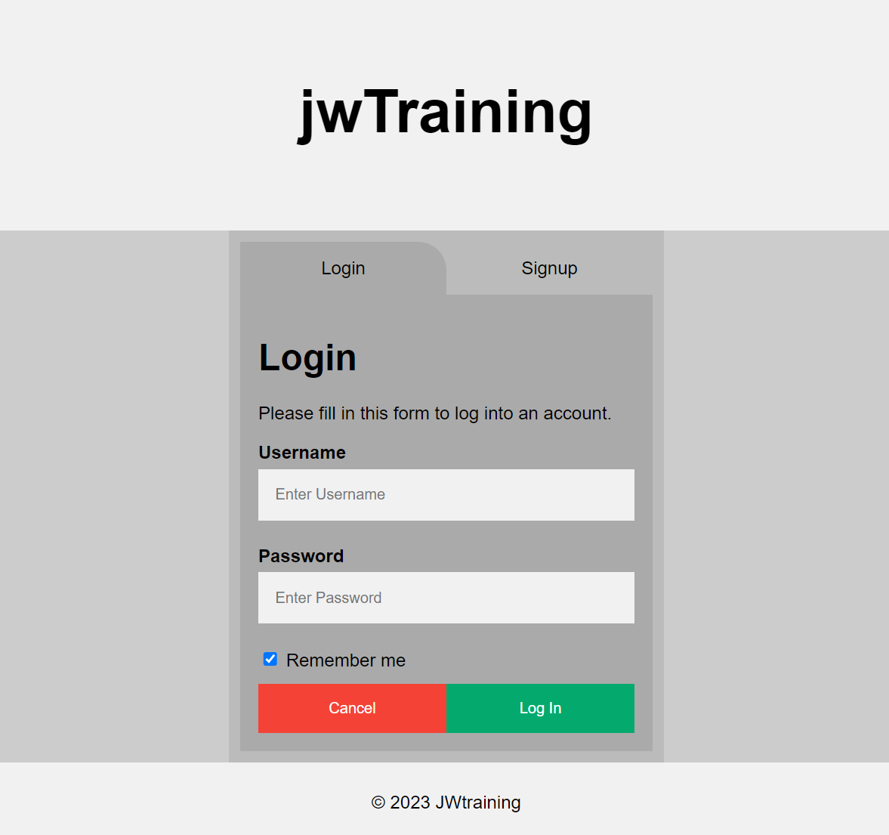

*Figure 271: footer with updating copyright (login UI)*

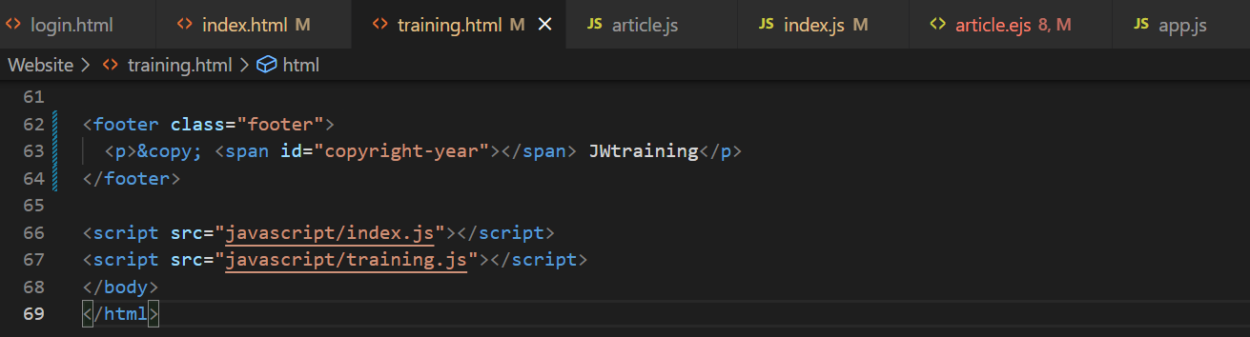

*Figure 272: footer with updating copyright (code)*

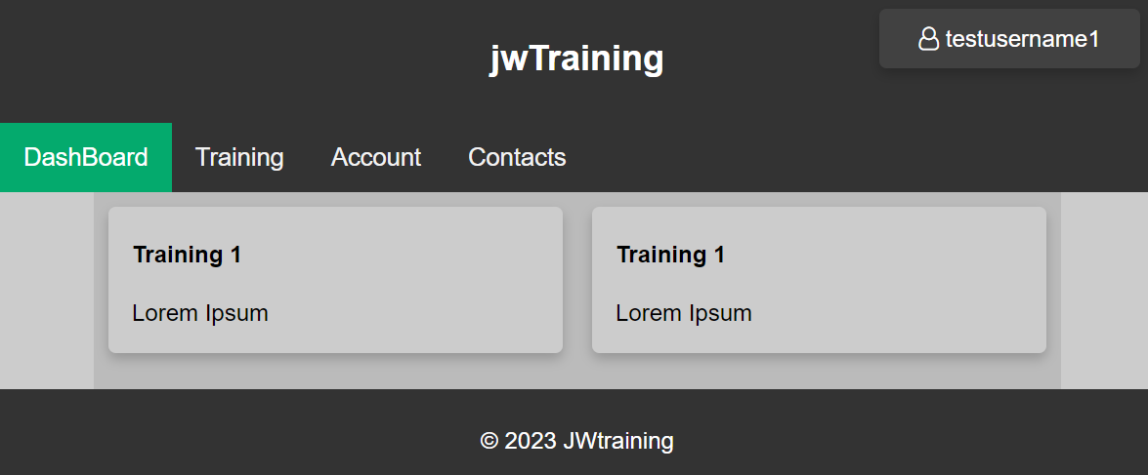

*Figure 273: footer with updating copyright (UI)*

The code for the training page was changed to set the progress bars progress to the actual percentage from the API response. This was yet another very minor change that needed to be made but I needed to revise my conversion between datatypes to use the function I created.

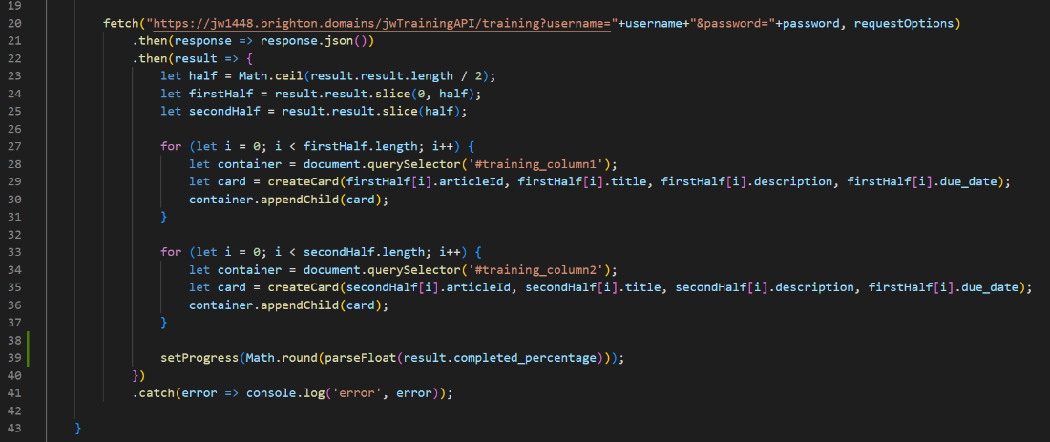

*Figure 274: training page incorporating real completion percentage (code)*  
  
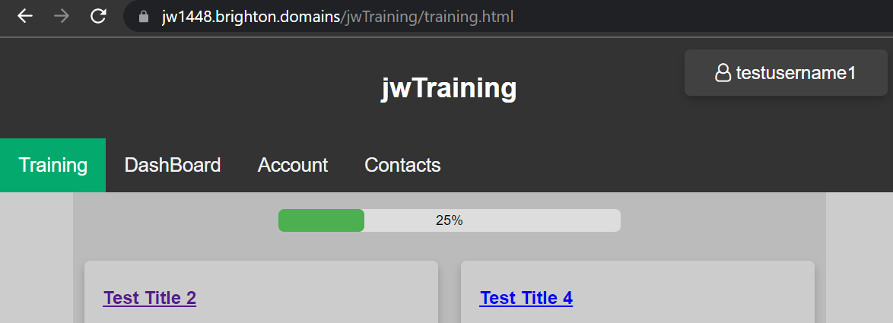

*Figure 275: training page incorporating real completion percentage (UI)*

While I had the code in place to check if a video had finished playing it was no longer appropriate as there was already a sufficient method in place to ensure the user had completed training. This feature would actually be an inconvenience to the user as they may already be familiar with the material, or the video may have all its content written about in the main content. Additionally if no video exists I would have need to account for that. I didn’t what to remove the feature entirely and so deicide to show appropriate message at the end of the video tell user unfamiliar with the site what to do next. This way I had still implemented the functionality I initially pitched but without inconveniencing the user or making inefficient code.



*Figure 276: new alert after video playback (code)*  
  
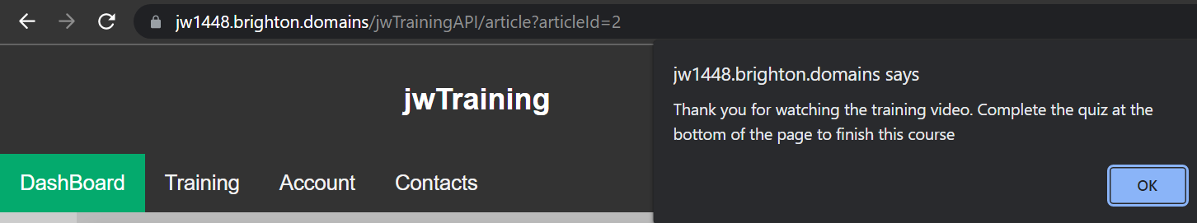

*Figure 277: new alert after video playback (UI)*

The confirmation emails were the next feature I planned to implement this day as I had planned to tackle many smaller tasks. However, this task ended up taking a lot more time than first expected as a lot of trial and error as well as research was required to get it functional. I assumed it would be small task as I knew how easy the sending of emails was to implement in PHP. This is why my backup plan, if I couldn’t get my chosen method to work, would be to outsource to a PHP file.

I chose to carry out the confirmation emails using the conventional nodemailer plugin. So the dependancy was installed by adding the latest version to the package file and running “install NPM packages” on Brighton Domains. The package was also installed locally for any local testing using a local server. It was set as a dependency at the start of the API code.

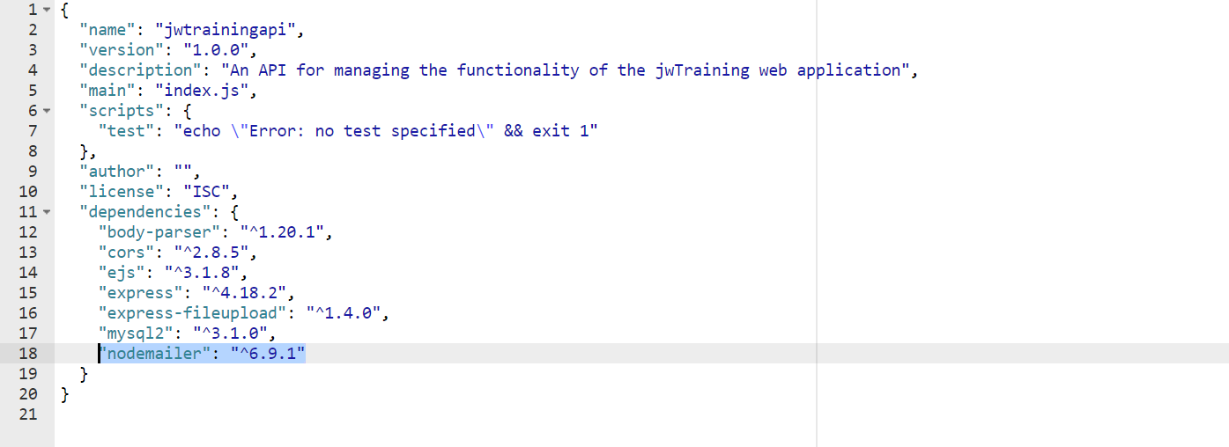

*Figure 278: adding nodemailer dependency to package file*

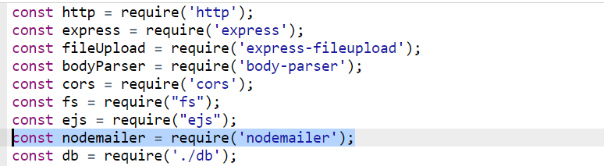

*Figure 279: adding nodemailer dependency to Express API*

A new Gmail account was created to send the emails from so that replies would actually reach the administration of the web application. A new account for the website was created and deleted each time this feature would be tested to see if the email had been sent. With this testing to remain ethical I would be using my own email account as dummy accounts would never show whether or not the email was received.

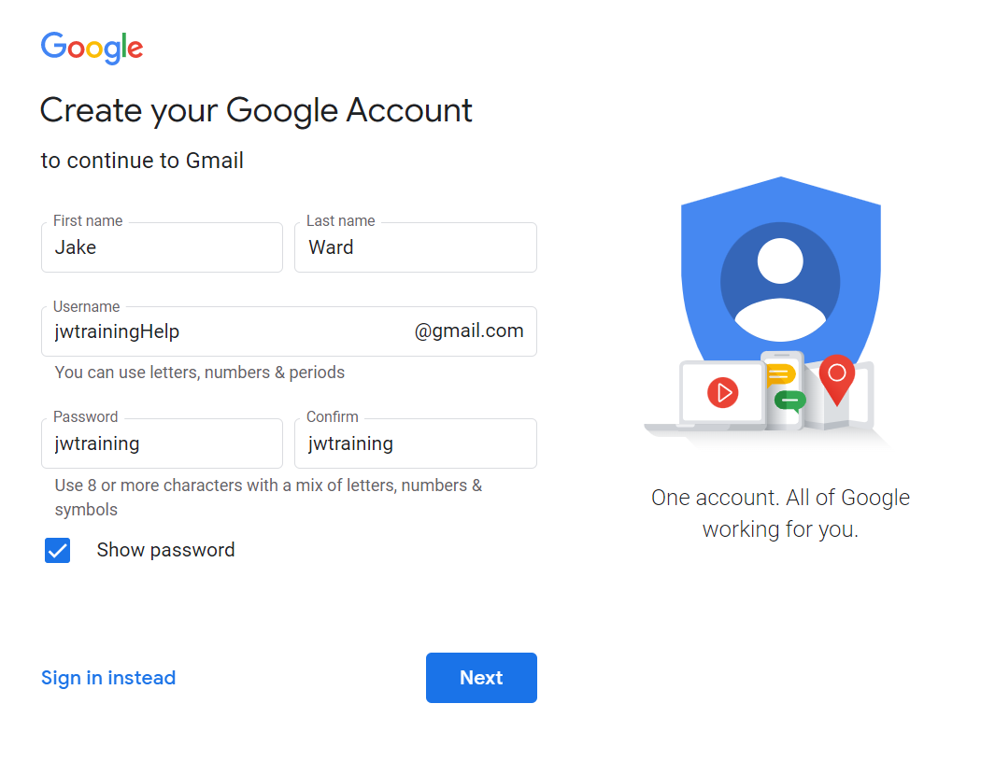

*Figure 280: new Gmail account created for sending confirmation emails and accepting queries*

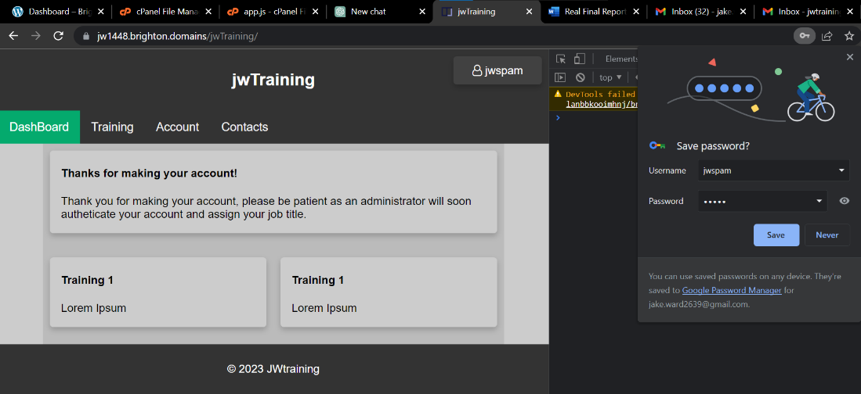

*Figure 281: UI of dashboard after account used to test emails is created*

The Gmail accounts login information was added to the transporter object that would be used to send emails on the API. The code to send the emails was then placed inside the signup method so that it would only be executed if a new user had been added to the database. This code added mail options to display who the email was from, who it was to be sent to, the subject and the content of the email. I would log the errors to the passenger file of the API to see details of what went wrong if anything did. The email was never received by the new user and so the file was consulted for details.

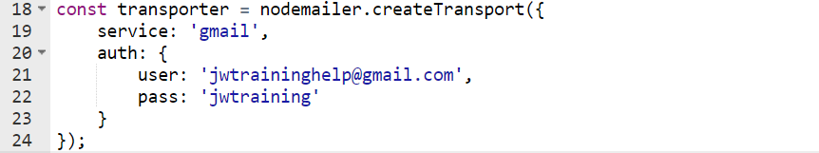

*Figure 282: creating transporter for outgoing emails*

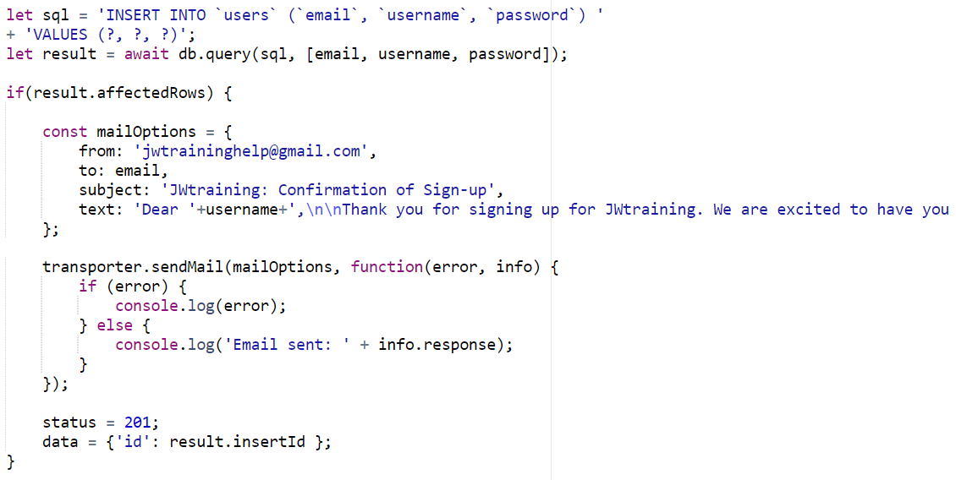

*Figure 283: API setting mail options for email and sending upon successful signup*



*Figure 284: error message logged to passenger file after no email sent*

The error message I first got suggests that the connection to the SMTP server was refused. This could happen if the SMTP server is not configured to allow external access or if the firewall is blocking the connection. The solution would have been enabling less secure app access but Google have long since permanently disabled it for security reasons.

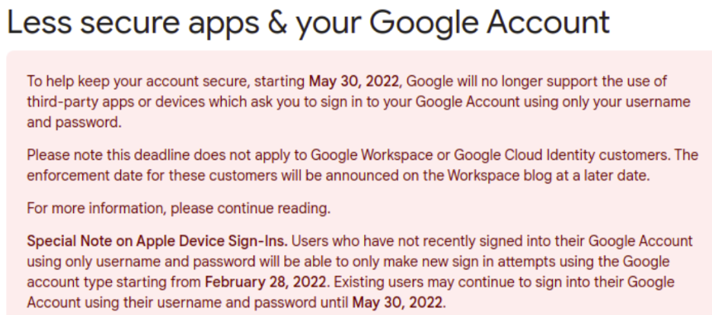

*Figure 285: Google’s notification of deprecation of less secure app access*

The next potential solution was the usage of app specific passwords. Many other developers on stack overflow that were aware of this problem recommended to practice of these app passwords. As detailed in the figure 286 this simply replaces the password in the authentication used in the transporter.

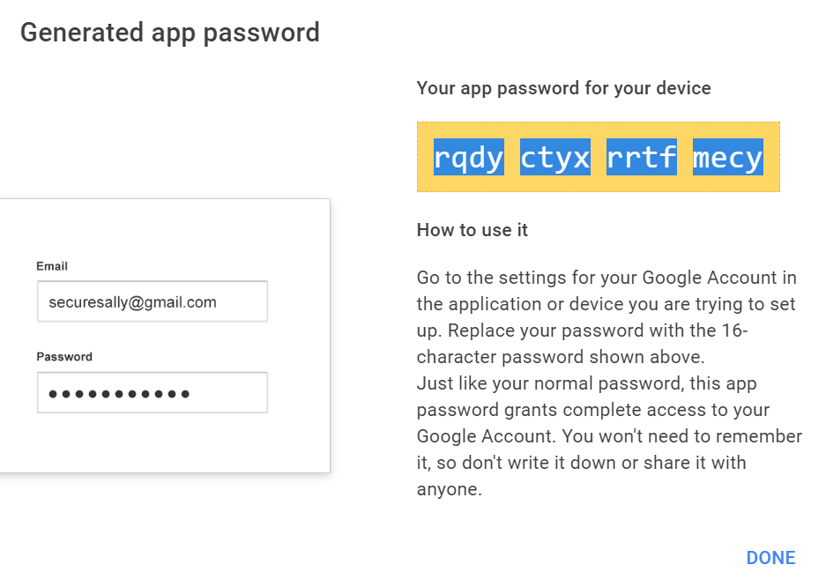

*Figure 286: generation of app password*

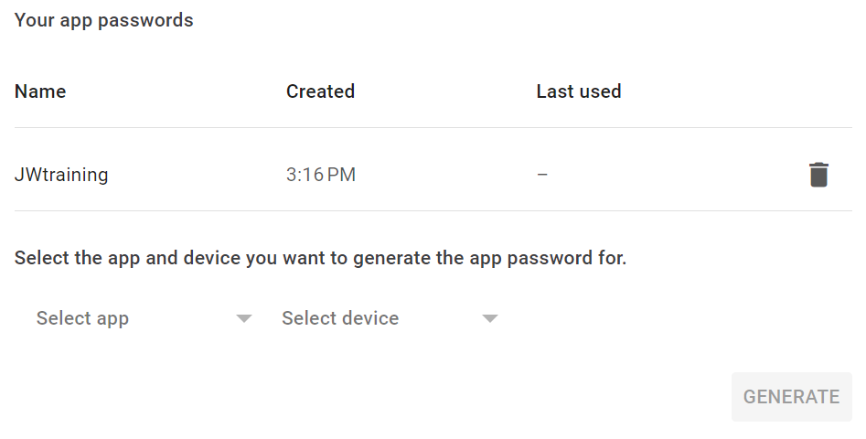

*Figure 287: app password saved under Gmail account*

After replacing the login information on the API for the Gmail account with the new app password I was met with the same error. Thus, I had to conclude that it must be restriction on the university firewall for outgoing messages on specific ports, in this case I was using port 465 to send messages over TLS protocol was it was the default user by nodemailer. So, I changed the port to 587 (commonly used for message submission with SMTP) and it worked. It must be noted that there are downsides to using Gmail as using Gmail is limited to 500 automatic emails before a ban, so this is only the solution for a small-scale operation. The email received by user who have signed up says that the user has signed up and must wait for their account to be authenticated but can contact the admins at the same email to speed up the process.

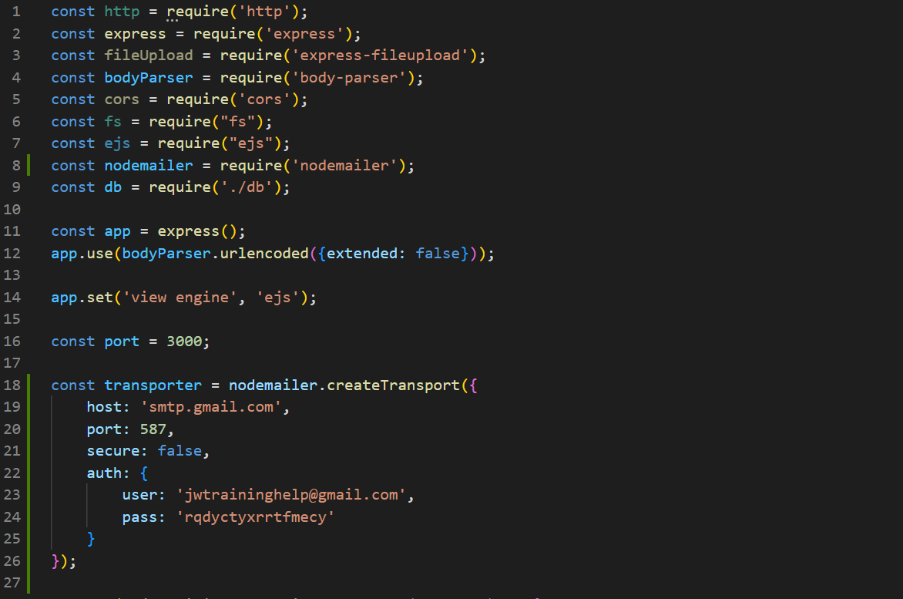

*Figure 288: transporter altered to include app password and port 587*

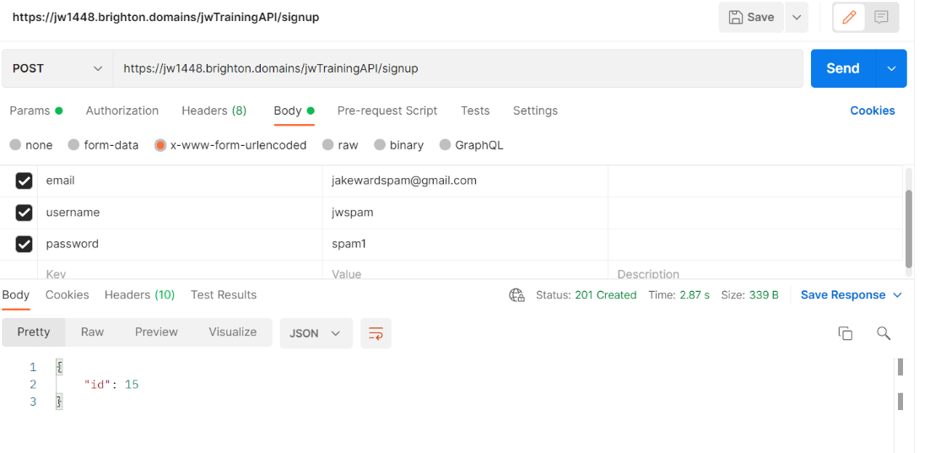

*Figure 289: Postman displaying success of test email signup*



*Figure 290: passenger log displaying email having been sent*  
  
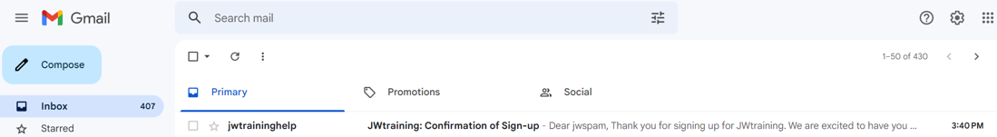

*Figure 291: received email (test user inbox)*

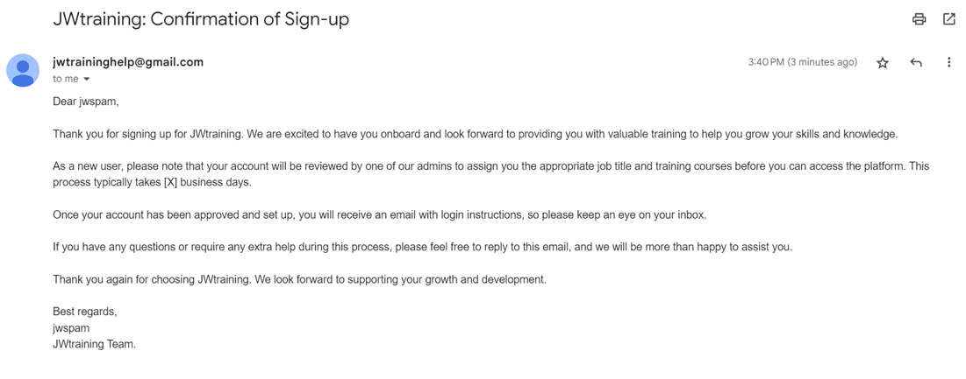

*Figure 292: received email*

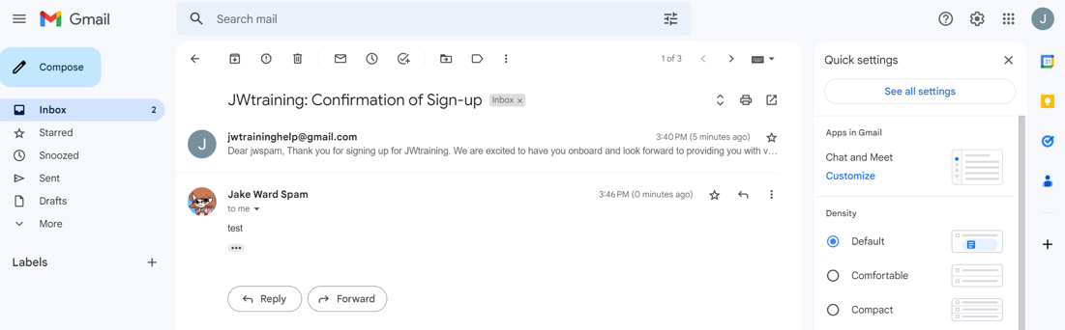

*Figure 293: reply to email visible on admin account*

With little time left in the working day due to the time sink into sending emails, I decided to implement the CSS formatting for the quizzes to make the both visually appealing, clear and obvious that they are quizzes.

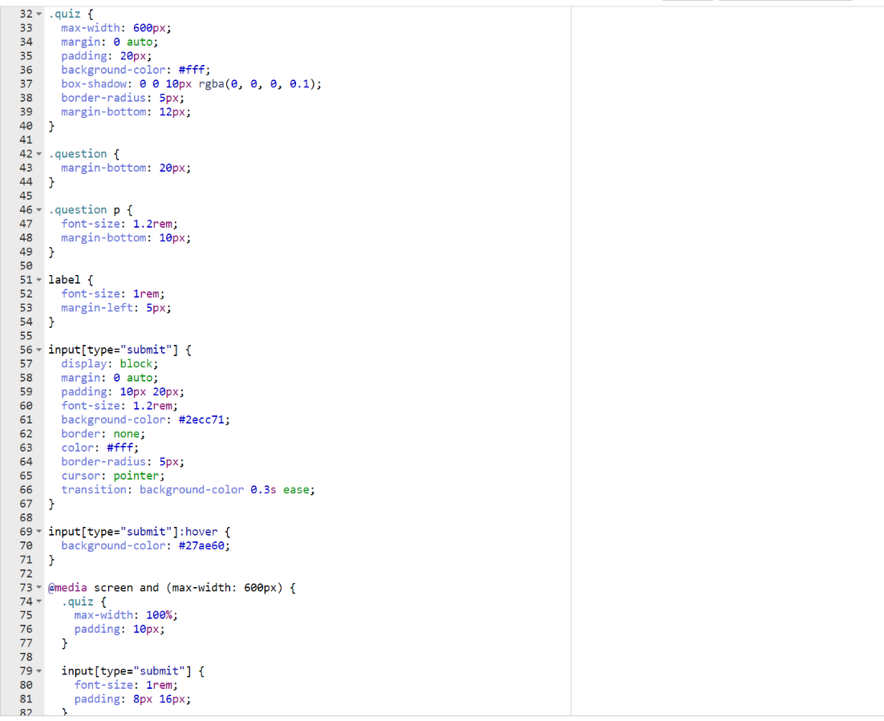

*Figure 294: CSS formatting of quizzes*  
  
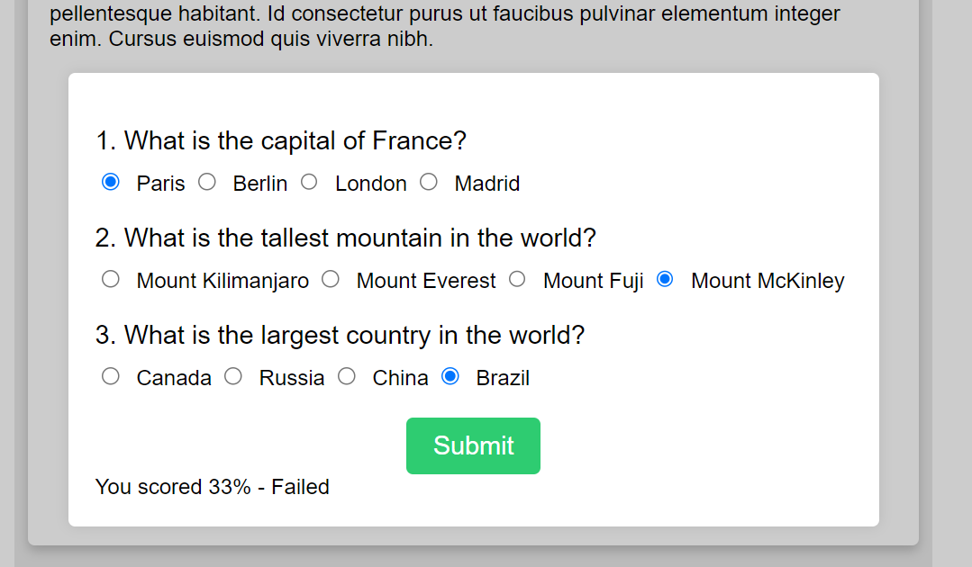

*Figure 295: quiz after CSS formatting in place*

### 08/03/23

Restrictions on the login systems client side was then next small addition that would need to be made. While there are already restrictions on the server side, client side restrictions would serve to give more immediate and easily detailed advise to users on how to make their input credentials valid. Again, these restrictions would only really apply to the signup page as all accounts created with these restrictions would have no need to test for them on login. The restrictions were put in place by using either using regular expressions or comparing text content of input fields. Errors would display themselves in the same way initially set up for efficiency.

The restrictions implemented in this case are as follows;

* All fields must be filled in
* Email must be valid
* Username and Passwords must be between 6 and 31 characters
* Usernames can only contain letters, numbers, dot, underscores and hyphens.
* Passwords must be between 6 and 31 characters long, and must contain at least one uppercase letter, one lowercase letter, one number, and one special character. Only (!@#$%^&*()_+). are allowed as special characters.
* Password and repeated passwords must match

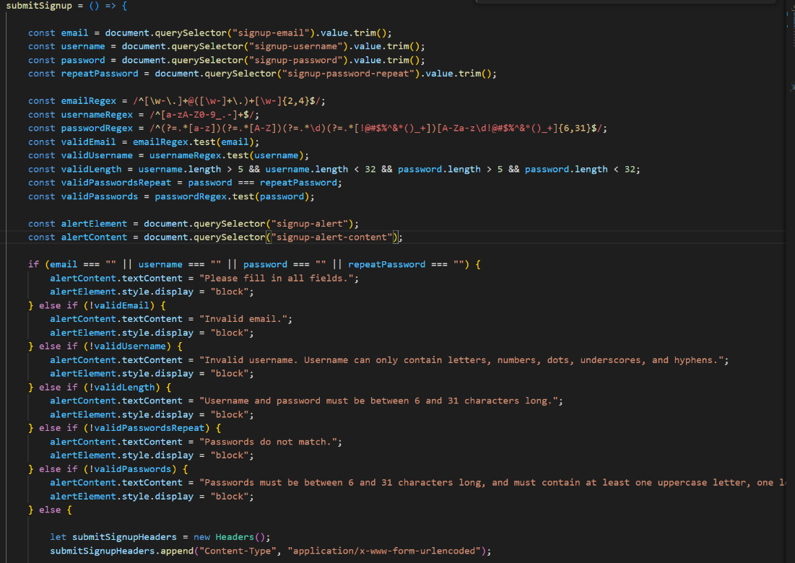

*Figure 296: restrictions added to login/signup functions*

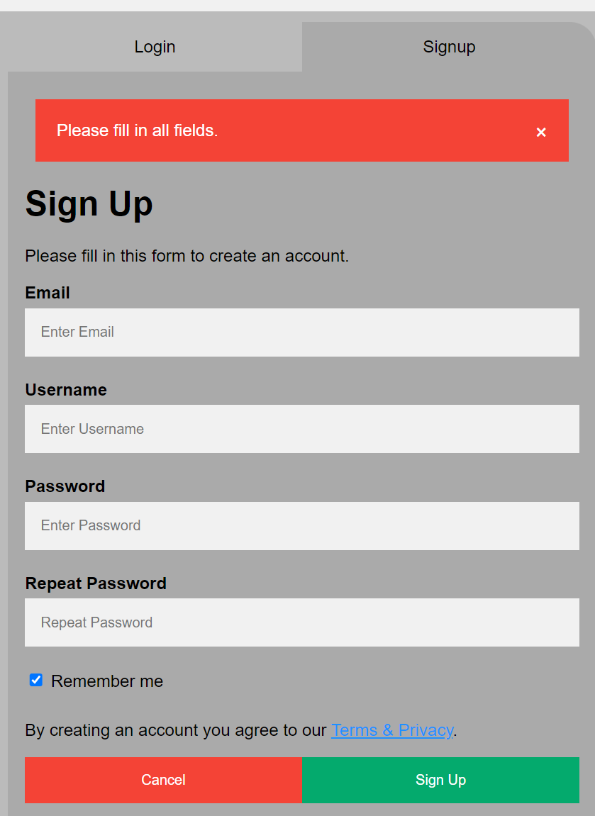

*Figure 297: error message displayed when not all field have been filled out*

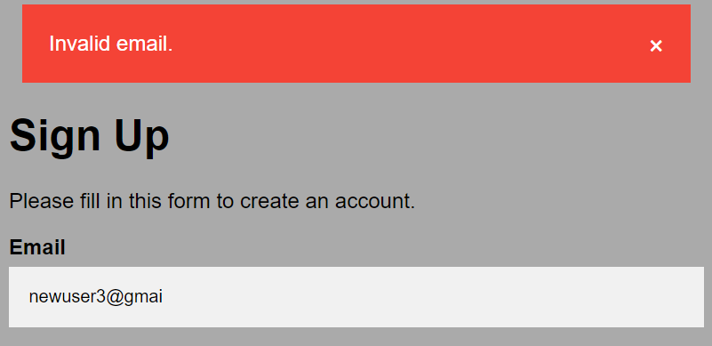

*Figure 298: error message when email doesn’t match email regular expression*

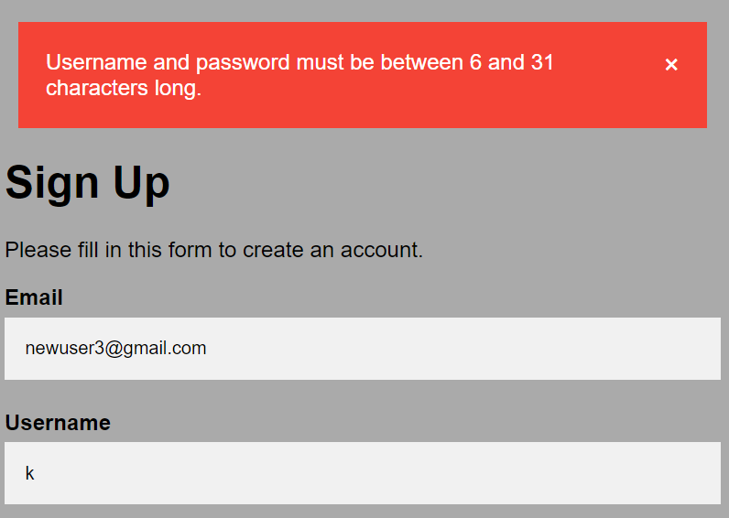

*Figure 299: error message displayed when username of password doesn’t fit length requirements*

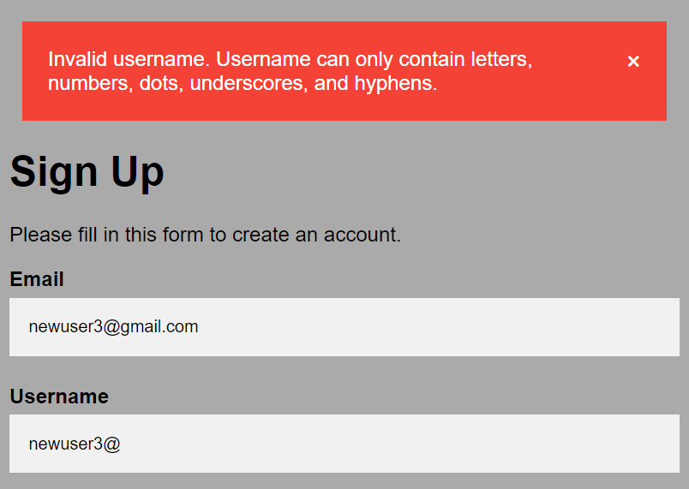

*Figure 300: error message when username doesn’t fit username regular expression*

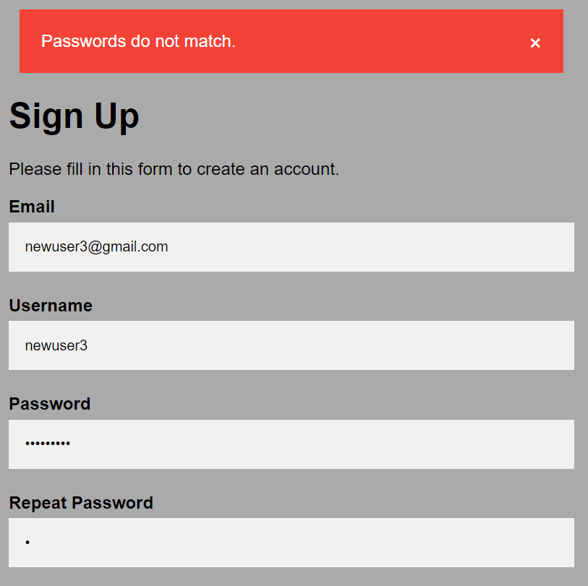

*Figure 301: error message displayed when passwords don’t match*

The figures below (302 - 304) display successful signup after using password3 as the password, being rejected and notified, then changing the password to Passw@rd3. Because all input align with the regular expressions assigned to them the signup is successful, the user is redirected to the dashboard and their information is added to the users table.

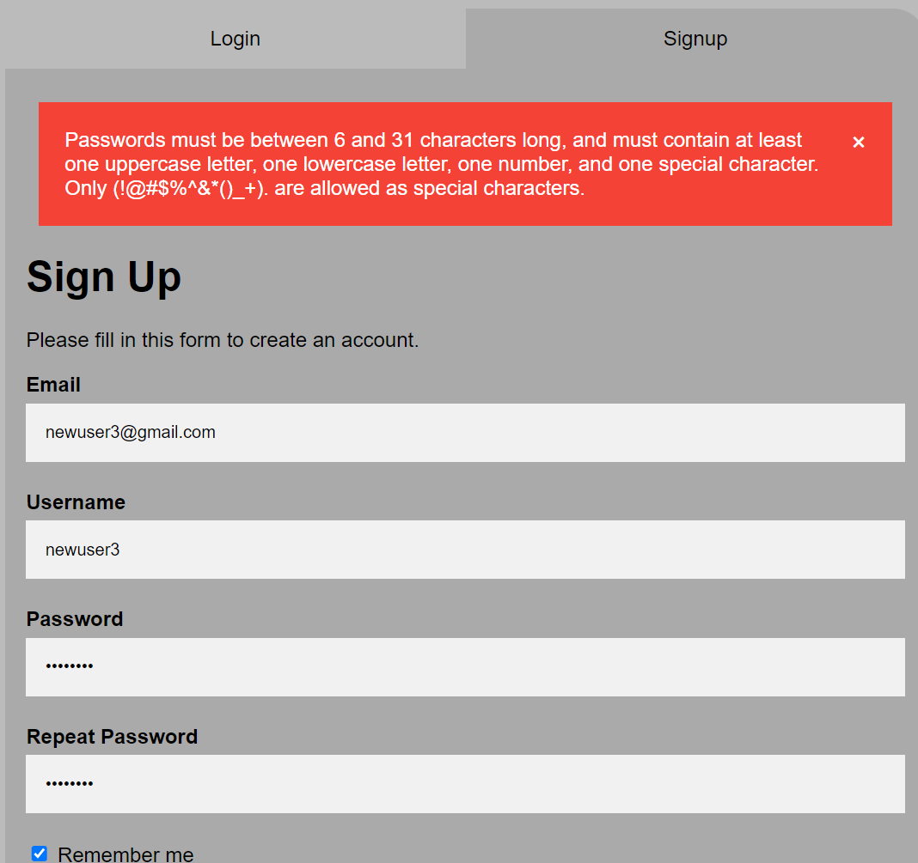

*Figure 302: error message when password doesn’t fit password regular expression*

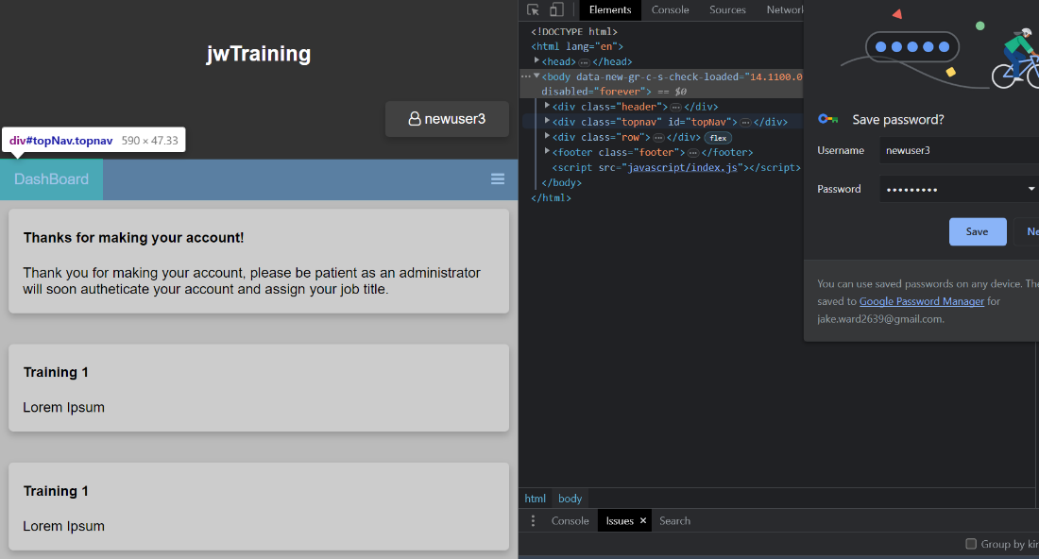

*Figure 303: new user redirected to dashboard after restrictions were put in place*



*Figure 304: new user added to database after restrictions were put in place*

Restrictions for passwords were added to the server side (they only need to be for signup because logically no one could have a matching account in the system without meeting those criteria because of the signup restriction). SQL injection is still moderated by length restrictions.

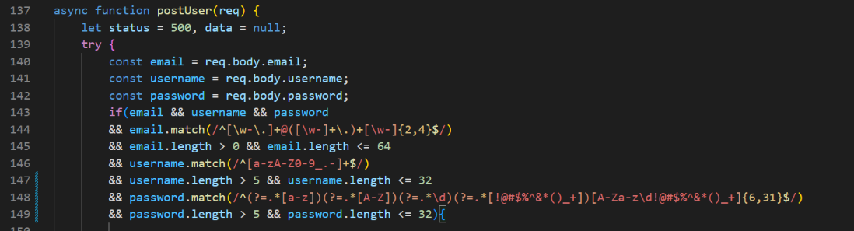

*Figure 305: new restrictions to passwords added to API signup function*

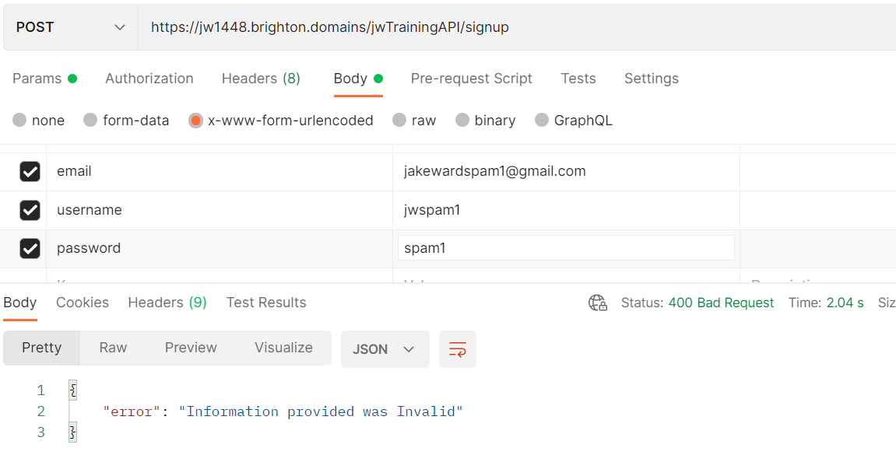

*Figure 306: rejection response to a signup request due to new restrictions*

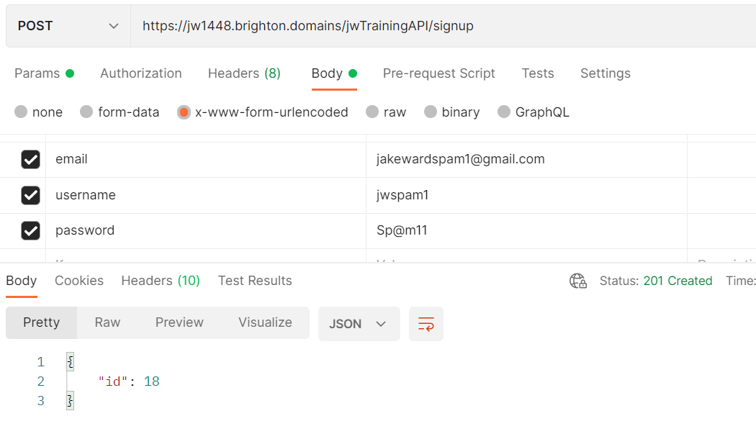

*Figure 307: successful response to a signup request due to new restrictions*

The next feature I planned to add involved adding Tags for articles in the database. This is so that the articles themselves would be easier to search through.

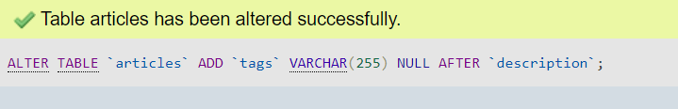

*Figure 308: SQL statement executed to add a tags column*

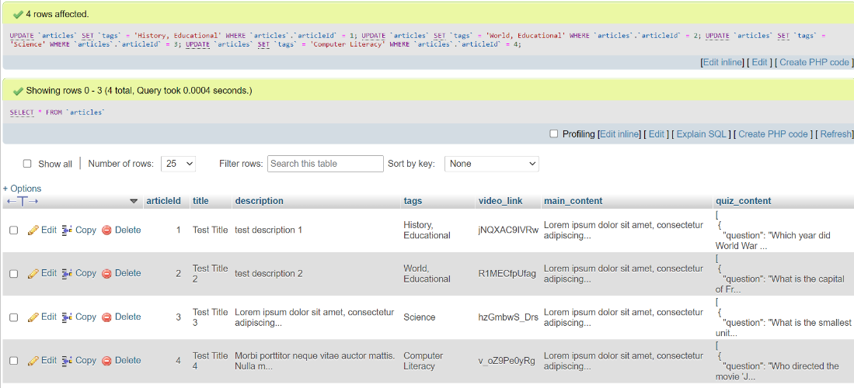

*Figure 309: database updated to hold tags for articles*

Instead of having suggested articles in a sidebar, I decided that a much more elegant solution would be having a search function for all articles. By doing this I would have established a more efficient alternate method for accessing articles than suggested articles as the user would have control over what they were displayed and full access to content would be granted. The tags would add another way for users to search through articles and they could be displayed in the same way as the training page. This would be an important method for users as it would mean they could revisit training that had completed before if revision was necessary, or they could read ahead if they wanted to. This also mean I as the developer would be able to create and display my competency with a search function. This would replace the account place holder in the navigation bar of all pages and would differ from the training page as the training page would only display assigned work while the other would display all articles.

As was common practice by this point I handled the request on the API by calling an async function. This async function would then authenticate the user before using the provided keyword to search the database for all results containing the keyword in the title, tags or description. If a keyword wasn’t provided then a zero length string would be used as default. The results would be returned as an array within the JSON object response.

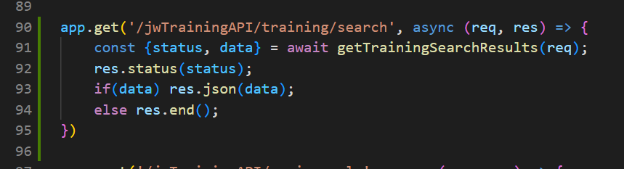

*Figure 310: API code for handling search requests*

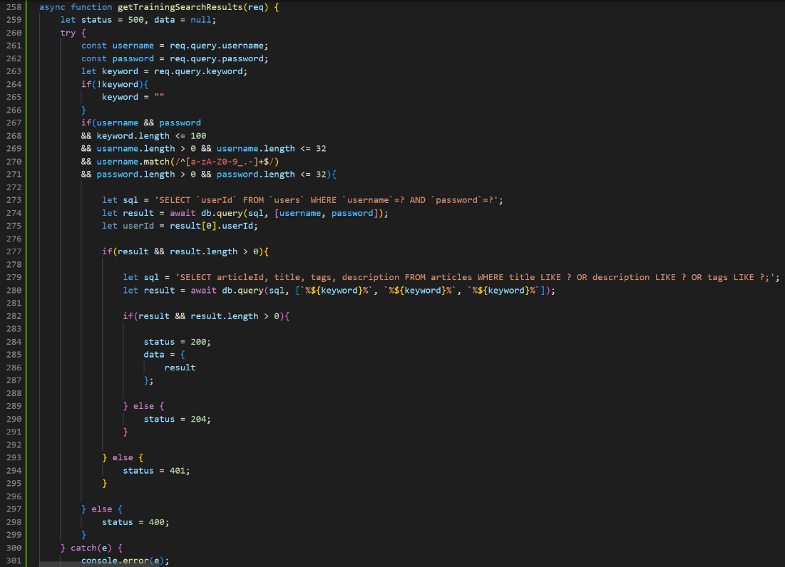

*Figure 311: async function used to search for articles in the database using a provided keyword*

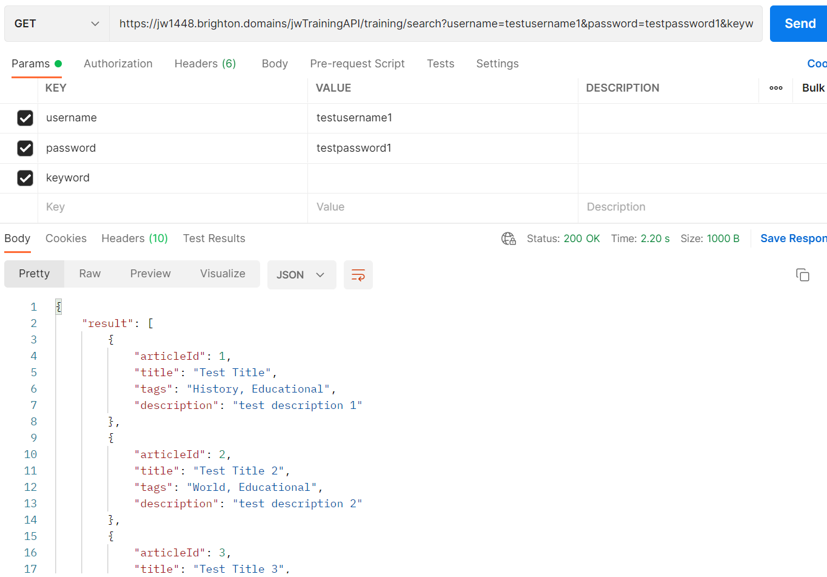

*Figure 312: response results from search endpoint when no keyword is given*

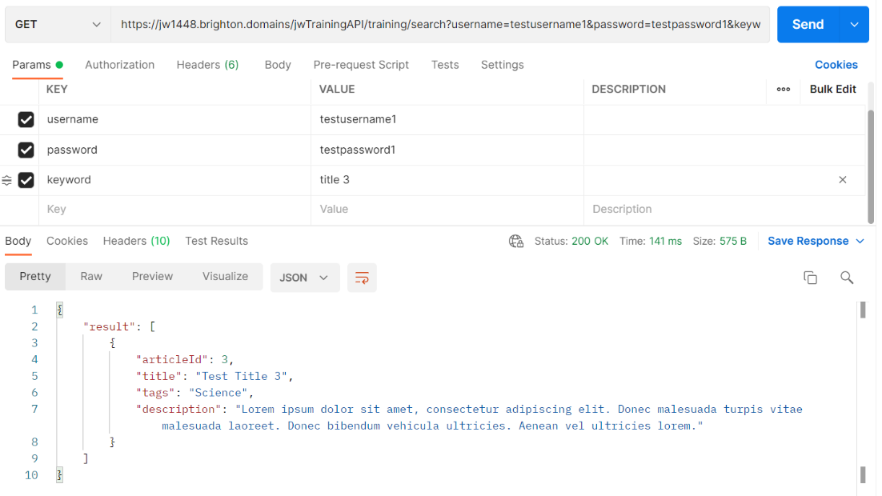

*Figure 313: response results from search endpoint when keyword is given*

Now that the server-side supported a search of all articles via the API I simply needed to incorporate this functionality into the client side and display the search results on a page. So I created a new page to be used for searching through all articles by using the training page HTML as a template. The link to the new page was added to the navigation bar on all other pages. The major difference between the design of the training page and the search page was that a search bar alongside a submit button had to be implemented in place of the progress bar.

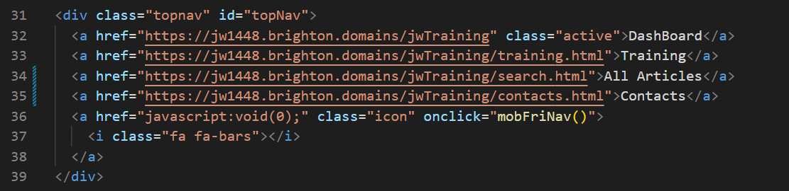

*Figure 314: adding search page to all navigation bars*

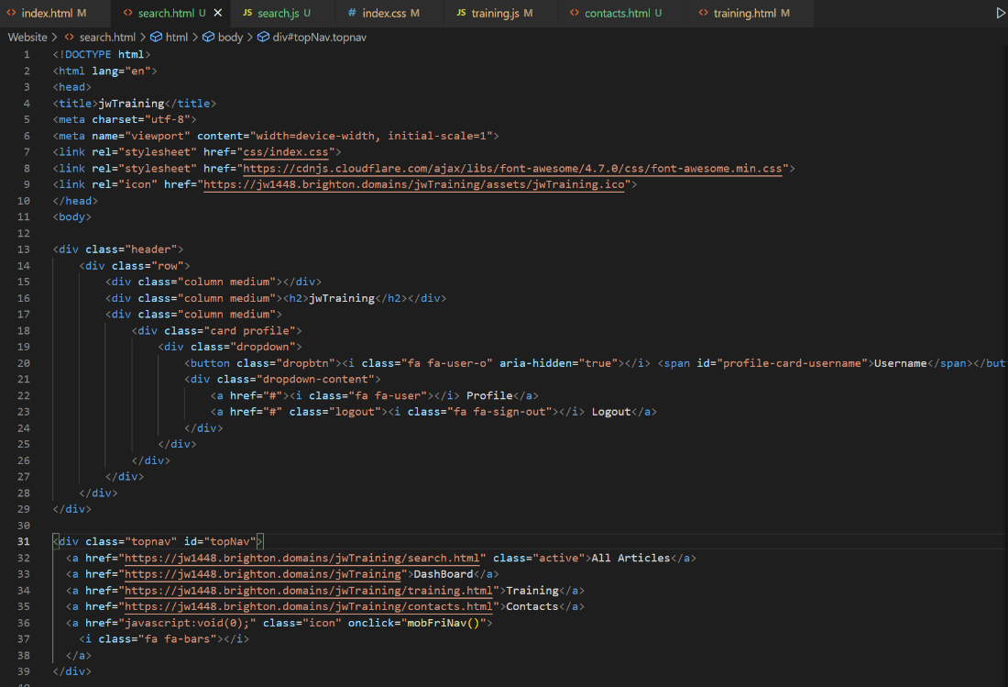

*Figure 315: HTML for search page (part 1)*

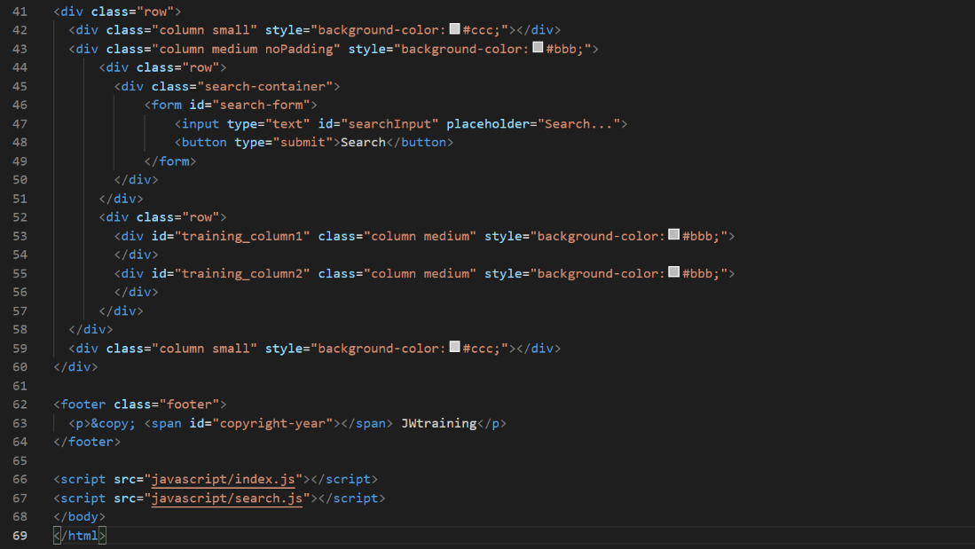

*Figure 316: HTML for search page (part 2)*

JavaScript was then added to contact the search endpoint and in the same fashion as the training page, split the resulting JSON array in two and display the results by creating cards in two columns. The only difference between cards on the search and training pages was that these cards wouldn’t hold due dates as the articles may not have been assigned to the user. So instead, the cards would hold the articles search tags in their place, with new CSS to have the tags formatted similar to social media tags seen on Twitter or Facebook. The tags would be separated by being converted to an array and added to the DOM individually as span elements. The sending of the fetch request was placed inside a function use the keyword in the search bar and would be executed every time the search button was clicked to the page was loaded. This way the results would automatically display on page load using a 0-length string as the keyword meaning all articles would display by default.

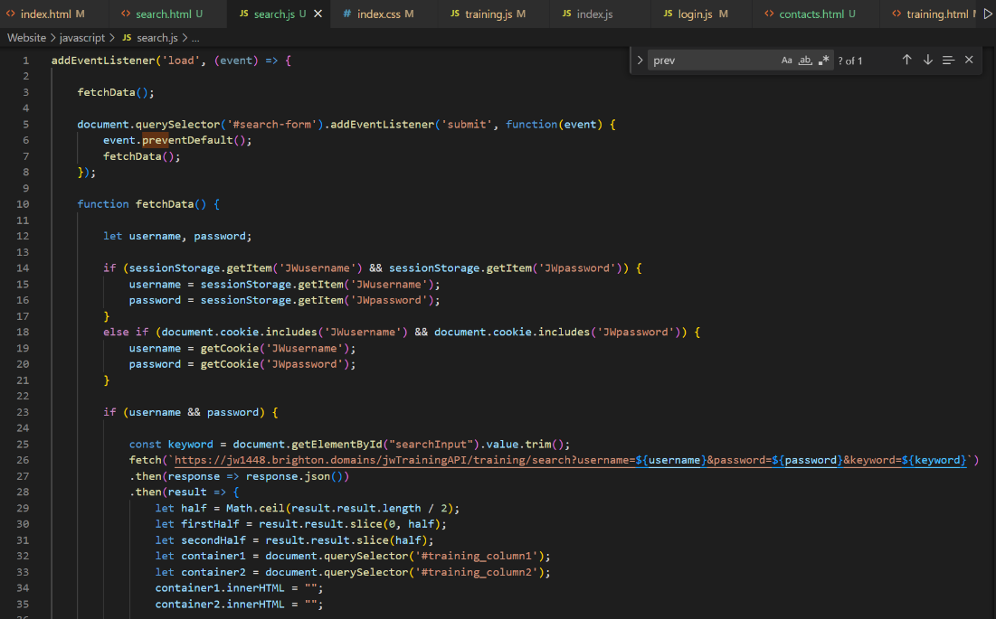

*Figure 317: JavaScript for search page (part 1)*

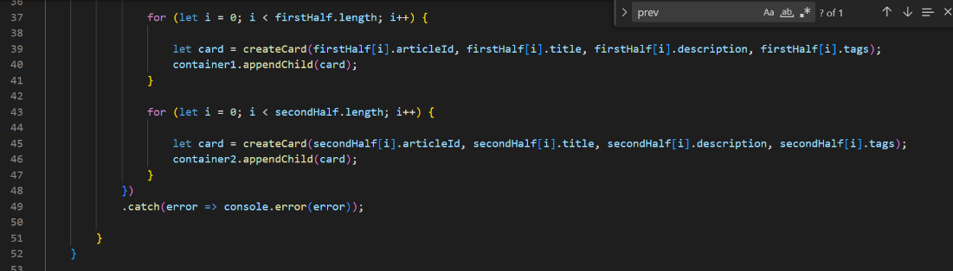

*Figure 318: JavaScript for search page (part 2)*

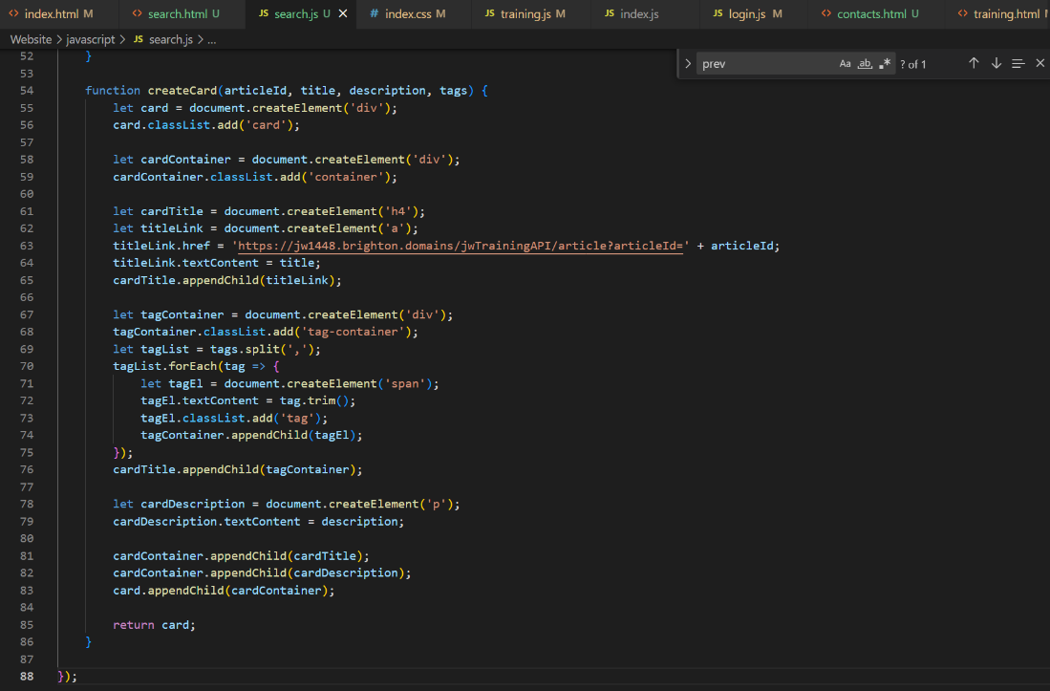

*Figure 319: JavaScript for search page (part 3)*

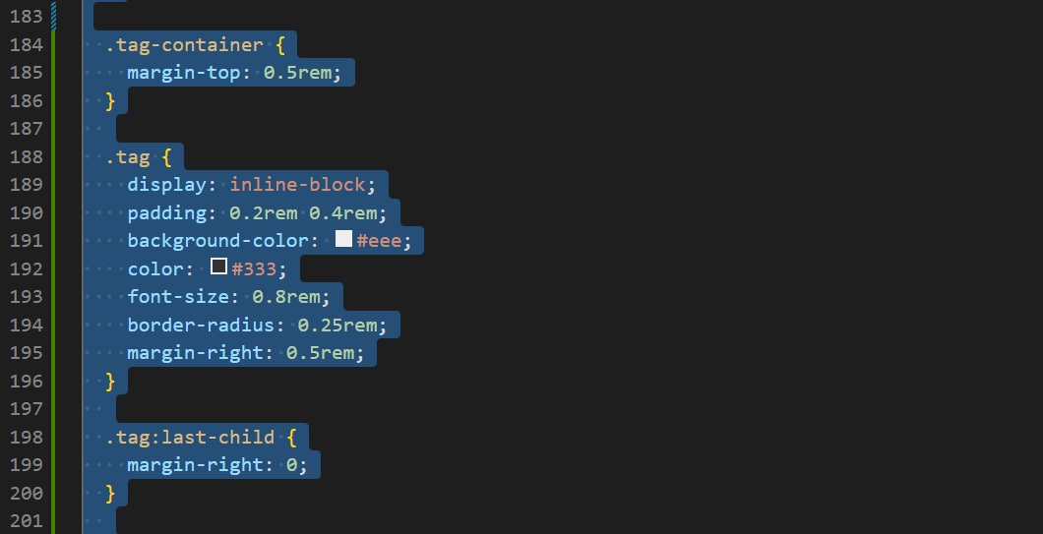

*Figure 320: CSS for tags*

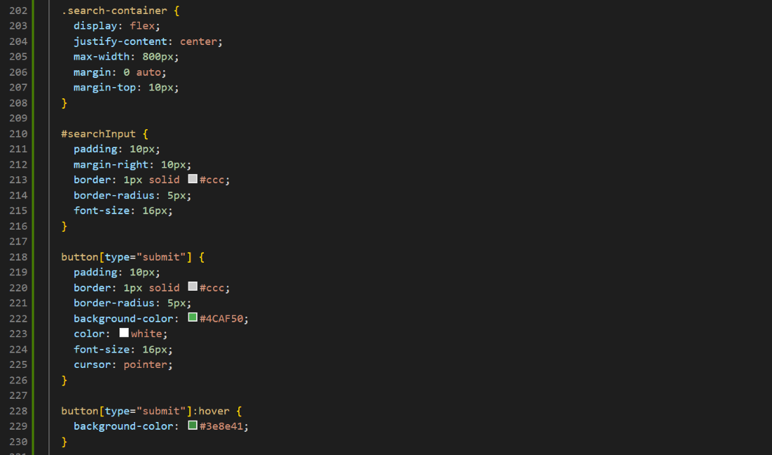

*Figure 321: CSS for search bars*

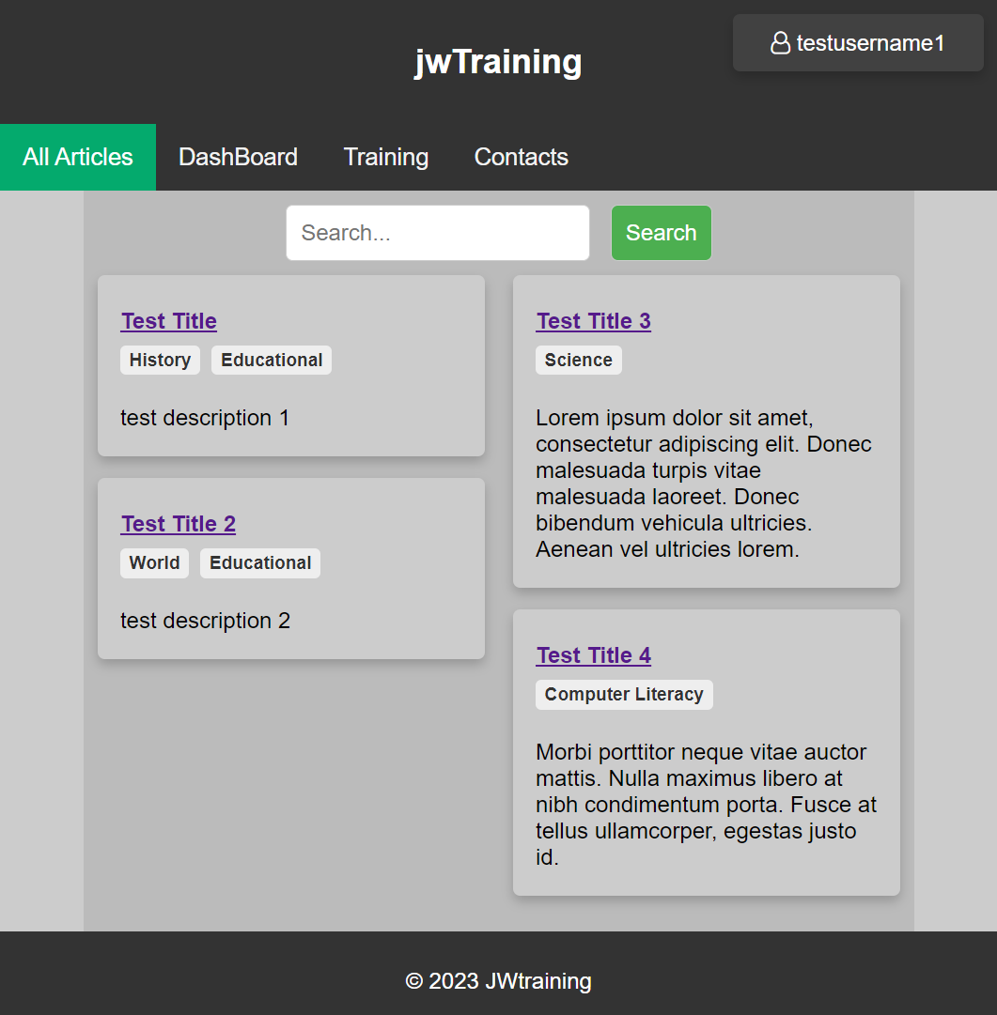

*Figure 322: search results on UI with no keyword*

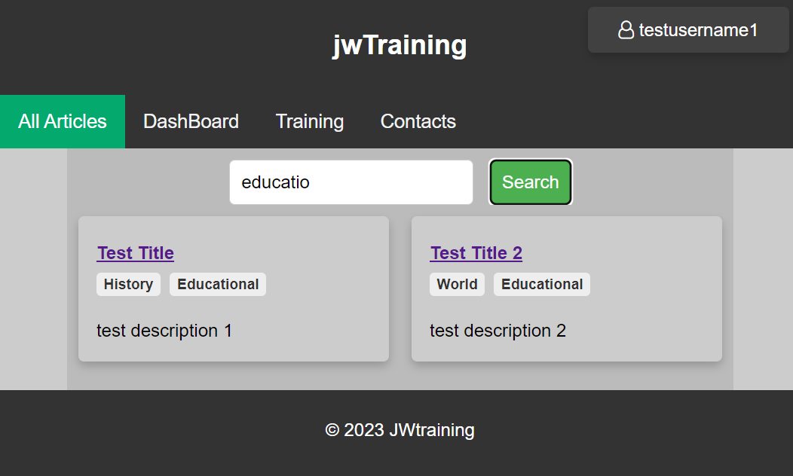

*Figure 323: search results on UI with keyword*

During the JavaScript's design there was a minor logic error that had to be fixed. The first half of the JSON response was being used to populate both columns, so it was promptly switched to the correct variable for each column.

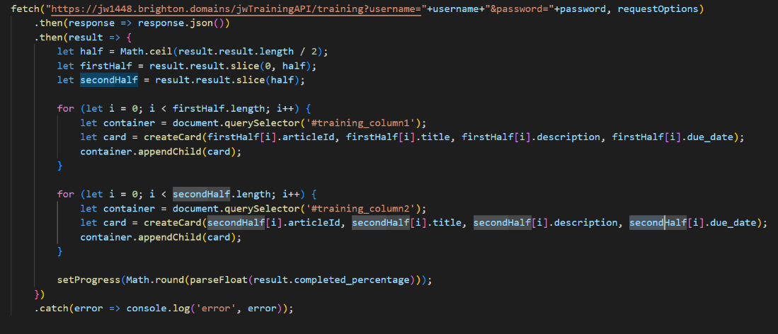

*Figure 324: search fetch request response handling with highlight code having been changed to fix logic error*

The last addition required was the most time consuming, this was the pagination of the search page. While the results of the training page would likely never hold enough results to warrant pagination to divide results, the result of the search of all articles would be highly likely to overflow the page without division. This feature took a lot of time to implement as a lot of time had to be dedicated to designing the most efficient method. While I attempted to implement it entirely on the server side I found that the most efficient method would involve changes to both the client and server side.

The changes on the server side made to accommodate pagination are as follows. The database was filled with enough articles that the results would go over the page limit so this feature could be sufficiently tested and displayed. Then to set up the links through the results on the client I would need to have the input parameters page number (defaulting to 1) and page size (defaulting to 10). With this information the results could be navigated to based on the page by adjusting the SQL query to limit the number of results by the page size and to offset results by the page number. Then so the client could generate the correct amount of links in the pagination I would have to get all results without a limit so I could respond with the total number of results.

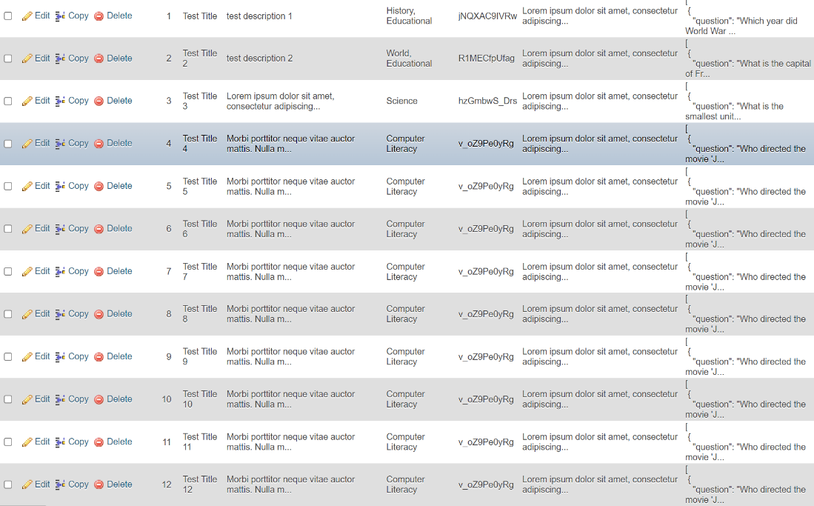

*Figure 325: adding articles to the database until the total was over the chosen page limit*

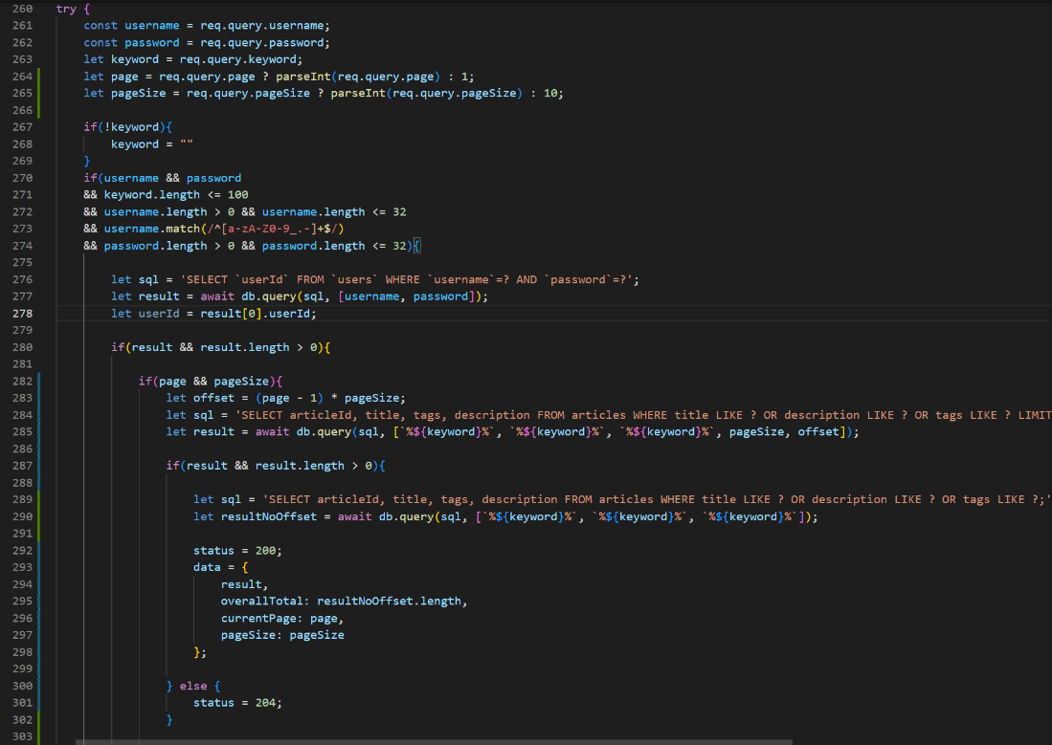

*Figure 326: API handling of search function with pagination features included*

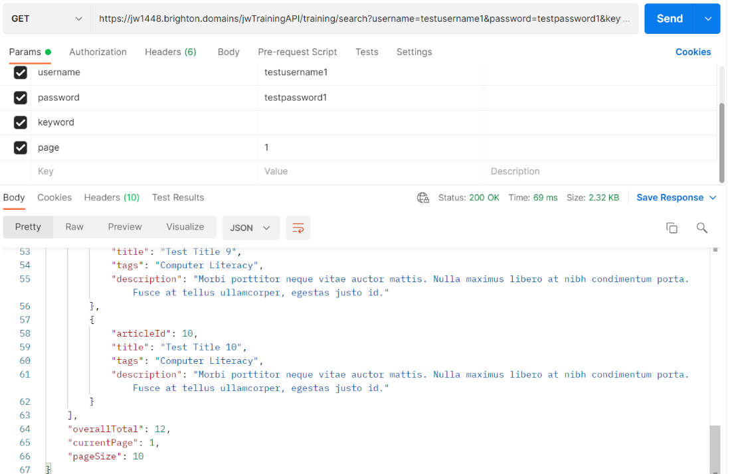

*Figure 327: successful response from blank search using page 1*

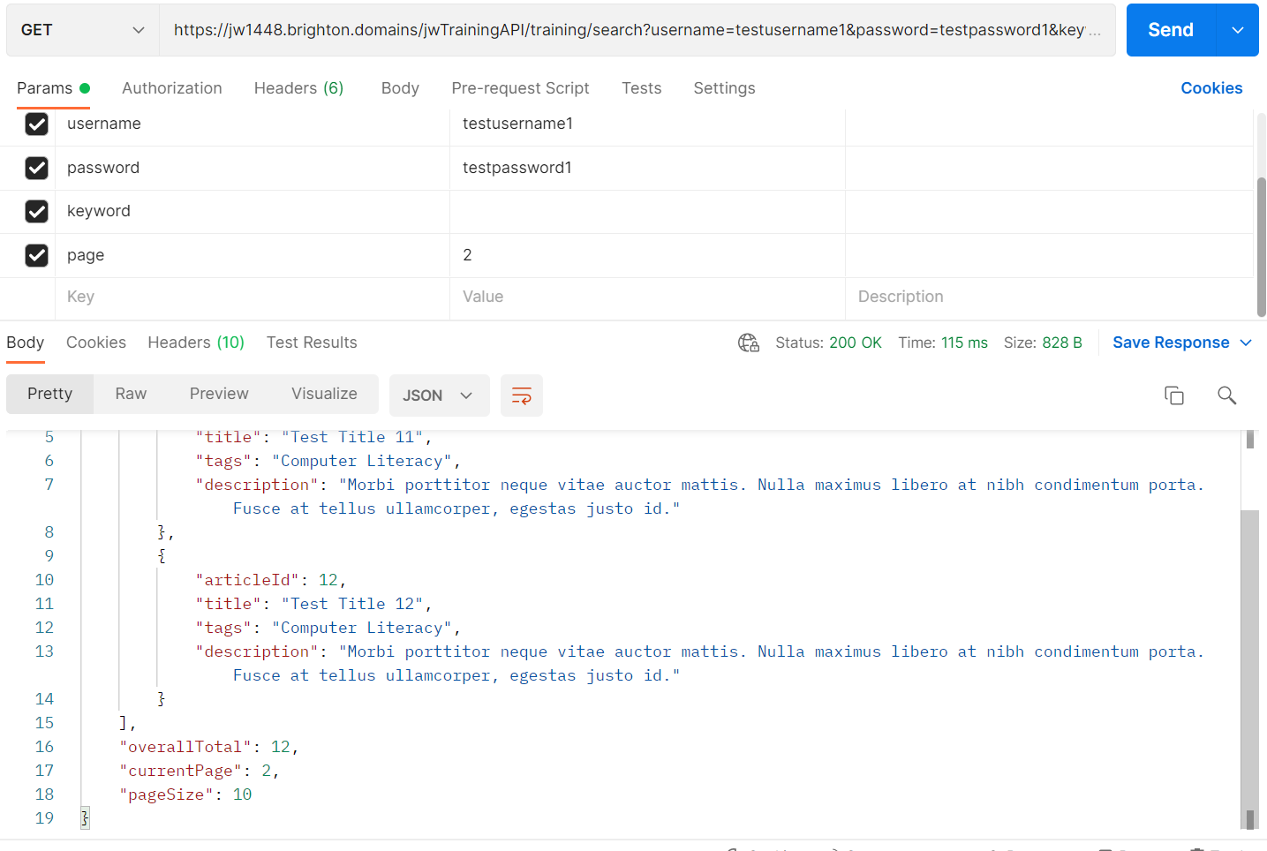

*Figure 328: successful response from blank search using page 2*

Then on the client side the function to display would have to accept a page and page size input to be used to gather the correct list of search results. While the server side would already set default value if these weren't provided I set default on this side too simply as its good practice. The results would still be displayed in the same way except now they would be limited due to the server side. Now the pagination would need to be generated after each search. The pagination section was specified in the HTML and CSS was established to format it. Now upon a successful response to a search the old pagination would be wiped and if the overall total of search results was more than the page limit (10) then the pagination would be added to the DOM. One link would be generated and labelled per page which would be calculated via dividing the total results by the page limit. Each “link” would have a click listener on it that would call the function again but with the page number it was labelled with.

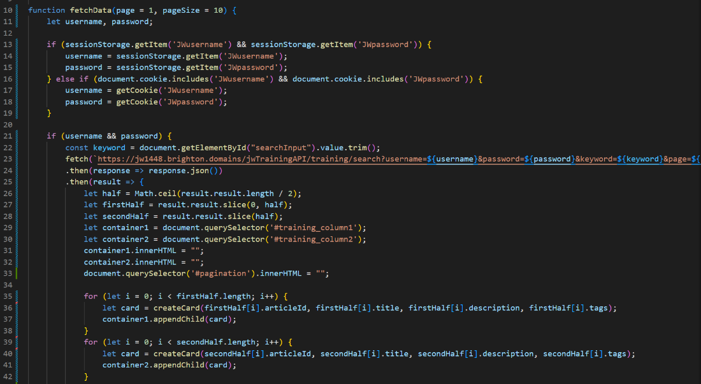

*Figure 329: JavaScript for search function with pagination (part 1)*

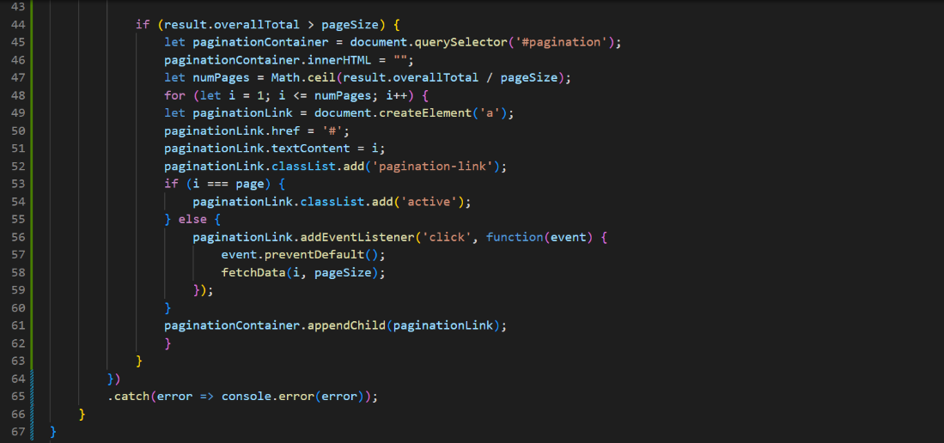

*Figure 330: JavaScript for search function with pagination (part 2)*

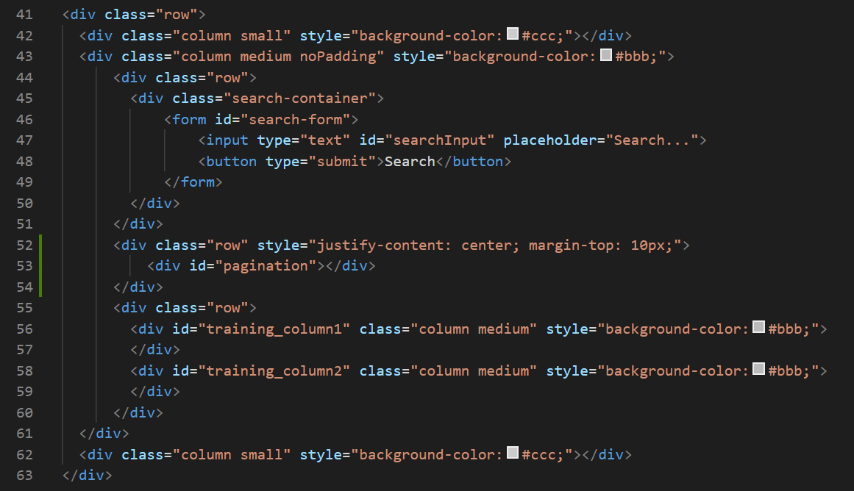

*Figure 331: search page HTML adjusted to include pagination*



*Figure 332: CSS for pagination*

As a result, you can see the UI splits the blank search showing all articles amongst two “pages”, both of which can be navigated to via the pagination. However, if the results are less than 10 (the page limit I set) then no pagination is generated as it isn't required.

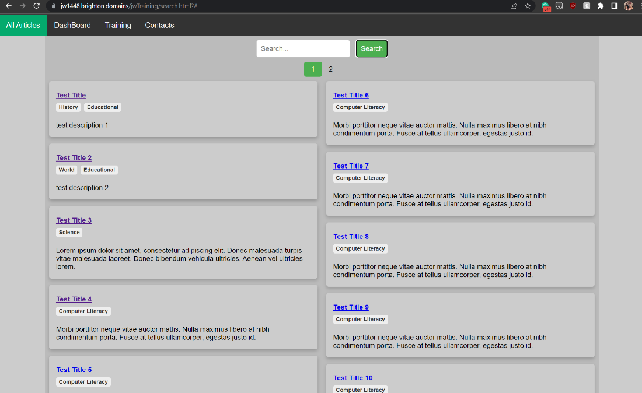

*Figure 333: search results for all articles page 1 displayed in UI with pagination*

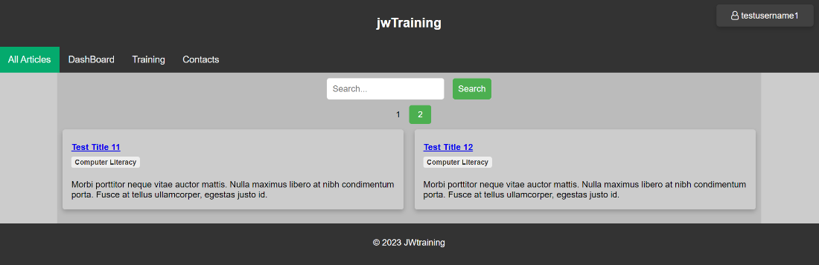

*Figure 334: search results for all articles page 2 displayed in UI with pagination*

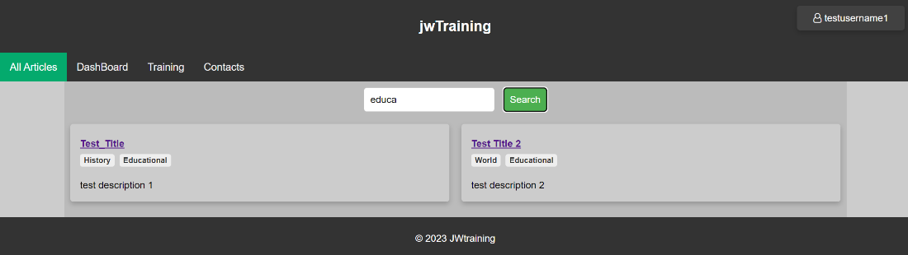

*Figure 335: search results for keyword displayed in UI with pagination automatically removed*

Before finishing for the day, a slight edit to search logic was made so that pagination would use the last keywork searched and not what was currently in the search bar. This change was made as it was found to be closer to most peoples idea of how a search function works as I found through brief contact of potential users and black box observational testing.

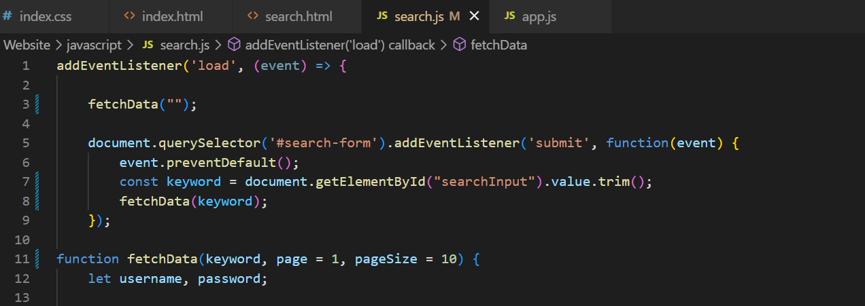

*Figure 336: JavaScript for search function edited so pagination would use previous search as keyword (part 1)*

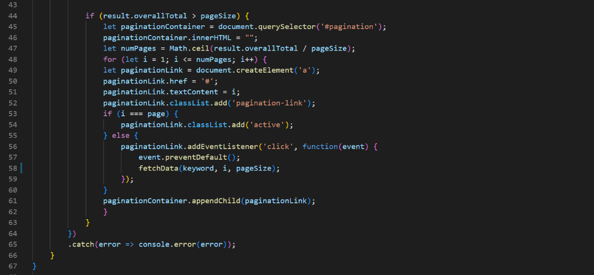

*Figure 337: JavaScript for search function edited so pagination would use previous search as keyword (part 2)*

### 09/03/23

The next small feature I decided to add was the statistics requirement. I decided to display statistics that I could gleam from the current database structure. This meant that I would be displaying statistics like;

* The amount of overall completed articles
* The number of articles uncomplete and past their due date
* The number of articles uncomplete with a future due date
* The article closest to its due date

By including the article closest to its due date two requirements could be met with one addition (as this would serve as a notification of work to be completed). So, I set up a new async function on the API to authenticate the user and then respond with that account’s statistics and researched the types of SQL queries I would have to use to get the information I wanted. The information in the response would then be used later to alter or generate elements in the DOM.

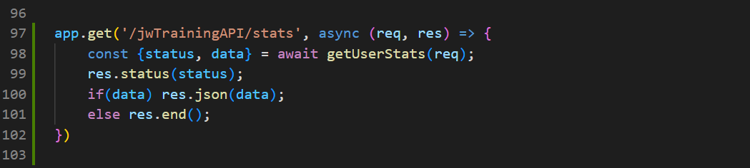

*Figure 338: handling of stats get request*

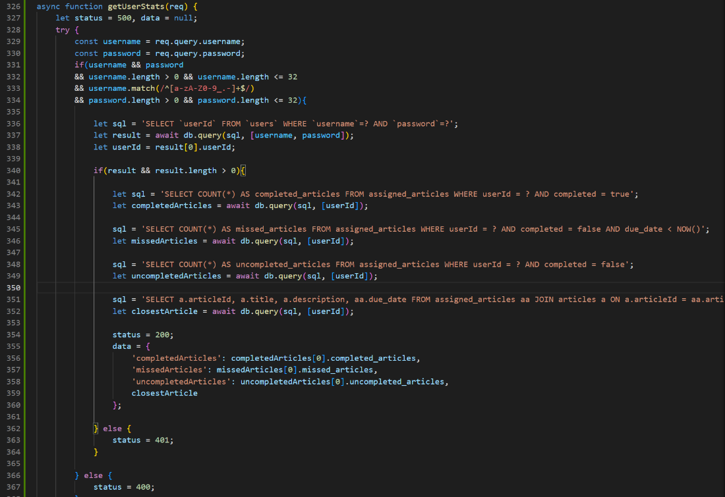

*Figure 339: async function on API to respond with statistic about the user*

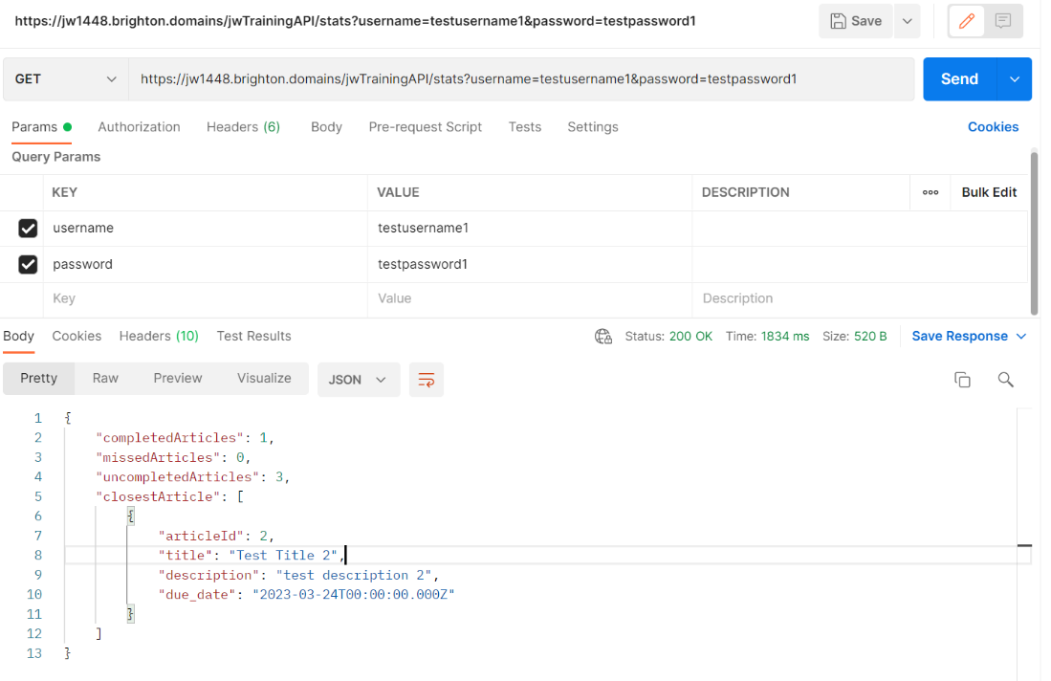

*Figure 340: response to get stats request in Postman*

### 10/03/23

A small quality of life update that was added this day was redirection back to the training page after an article had been completed. I added this functionality on a successful response from the quiz submission so it would only execute after the assigned article had been listed as completed in the database. I then would display an alert as it would notify the user that the work was complete and pause the rest of the functionality so that upon the user clicking “ok” on the alert, the user would be redirected back to the training page. While they could have navigated to the article from elsewhere, it is likely they would want to be on the training page to see their updated progress and also because unassigned articles wouldn't make use of this function.

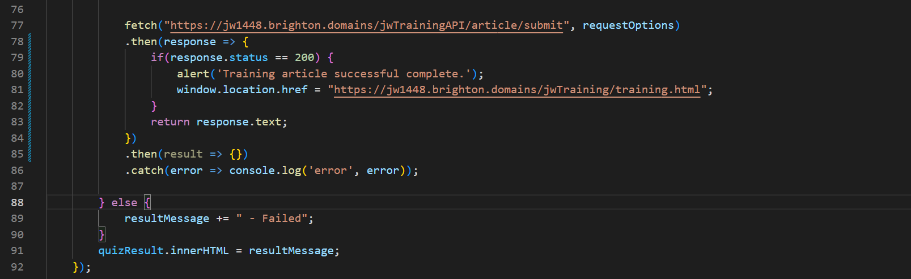

*Figure 341: code responsible for alert and redirection after successful quiz submission*

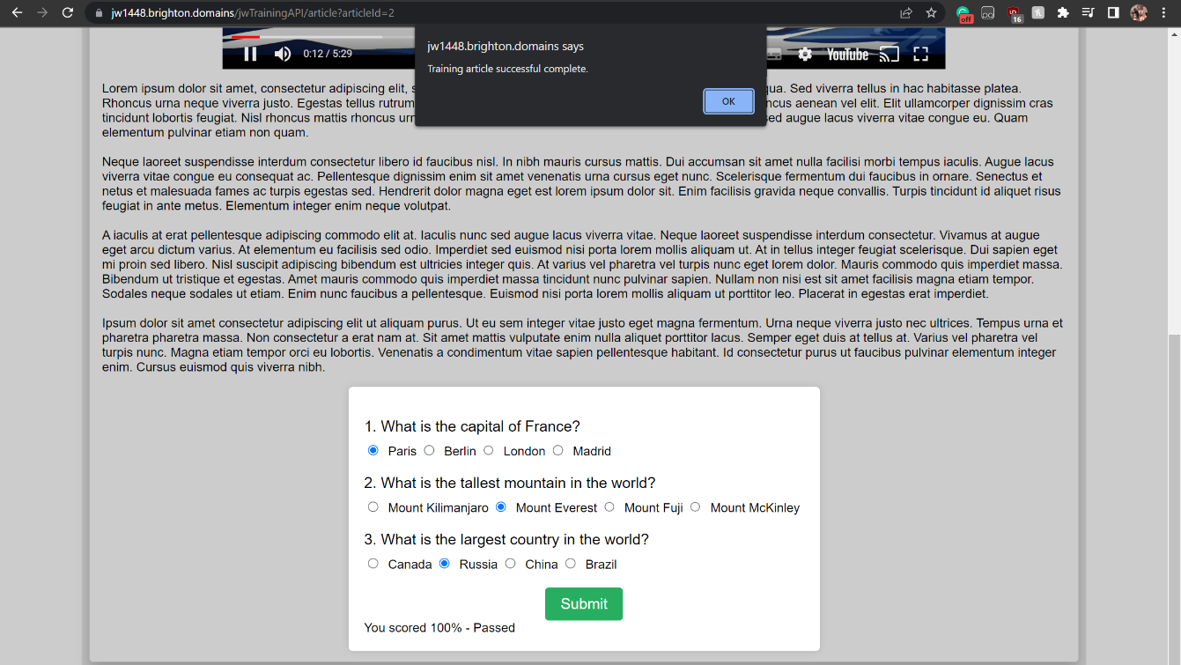

*Figure 342: alert displayed after successful quiz submission*

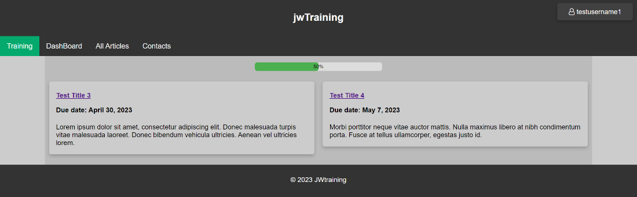

*Figure 343: training page having be redirected to after quiz submission*

Next I needed to display these stats on the client-side. It made sense to see these stats on the dashboard as the notification would only be successful if the user always had to see it, which they would if it was on the dashboard as it would be the first page to be sent to after logging in. I setup the usual getting of the credentials and sent them to the endpoint I had just set up using the fetch API. The response would then be added to the DOM in the place of the original placeholder cards. This meant changing the text content of elements and generating new elements. The HTML of the page required little adjustment other than some title changes and IDs to target. The notification about upcoming work would be on a separate card from the other statisics to show it importance and to group the other stats together.

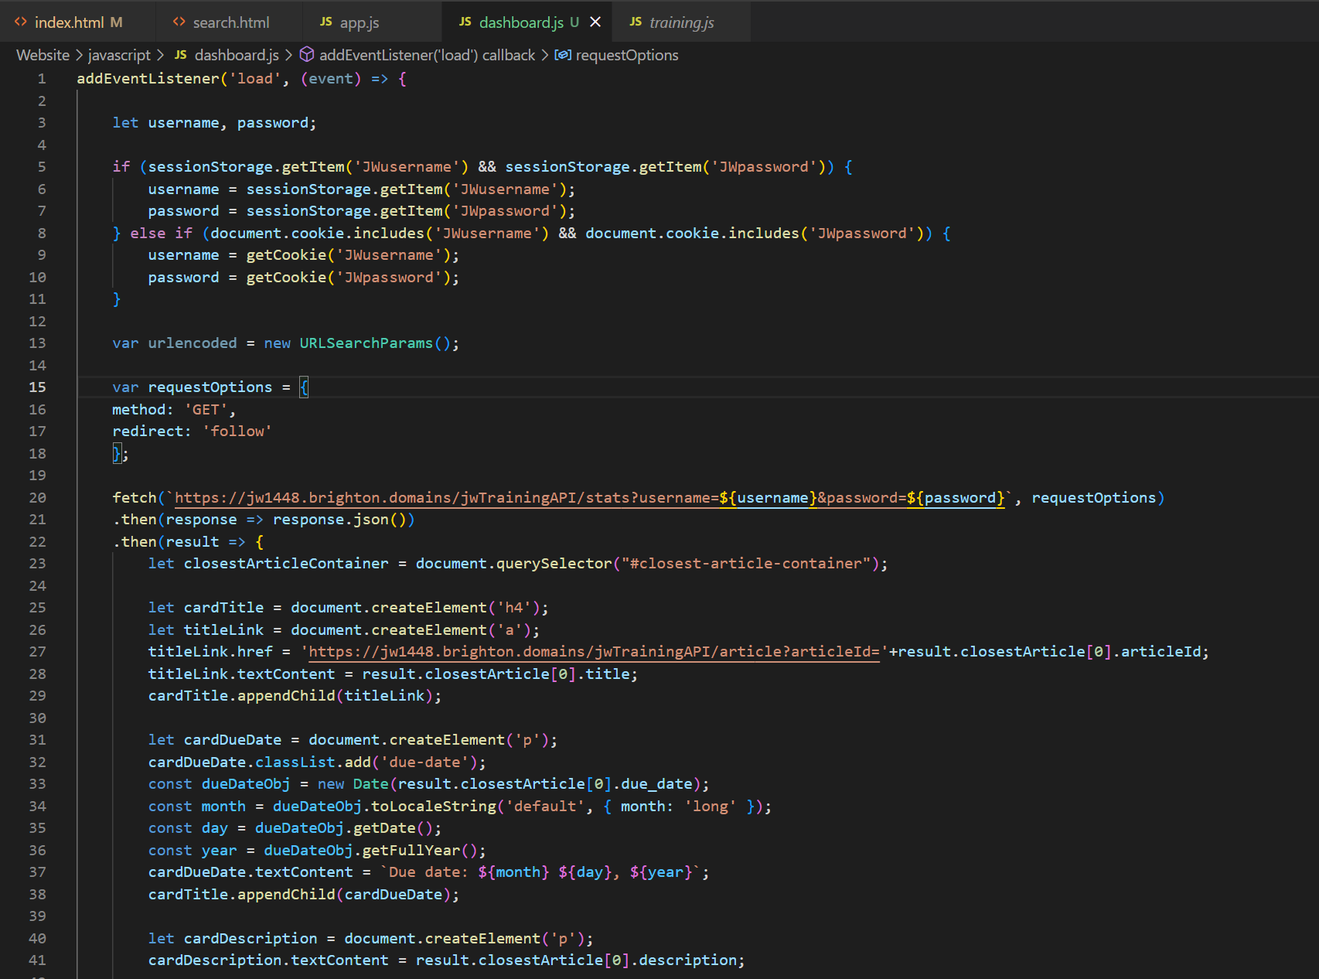

*Figure 344: JavaScript for displaying statistics (part 1)*

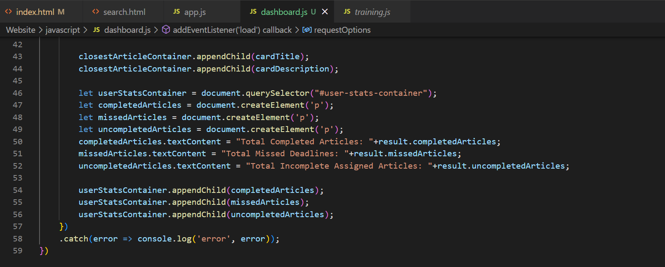

*Figure 345: JavaScript for displaying statistics (part 2)*

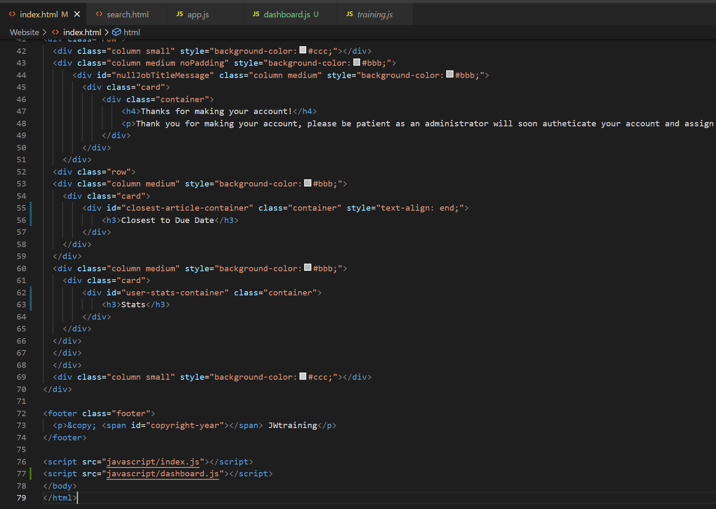

*Figure 346: HTML of dashboard altered to incorporate stats*

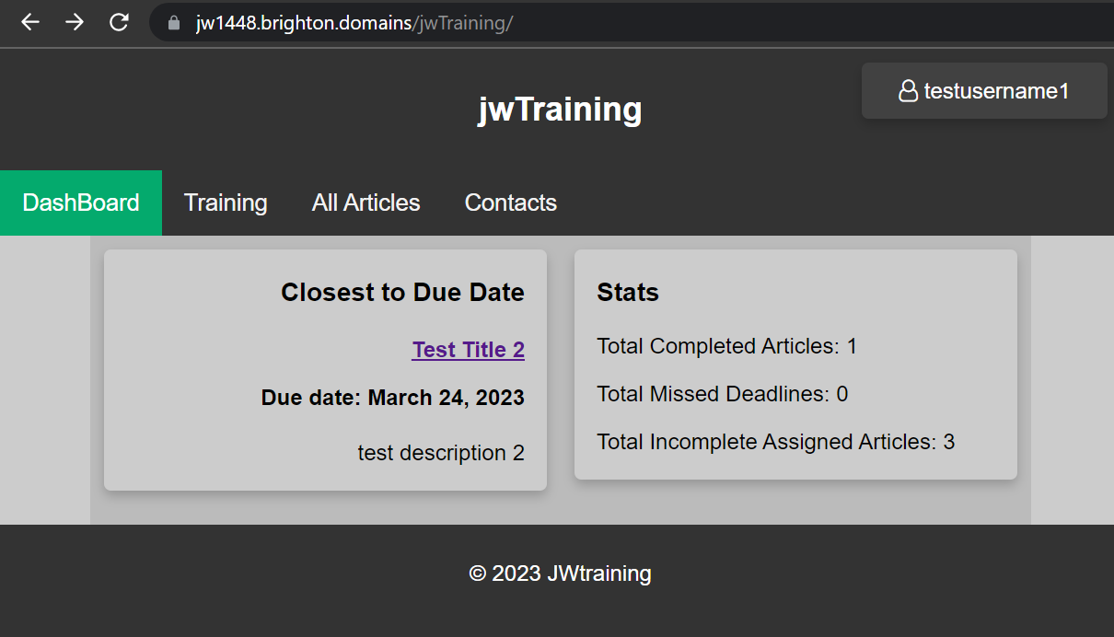

*Figure 347: dashboard UI successfully displaying stats*

Another minor task was to add the logo png image id previously made and stored in the assets folder to all pages. The logo would take up too much space on mobile views so CSS would have to be put in place to alter its dimensions on mobile.

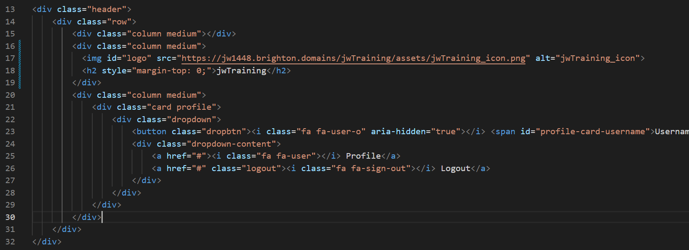

*Figure 348: logo added in header of all pages HTML*

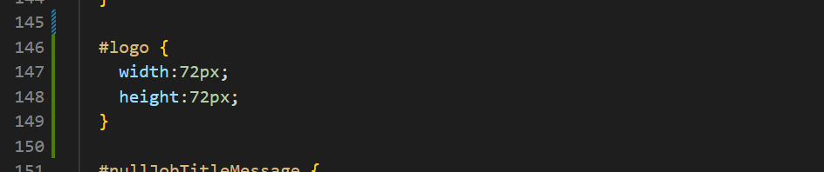

*Figure 349: CSS setting logo’s dimensions*

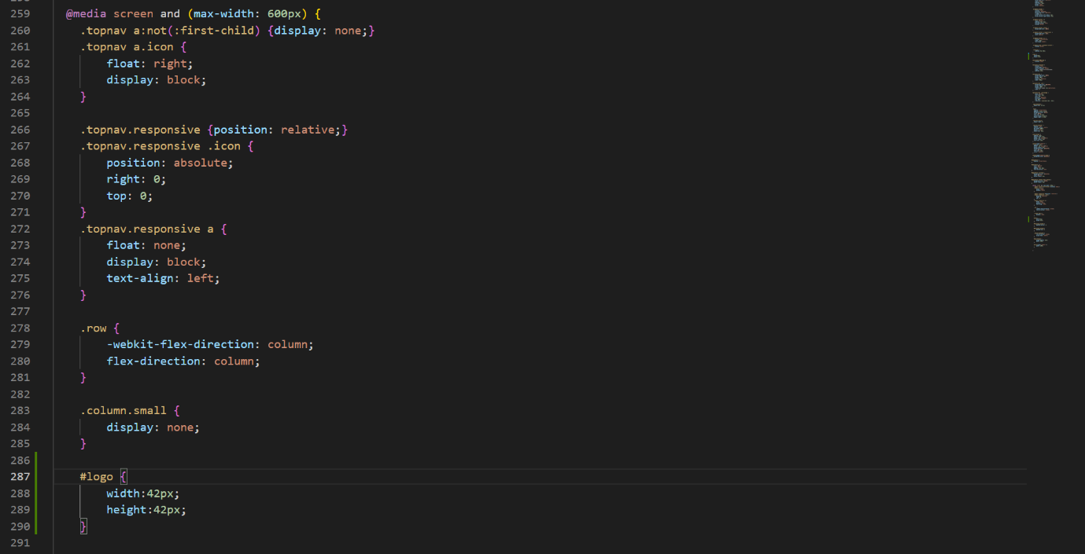

*Figure 350: CSS setting logo’s dimensions on mobile-view*

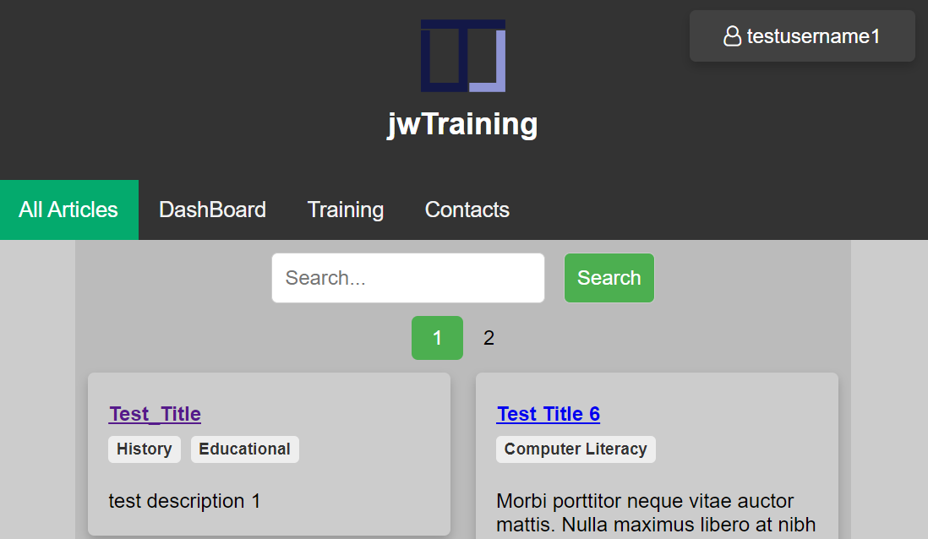

*Figure 351: example of UI with logo incorporated*

I decided to fill out the final placeholder in the navigation bar by adding a link to a contacts page. This would simply hold the address to the email id set up for contacting admins. This would open the default application for sending emails once clicked. In a real-world scenario this would hold more content relevant to the compony but in this case the help email suffices due to the lack of ownership or usage behind the site.

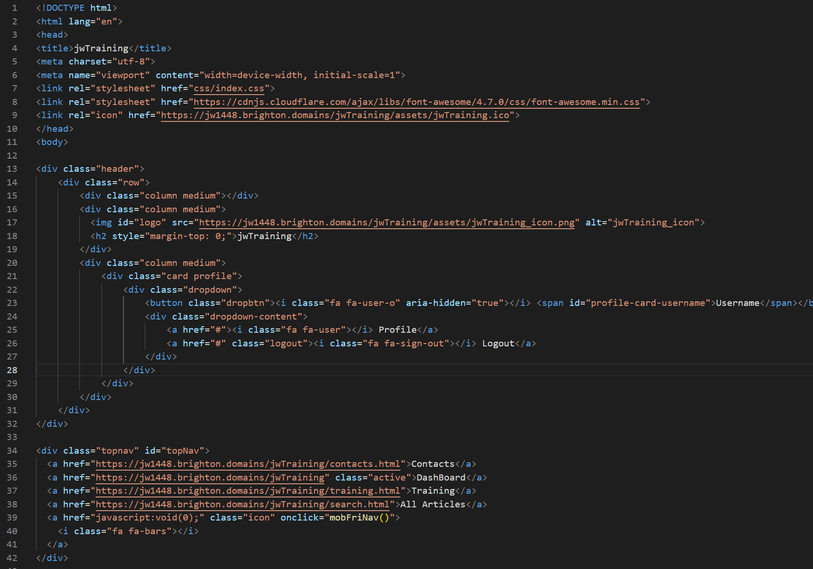

*Figure 352: HTML for contacts page (part 1)*

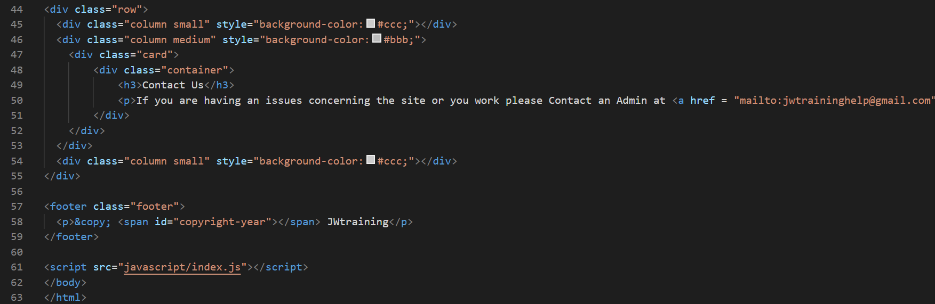

*Figure 353: HTML for contacts page (part 2)*

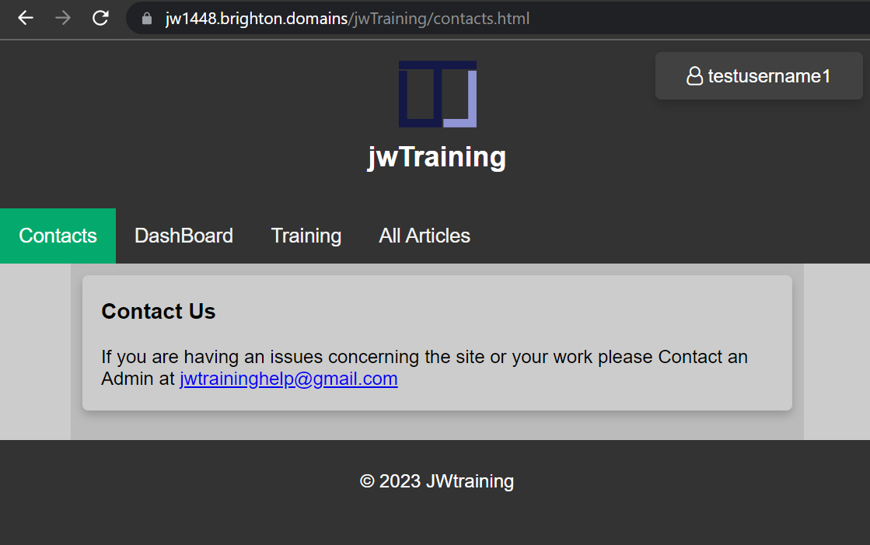

*Figure 354: contacts page UI*

I went back through all the code and beautified it to make it easier to mark and for other developers to read. If it were to be placed on an actual system, then it would instead by minified and bundled using something like Gulp to ensure it could be run efficiently and would be harder to analyse. The EJS file had to be beautified manually due to its nonconventional usage meaning a lack of support in the area.

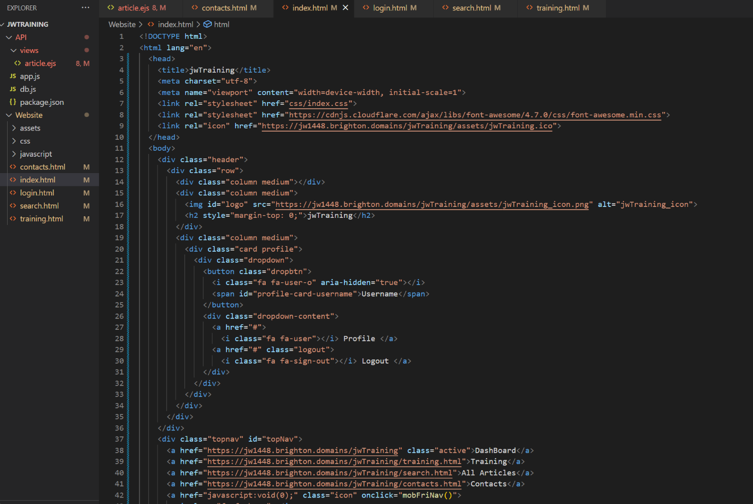

*Figure 355: all HTML after being beautified*

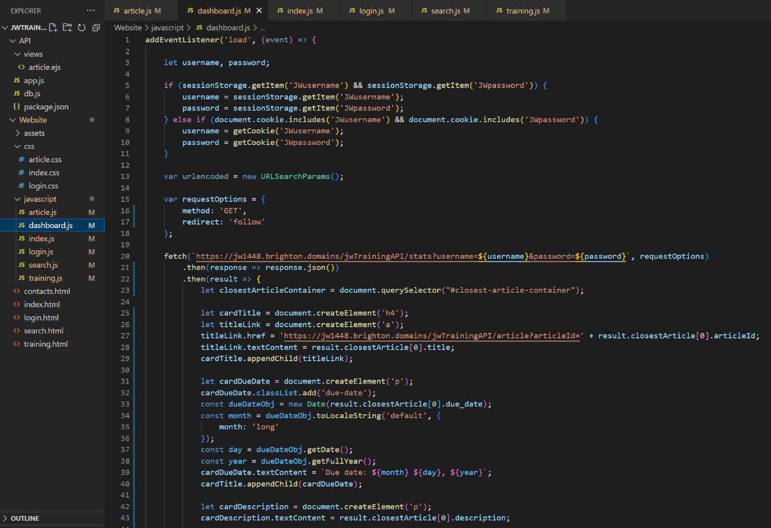

*Figure 356: all JavaScript after being beautified*

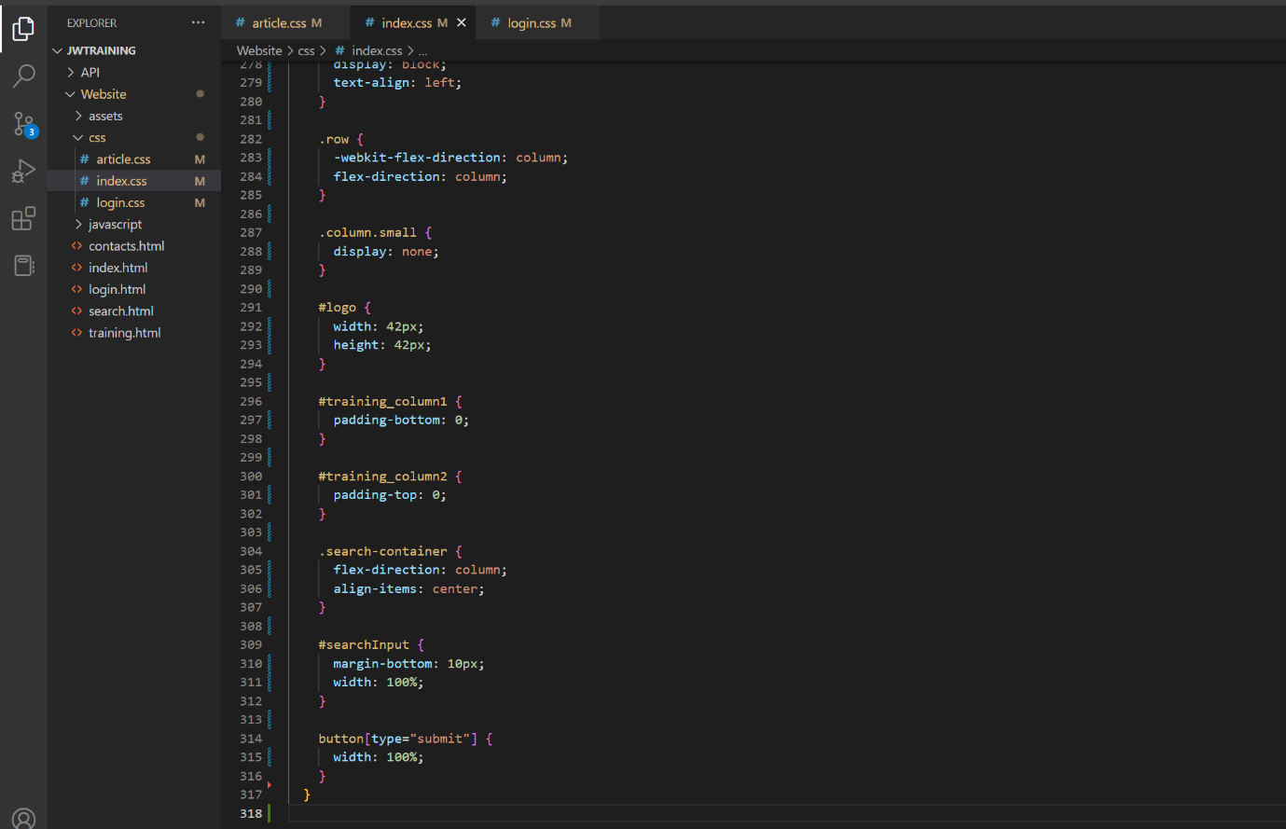

*Figure 357: all CSS after being beautified*

Now all integral features had been implemented I used HTML validation one final time to ensure accessibility on the site. I found that there were no errors as I had followed the markup, except for a lack of language tags on the EJS template. This was quickly changed and the first fully stable version of the project was committed to the GitHub repository.

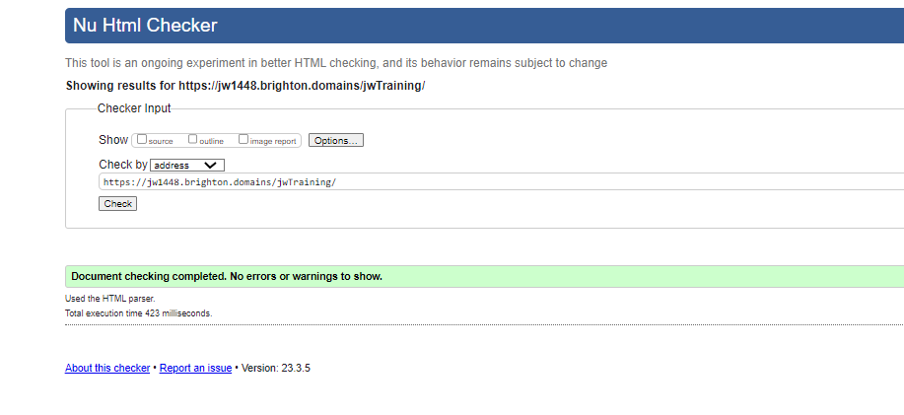

*Figure 358: successful test of HTML validation on all pages*

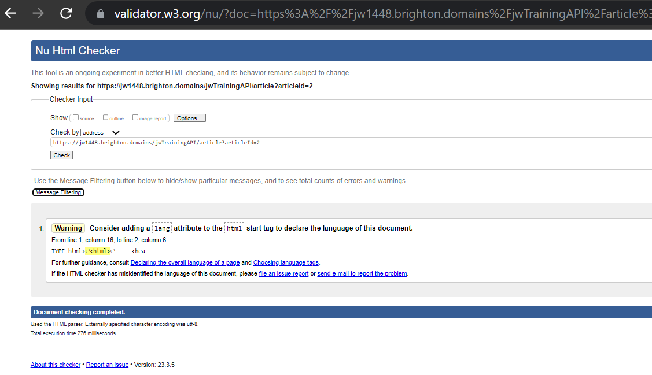

*Figure 359: unsuccessful test of HTML validation of EJS template*

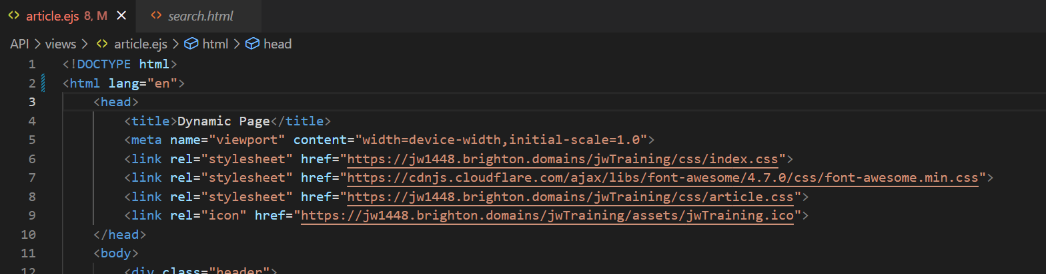

*Figure 360: language added to EJS template*

### 12/03/23

After using the admin account I realised that if there was no work due then the page wouldn’t load the stats due to stopping at the line displayed in figure 361. So, the code was adapted to account for this by checking if the array for closest article information held content, and if not them adding an appropriate message.

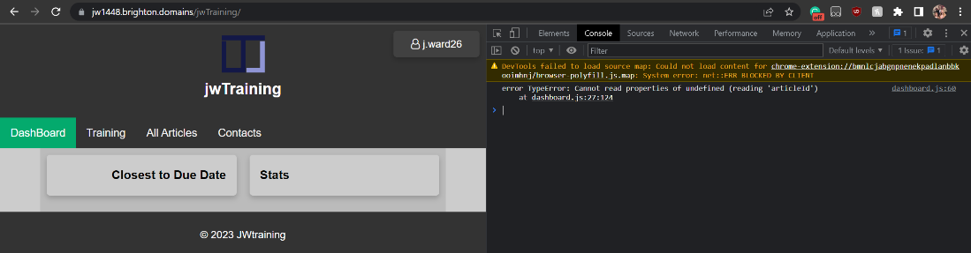

*Figure 361: dashboard not displaying stats due to lack of set work*

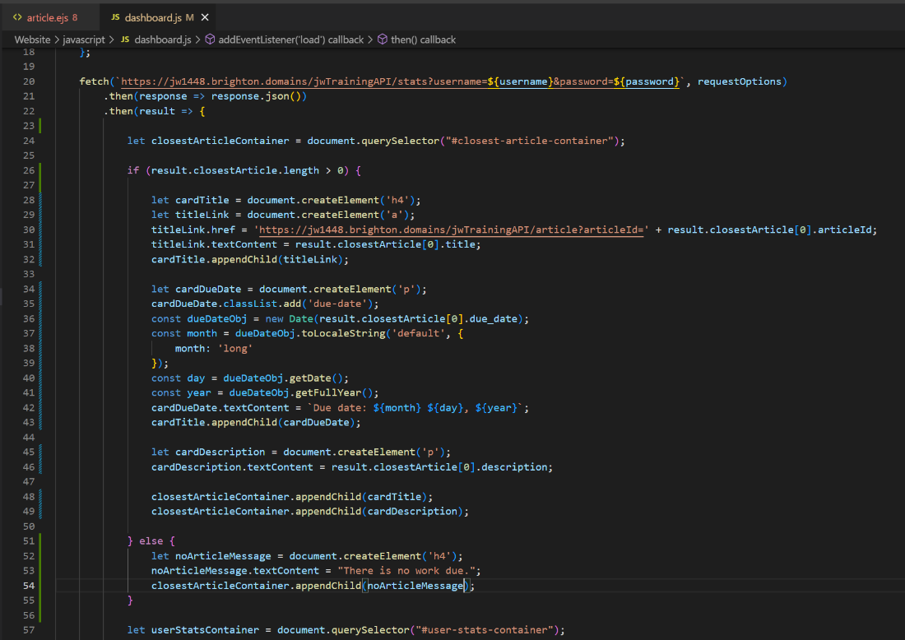

*Figure 362: JavaScript code of dashboard altered to account for lack of uncoming article*

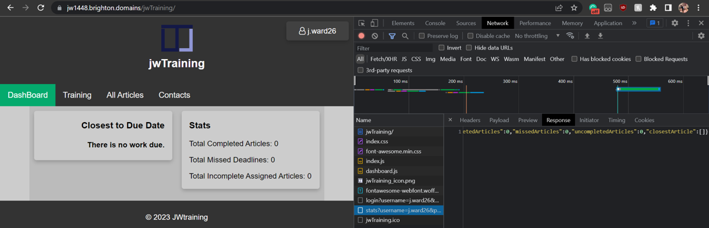

*Figure 363: dashboard functioning with message displayed for when work isn't set*

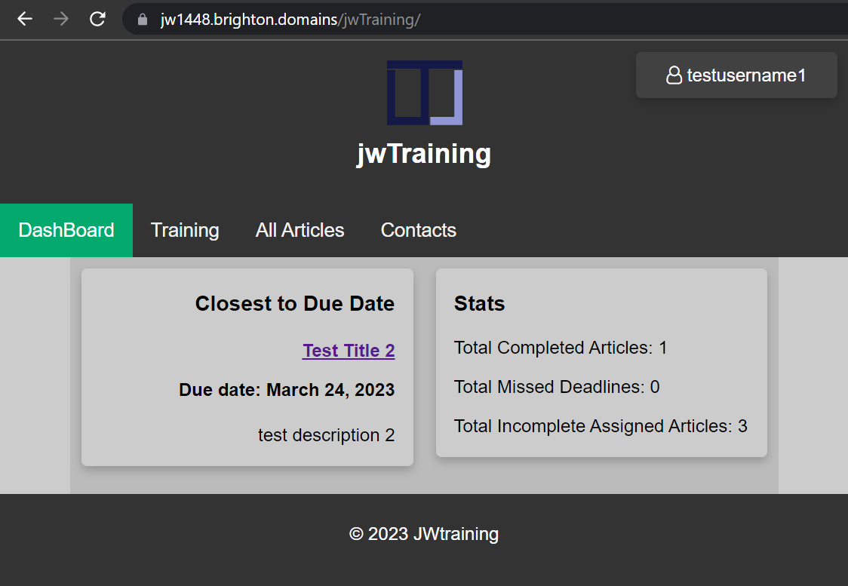

*Figure 364: UI still functioning after addition when work is available*

## Sprint 5: Documentation, Debugging & Minor Additions

### 14/03/23

I remembered that I should have given functionality to the cancel button on the login page long ago but had glossed over it in the rush of the initial design. I went back to add the functionality using the window.history to check previous entries in the history by number and see whether or not they contained then domain name. In this way I would be able to remove the user from the domain if they refused to login or signup. However, while you can go back to the previous URL in the browsers history and even see the length of the history you cannot go through all previous URLs as an array like I was planning. As this functionality wasn't available I turned to the use of window.referrer but found it could only be used to get the URL of the previous page. With these options exhausted I had to make the button simply take the user back a page. As the login page replaces the current URL instead of a redirect clicking this button over and over will result in leaving the domain but the process will take as many clicks as the pages that were previously visited on the domain in this tab session. This was not the optimal solution I was hoping for, but it was the only one available to me. This could be counted as a bug fix as the lack of functionality was only rediscovered due to user testing.

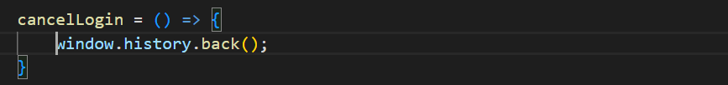

*Figure 365: JavaScript code to send the user back a page*

### 16/03/23

While writing the documentation it occurred to me that I hadnt put in place any kind of alert to let the user know that there were no results to a search. So I quickly added this to the code which required restructuring the request handling slightly so as to no log errors to the console every time. Rather than have to delete all results display a message and have that message remove itself upon every new search I decided the more elegant solution would be to simply send an alert as alerts also connote an error which this could be viewed as. The code was restructured so that id there was no Json to use then it would never attempt to be returned.

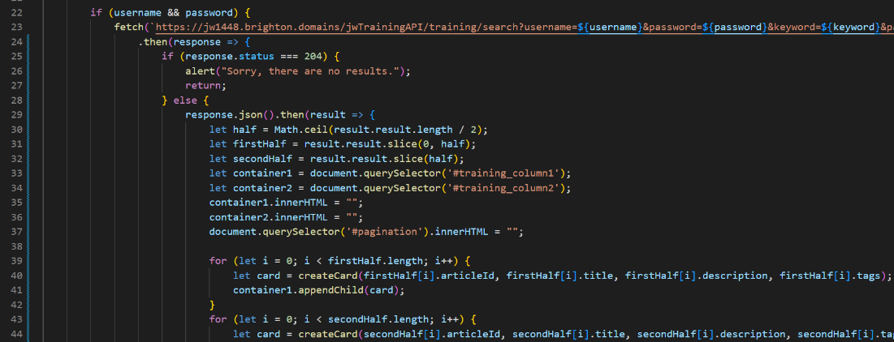

*Figure 366: JavaScript of search function altered to notify the user of no results*

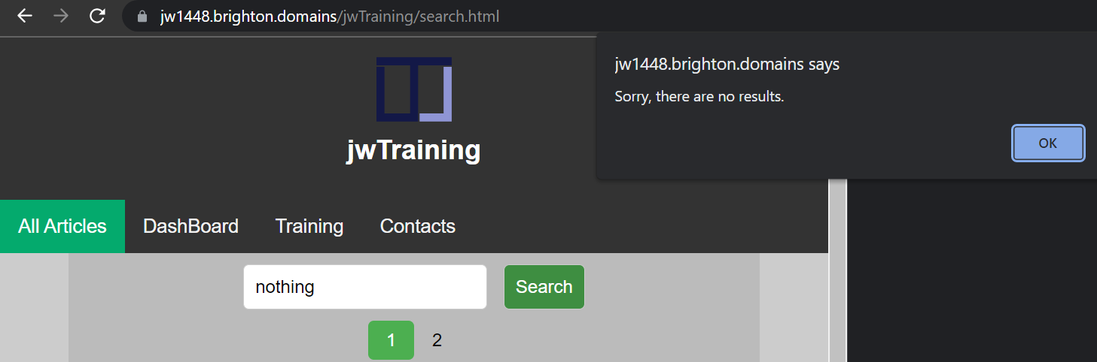

*Figure 367: alert conveying lack of results to user after search*

### 18/03/23

While writing up the API documentation I realised that I had placed no handling on the results of assigned training when there was none. This would either mean that no work has been assigned or all work has been completed. So, I made it that if a status code 204 was returned then a message would be displayed and the progress bar would be set to 100%. This is valid in both scenarios as if a user has no work regardless of reason then their progress is 100%. This briefly broke the training page for valid searches but it was simply because of a typo with 204 instead of 200 (it was quickly located and fixed).

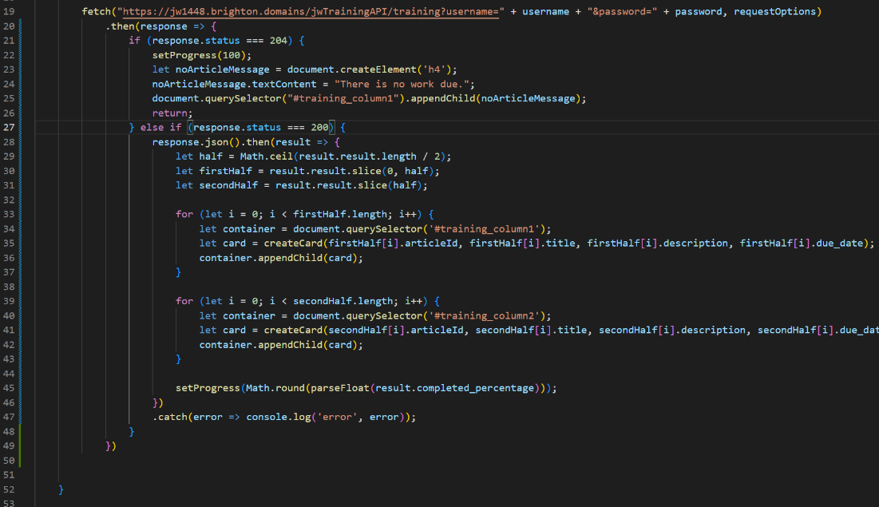

*Figure 368: training page altered to account for lack of work*

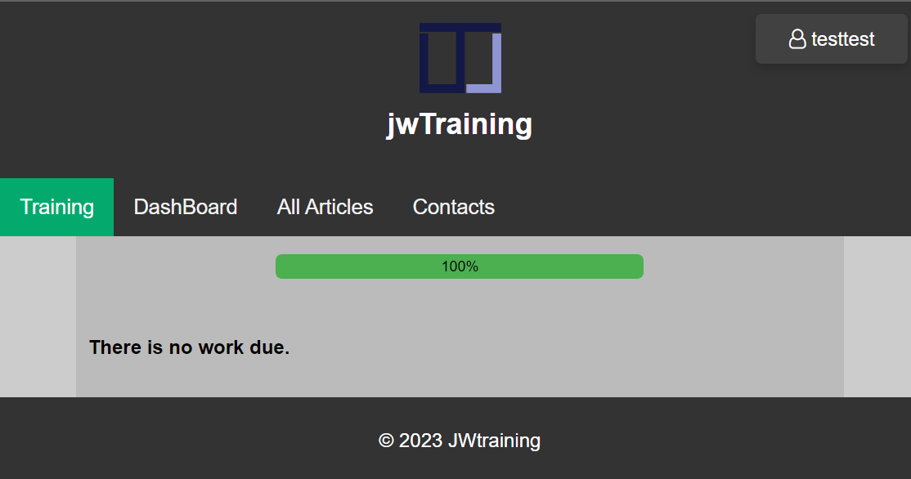

*Figure 369: training page UI when no more work is set*

After reanalysing the entire API and fixing any bugs, the documentation of the API was made to be submitted as an extra deliverable, in case another client was to be made without the developer wanting to change the backend.

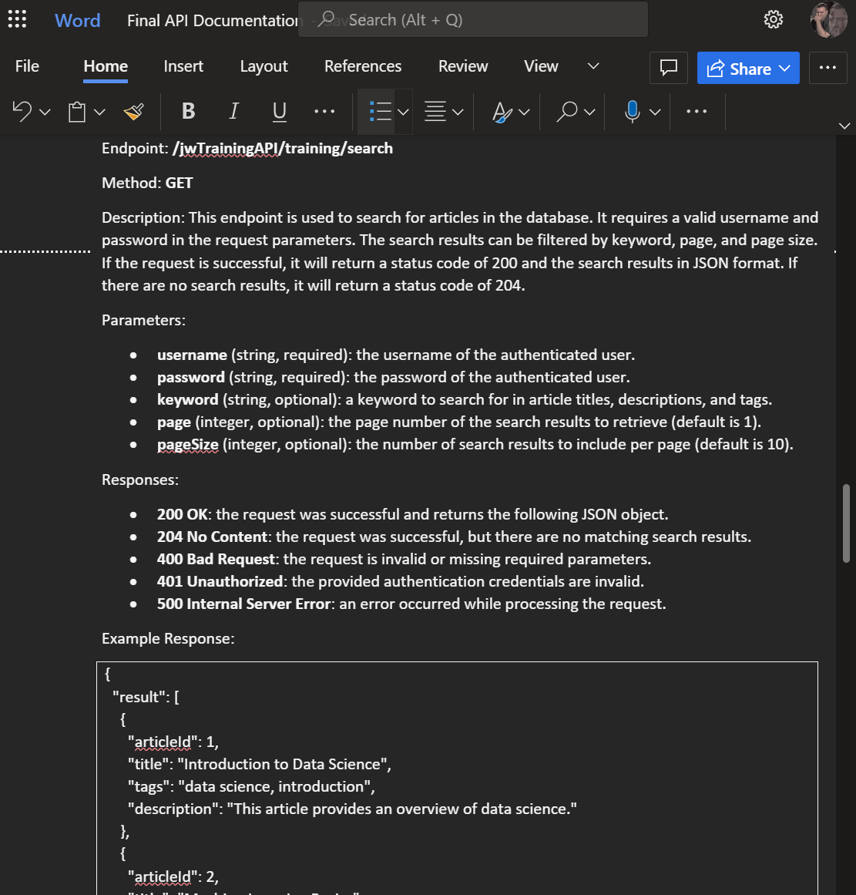

*Figure 370: API documentation being written after debugging and analysis*

### 21/03/23

Although I figured that there may not be enough time to properly implement profile pictures, I revised the best practice for image file uploads and added a method to upload images to the API as proof of concept. This handles the file to make sure they are in a valid image format (jpg or png) as well as checking if the image exists and if so then uploading the file to the specified folder. To flesh out the feature should extra time be found before the deadline then authorisation would need to be added and the name of the profile picture would need to be added to the database with the corresponding user. The upload endpoint would need to be accessed by a profile page on the web site which I had already established a placeholder for. If development were to continue after the deadline or if extra time was available without risking other projects then I would implement this. For the time being the new endpoint would not be added to the documentation of the API as it is incomplete, only serving as proof of concept for image file uploads.

To keep the images uniquely named, I would save them as the current date and time in milliseconds, the users username or a combination of the two. For simplicity I have not implemented this yet as the get function would be harder to demonstrate.

At this stage the project report is taking up most of my time as it needs to be divided with two other modules as well as work and other responsibilities. Due to this I predict this will be the last entry or there will be a significant gap between entries. If this is the last entry, then I would call the completion of requirements 1 through 21 a success with feature 22 in development.

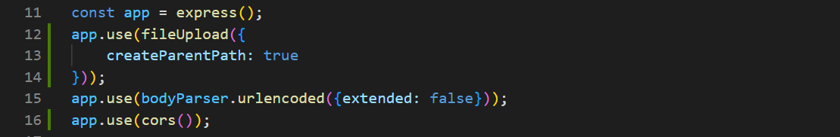

*Figure 371: enabling the upload of files to the Express API*

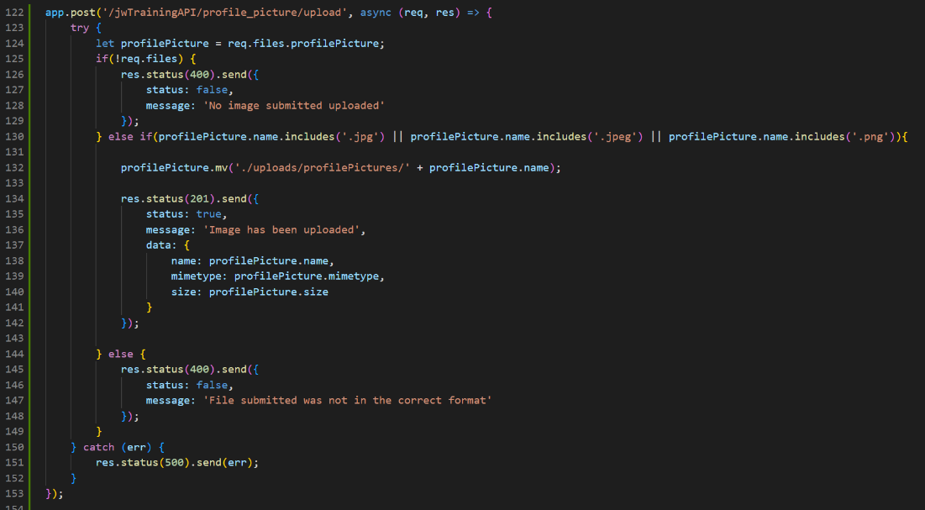

*Figure 372: handling uploaded images*

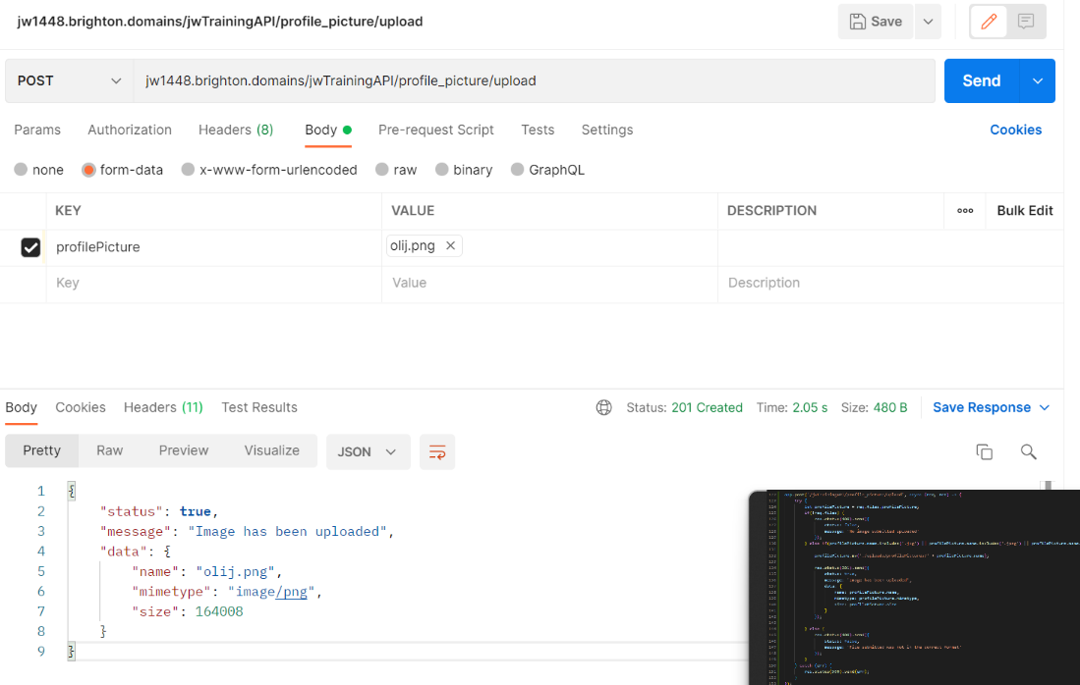

*Figure 373: API 201 response to image in correct format*

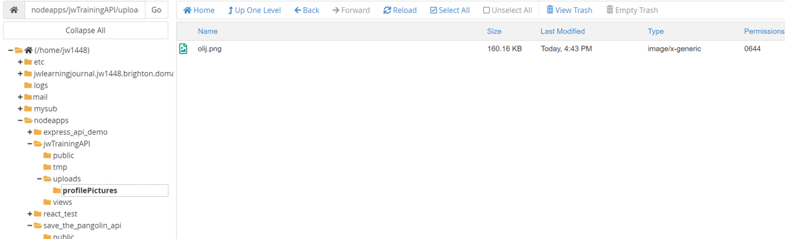

*Figure 374: API with image saved in uploads folder*

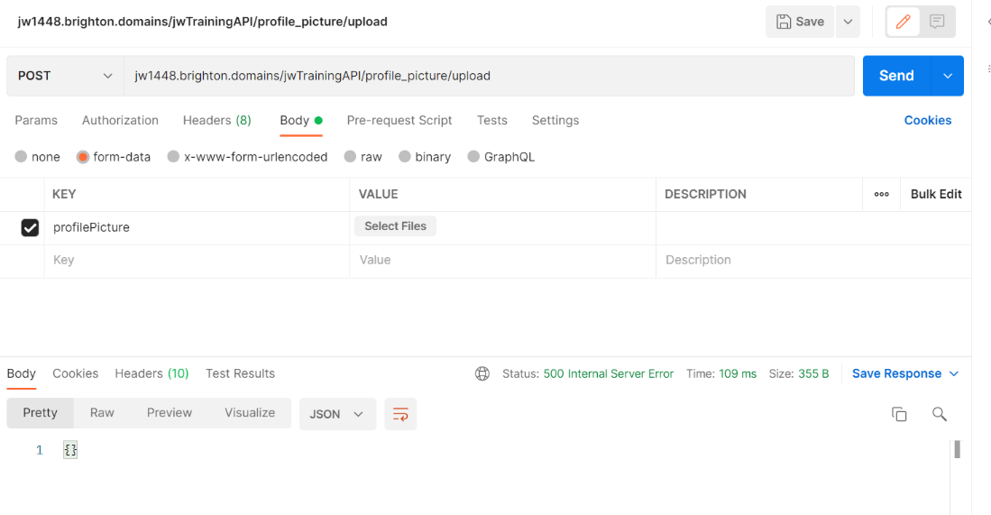

*Figure 375: API 500 response to no image/file*

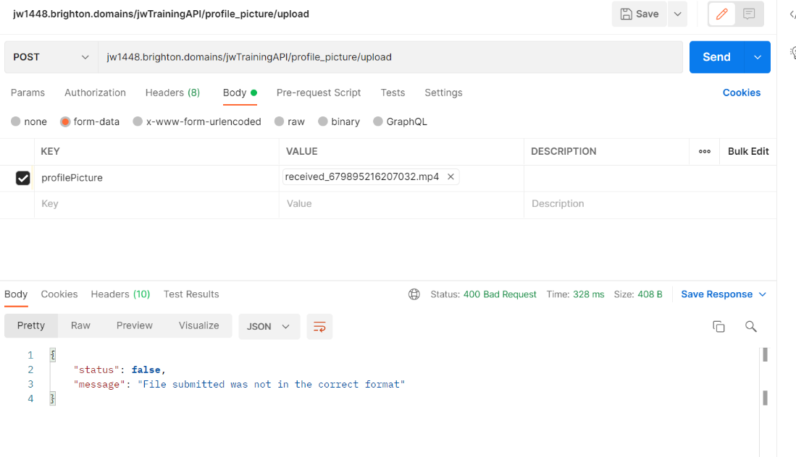

*Figure 376: API 400 response to image in incorrect format*

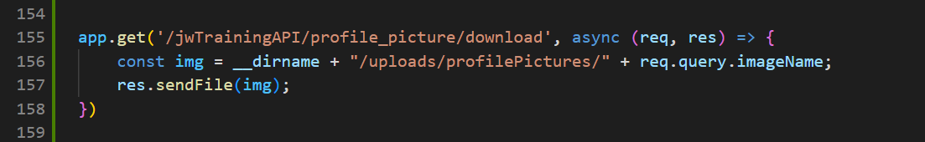

*Figure 377: API GET request for images*

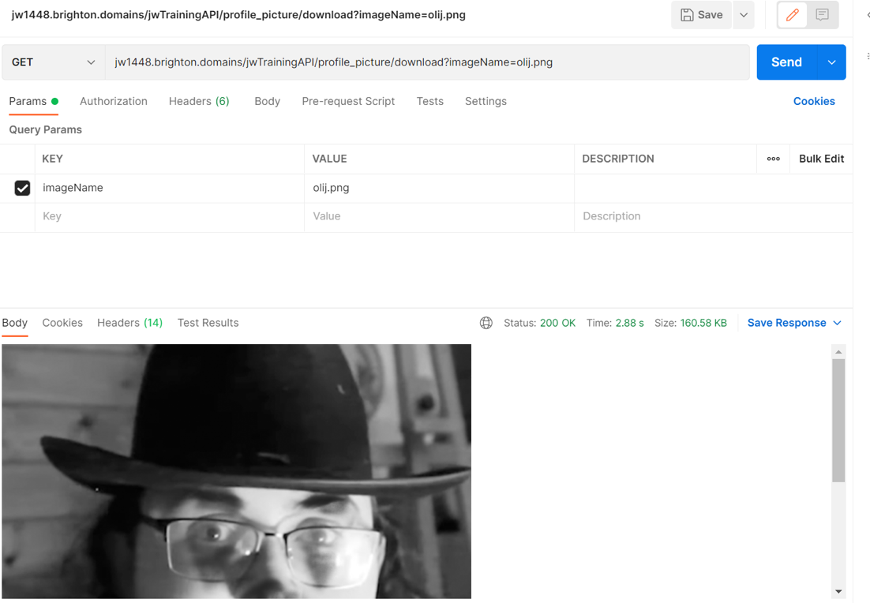

*Figure 378: API 200 response for GET request of images*

### 23/03/23

While performing what was expected to be the last session of regression tests a very minor bug prevented itself in that when I was beatifying the code the IDs used in the query selectors had had their hashes removed. I added them back and restored functionality. I checked all other code to see if the same issue had presented itself and it had not.

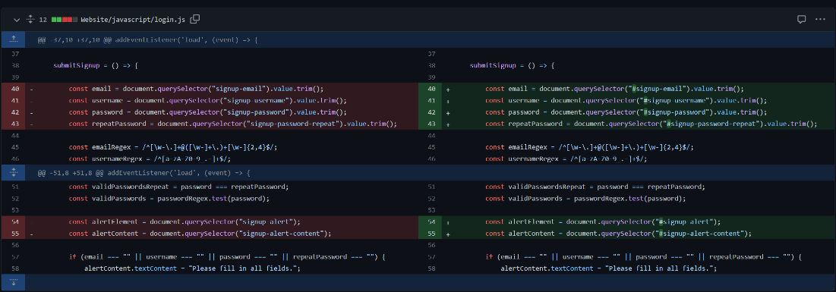

*Figure 379: change made to login JavaScript to select valid IDs*

I found a little more spare time and so decided to add onto the profile picture functionality, at first I was going to add a new column to the database until I realised it would be inefficient. This is because if all profile pictures are named after the username then there would be no need for an extra column repeating the same information. Therefor the code would just need to be adjusted to name the files after the user who is logged in and have the get requests get whichever format of file it exists in. The only problem that would arise with this method would be if files didn’t overwrite others however, I tested this, and they do. With this added there is now profile picture upload and download functionality, even if only on the server side. This feature took a lot longer than anticipated as many methods I researched on file handling (specifically how to search for file by name) failed. Only after attempting to use a blob object did I find a working solution (pictured in the figures 380 - 385).

The client side upon implementation would need to have a default profile picture that would be replaced by the real one if it exists. As well as having a fetch request sent from the profile page to upload profile pictures.

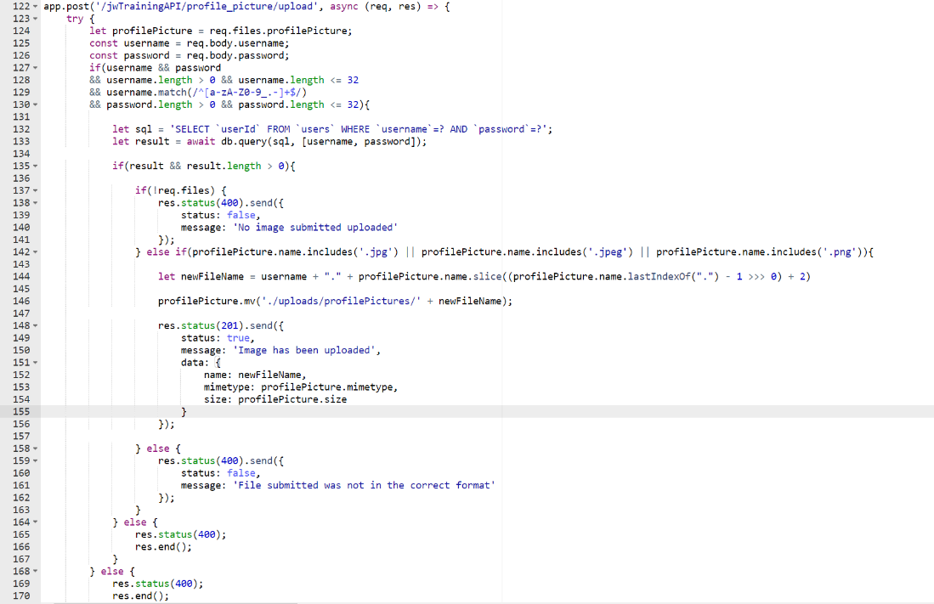

*Figure 380: new API code for uploading profile pictures*

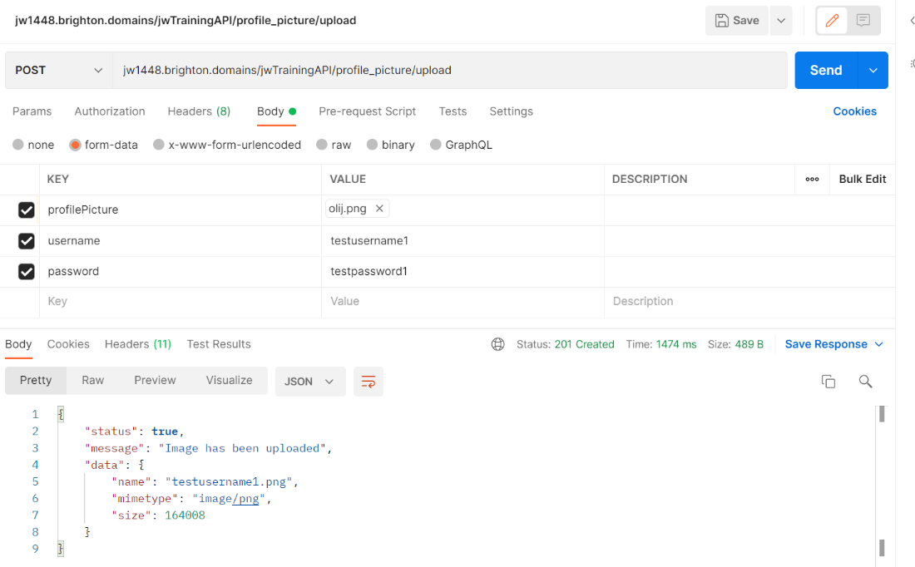

*Figure 381: API response having uploaded file*

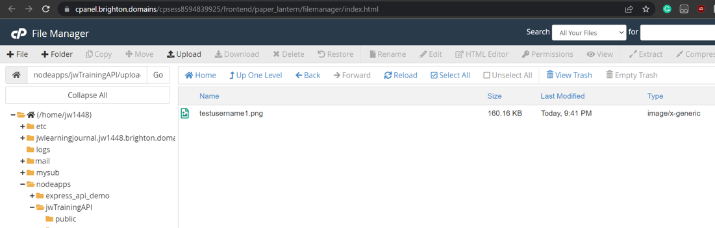

*Figure 382: file having been saved and renamed on API repository*

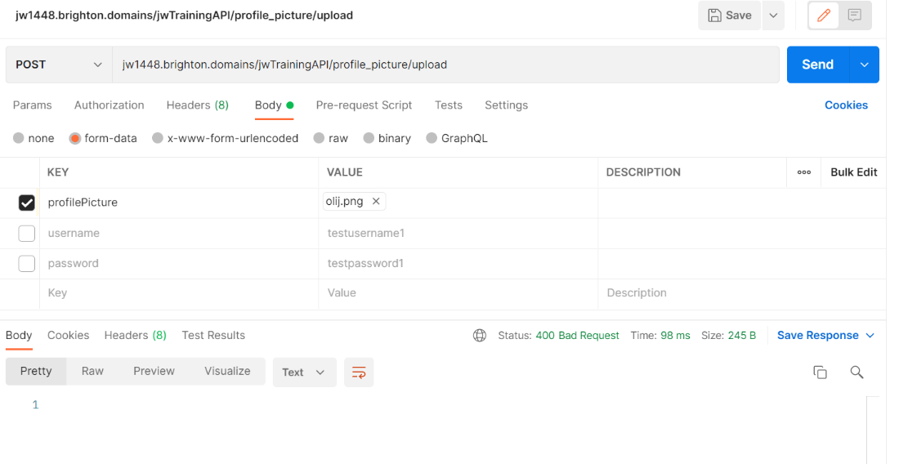

*Figure 383: API response having only attached image*

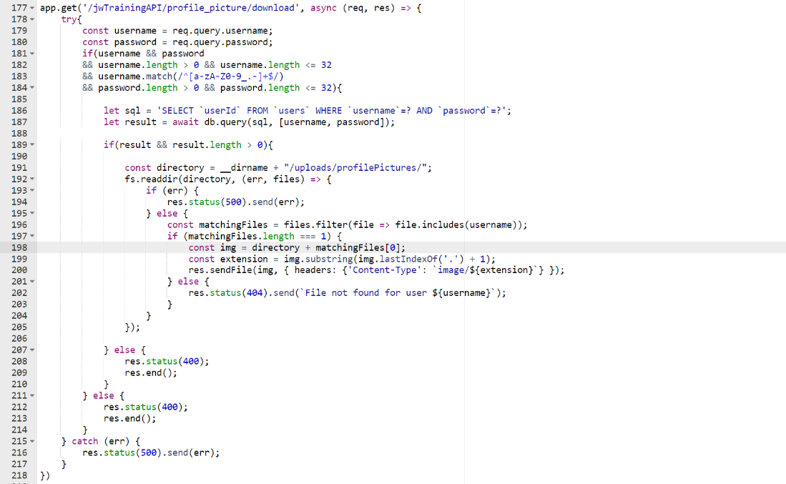

*Figure 384: new API code for downloading profile pictures*

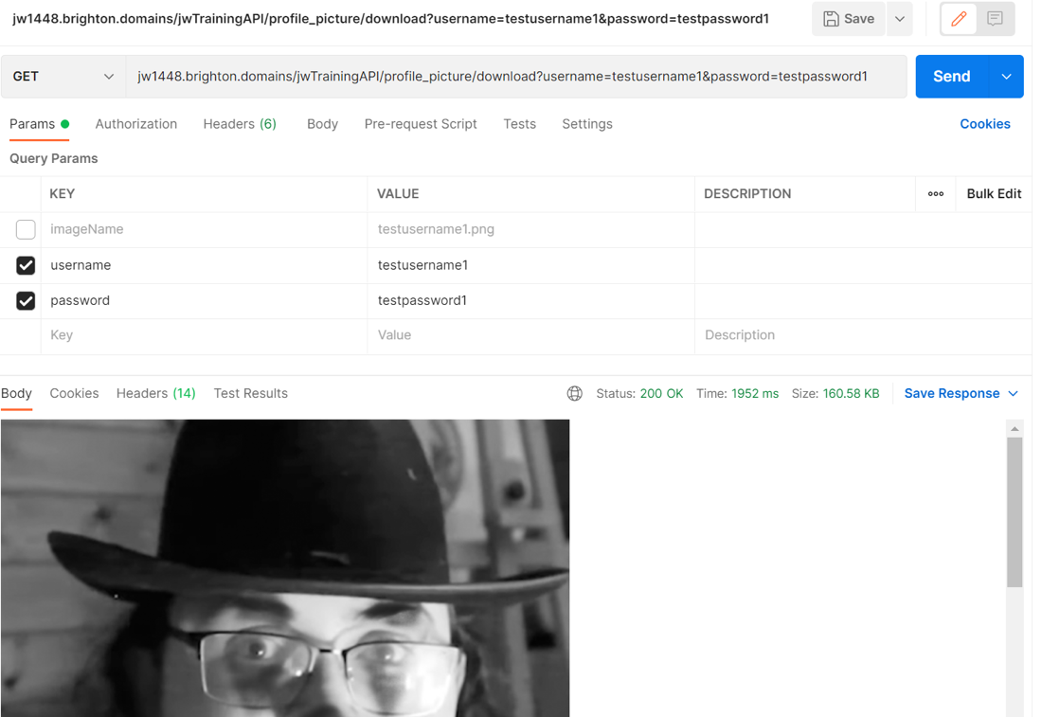

*Figure 385: API response having downloaded file*

### 01/04/23

While carrying out the final wave of observational testing it was stated that the work that was overdue could be clearer, and I also noticed that the closest date statistic would exclude past dates and so needed to alter it. I changed the query on the stats endpoint to exclude past dates. I then added it so that if the client-side found the date to be in the past then it would add an overdue class to the card giving it a border and would add “(overdue)” after the date to be as explicit as possible.

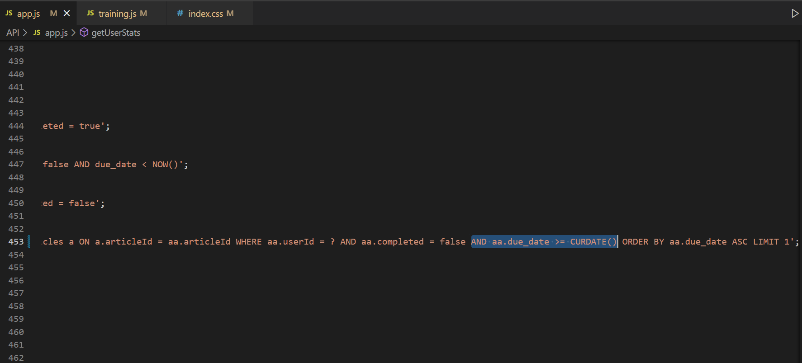

*Figure 386: Alteration to stats query to exclude entries with past dates*

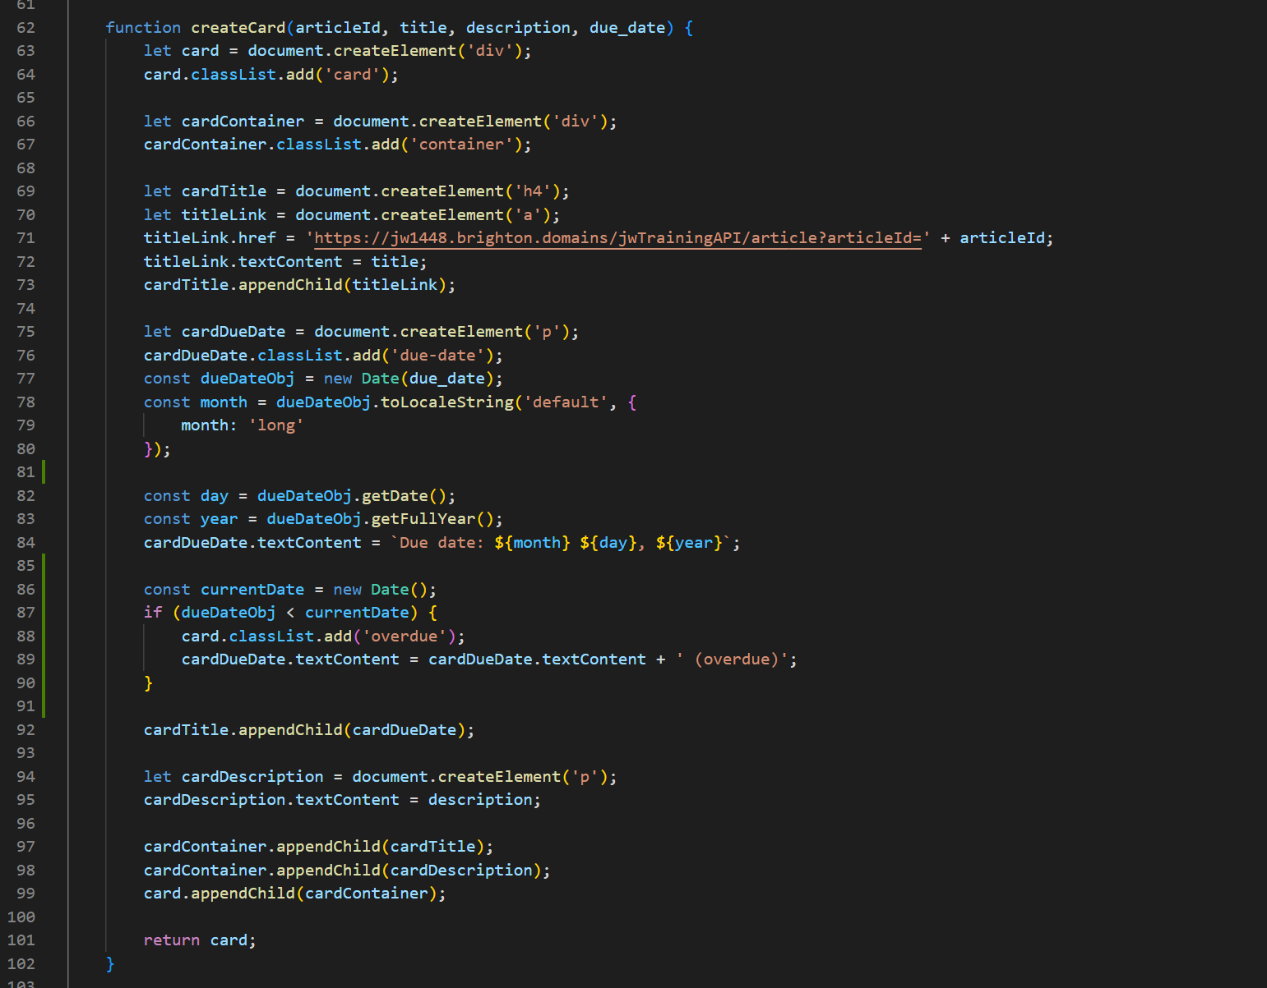

*Figure 387: card creation on training page altered to accommodate overdue dates*

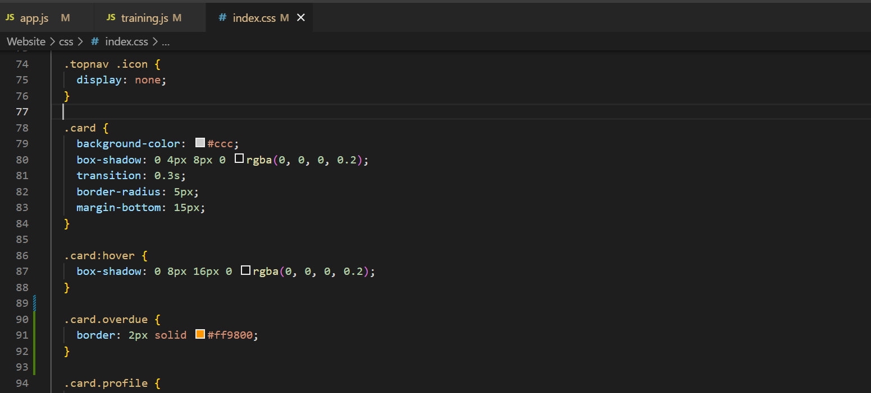

*Figure 388: CSS added for overdue dates borders*

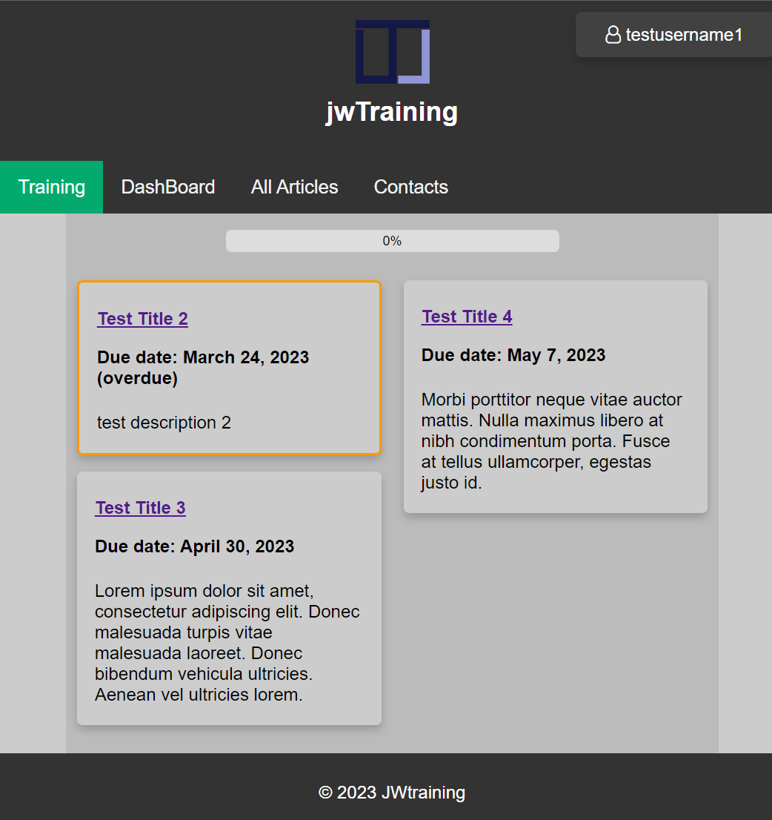

*Figure 389: overdue work on training page UI*

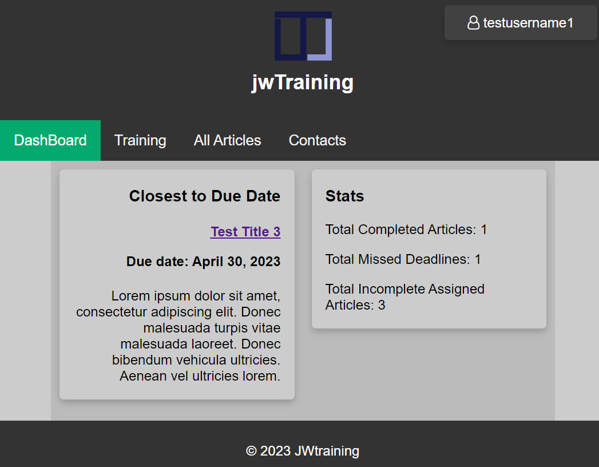

*Figure 390: accurate due date stats*

### 04/04/23

For example purposes I added new articles to the articles table so that the content would be more relevant and actually resemble what it would look like in practice at a company. However, the longer quizzes made me realise that the quizzes would need some slight alterations to the formatting which can be seen below. I chose to write briefly about other topics I had studied while at the university so as to show more examples of learning in different areas. The database content was then all exported as an SQL file and added to the GitHub repository so that the database could be remade if at all useful. Everything was tested and found to still be working.

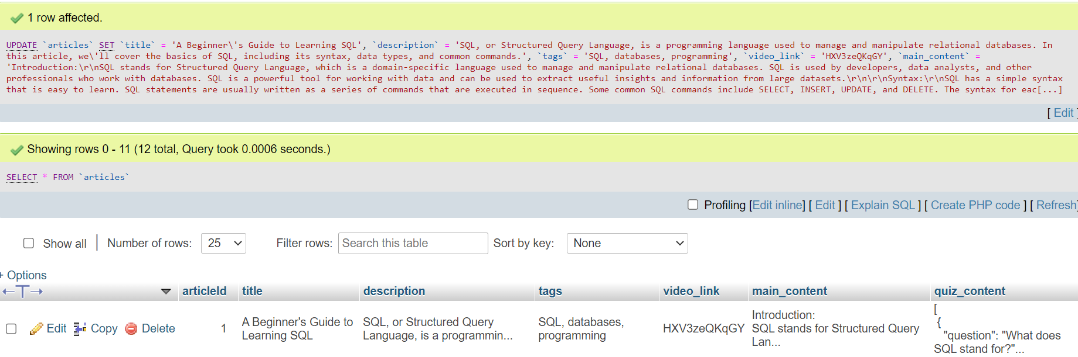

*Figure 391: updating the database with a couple relevant example articles*

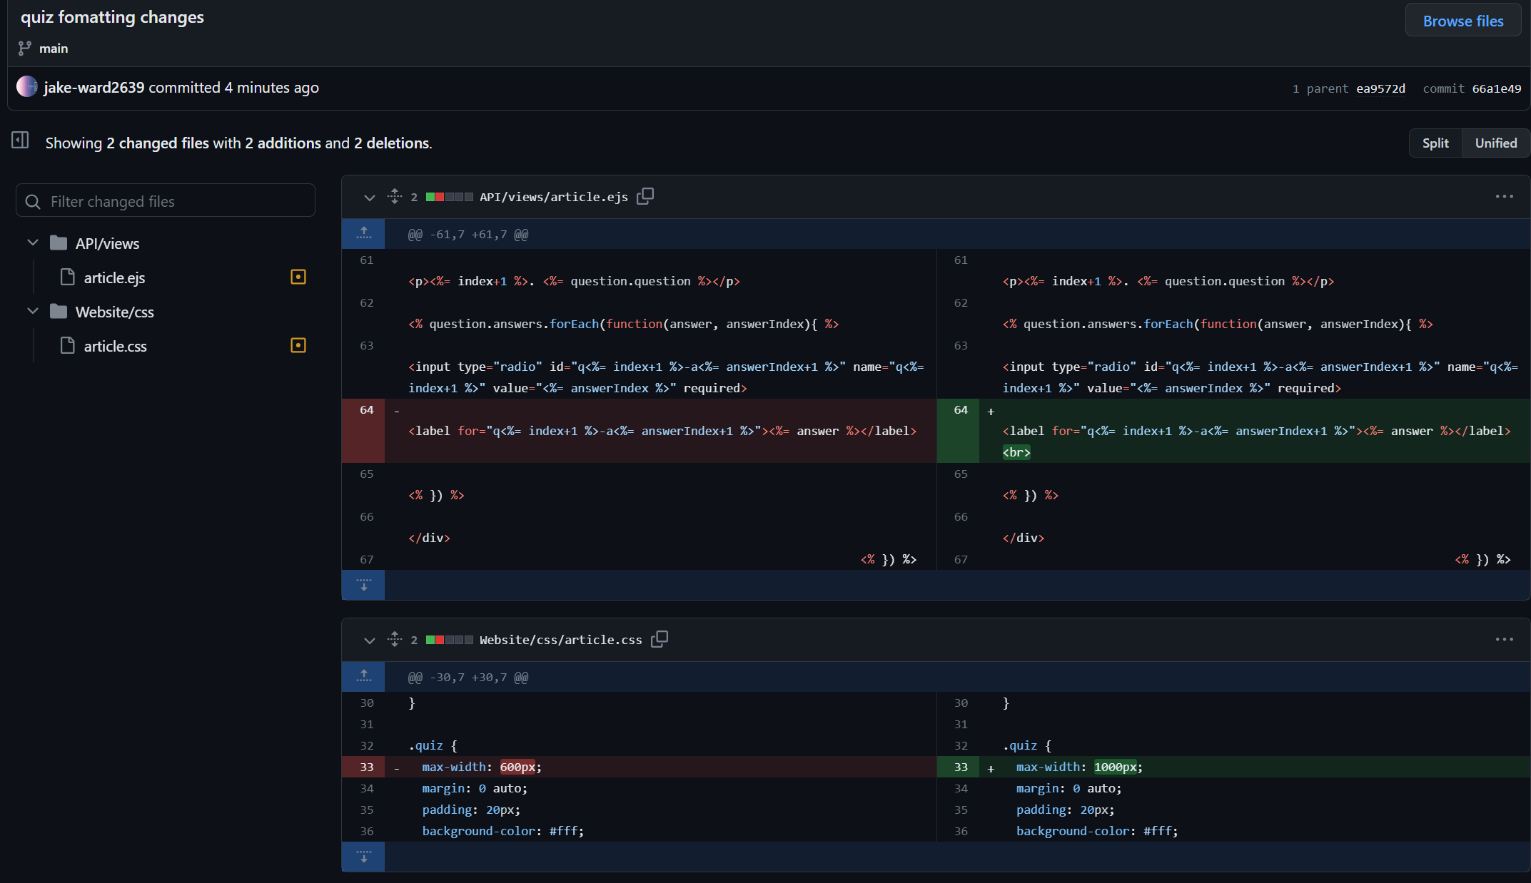

*Figure 392: new formatting of the quizzes (code)*

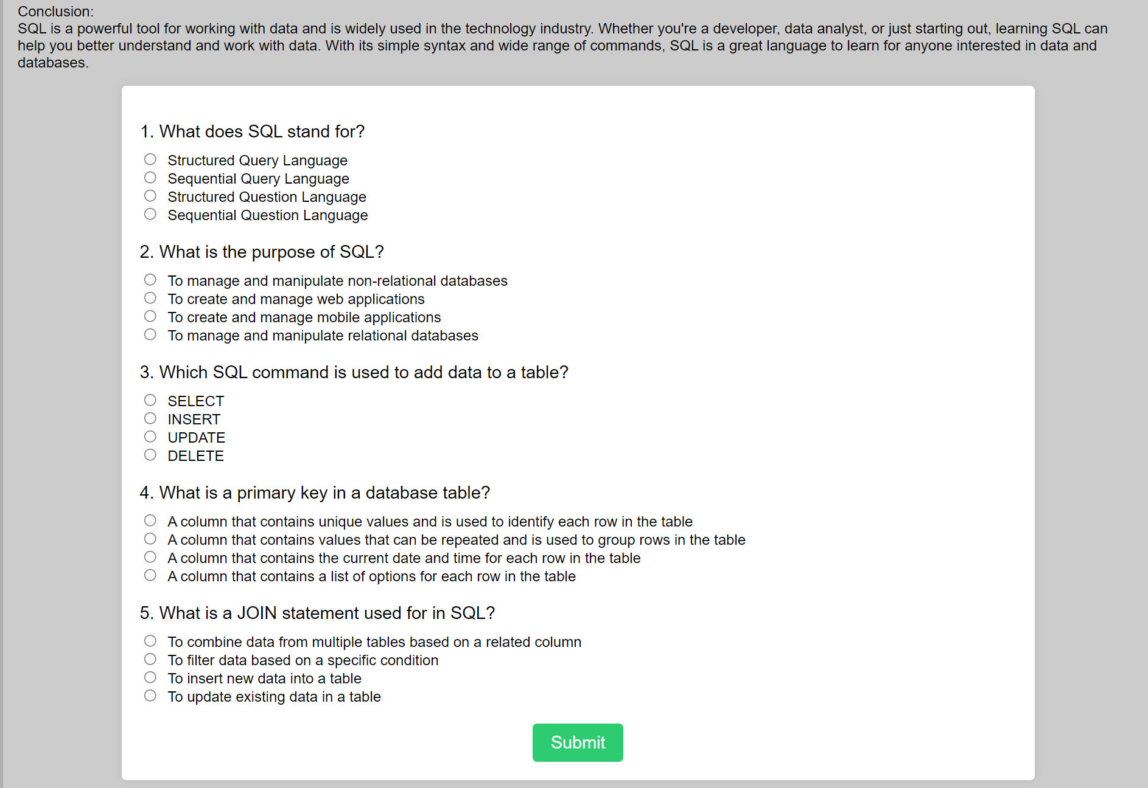

*Figure 393: new formatting of the quizzes (UI)*

### 12/04/23

While implementing an account that assessing users could use it occurred to me that the SQL statement for login wasn’t case sensitive. This was a very small fix as the only addition needing to be made was the “BINARY” operator to the MySQL query. I breifly tested it and found the issue to have been fixed.

# Testing

Proof of all testing was documented in a separate document so as to not overflow the main document and to better organise the documentation material. However, this also means that they cannot be submitted with the main document as the method of submission (Turnitin) only allows for one file submissions as well as disallowing the submission of zip files. As such the extra documents have been linked at various points in the report in a way that university emails can access them.

* Link to Testing Documentation: [JW Testing Documentation](https://unibrightonac-my.sharepoint.com/:x:/g/personal/j_ward26_uni_brighton_ac_uk/EcdlyIxuirVLqYT9H4kcPIwBn1qbREksJDRDJ6PQyHmPhg?e=R5QFNm)
* URL for Testing Documentation: <https://unibrightonac-my.sharepoint.com/:x:/g/personal/j_ward26_uni_brighton_ac_uk/EcdlyIxuirVLqYT9H4kcPIwBn1qbREksJDRDJ6PQyHmPhg?e=R5QFNm>

Testing was by far the most underestimated process timewise, as the sheer number of tests with a great number of users (while providing detailed evidence of the whole development life cycle) was a much greater time-sink than was first anticipated. This process of testing after each new implementation took up many hours each day and so if the project were to be done with hindsight, the realistic length of the project would have been taken into consideration and the number of testers may have been lowered. However, its usage in this case does show considerable evidence of project management and wholistic coverage of testing/the SDLC (software development lifecycle). Relevent screenshots of all tests are included in the implementation section.

### Test Requirement Matrix

User testing with a test requirement matrix was used to document the majority of tests that had taken place. Basic user testing helps to identify user experience issues early on in the development process as well as identify errors throughout the entire development process. By utilising white box testing I could ensure comprehensive testing that explored all code paths, ensuring all had been executed and tested. Any tests done by the developers to establish that the code was working would also be classified as white box testing as the developer would have knowledge of how the system worked. On the other hand, by utilising black box testing the system could be tested from the average user's perspective, allowing for critique and testing of the user experience, functionality and usability of the system. This mix of both white and black box testing from various parties ensured that all bases were covered in terms of testing.

By specifically using a test-requirement matrix I can display how specific requirements were being met and tested. By implementing dates into this table, it would allow easy navigation between the implementation documentation and testing documentation, meaning it would be easy to follow explanations of tests and implementation to the evidence of tests and vice-versa. By mapping each requirement to specific tests it is ensured that all requirements are tested and there is no gaps in coverage. The requirements used in this case are the revised requirements to make things easier to read for outsiders. By linking dated tests to specific requirements, we can easily track what was tested and why allowing for easier bug fixes and troubleshooting. While this method would also facilitate collaboration due to the organised tests, this isn't relevant when there is a singular developer, like in this case. For convenience, a key for requirements was included in the testing documentation to ensure easier navigation for viewers of the document. Progress can easily be tracked via this matrix and the matrix can be seen to have prioritised the high-priority requirements in favour of low-priority ones. The matrix would also double as the recording of errors, as all errors would have to be discovered via a test. This means that errors that had happened in the past could potentially be solved faster by consulting the test-requirement table and following either the changes made to fix the error or consulting the associated implantation entry via consulting the date. No identifying features about participants were added to the testing documentation so it remains ethical as originally designed.

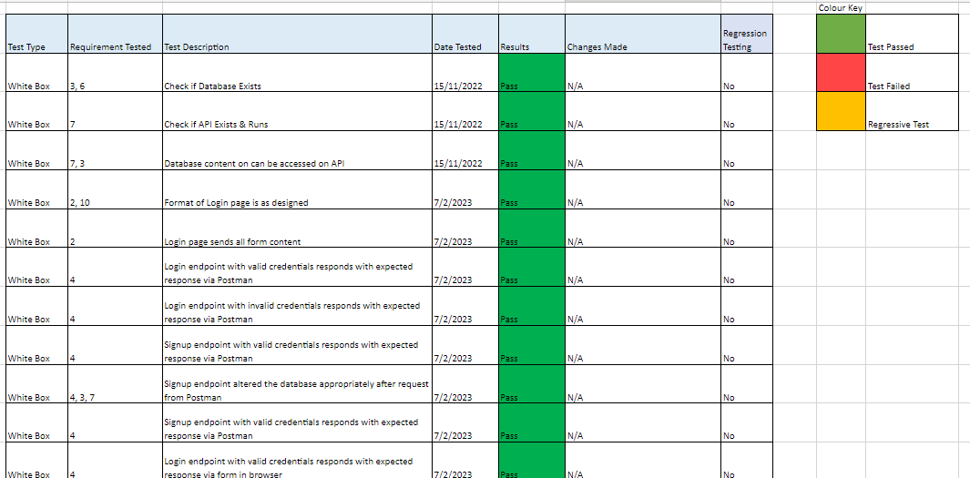

*Figure 394: test-requirement matrix*

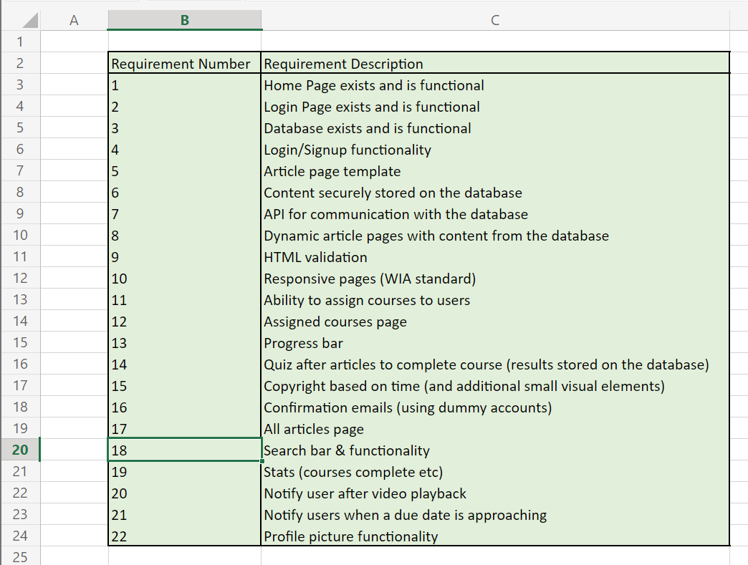

*Figure 395: requirement key for test tables*

On occasion, errors would be encountered that would not be recorded in the test-requirement matrix due to the cause of the error being unrelated to the artefact. This would often be due to a poor internet connection or temporary problems on Brighton Domains (the hosting site).

### Observational Testing

The observational method was used to display current mock-ups of the system and have users provide feedback which would in turn shape the project to improve usability. This is another form of testing which on occasion would overlap with the tests recorded in the test-requirement matrix. It allows developers to observe users performing real-world tasks with the software artefact, in turn providing insight into how users actually use the system as opposed to how the developers intended for it to be used. This method can shed light on usability issues that may not have been apparent through other methods as many users may have different methods of using the system.

The exact way I carried these tests out was in the room as the user or over a Microsoft Teams or Discord call with screenshare allowing me to see what they were doing. I made it clear to them that I was open to critique and while I would be asking for it at the end, they were allowed to interject at any point in the test with critique that I would note down. This critique would shape the project incrementally as it would usually be carried out with the days dedicated to regression tests with as many participants as were available.

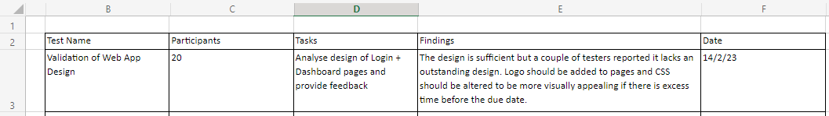

*Figure 396: design of observational test table*

### Regression Testing

The final type of testing to mention that was carried out was regression testing. Regression testing is the retesting of previously tested elements to ensure functionality is still present. As such I made the most sense to carry these out at the end of every sprint as well as every time a new feature was implemented or changed that could have a direct effect on the other elements. Tests would also be carried out again if a potential path for the user had been overlooked. These were included in the test development matrix with a colour-coded column present to visually represent the difference between tests and regressive tests. Regression testing inherently ensures that changes to code do not introduce any issues or highlights them if this is the case.

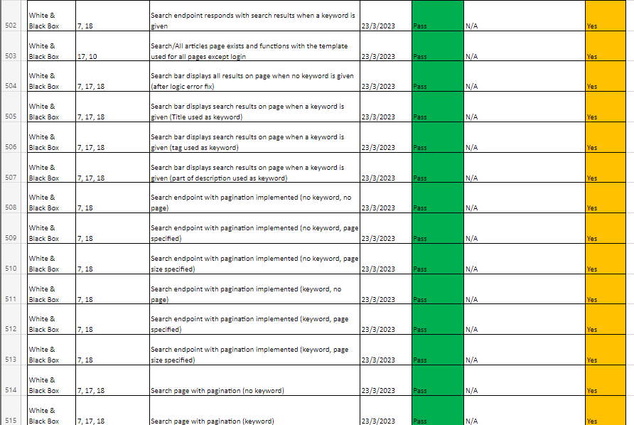

*Figure 397: regression testing in test-requirement matrix*

# Evaluation & Critical Review

Before evaluation of the entire project, below can be seen the state of the Kanban/Trello board at the end of development as well as the state of the GitHub repository. It can also be seen that I’ve sent requests to grant permission to my supervisors so they can easily access the codebase if they please.

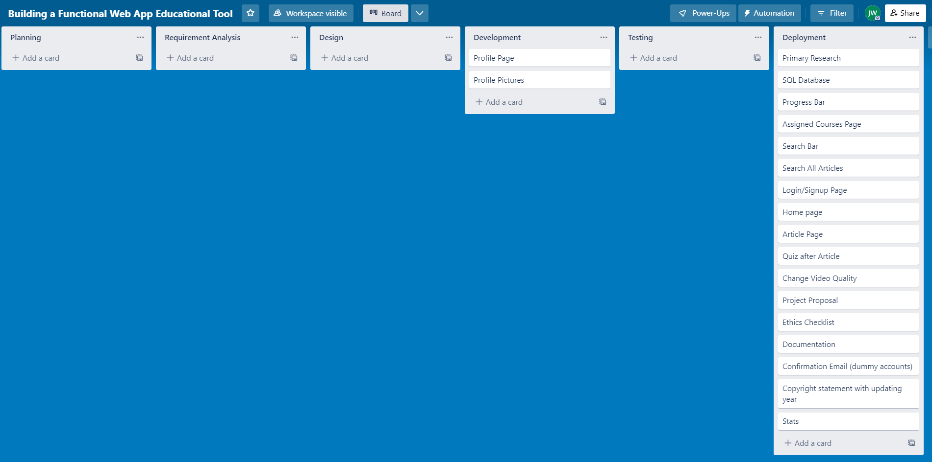

*Figure 398: Trello board at end of development*

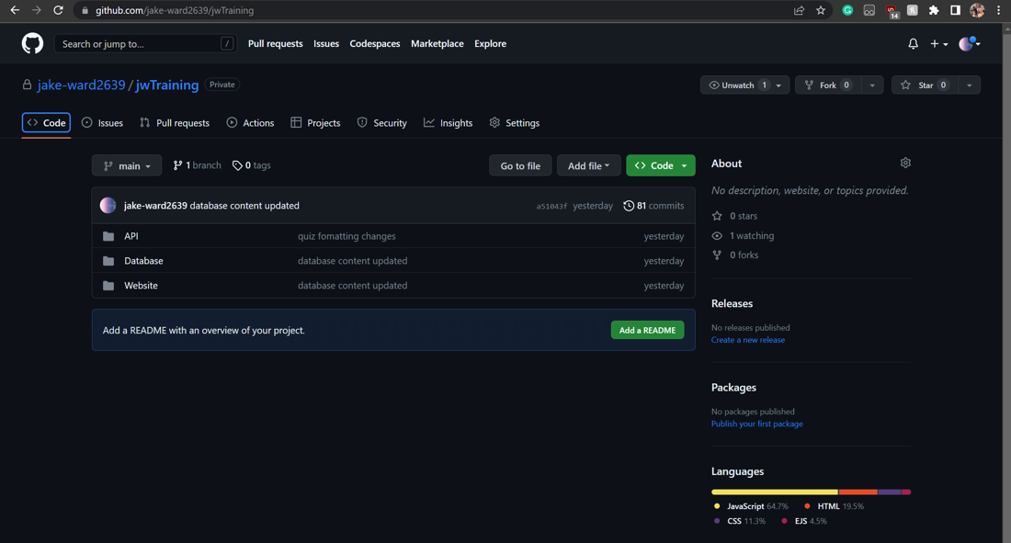

*Figure 399: GitHub repository at end of development*

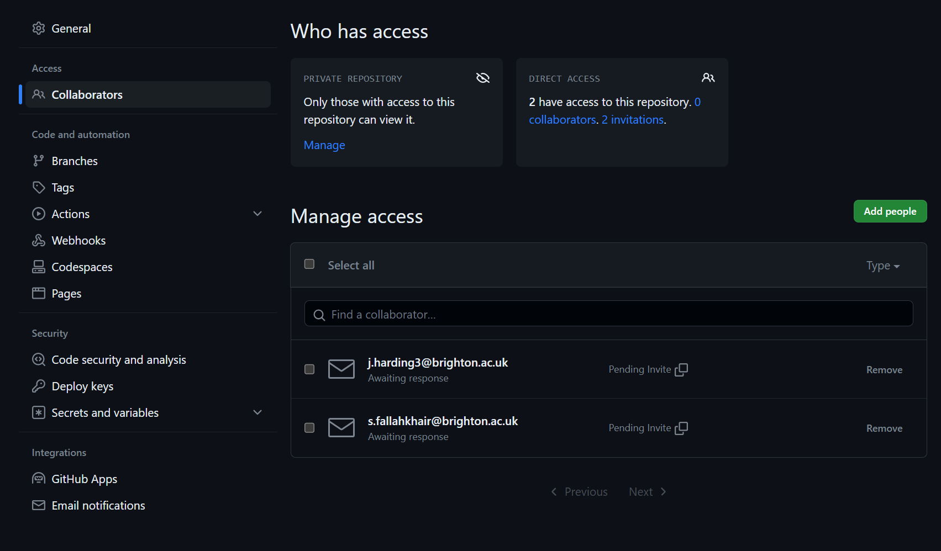

*Figure 400: GitHub settings changed so that supervisors can check codebase*

These are evidence of the project management that had to be carried out which I would consider very successful. Not only did the application get made in time but the documentation of the entire lifecycle means that the project could easily be continued at a later date and/or by another developer. The “must-have” and “should-have” requirements were all met with the last few requirements only left under development due to time constraints. In reflection, I believe that while I had initially set my requirements with the conventions of “Requirement Analysis”, this may have been hard to follow for developers or outsiders as there was more than one list of requirements, with an explanation required to understand which applied to the project to prove it successful. As such a single list of revised requirements prioritised by numbers was used as the requirements to show the project's success, however as I still see the other method as valid, I have included both requirement analysis and the revised requirements in the reflective report. Another reason the project’s requirements had to be revised is that over the course of development, some of the project’s requirements became invalidated by new designs, additional features and restrictions. An example of this is how I initially stated that I would be adding the ability to change the quality of the video on articles yet that functionality was inherently part of the YouTube Player API which I decided to use to host the videos, thus the requirement was met, no effort was placed into incorporating it and so it was invalidated as a requirement and dropped. Due to this I learned the importance of being flexible with project requirements and adapting them as needed throughout the development process as requirements remain relevant and achievable as the project continues to evolve.

## Module Relevance

This project was chosen to specifically display skills and knowledge learned from various modules including but not limited to;

* CI404 – Introduction to Cyber Security
* CI405 – Computing Technologies (SQL)
* CI435 – Introduction to Web Development
* CI453 – Working in the Computing Industry
* CI536 – Intergrated group project
* CI527 – Web Application Development
* CI583 – Data Structures and Operating Systems
* CI615 – Object Oriented Design and Architecture
* CI646 – Programming language, concurrency and client-server computing
* CI609 – Advanced Web Application Development

Cyber security had to be deeply considered during the project as only practices that enforced security had to be allowed due to the fact the application entailed handling user data. While some of this functionality was inherently built-in via applications such as the MySQL database, security mostly had to be considered by making sure all executable routes were considered and prevented if they posed any kind of threat. An example of this is the denying of any type of request (beside login and signup) if the user wasn’t using valid credentials, in doing so it meant that users couldn’t gain unauthorised access by sending HTTP requests manually, as they would still need their credentials to access any information or make any changes. The only security issue I am aware of is that the credentials being saved in the browsers means that third parties may try to steal the information. However, on a private network (as would be the case at most companies) this issue is greatly minimised and the credentials expire fairly quickly, but if development were to continue after the submission date, then I would place encryption on the credentials placed in the browser and decryption on the API to remedy this potential issue. Multifactor authentication could also be added, and I acknowledge that private networks are still susceptible to attacks that could compromise the network. This all shows that while it wasn’t the focus of the project, elements from CI404 were considered and incorporated many times. These issues were not placed at high priority as the data a training site would be working with wouldn’t be sensitive and thus wouldn’t be worth stealing. This is because if the users were all using unique usernames and passwords then any potential attacker could only get credentials that would be useless for anything besides accessing generic training content. In hindsight after later research, tokens should have been used to keep the user logged in, however this was discovered too late into the projects development to be implemented without greatly affecting the projects progress. If I were to do the project over from scratch tokens would have been used to keep users logged in, an example can be found below in figures 401 and 402.

Content from CI405 was crucial to the chosen project as it involved construction of an application with database storage. This is because this model started teaching us about SQL which prompted independent learning into the subject which would become the foundation for how to store content in the application. While alternatives for storing data like Firebase exist, MySQL was chosen due to the learning material from CI405 and hereafter study of SQL that it prompted. As previously stated, MySQL was chosen for many other reasons such as convenience, security, and etc and much revision had to be done into the subject. In reflection it produced no issues and data was held securely. The use of phpMyAdmin made the altering of databases convenient and simple however to display knowledge of the subject I still wrote out most queries manually, as evidenced by the queries stored in the API. The communication between the MySQL database and API was fluid and storing the credentials in an external file made security tighter. Overall, I believe all decisions surrounding the storage of the data were correct, however, the debate over null values was a large discussion point. Reflecting back on the null values debate (as can be seen on implementation entry 22/02/23), I acknowledge that I should have possibly removed all null values from the database as research suggested that developers shouldn’t use null values because then corrupted entries are indistinguishable so it’s good practice in the industry to never allow nulls. However, due to conflicting research and advice suggesting that null values should be used to signify when a value is to be ignored, I opted to use them for values that don’t exist and will not exist. It was due to the lack of community consensus on the issue that I proceeded to use null values in SQL, however, it can clearly be seen that I took the research into account to only use them when appropriate and use default values frequently to enforce best practice.

The modules CI435, CI527, CI609 and parts of CI536 are all integrally relevant to the project chosen due to them all sharing the same subject matter, Web Development. Due to this project being based around the creation of a web application, it would naturally be relevant to all the modules which taught me the various elements of web development. While CI435 and CI527 taught the basics of web app creation, CI609 taught the more advanced techniques that would be used in this project including the creation of JavaScript APIs, sending custom HTTP requests, modern JavaScript practices and etc. While a lot of the coding practices exhibited in this project are the result of individual research it is still relevant to these modules. In reflection, I believe there to be no fault relevant to the area showcased in the project. However, I acknowledge that if a different type of site had been chosen for the project, then I would have been able to display more skills relevant to the area. Namely, if the site chosen could have functioned offline then offline functionality such as service workers and manifests could have been implemented so that app could be installed and resume functionality when an internet connection was returned. This was not the case as this project was reliant on loading dynamic information from the database, meaning it couldn’t have any meaningful offline functionality despite knowing how to implement it. So, in hindsight, a different type of site should have been chosen to display skills in implementing offline functionality, but it was such an early decision that it would have been illogical to overhaul.

The modules CI536 and CI453 were very relevant to the learning displayed in this report as they served as the introduction to project management. The choice of project was relevant to these modules as the creation of a web application (or any software artefact) in a professional setting would involve the use of project management methods that were learnt or researched independently over the course of these modules. This included research into different methodologies, various methods of documentation and etc. This will be expanded upon in the section labelled “Methodology and Planning Evaluation” so as not to repeat the same information.

CI583 prompted learning into many of the programming practices that would be displayed in any project that involve the use of a programming language. In this way it would have been difficult not to choose a project which didn’t hold relevance to the module. It also taught about security and file systems, both of which would have to be considered when the project involved the storage of files and a public UI.

Figure 43 displays one of the class diagrams created for the projects architectural design which directly relates to the CI615 module. The CI615 module heavily focused on the implementation of UML diagrams such as class diagrams when designing a system. Again, any project chosen with a software artefact being created would have allowed the usage of such diagrams.

Finally, the choice of project relates to the CI646 module as it required a great amount of research into the JavaScript language, Concurrency, Networking and many other topic that would have to be involved in the creation and planning of a web application. I believe that the networking aspect of the module was the most deeply explored as evidenced by the large amount of effort placed into communication between the client and API. In reflection, I feel that no flaws were made with the API or general networking aspects, but more features of JavaScript networking could have been utilised such as WebSockets.

Overall, I think it is clear that the choice of project relates heavily to the modules attended throughout the three years of attendance at university and its choice allows for a display of skills from the culmination of them.

## Research Evaluation

Background research influenced the project and its development in many ways. As detailed over the entirety of the research section, many resources, architectural designs and ethical/legal issues were researched before and during implementation. So as not to repeat the same points, I will only be detailing research that had an unexpected or significant impact on the project.

While I was already aware of a lot of copyright law and ethical issues, research and revision of these subjects enlightened me on the specific restrictions I had to be wary of and would include in the terms and conditions of the site. These included prohibitions on the sharing of copyrighted material without permission, restrictions on hate speech and discriminatory language, guidelines on appropriate user behaviour and content, and protocols for handling user data and privacy. The biggest effect this had on the development of the application was that to avoid the need for consent forms there could be no identifying features during testing or research, this meant only using dummy email accounts for signups, survey answers remaining anonymous with a unique ID so that the user's information could be pulled if requested and testing documentation without entries unique to participants. This worked well and effectively however the dummy accounts could only be used up to a point, as the confirmation email feature would need a valid email address to test. To remain ethical, I used my own accounts for this testing and would recommend others use a temporary email address should they want to test the same thing. To avoid issues with intellectual property I learned that I must use publicly available content for the demonstration purposes, while if implemented at a company then that company must be the corporate author of the content they are hosting, or it has to be bought or be in the public domain. I learned that the videos used for demonstration purposes must be publicly available to anyone on the internet and be used for educational purposes to fall under fair use. Meeting these criteria by nature of being used via the YouTube Player API and for a university project meant that there were no longer any ethical or legal concerns with the project. While I learned a lot about the legal and ethical issues presented throughout the entire agile lifecycle it didn’t produce any additions and served only to restrict. I am confident that my awareness of these restrictions will help avoid issues in the future.

There aren't many things to evaluate when it comes to architecture, the client-server system that was set up was fit for purpose and didn’t inherently cause any issues. This only serves to reaffirm that the correct choice was made and it would be continued to be used in the future. The only issue arose from where the server was hosted. Due to the API and Database being hosted on Brighton Domains it would often cease functioning. This was likely due to the number of other students using the platform at the same time as errors would often complain of “too many connections at once”. This made testing the application problematic as the application’s functionality would be dependent on the state of the host. While this couldn’t have easily been foreseen it is noted that another choice of host, while less convenient, could have prevented this issue. Client-server itself continues to make the most sense for this type of web site and server-side rendering was used effectively for dynamic articles with EJS, enforcing the idea that it could also be used effectively moving forward to save the clients processing power.

The choice of resources was directly tied to research into Environments, Frameworks, Toolkits, Databases, Middleware, Testing software and APIs, displaying how impactful the research into resources was to the project. The choice of resources based on research would impact how the code was written and in what form it had to be written. An example of this would be the use of Express and how its usage dictated the method that would be most effective for handling requests. These practices are evidenced by all figures throughout the implementation section of the report as well as all files found through the site or via the GitHub repository. Due to the wide success of the project in terms of requirements met, the choice of resources can be viewed as correct.

Some resources researched were never made use of for various reasons. In most cases, resources didn’t need to be made use of due to another resource fulfilling the same purpose at it (like Express being used in favour of Django). However, when it came to toolkits neither Gulp nor Webpack was required as minification of code was opted against. This is because the use of either Gulp or Webpack would make the code confusing and difficult to read/analyse for outsiders. So instead of using a toolkit unnecessarily to uglify code, the opposite was done, and the code was beautified using online resources to make the code more readable for the report so the outsiders could easily understand the inner workings of the application. If the application were to be implemented in a real-world scenario, then Gulp would be used to improve performance by optimizing the code and reducing file size, offering benefits, such as faster load times, reduced bandwidth consumption, improved website or application performance and increased security. Overall, while Gulp would be useful in a real-world scenario, choosing to beautify the code for the report using online resources was a better-suited alternative to toolkits like Gulp and Webpack, which would make the code confusing and difficult to read.

I learned about extra resources along the way as the email requirement’s most elegant solution involved a middleware called nodemailer and the same for the video hosting in the form of the YouTube Player API. This demonstrated how the flexibility of the agile development method allowed for adaptation in the choice of resources allowing for the most efficient solutions to be carried out. Specifically, the use of the Player API met many requirements at once including the ability to change video quality, embed the videos in articles, and handle playback events. This in turn was one of the causes for revising the requirements as the changing video quality requirements was met inheritly from this technology without effort, invalidating its status as a requirement.

The resources researched for testing were all utilised, creating a comprehensive documentation of testing, further displaying the full software development lifecycle. However, in reflection the use of all these testing tools elongated the process significantly, reducing the time that could have been used as further development. Despite the comprehensive documentation of testing and the display of the full software development lifecycle, it is important to note that the elongated testing process had a negative impact on the development timeline. The takeaway of this is that while it is essential to thoroughly test software to ensure reliability and stability, testing should be balanced with development to ensure an even schedule. In future projects a more streamlined approach prioritizing the most critical aspects of the software and minimizes the use of non-essential testing should be used.

The primary research of course had a significant impact on the project's development, however while the majority of conclusions drawn from the primary research were acted upon, some were subverted which will be detailed here. First of all, the primary research suggested that the design of the pages should be colourful and vivid however the question leading to this conclusion was both leading and shouldn’t have been asked due to a specific limitation I was more than aware of. This is because I, as the sole developer, am colourblind, preventing me from making good design decisions based on colour without constant outside help. As such it was opted that a safe design making use of shades of grey, red for negatives and green for positives would be used. The colour palette of the page shouldn’t have been queried with the target audience due to this known disability but in the future, it wouldn’t be an issue as outside help would be available in a real-world setting. Dark mode (while popular in primary research surveys) was reduced from a requirement to a future development requirement as the design choices made already constitued as a dark mode due to is muted colours and lack of brightness. This decision was made as dark mode themes are often still visible in the day making it the most appropriate theme for all times of day. As such if the development were to continue after the due date, then a light mode would have to be implemented instead of a dark mode. All other conclusions drawn from the primary research were implemented in their originally specified ways. These conclusions can all be found at the end of the primary research section of the report.

Where applicable secondary research would dramatically impact the design of the UI for the project. The most impactful being the training site that I had constant access to as it was the closest to a website that held the same target audience as me. However, the goal of the project wasn’t to copy bet was to improve upon the design that is present in other products. As such the design was deviated from by offering information about due dates, allowing users to access previously completed training for revision and displaying notifications for approaching deadlines. Through this I've demonstrated that while reference is useful to construct a product, it is important to tailor unique designs relevant to your own goals. I’ve also demonstrated that using reference is important in the construction of conventional design so that the UX isn’t interrupted by hosting unusual layout or functionality.

## Methodology and Planning Evaluation

Overall, the Agile methodology was the correct methodology to pick over Waterfall. This conclusion is drawn due to its greater flexibility allowing for useful unplanned additions as well as allowance of deviation and return to previous requirements allowing for easier bug fixes and problem solving. In addition, breaking the task down into smaller requirements as well as enforcing an iterative and responsive approach meant a higher quality product could easily be delivered (as proven by every high priority requirement being met). Waterfall would restrict developers from adhering to these practices which would have damaged the product, this is evidenced by the multiple quality of life changes improving the product after the development stage was officially over, which would not have been allowed outside of Agile development.

I feel that the Agile development lifecycle has been fully documented to show competence in the field of project management. This is evidenced by the large amount of documentation spanning all stages of development including; requirement gathering, planning, an appendix of meetings, research, design, implementation, the codebase, testing, debugging and evaluation with evidence of each. This documentation proves the flexibility and responsiveness initially promised by the methodology to be true, as well as highlighting the challenges that arose and how they were overcome. However, while I believe that the thorough documentation of the Agile development lifecycle demonstrates professionalism and attention to detail, it could be viewed that this level of documentation hindered the project due to the amount of time required to ensure a comprehensive view of the entire project and lifecycle. I’ve now learned that there are disadvantages with over-documentation such as slowing down the development process or making it difficult for others to understand.

An issue that was made clear at a meeting was the confusion over the priorities of requirements. This was because they were divided into the conventional Business, User and System requirements but with priorities all labelled via numbers. It was stressed that the system requirements would be used to test the project's success as they are the requirements that were relevant to the development team. However, this was not obvious to the casual observer and would possibly make a requirement-test matrix difficult to write as a result. So, the old requirements were maintained to show the initial planning and revised requirements were created to showcase the level of success the project would achieve. Feedback from supervisors validated this change and so the issue was solved. In future projects clarity must be considered when carrying out and documenting requirement analysis.

While the overall plans didn’t deviate the way in which they would be carried out would frequently stray from the original plans. This included adding, removing or changing requirements and well as researching new technologies and adapting previously written code. All of this can be evidenced many times over the course of the implementation section as well as in the justification written under the revised requirements section. But to summarise, the web application project deviated from the original plan by adding an "all-articles" page to replace the suggested articles feature and dropping the changing of video quality requirement as it was already a part of the YouTube API. The search bar requirement was revised to be for the "all-articles" page and not the assigned training page. The report button was invalidated due to the lack of user-to-user interaction and admin status required to submit information. Dark mode was dropped as it would require a huge investment of time for a not especially complex feature, and other minor CSS/visual adjustments were made in its place. I had to shift focus to other commitments, leaving feature 22 to remain partially complete and 23 to be implemented later if time allowed. Other than that, minor changes were made to fix bugs or facilitate new additions, all of which are dated and indexed in the test-requirement matrix to allow for fast consultation of the implementation section for clarification on the specifics. All of this shows once again that Agile allowed for flexibility that improved the level of quality the final product could achieve.

Another prominent feature of project management included the constant backing up of the codebase and documentation. This was planned and carried out so that there was as reduced chance as possible for progress to be lost. This was of the utmost importance so GitHub was utilised with its version control so that a backup copy of an older version could always be obtained. The codebase would be regularly updated in three locations: GitHub, the project managers PC and on Brighton Domains (the hosting platform). While this elongated the time spent on development it was a necessary sacrifice to ensure that a competent final product was delivered. In the same vein all documentation was stored and regularly updated on a PC, OneDrive and Google Drive.

When talking about the planned schedule, development was always planned to be done with time to spare in case an unexpected delay was to occur. This concern was validated as a medical issue concerning a family member and later injury caused a large suspension to be taken from the project's development. Fortunately, the head start meant that the project was not in danger of non-submission. This practice would be carried out in the future due to this validation. This schedule was kept track of in many ways including the use of a kanban board and frequent note of tasks to carry out. While a Gantt chart was initially made, this unforeseeable set back caused the schedule to be carried out in a more flexible fashion to catch up. With some requirements being implemented over the course of singular days where weeks had been planned. Despite this the schedule was still divided into sprints, it simply meant that the certain sprints had to be accelerated somewhat.

## Progress, Problems and Solutions

When assessing the progress made over the entire project, I believe it should be considered a success. This is due to the fact that all high priority requirements were met resulting in a product described by the goal of the project. The software artefact was successfully created resulting in a web app that could be used for educational purposes. While all problems and solutions have been documented at length over the course of the implementation section and test table, I will attempt to summarise the problems and solutions that are worthy of discussion/reflection.

There was an issue where the main content of articles that was stored in the database was not being displayed on the article pages properly. The issue was that new lines were not being implemented on the EJS template and would remain as the characters “\n”. It was discovered that the solution was to store the main content in the database with new lines, instead of using \n to indicate when a new line should be implemented. This problem and its solution demonstrate the importance of understanding formatting details and ensuring consistency in data entry to avoid technical issues.

A problem occurred while externalizing the JavaScript code for utilizing the YouTube player API in an EJS template. It involved exclusion of the page load event listen, incorrect code loading sequence, and inability to access video ID externally. The solution required rearranging the script tags, passing the video ID as a hidden element, and initializing the ID within the function to create the player. The lesson learned is to ensure proper initialization and placement of script calls to avoid potential errors and improve website performance. There is still no understanding of why the placement of the API functionality in a load listen caused an issue but it's important to document these types of technical issues and their solutions to help with future troubleshooting.

There were a few occasions where small bugs would appear due to syntax errors or simple forgetfulness. Examples of this include when a query wasn’t excluding completed articles due to human error and when status codes were used in the wrong places due to simple syntax errors. This reaffirmed the importance of re-reading code and the importance of testing to find these errors and fix them.

There was a presentation and logic issue as the code for creating the iframe for YouTube video hosting would appear regardless of whether or not a video ID had been provided. To fix this problem, the code was altered to create the iframe only if the video ID existed (as a hidden element) and the code was further altered to hide the video container until a video had successfully loaded so as to be more presentable. This experience highlights the importance of considering presentation as well as logic issues when integrating third-party APIs. It demonstrates how adjustments to display certain elements only when necessary, can improve the UX of a web application.

There was a brief issue where I noticed that the variable “quiz content” was not available from the external JavaScript despite being passed into the EJS template upon rendering. Because making it a hidden element would allow those with knowledge of developer tools to cheat it was instead set as a global variable. This highlighted a new usage for global variables in JavaScript that I was previously been unaware of.

The implementation of a quiz grading feature on an API was delayed due to an error that caused a status error 500. It was found that the answers array was being converted to a string during the process of handling it between the client and server side. The solution involved implementing code to change the array back to its original format and the issue was identified by returning all variables in the response JSON object due to an inability to access the console. In the future if there is a similar issue, I will check for unintended conversions of data types when passing data between client and server and have learned that the JSON response can be used for temporary debugging purposes.

The implementation of confirmation emails took longer than expected due to trial and error and required research. The nodemailer plugin was chosen and installed as a dependency in the package file. A new Gmail account was created to send emails from and the transporter object was set up with the login information. The code was placed in the signup method to execute when a new user was added to the database. After receiving an error message suggesting the connection to the SMTP server was refused, research was done and an app password was generated to attempt to solve the issue. The solution was found to be changing the port to 587 instead of using port 465 likely due to the firewall on domains. This taught me how easy it is to change the ports of an outgoing message as well as how firewalls can have weaknesses depending on the port used and how this may be a solution in the future. The research also demonstrated how Google has been cracking down on security recently, making it harder for developers to make use of their technologies.

Through observational testing, I found that UI elements that serve as visual indicators are important to users. This is because users found it confusing why work past its due date was still being presented or hadn’t seen that it was past due and were confused as to why completion didn’t change the state of the progress bar. This was fixed by including an “overdue tag” as well as orange boarder to signify a warning about the card representing the overdue work. This conclusion was also formed by the request for a visual indicator such as a progress bar and the reported improved quality of life after its inclusion.

## Further Development

There are a few plans for further development after submission, some of which result from existing requirements, while others are improvements that can enhance the product. Some implementations would have to be included when applying the product to a real-world scenario rather than an educational demonstrative one. For example, previously mentioned, Gulp's usage to minify code. While the codebase was beautified to ensure easy understanding by outsiders, if the application were to be implemented in a real-world scenario (such as on a small company's private network), Gulp would optimize the code, leading to faster load times, reduced bandwidth consumption, and increased security. This process was already demonstrated in the assessment of the CI609 module.

An example of further development based on requirements would be continuing the profile picture functionality, specifically an upload on the client-side. Although the feature's primary implementation was on the server-side, its client-side functionality was never fully realized due to time constraints. The proof of concept for carrying this out was demonstrated by Postman's usage at implementation entry 23/03/23. Implementing a profile page, fetch requests, and response handling would be the remaining tasks. While the profile pictures requirement was to only be implemented if extra time was available, only enough time was found to halfway implement it. However, I believed the server-side functionality was the more difficult and important functionality to demonstrate, involving file handling over a client-server architecture and the use of new plugins. By implementing the server-side profile picture functionality, the ability to handle file uploads and integrate them into the user profile system was demonstrated. Thus, I feel justified in prioritizing the server-side functionality of the requirement and leaving the client-side for further development. The client-side development would entail a profile page with an upload button to display the image onscreen if it fit the appropriate restrictions, an apply button to send the request, and would automatically get the user's profile picture (if non-existent, a default image would be used in its place).

The requirement specifying the saving of the states of pages (or aspects of them) went unrealized but would be implemented if extra time in the schedule were found, or if development continued past the due date. I am knowledgeable about how to implement this, again because of the CI609 module. The first place this feature could be applied would be on the login/signup page. By saving the form's input content even after reloading the page, it would display a feature of progressive web applications, as well as being potentially useful to the user. With more time, certain articles could be cached so that the site could function even if the internet went offline.

Another future development would be the implementation of a forgot password system. This was not initially implemented due to the fact that such systems can create holes in security. For example, if the system relies solely on personal information or weak authentication methods, it could be vulnerable to social engineering attacks and/or password guessing. As well as the fact that if the verification process for resetting a password is weak, attackers can easily bypass it. Like how if the system sends a password reset link to the user's email address, but the email account has been compromised, an attacker can intercept the email and reset the password, locking out the real user. For this reason, it wasn’t implemented in the base product as the administrator at work would be just as convenient and a lot more secure for changing account information (by altering the database). But it could still be implemented in the future, so long as many security measures, such as strong authentication and verification methods, ensure that attacks are prevented.

If I were to continue development after the due date, then I would consider a “reset work” endpoint that would allow creating new entries or overwriting assigned articles' entries to reset their complete condition and add a new due date. This is so as to give more functionality to the company without having to manually alter the MySQL database. This could be useful in the scenario where a user's work is past the due date, and the employer wants to make the work relevant to the user again.

As previously mentioned, although security is not the focus of the project, credentials generally should not be stored in the browser. Although it was realized too late into the project's development to overhaul, token-based authentication should have been used to prevent this issue while still allowing users to stay logged in. I chose to simply use credentials as the application was to be used on a private network, in practice would not be housing potentially sensitive information, and they could be reused for security on every request. However, I have now learned otherwise as private networks can be vulnerable to attacks, and I will use token-based authentication moving forward. To prove that development could have been done to implement this if it were not too late upon realizing, I have detailed in the paragraph below and figures 401-402 how the implementation would have been done. If the project were to be done again, this is how it would be implemented, although with enough time, the project could be overhauled to use this approach.

As already implemented, a POST request would need to be made with the user's credentials, and they would have to be verified with the database (login or signup). However, a JSON web token would have to be generated with a unique identifier like their ID upon success and returned to be stored in the client browser as a session value or cookie. Then, upon any other request (including an alternate login route using the token), the client would send the token in the authorization header of the request, the API would verify and extract the ID, and then use it to fetch the data in place of the username and password. To log out, the user would only need to remove the token. Figures 401-402 display how this can be done on both client and server-side in a simplistic format. Both figures hardcode values for simplicity in demonstration but would use database-held values in practice.

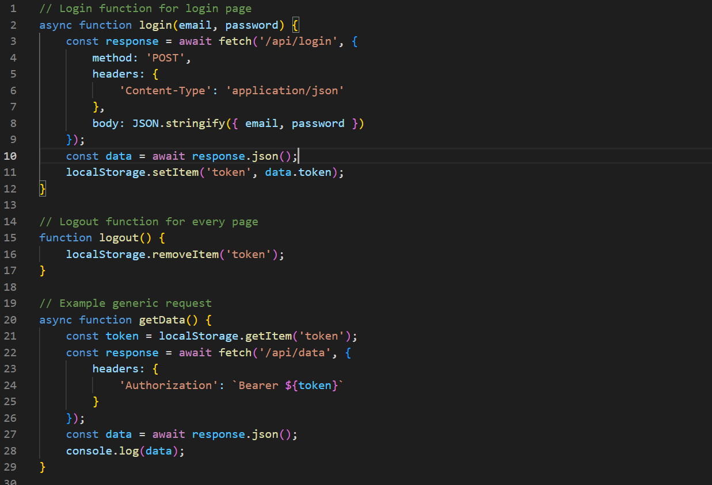

*Figure 401: Token-based authentication example with comments (client-side)*

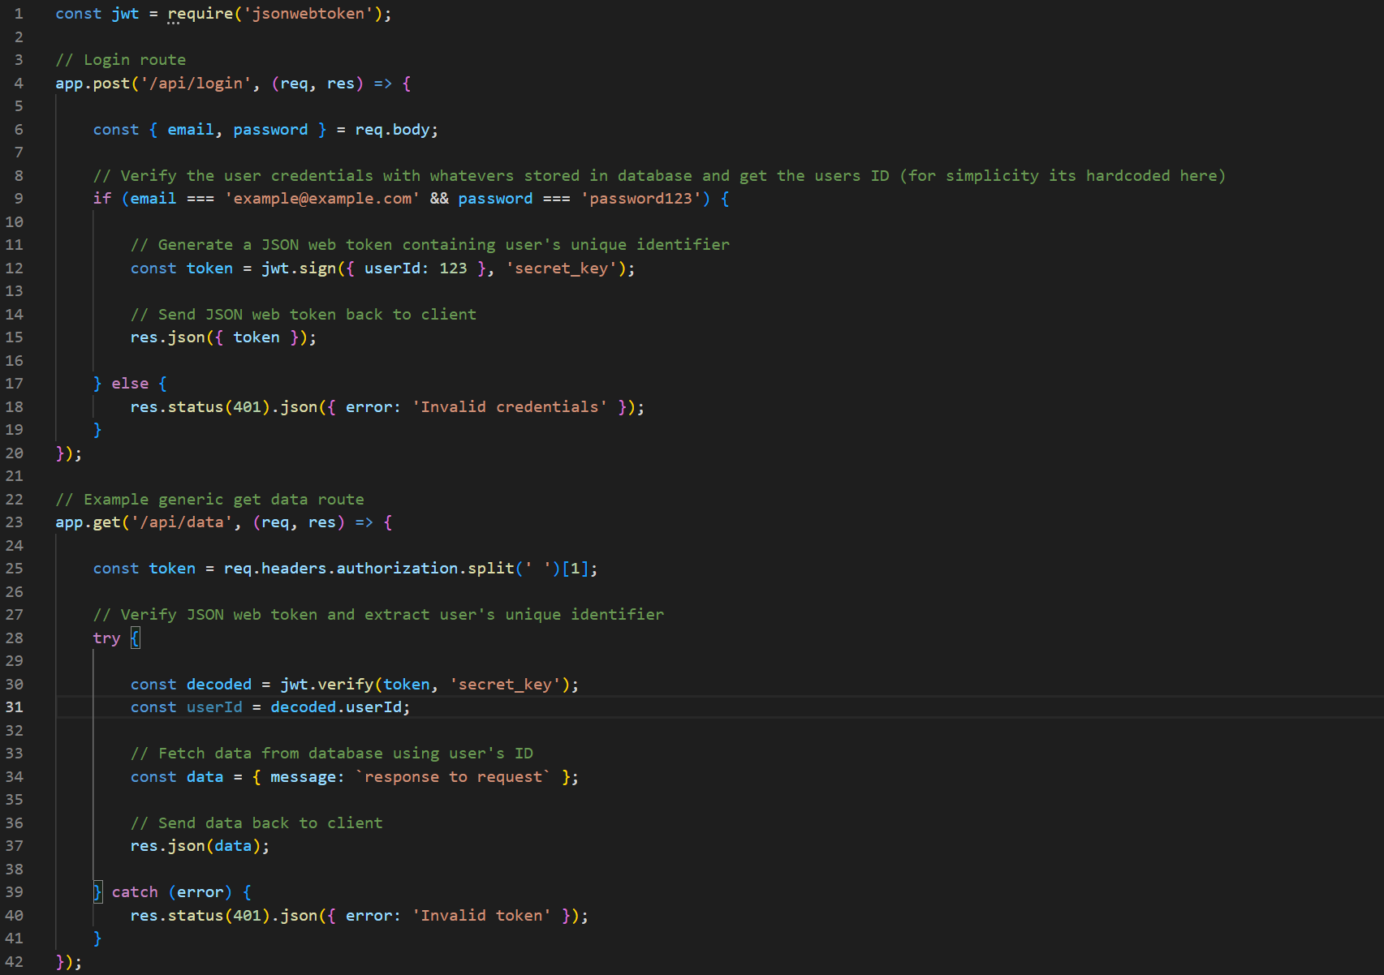

*Figure 402: Token-based authentication example with comments (server-side)*

Encryption is an alternative solution to the security issue that would not require as extensive changes. By encrypting the credentials sent to the client and decrypting them on the server-side API (so long as the key is hidden), credentials would never be able to be stolen.

In conclusion, the project met all necessary requirements to be viewed as successful and displays a wide range of programming and project management skills. Future development potential requirements have been detailed and justified. Lessons have been learned from both research and errors overcome. The entire project, as well as the software development lifecycle has been documented. I as the project manager am satisfied with the software artefact, documentation and plans moving forward to improve the project.

# Research Material & References

(no date) *Software development life cycle (SDLC)*. Available at: https://www.w3schools.in/sdlc/software-development-life-cycle-sdlc (Accessed: October 11, 2022).

Hamilton, T. (2022) *Agile vs waterfall – difference between methodologies*, *Guru99*. Available at: https://www.guru99.com/waterfall-vs-agile.html (Accessed: October 11, 2022).

Corporate Finance Institute. 2021. *Data Protection*. [online] Available at: <https://corporatefinanceinstitute.com/resources/knowledge/data-analysis/data-protection/> [Accessed 12 October 2022].

GDPR.eu. 2016. *GDPR Archives - GDPR.eu*. [online] Available at: <https://gdpr.EU/tag/GDPR/> [Accessed 12 October 2022].

Boyd, C., 2021. *The User Researcher's Guide to GDPR*. [online] Userinterviews.com. Available at: <https://www.userinterviews.com/blog/the-user-researchers-guide-to-GDPR> [Accessed 12 October 2022].

Geitgey, A., 2018. *Understand the GDPR in 10 minutes*. [online] Medium. Available at: <https://medium.com/@ageitgey/understand-the-gdpr-in-10-minutes-407f4b54111f> [Accessed 12 October 2022].

Gaurav, S. (2022) *Difference between peer to peer and client server*, *Scaler Topics*. Available at: https://www.scaler.com/topics/computer-network/difference-between-peer-to-peer-and-client-server/#:~:text=the%20computer%20systems.-,The%20main%20focus%20of%20the%20client%2Dserver%20network%20model%20is,stores%20individual%20files%20and%20data. (Accessed: October 23, 2022).

Breux, G. (2018) *Client-side vs. server-side vs. pre-rendering for web apps*, *Toptal Engineering Blog*. Toptal. Available at: https://www.toptal.com/front-end/client-side-vs-server-side-pre-rendering#:~:text=Client%2Dside%20rendering%20manages%20the,displays%20a%20blank%20page%20first. (Accessed: October 23, 2022).

Low, A., Siu, J., Ho, I. and Liu, G., 2014, November. Introduction to Node. js. In *Proceedings of 24th Annual International Conference on Computer Science and Software Engineering* (pp. 283-284).

Editor (2020) *The good and the bad of Node.js Web App Programming*, *AltexSoft*. AltexSoft. Available at: https://www.altexsoft.com/blog/engineering/the-good-and-the-bad-of-node-js-web-app-development/ (Accessed: October 23, 2022).

(no date) *Brighton Domains Support Documentation*. Available at: http://brighton.domains/docs/ (Accessed: October 23, 2022).

*Pros and cons of reactjs - javatpoint* (no date) *www.javatpoint.com*. Available at: https://www.javatpoint.com/pros-and-cons-of-react (Accessed: October 24, 2022).

*React* (no date) *npm*. Available at: https://www.npmjs.com/package/react (Accessed: October 24, 2022).

*Good and bad of angular development* (no date) *OdinSchool*. Available at: https://www.odinschool.com/blog/programming/good-and-bad-of-angular-development (Accessed: October 25, 2022).

Raval, N. (2022) *React vs angular: Which one is best for your next front-end project?*, *Radixweb*. Radixweb. Available at: https://radixweb.com/blog/react-vs-angular (Accessed: October 25, 2022).

*Express.js mobile app development: Pros and cons for developers* (no date) *Binariks*. Available at: https://binariks.com/blog/express-js-mobile-app-development-pros-cons-developers/ (Accessed: October 26, 2022).

*EJS* (no date) *npm*. Available at: https://www.npmjs.com/package/ejs (Accessed: October 26, 2022).

*Express-fileupload* (no date) *npm*. Available at: https://www.npmjs.com/package/express-fileupload (Accessed: October 26, 2022).

*Body-parser* (no date) *npm*. Available at: https://www.npmjs.com/package/body-parser (Accessed: October 26, 2022).

*Cors* (no date) *npm*. Available at: https://www.npmjs.com/package/cors (Accessed: October 26, 2022).

*MYSQL2* (no date) *npm*. Available at: https://www.npmjs.com/package/mysql2 (Accessed: October 26, 2022).

Patel, J. (2022) *Django vs express: 2 best web frameworks compared in 2022*, *Monocubed*. Available at: https://www.monocubed.com/blog/django-vs-express/#:~:text=Django%20is%20an%20advanced%20Python,js. (Accessed: October 27, 2022).

*Why developers like gulp* (no date) *StackShare*. Available at: https://stackshare.io/gulp (Accessed: November 12, 2022).

Reeves, S. (2021) *Webpack vs gulp – the best build tools for Javascript projects*, *GoodCore Blog*. Available at: https://www.goodcore.co.uk/blog/webpack-vs-gulp/ (Accessed: November 12, 2022).

*Gulp vs Webpack: Top 8 differences between gulp vs Webpack* (2021) *EDUCBA*. Available at: https://www.educba.com/gulp-vs-webpack/ (Accessed: November 12, 2022).

*Webpack* (no date) *npm*. Available at: https://www.npmjs.com/package/webpack (Accessed: November 12, 2022).

*Gulp* (no date) *npm*. Available at: https://www.npmjs.com/package/gulp (Accessed: November 12, 2022).

Gupta, A., Rastogi, P. and Jain, S., 2018, August. Smart parking system using Cloud based computation and raspberry Pi. In *2018 2nd International Conference on I-SMAC (IoT in Social, Mobile, Analytics and Cloud)(I-SMAC) I-SMAC (IoT in Social, Mobile, Analytics and Cloud)(I-SMAC), 2018 2nd International Conference on* (pp. 94-99). IEEE.

Wagner, J., 2016. *Web Performance in Action: Building Fast Web Pages*. Simon and Schuster.

Hu, K. and Zhu, J., 2018. A progressive web application on ancient roman empire coins and relevant historical figures with graph database. In *Digital Heritage. Progress in Cultural Heritage: Documentation, Preservation, and Protection: 7th International Conference, EuroMed 2018, Nicosia, Cyprus, October 29–November 3, 2018, Proceedings, Part II 7* (pp. 235-241). Springer International Publishing.

Carriόn, V., Nordgren, R., Binns, S., Szczypka, G. and Emery, S., Social Media Data: Search, Fetch and Conquer!-The HMC Experience.

Abdur Rahman, M., Alkhaldi, A., Cha, J. and El Saddik, A., 2010, October. Adding haptic feature to YouTube. In *Proceedings of the 18th ACM international conference on Multimedia* (pp. 1643-1646).

Driscoll, D.L., 2011. Introduction to primary research: Observations, surveys, and interviews. *Writing spaces: Readings on writing*, *2*, pp.153-174.

Glass, G.V., 1976. Primary, secondary, and meta-analysis of research. *Educational researcher*, *5*(10), pp.3-8.

Muhairat, M.I. and Al-Qutaish, R.E., 2009, February. An approach to derive the use case diagrams from an event table. In *Proceedings of the 8th WSEAS Int. Conference on Software Engineering, Parallel and Distributed Systems*.

Cervone, H.F., 2011. Understanding agile project management methods using Scrum. *OCLC Systems & Services: International digital library perspectives*, *27*(1), pp.18-22.

Brown, E., 2019. *Web development with node and express: leveraging the JavaScript stack*. O'Reilly Media.

DuBois, P., 2008. *MySQL*. Pearson Education.

DuBois, P. and Widenius, M., 2000. *MySQL* (p. 506). Indianapolis, IN: New Riders.

Ferekides, C.S., Marinskiy, D., Viswanathan, V., Tetali, B., Palekis, V., Selvaraj, P. and Morel, D.L., 2000. High efficiency CSS CdTe solar cells. *Thin Solid Films*, *361*, pp.520-526.

Welling, L. and Thomson, L., 2003. *PHP and MySQL Web development*. Sams publishing.

Park, T.H., Dorn, B. and Forte, A., 2015. An analysis of HTML and CSS syntax errors in a web development course. *ACM Transactions on Computing Education (TOCE)*, *15*(1), pp.1-21.

Ranjan, A., Sinha, A. and Battewad, R., 2020. *JavaScript for Modern Web Development: Building a Web Application Using HTML, CSS, and JavaScript*. BPB Publications.

Grant, J., 2008. Null values in SQL. *ACM SIGMOD Record*, *37*(3), pp.23-25.

# Appendix A: Record of meetings

* Progress Update 12/10/22 1hr (estimated) participants; Jake Ward, Jennie Harding
* Progress Update 14/11/22 36m 53sec participants; Jake Ward, Jennie Harding
* Progress Update 28/11/22 27m participants; Jake Ward, Jennie Harding
* Viva 05/12/22 1hr (estimated) participants; Jake Ward, Jennie Harding, Sanaz Fallahkhair
* Progress Update 01/02/23 50m (estimated) participants; Jake Ward, Jennie Harding
* Progress Update 27/02/23 45m 55sec participants; Jake Ward, Jennie Harding
* Progress Update 20/03/23 45m (estimated) participants; Jake Ward, Jennie Harding
* CI601 Q&A 29/03/23 1hr 27m participants; Jake Ward, Jennie Harding, Other University of Brighton Students
* Progress Update 29/03/23 45m (estimated) participants; Jake Ward, Jennie Harding

# Appendix B: Source/Assets & External files

* API Documentation via Link: [JW API Documentation.docx](https://unibrightonac-my.sharepoint.com/:w:/g/personal/j_ward26_uni_brighton_ac_uk/EcL3WwND4NVHoOG9qED2HbEBe1Bl3NzSY59Z58-ua_JIJw?e=hA1qxI)
* API Documentation URL: <https://unibrightonac-my.sharepoint.com/:w:/g/personal/j_ward26_uni_brighton_ac_uk/EcL3WwND4NVHoOG9qED2HbEBe1Bl3NzSY59Z58-ua_JIJw?e=hA1qxI>
* Testing Documentation via Link: [JW Testing Documentation.xlsx](https://unibrightonac-my.sharepoint.com/:x:/g/personal/j_ward26_uni_brighton_ac_uk/EcdlyIxuirVLqYT9H4kcPIwBn1qbREksJDRDJ6PQyHmPhg?e=rOJSJB)
* Testing Documentation URL: <https://unibrightonac-my.sharepoint.com/:x:/g/personal/j_ward26_uni_brighton_ac_uk/EcdlyIxuirVLqYT9H4kcPIwBn1qbREksJDRDJ6PQyHmPhg?e=rOJSJB>
* Codebase at GitHub Repository: <https://github.com/jake-ward2639/jwTraining>
* Web Application URL: <https://jw1448.brighton.domains/jwTraining>
* Web Application API URL: <https://jw1448.brighton.domains/jwTrainingAPI>